Yan-Ming (Victor) Chen **陳彥銘**

(+886) 0920551629

[donotfeelup@gmail.com](mailto:donotfeelup@gmail.com) 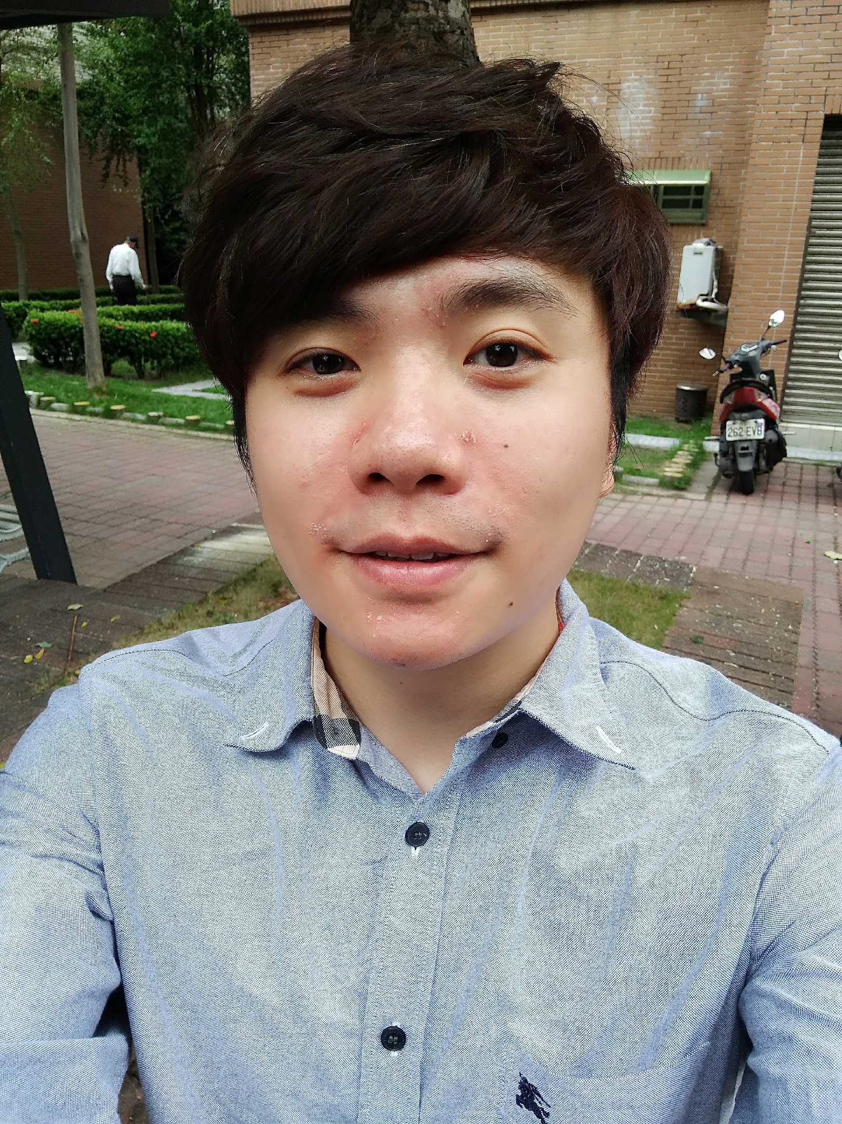

**Career summary**

* Experience in development of bootloader function porting with NVIDIA/Qualcomm/Intel/MTK SoCs
* Integration of security features for Android devices
* Storage function porting for eMMC/SD and vold
* Stability issue analysis
* Experience with on-site support in Google for Nexus devices and in factory for device manufacturing

**Education**

* 2003.09 – 2007.06 NTHU/Bachelor of Computer Science
* 2007.09 – 2010.06 NTHU/Master of Computer Science

**Qualification**

* Skills: **C** (Proficient), **Git** (Intermediate), **Linux** **kernel** (Intermediate), Java (Basic)
* Language: Mandarin, Taiwanese, English, Japanese.
* Expertise: Android, BSP, Bootloader, Security, Stroage.
* Hobbies: Table tennis, Photography, Singing.

**Work Experience and Contribution**

* 2016.07 – present *ASUS/Function Senior Manager* (ZenPad 10, Verizon ZenFone live)
  + Board bring up to setup basic porting environment for team members by integrating AOSP and platform-specific codes
  + Modification of building process to make a single codebase adoptable to two devices by dynamically loading two different groups of DDR parameters
  + Storage feature porting including eMMC/SD kernel driver and vold
  + Preparation and verification of pre-burned rom image for manufacturing
  + Analysis and debugging on CTS issues for Google approval
  + Merging monthly patches of Android Security Bulletins into codebase
* 2014.07 – 2016.06 *ASUS/Senior Engineer* (ZenFone 3 Ultra, ZenPad 7)
  + Design lock/unlock mechanism in bootloader to enhance security, such as preventing end users from changing their own system rom images
  + Implementation of built-in tools to make keybox/hdcp keys provisioned in a secure environment during the device manufacturing process
  + Debugging with SoC vendors to figure out possible reasons for booting failures after secure boot mechanism is enabled
  + Integration of DRM features such as Google Widevine and ARM HDCP
* 2011.09 – 2014.06 *ASUS/Software Engineer* (ASUS Transformer Pad, Google Nexus 7)
  + Implementation of bootloader customized requirement, such as adding fastboot commands, designing fastboot menu layout and modifying the mechanism of image flashing
  + Co-working with Google for official bootloader binary release
  + Software support such as immediate issue analysis and debugging for product manufacturing in factory
  + Experience in debugging with JTAG to analyze boot fail reasons caused by hardware defects
  + Stability analysis on monkey test issues like process crash or kernel panic