5007439
SLAM: Localización de robots y construcción simultánea de mapas

SLAM simulator for MatLab

The slam.m program is a simple SLAM simulation written in MatLab. A mobile robot carries out a square trajectory in an environment with point features at each side of the trajectory, similar to a cloister (see figure below; red points and trajectory are ground truth):

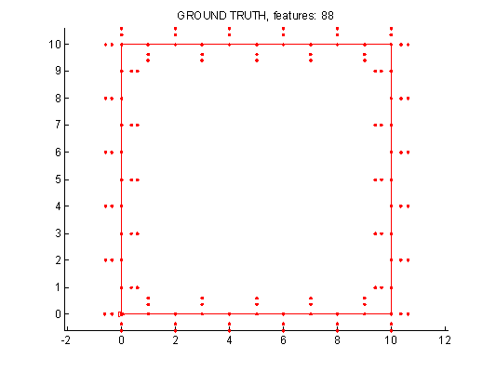

The vehicle is equipped with a point detector whose characteristics (range, precision) can be modified. Vehicle odometry can also be modified. You can also try different data association algorithms: the Nearest Neighbour, the Joint Compatibility Branch and Bound, or your own!

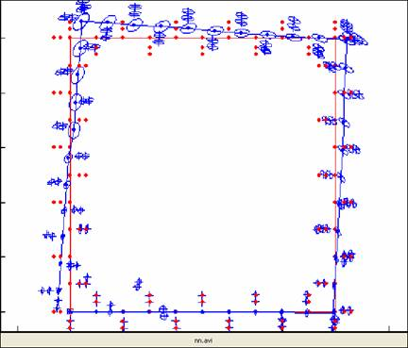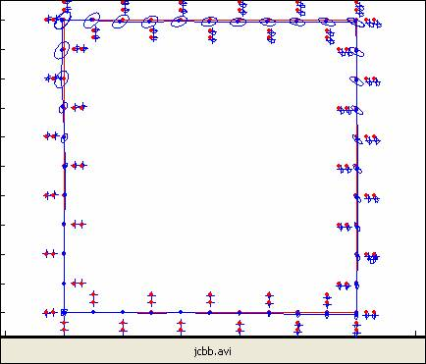



- Load slam.m, find where data association is done and try the nearest neighbour (NN) algorithm.

- Complete SINGLES and try it:

You have observations.m observations, and prediction.n predicted features.

For every observation i, check whether it has only one neighbour,
feature, and whether that feature j has only that one neighbour
observation i. If so, H(i) = j.

You will need to check the compatibility.ic matrix
for this:

compatibility.ic(i,j) = 1 if observation i is a neighbour of
feature j.

- Include people (configuration.people = 1) and try SINGLES
- Try Joint Compatibility Branch and Bound (JCBB)

