May 23, 2017

victor hurtado
piasc
1234 test street
Los Angeles , CA 90040

Dear victor:

Thank you for your recent contribution of $500.00 to PrintPAC of California—the political action committee of our industry’s statewide government affairs office.

Your support is critical in our continued effort to protect and promote the interests of the graphic communications industry before the state legislature and various statewide regulatory agencies.
In the recent past, your support has made it possible for us to advance the manufacturing tax credit on equipment . . . competitive workers’ compensation insurance . . . sensible air and workplace safety regulations, sales tax exemptions for various printed products, and other important industry goals.

I am confident that with your support, we will continue our campaign to build a more visible, stronger graphic communications industry in California.

Sincerely,
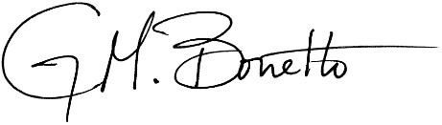
Gerald M. Bonetto, Ph.D.
Vice President, Government Affairs

