# **IPMLogo09Color_1**

315 Torrance Blvd, Carson, California 90745 • (310) 515-7166 fax: (310) 515-8266

*www.printmuseum.org mail@printmuseum.org*

May 23, 2017

victor hurtado

piasc

1234 test street

Los Angeles , CA 90040

Dear victor:

STATEMENT OF DONATION

Thank you for your generous $500.00 contribution to the International Printing Museum Foundation on behalf of Bob Lindgren. Your financial support helps the Printing Museum with its continuing efforts to preserve the important heritage of printing and the use of its resources for education through many programs. Bob Lindgren remains a passionate supporter of the Printing Museum and its educational mission since its inception in 1988, having also served on the Museum’s Board of Trustees since the beginning.

Please retain this receipt for tax purposes. The International Printing Museum Foundation is a 501(c)(3) tax exempt organization. Thank you again for your gift in the name of Bob Lindgren and your support of the Printing Museum’s mission of *Preservation Through Education.*

Sincerely,

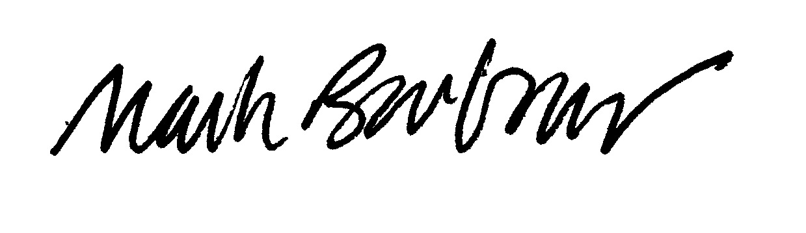

Mark Barbour

Director and Curator