

May 23, 2017

victor hurtado

piasc

1234 test street

Los Angeles , CA 90040

Dear victor:

We want to thank you for your continuous support of our educational program on behalf of Bob Lindgren!

R.A.I.S.E. Foundation’s 29-year Educational Program could not have possibly achieved local, statewide, and national recognition without your generous support. Thanks to contributions like yours, we are able to continue and to refine a program that is an investment in our youth and the future workforce for our industry.

We truly appreciate your confidence in our educational efforts and thank you for your generous gift of $400.00. Your contribution will allow us to continue making a significant difference in graphic communications programs.

Sincerely,

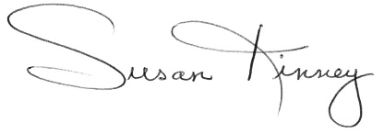

Susan Kinney

Education Chair

Please retain this receipt for tax purposes. The R.A.I.S.E. Foundation is a 501(c)(3) tax exempt organization.