Victor

2201741946

LC01

Object Oriented Analysis & Design

**I. Essay (30%) All essay questions should be answered within minimum 300 words, and may be provided with additional examples.**

1. (Weight 15%) The objective of designing the physical architecture layer is to determine what parts of the application software will be assigned to what hardware. There are three principal application architectures in use today: server-based architectures, client-based architectures, and client–server architectures. The three primary hardware components of a system are client computers, servers, and the network that connects them. All software systems can be divided into 4 (four) basic functions. Name it and describe each of them. Put those function on the Three Tier and Four Tier Client Server Architectures **physical architectural design**.

Four software systems which can be divided into four basic functions:

* **Data Storage**: this component manages how data are stored in the system and how the data being handled by the programs that run the system. This component is composed of a set of object persistence classes. Efficient of object persistence will decrease the chances of inefficient system, long system response, etc.
* **Data Access Logic**: this component is used for accessing and manipulating the data which is being saved in data storage. SQL is usually being used to access and manipulate the data being stored in data storage.
* **Application Logic**: Logic documented in functional and behavioral models. In this component all business logic that exists in this application will be written in this component. This component is usually written with server-side programming language like C#, Java, etc.
* **Presentation Logic:** This component is used to handle user interaction with the application. When the user interacted with the application, the application will send it to the application logic to be handled. And lastly this component is also a presentation of information to the user. This component is usually written with client-side programming language like Javacsript, CSS, AJAX, etc.

**Three Tier Client Server Architectures**

In three tier client-server architectures there are three tiers, there are **Presentation Tier, Application Tier, and Data Tier.** The **Presentation Tier** is the front-end layer in the 3-tier system and consists of the user interface. The user interface is accessible through a web application which display the content or information that is useful for the user. The **Application Tier** contains the business logic of the application which is an application’s core capabilities. Lastly the **Data Tier** contains both Data Storage and Data Access Logic.

**Four Tier Client Server Architectures**

In four tier client-server architectures the client is responsible for Presentation layer, database servers (Data Storage and Data Access Logic) responsible for the data access logic and the application logic is spread into two or more different sets of servers. The main advantage using four tier client server architectures compared with three or two tier is it separates the processing that occurs to better balance the load on the different servers and it is more scalable.

1. (Weight 15%) Developing documentation of the system must be done throughout the system development. In many ways, the documentation of a system is a system. So, developing documentation can follow a similar, but simpler, approach as software development. There are some fundamentally **different types of user documentation**: name them, describe, and give examples!

Different types of user documentation:

* **Reference Documents / System Documentation**

This type is designed to be used when the user needs to learn how to perform a specific function. People often read reference information while they are trying or failed to perform some specific function.

Example of Reference Documents / System Documentation:

* + Documentation of how to insert or adding a new record to some table in the database.
  + Updating some field.
* **Procedure manuals**

This type is designed to describe how to perform some business tasks. For each item in the procedure manuals typically guides the user through a task that required several functions or steps in the system. Therefore, each item is typically much longer than an entry in reference document.

Example of Procedure manuals:

* + Taking a customer order.
  + Printing a monthly financial report.
  + Replying customer complaints.
* **Tutorials**

This type is designed to teach people how to use major components of a system. Each entry in a tutorial is typically longer than the entries in procedure manuals, and the entries are usually designed to be read in sequence where in reference documents or procedure manuals are designed to be read individually.

Example of Tutorials:

* + Introduction of the basic operations of the system in an application

**Other Specific Documentation**

* **API Documentation**

This type of documentation contains instructions about how to effectively use and integrate with an API. It’s a concise reference manual containing all the information required to work with the API, with details about the functions, classes, return types, request body, http methods, and many more. API documentation has traditionally been done using regular content creation and maintenance tools and text editors.

Example tools than can be used for API Documentation:

* + Swagger.io
  + Postman
* **Code Documentation**

This type of documentation is designed to help someone else understand how the code works or how is the flow of the application/code works.

Example of Code Documentation:

* + README file.

**II. Case Study (70%)**

a. (Weight 25%) Draw the Class Diagram for this scope of this module/new requirements, find out or assume all objects you may needed, don’t use “system” or “database” as class!

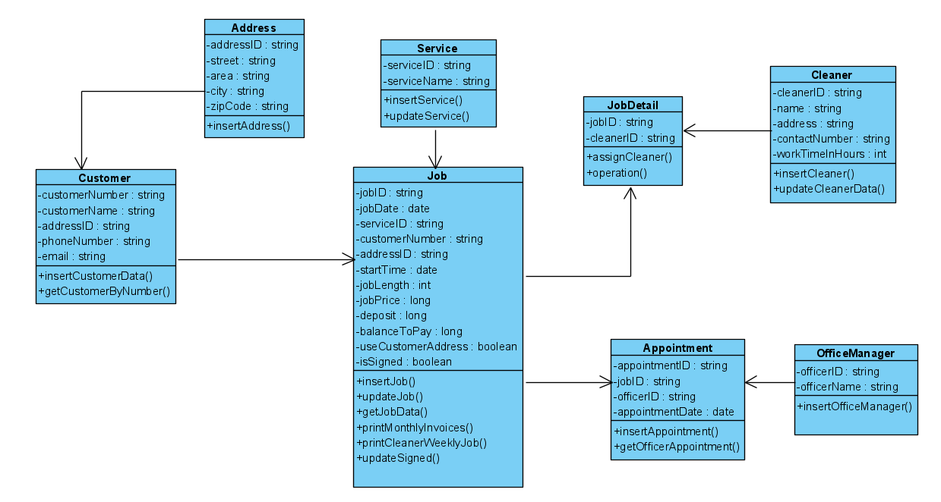

b. (Weight 25%) Map your class diagram into the Relation Model Diagram, for the implementation of physical database.

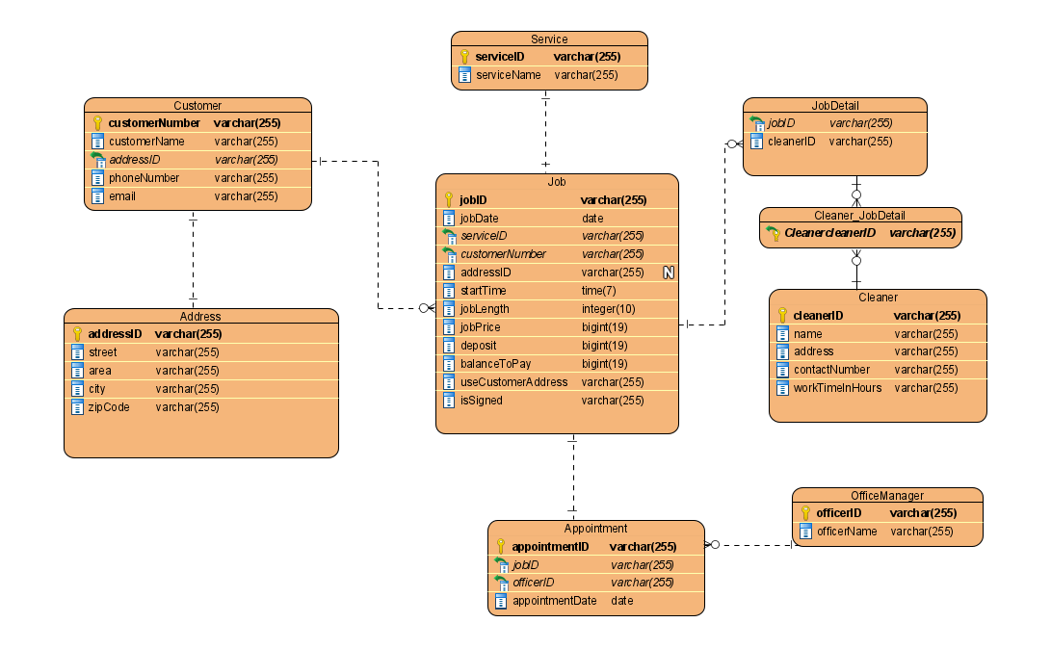

c. (Weight 20%) Assume that the Process Sales is the integrated system and has some Branch Offices in the whole country, and you might draw the Deployment Diagram to show the need for infrastructure of the system.

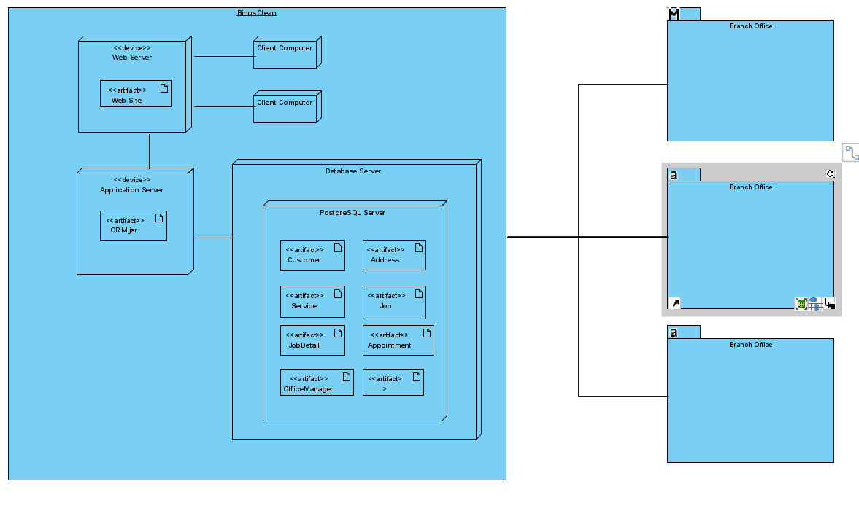

References

* <https://www.jinfonet.com/resources/bi-defined/3-tier-architecture-complete-overview/#:~:text=What%20is%20a%203%2DTier,type%20of%20client%2Dserver%20system>.
* https://www.coursehero.com/file/p40odsnn/All-software-systems-can-be-divided-into-four-basic-functions-Primary-hardware/
* System Analysis & Design an Object -Oriented Approach with UML by Alan Dennis, Barbara Haley Wixom, David Tegarden
* <https://www.atlantis-press.com/article/8022.pdf>
* https://swagger.io/blog/api-documentation/what-is-api-documentation-and-why-it-matters/