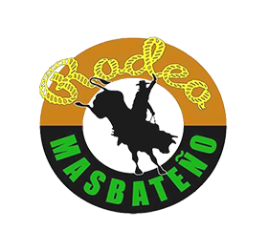
Philippine Rodeo Finals
Rodeo Masbateño Grand Arena
April 9-13, 2019

TEAM ROSTER

Team: _____________________________________________________

Category: _____________________________________________________

EVENTS | MAIN PLAYERS | ALTERNATE/S
- Load Carrying | 1.  2.  3.  4. | 1.  2.  3.  4.
- Herding w/ Whip Crack | 1. | 1.
- Cattle Wrestling on foot | 1. | 1.
- Lassoing from horseback  (Women only) | 1. | 1.
- Cattle wrestling from horseback – (men only) | 1. | 1.
- Two-Person Carambola | 1.  2. | 1.  2
- Four-Person Carambola | 1.  2.  3.  4. | 1.  2.  3.  4.
- Casting Down | 1.  2.  3.  4. | 1.  2.  3.  4.
- Bull Riding | 1. | 1.
- Miss Rodeo Cowgirl | 1. | 1.
Note: save this file in PDF format and send to philippinerodeofinals

