# Installation Instructions

# Digital Ocean via Packer

* create new folder "New Server" and open a command console from this folder (i.e. 'Git Bash Here')

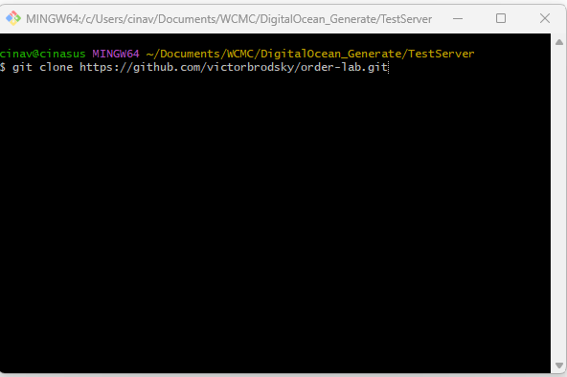

* Clone ORDER repository from git:

git clone https://github.com/victorbrodsky/order-lab.git

* Go to packer directory:

cd order-lab/packer/

* Run packer installation script:

bash deploy-order-digital-ocean.sh --token mytoken -os alma9 --protocol https

Example to install Alma9 server with multi-tenancy for “https://view.online” domain:

bash deploy-order-digital-ocean.sh --token mytoken --os alma9 --protocol https --domainname view.online --sslcertificate installcertbot --email oli2002@med.cornell.edu --sshfingerprint 1a:55:66:2b:11:3c:11:b4:33:d5:99:44:f6:33:22:11 --multitenant haproxy | tee deploypacker.log

Notes:

--sshfingerprint option is required for certbot and certificate installation.

To use ssh, ssh key should be added to DigitalOcean: Settings->Security->Add SSH Key

If certbot installation will fail during automated installation, certbot can be installed later manually via Droplet Console or by running doctl.

# Via Droplet Console:

Go to DigitalOcean: Droplets -> click on newly generated droplet -> click Access -> Launch Droplet Console

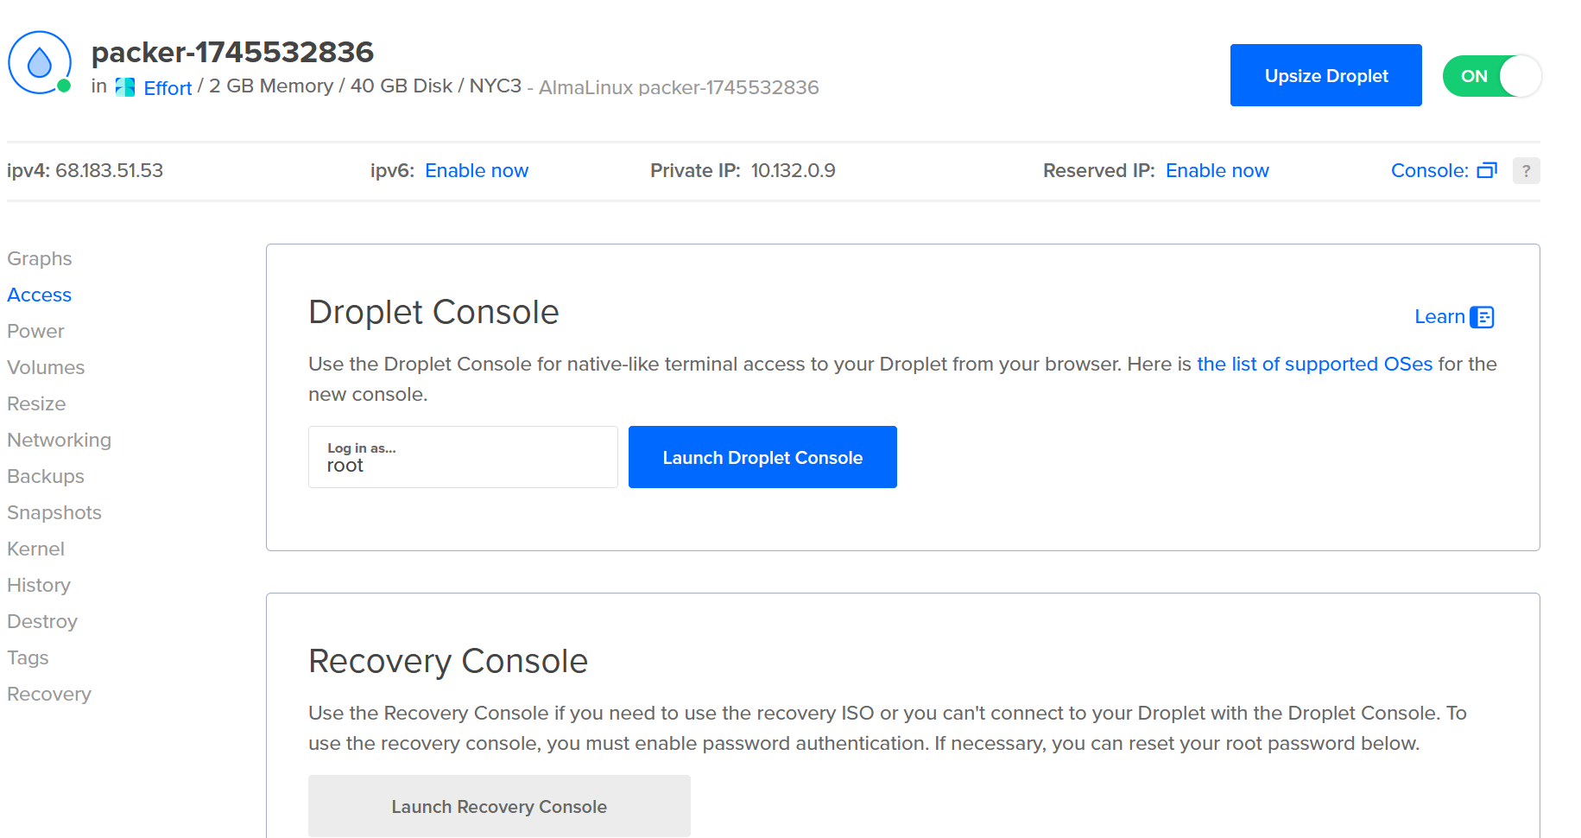

In console, run these command:

cd /srv/order-lab-homepagemanager/packer/

bash /srv/order-lab-homepagemanager/packer/install-certbot.sh view.online installcerbot oli2002@med.cornell.edu haproxy

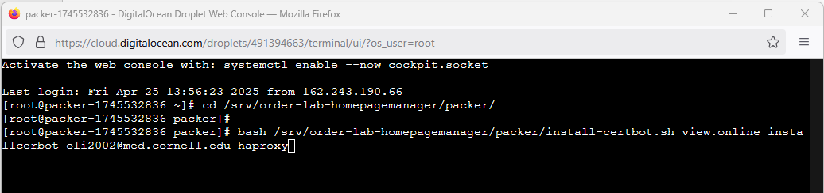

This script will install Certbot, set up the certificate, and configure haproxy.cfg to apply it.

# By running doctl from local PC:

*doctl compute ssh "packer-1745521900" --ssh-key-path ./sshkey --ssh-command 'bash /srv/order-lab-homepagemanager/packer/install-certbot.sh view.online installcertbot oli2002@med.cornell.edu haproxy'*

It might be required to resize the droplet to 4 GB Memory (php-fpm is not working properly if the memory size is 2 GB):

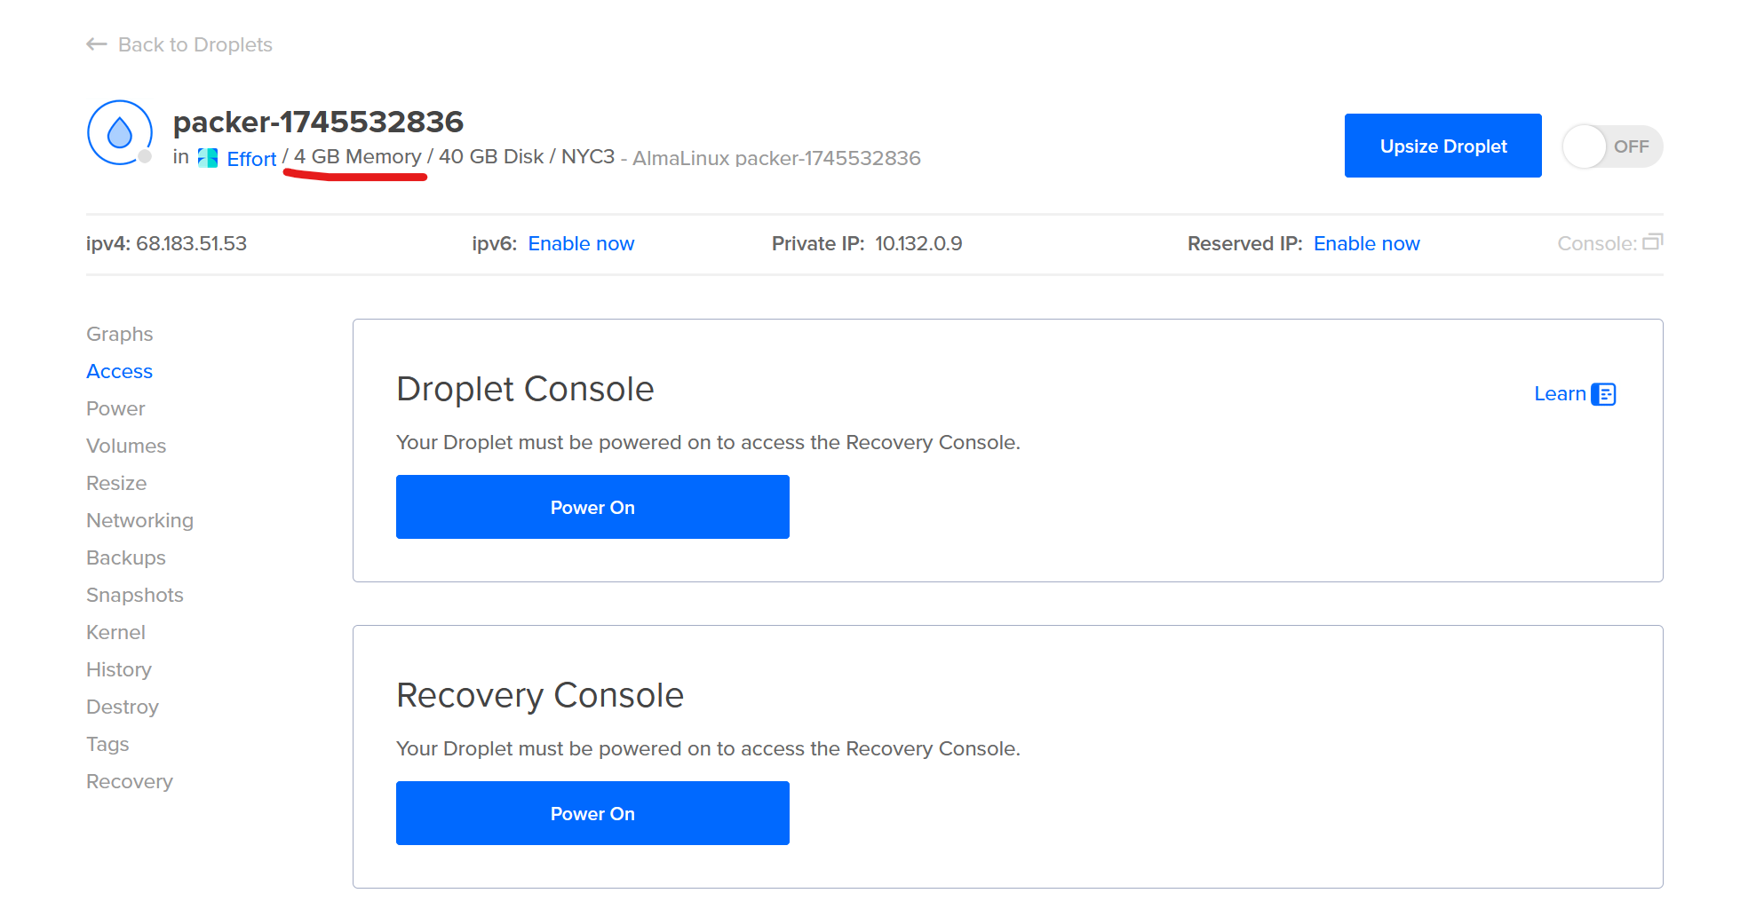

To initialize tenant run in browser:

**http://view.online/directory/admin/first-time-login-generation-init**

# Installation ORDER on the provided server with already installed Alma9 or RHEL9

If the server is already provided with Alma9 or RHEL9, go to the server console and run:

sudo yum install -y git  
cd /srv  
git clone https://github.com/victorbrodsky/order-lab.git  
cd order-lab/packer/

Run alma9_install.sh to install Apache, Postgresql, PHP, required utilities:

bash alma9_install.sh dbusername dbpassword protocol domain sslcertificate email multitenant

Run install-multitenancy.sh to install multi-tenant ORDER system with HaProxy for view.online domain, the installation log will be stored in multitenancy.log file:

bash install-multitenancy.sh -u dbusername -t dbpassword -m haproxy -p /srv -s none -d none -e none -l none | tee multitenancy.log

Example to install Apache, Postgresql, PHP, required utilities, multi-tenant ORDER system with HaProxy for view.online domain:

bash alma9_install.sh symfony symfony https view.online installcertbot oli2002@med.cornell.edu haproxy

bash install-multitenancy.sh -u symfony -t symfony -m haproxy -p /srv -s none -d none -e none -l none | tee multitenancy.log

To initialize tenant run in browser:

**http://view.online/directory/admin/first-time-login-generation-init**

In all cases: if the web site is not opening, check haproxy and php-fpm status on the server:

sudo systemctl status haproxy  
sudo systemctl status php-fpm  
sudo systemctl status httpdhomepagemanager  
sudo systemctl status httpdtenantmanager  
sudo systemctl status httpdtenantapp1  
sudo systemctl status httpdtenantapp2  
sudo systemctl status httpdtenantappdemo

# Initial Configuration

By default, ‘/’ points to the home page manager tenant. First, initialize this tenant by this url:

<https://view.online/directory/admin/first-time-login-generation-init/>

This will initialize the home page manager and create administrator user. Default password is ‘1234567890’, and you will be redirected to the login page:

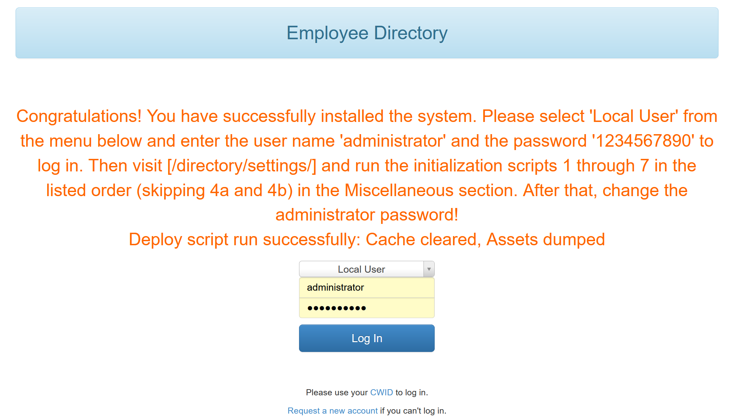

Select ‘Local User’, enter the default username ‘administrator’ and password ‘1234567890’ and click ‘Log In’.

On the first login, you will be redirected to the initializing page.

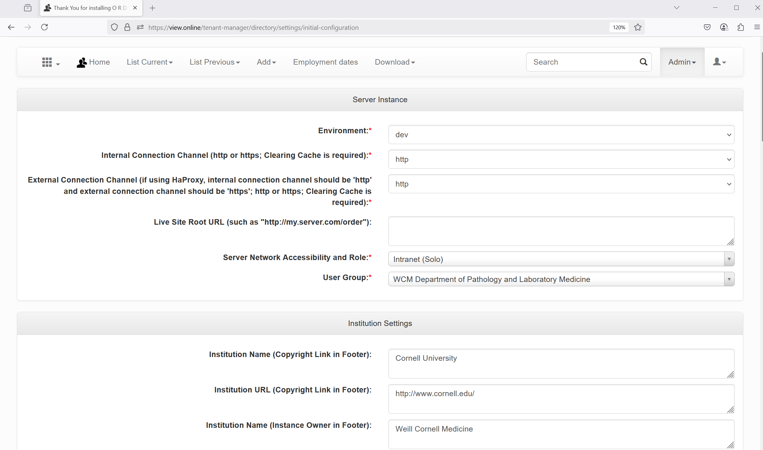

Set all required initializing fields:

For multi-tenancy with HaProxy set the ‘Internal Connection Channel’ to ‘https’ and ‘External Connection Channel’ to ‘https’.

Set the ‘Environment’ to ‘live, If it is a live server.

Set ‘E-Mail address for the Administrator account’.

It is also recommended to change administrator’s password and in case of ‘test’ or ‘dev’ environment, set the ‘Reroute all outgoing emails…’ field to your email to prevent sending automatic emails to other users.

Click ‘Update’.

You will be redirected to the home page. On the top ‘Admin’ menu, click ‘Site Settings’ and click ‘[Miscellaneous](https://view.online/tenant-manager/directory/settings/#miscellaneous)’. For homepage and tenant manager, pre-populate only lists 1), 2), 3).

Go to the cron jobs (Admin -> Cron Jobs) and review all cron jobs, for example, remove all cron jobs for homepage and tenant manager tenants, except ‘Status cron’.

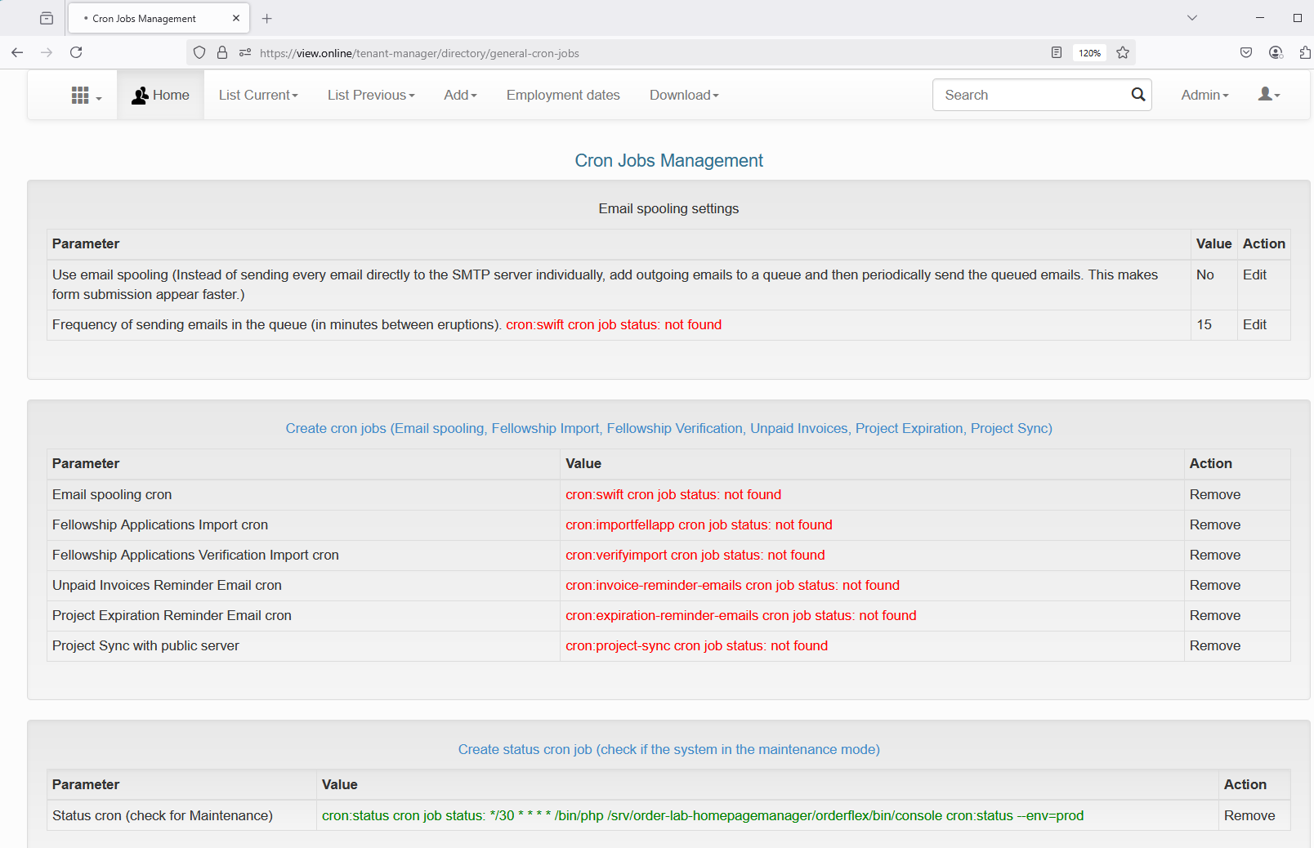

To apply the update, click on Admin -> Run deploy script deploy.sh.

Similarly, initialize the tenant manager:

<https://view.online/tenant-manager/directory/admin/first-time-login-generation-init/>

All tenants are already pre-installed on the server. Utility script sync_tenants.sh allows to synchronize the source code across all tenants and perform some other tasks. This script can be run from any tenant’s orderflex folder.

For example, after installation, we need to add all versions to the symfony’s database migration: go to /srv/order-lab-tenantapp1/orderflex and run: *bash sync_tenants.sh /srv addallversions*

Plus, we need to create db.config for backup/restore: *bash sync_tenants.sh /srv dbconfig*

Some other options:

basic - sync the source code, run deploy script, check migration status, install python requirements

full – all from basic, plus sync database, sync yarn for react js

yarn – only sync yarn for react js

sync – only sync the source code

dbstatus – only check database sync status

dbmigrate – only sync the database schemas. Symfony calls it ‘migrate’

composer – only install all symphony updates

python – only install python requirements

dbconfig – only create db.config for postgres management by python (backup/restore)

addallversions – only add all versions to the symfony’s database migration, so the command php bin/console doctrine:migrations:status will not show any new migrations

# Multi-Tenancy Configuration

Go to the ‘Tenancy Configuration’ page:

<https://view.online/tenant-manager/directory/settings/tenant-manager/configure/>

Click on ‘Update DB Configuration from the server’. This will populate multi-tenant settings in Database from the server configurations: haproxy.cfg and tenant’s httd (httpdhomepagemanager, httpdtenantmanager, httpdtenantapp1 …). You will be redirected to the Tenancy Configuration page with all tenant’s settings:

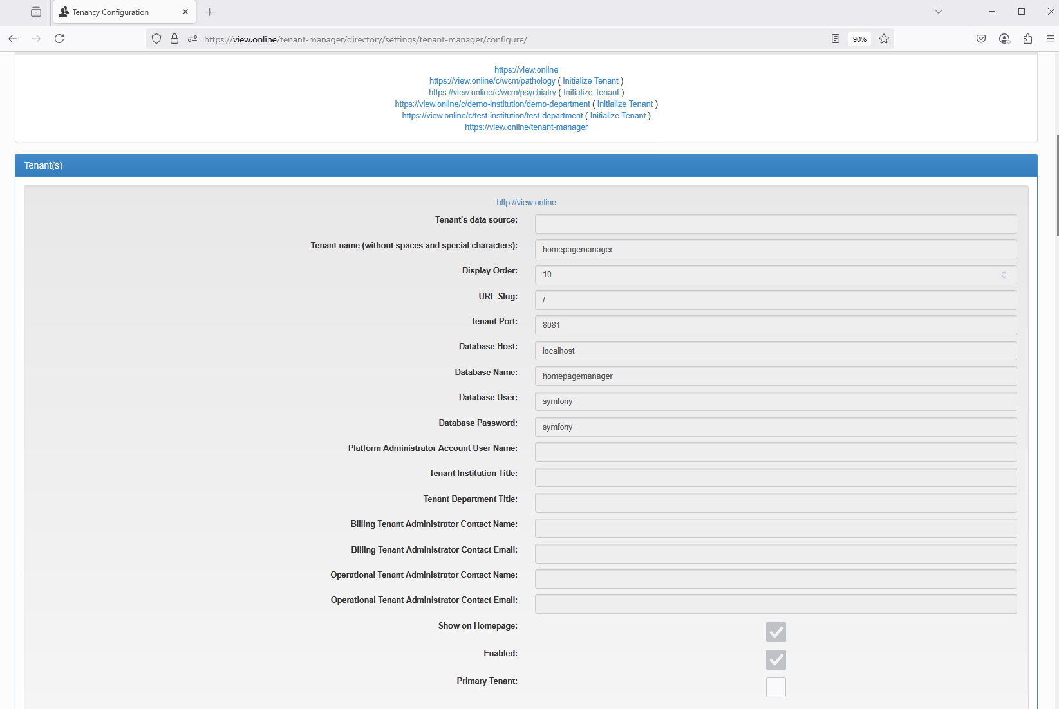

On this page, click ‘Initialize Tenant’ to make initial initialization of the tenant.

The tenant’s parameters can be edited on the edit page: click ‘Edit’.

To make a tenant to be accessible by /, check ‘Primary Tenant’ check box. For example, check ‘Primary Tenant’ for ‘c/wcm/pathology’ tenant and this tenant can be accessed by / path.

After making changes in Database, click ‘Update Server Configuration from DB’ button.

If the apache user does not have a permission to update haproxy.cfg file, then haproxy.cfg must be changed manually:

Replace

‘use_backend homepagemanager_backend if homepagemanager_url’

by

‘use_backend tenantapp1_backend if homepagemanager_url’.

Run systemctl restart haproxy.

After that, both url / and https://view.online/c/wcm/pathology/ will lead to tenantapp1, it is possible to verify that on ‘about’ page <https://view.online/directory/about>:

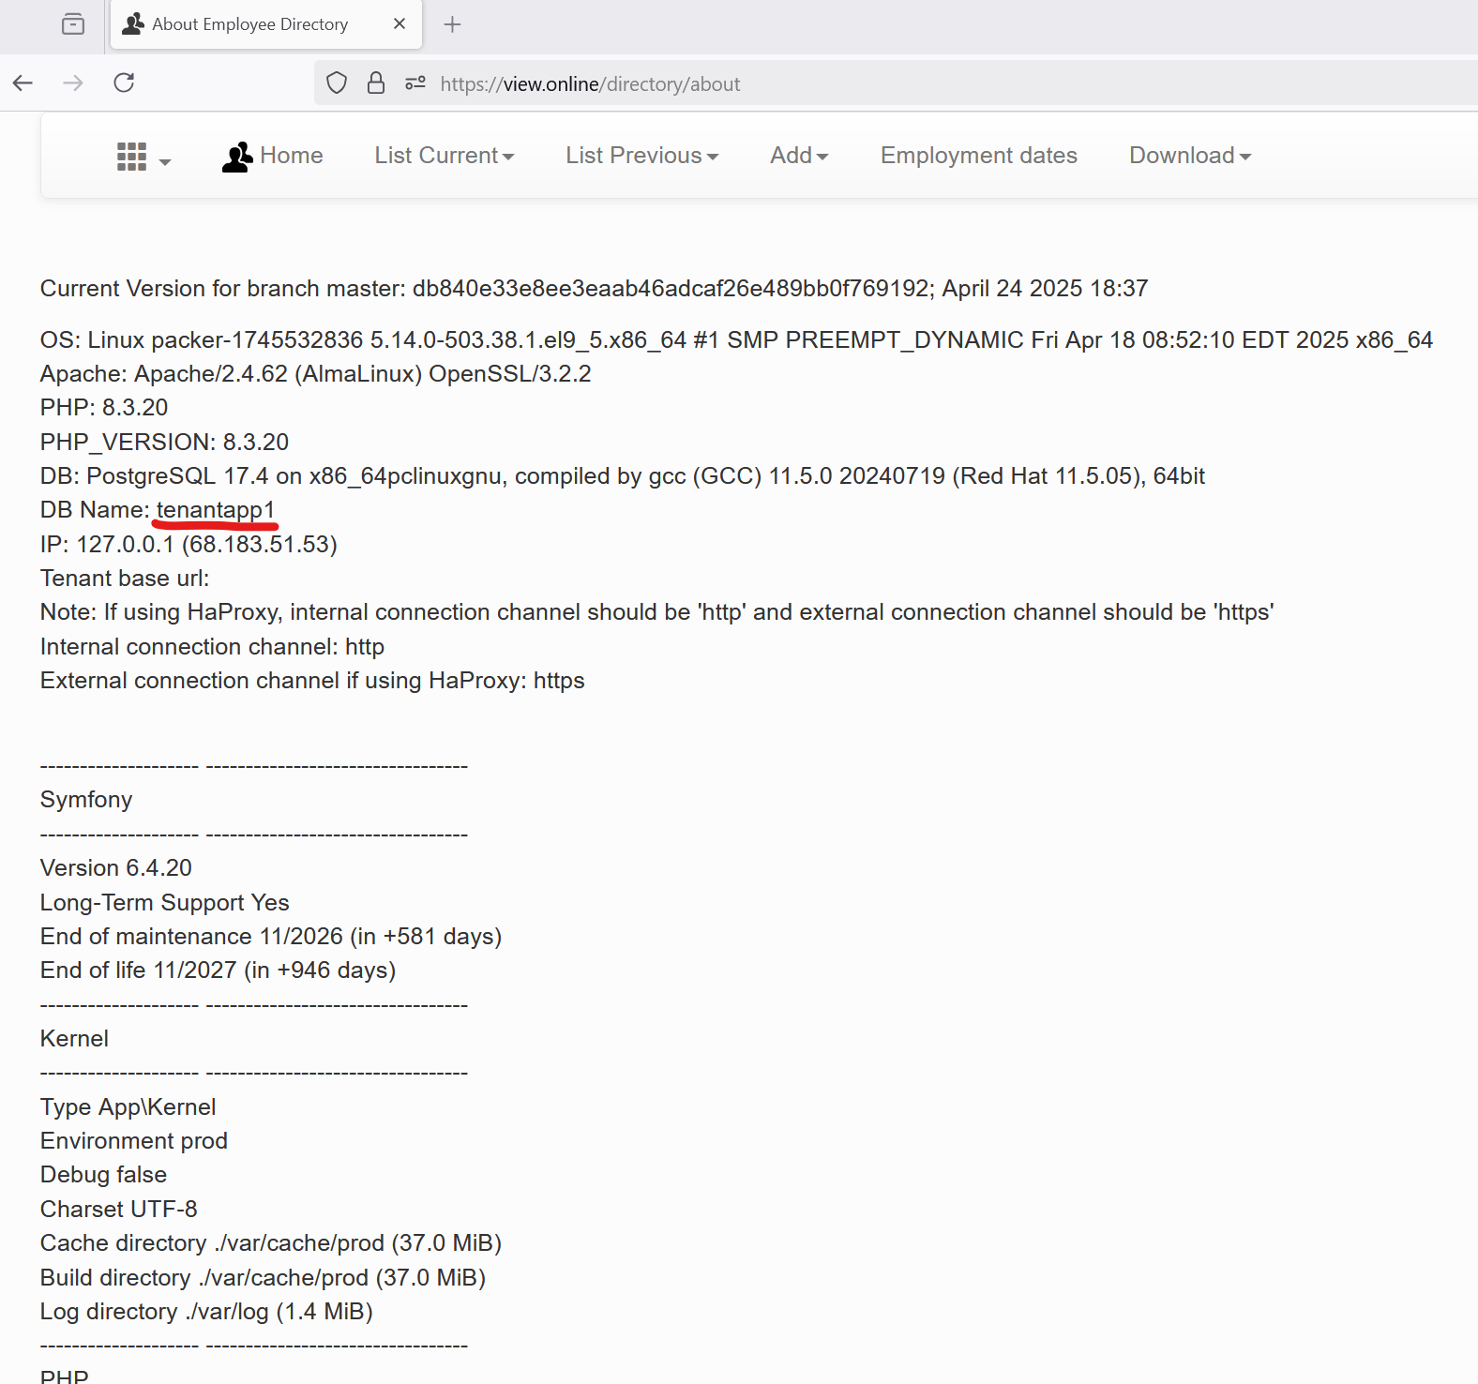

# Restore Database and Uploaded files

First set the ‘Network drive absolute path to store DB backup files’ on the Site Settings page, for example to /srv/order-lab-tenantapp1/orderflex/var/backups/

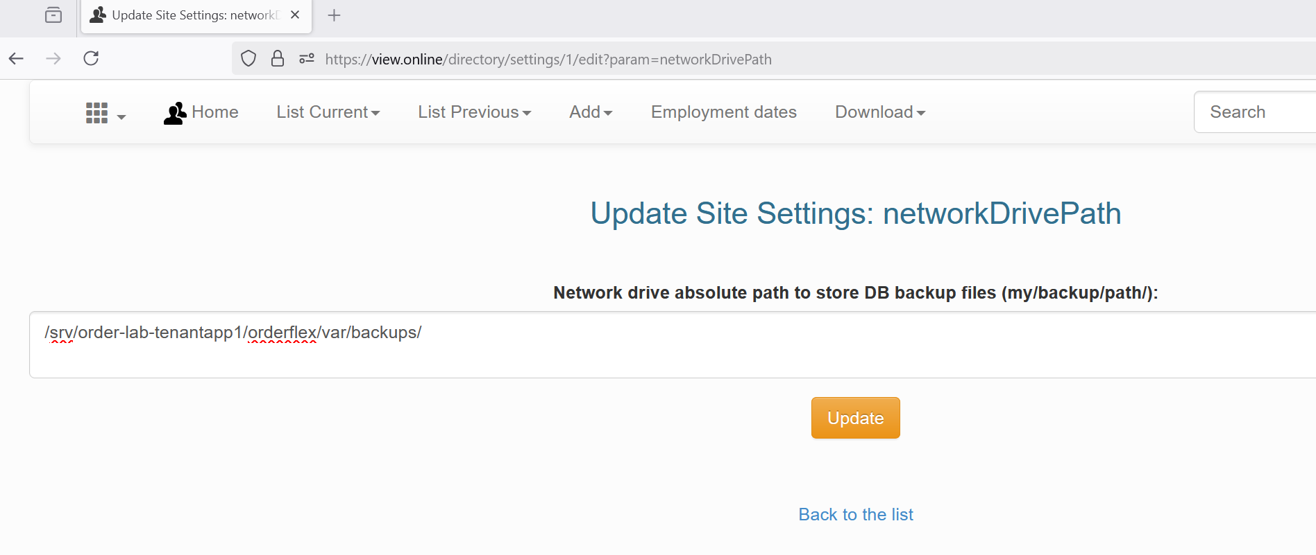

Before, restoration in the Site Setting, set the environment to ‘dev’, to prevent pulling the fellowship applications from Google drive.

Then go to the ‘Manual Backup/Restore’ page <https://view.online/directory/manual-backup-restore/>.

Upload file upload archived file using ‘Upload backup files’ section. The database backup file should include 'backupdb' in its name, while uploaded files should contain 'backupfiles'.

In ‘Restore from backup’ section, choose upload backup file, confirm password and click ‘Restore uploaded files…’ button.

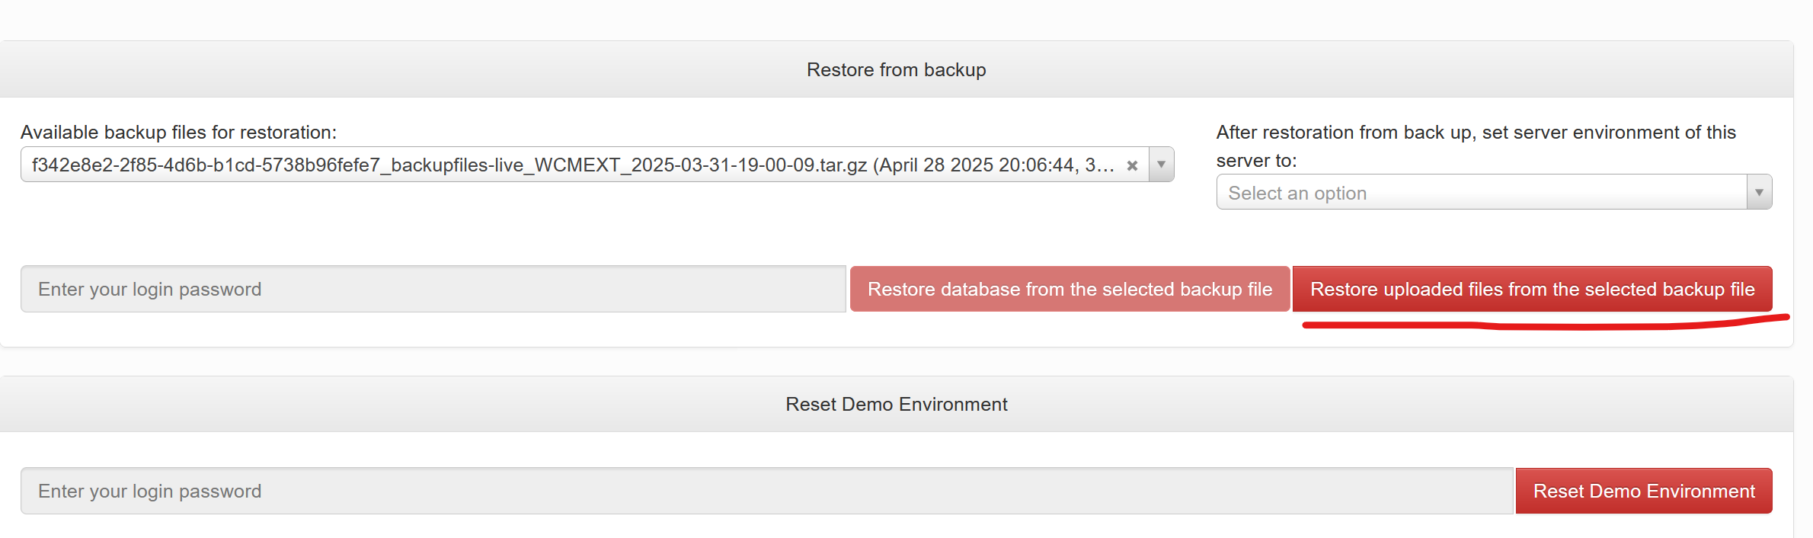

Restore database backup: choose the backup, set environment to ‘dev’, confirm password and click ‘Restore database …’. After restoration, verification and testing, the environment should be changed to ‘live’ if it is a live server.