UNIVERSIDAD ANÁHUAC MAYAB • DIVISION OF ENGINEERING

LABORATORY ACTIVITY 16: MULTI-MODEL REGRESSION COMPARISON & DIAGNOSTICS BAKE-OFF
Predictive Modeling: OLS Fitting, Multi-Model Selection, & Residual Health Checks

Course & Period: | Data Mining & Modern AI Systems (IIND4417) — Academic Period: 202660
Class Session Alignment: | Session 19: Unit 5.2 Optimization & 5.3 Assumption Diagnostics
Instructor: | Dr. Víctor Cardoso
Team Assigned Database: | Team 3 — EV Battery
Student Names & IDs: | Eduardo Gallegos Bolaños - Cacho — 00474516  María Jimena Escalante Cámara — 00470871  Carlos Emilio Mejía Martínez — 00477485  Rodrigo Meouchi Dena — 00480093  José Carlos Vera Ovando — 00473456  Victoria Morales Cabrera — 00473430

🎯 THE MULTI-MODEL BAKE-OFF CHALLENGE: In real-world data science and AI engineering, you never fit just one model and blindly trust it. Today, your team will configure 5 distinct regression models on your assigned industry database. You will evaluate their R², Adjusted R², MAE, and RMSE metrics, examine their residual diagnostic health checks, and defend which model represents the true 'Best Fit' for your client.

Objective & Engineering Mission
As we transition into predictive modeling for continuous numerical outcomes (regression), engineers must balance two competing forces: explanatory power versus model complexity. Adding more variables to a linear model will almost always increase the raw R² score—even if those variables are completely irrelevant noise! To prevent building overcomplicated models, engineers evaluate Adjusted R² (which penalizes useless predictors) and inspect residual health checks.

By the end of this laboratory activity, your team will:
  - Ingest your team's assigned domain database and understand its continuous target variable.
  - Configure 5 distinct candidate regression models with varying feature combinations.
  - Train all 5 models using an identical 80/20 train/test split to guarantee fair, rigorous benchmarking.
  - Log R², Adjusted R², MAE, and RMSE across all 5 models in a clean comparison table.
  - Generate residual diagnostic plots (Fitted vs. Residuals and Q-Q plots) to verify regression health.
  - Defend the single 'Best-Fit' model based on statistical evidence, physical interpretability, and client ROI.

Team Database Assignment Reference Table
To emulate specialized engineering squads and prevent cross-team code sharing, each team is assigned a completely distinct real-world telemetry dataset. Download your assigned CSV file from the course repository or Brightspace:

Team # & Domain | Assigned CSV File | Target Variable (y) | Predictor Pool (Features X)
Team 1: Solar Power | regression_team1_solar.csv | power_output_kw (Kilowatt output) | solar_irradiance_w_m2, ambient_temp_c, wind_speed_m_s, panel_temp_c, sun_elevation_deg, dust_accumulation_pct
Team 2: Semiconductor | regression_team2_semiconduc tor.csv | wafer_yield_pct (Yield %) | rf_power_watts, chamber_pressure_torr, etching_time_sec, gas_flow_sccm, wafer_temp_c, cleanroom_humidity_pct
Team 3: EV Battery | regression_team3_ev_battery.c sv | battery_cell_temp_c (Cell temp °C) | discharge_current_a, ambient_temp_c, state_of_charge_pct, internal_resistance_mohm, coolant_flow_l_min, cell_voltage_v
Team 4: Biomedical ICU | regression_team4_biomedical. csv | cardiac_output_l_min (Blood flow L/min) | heart_rate_bpm, stroke_volume_ml, systolic_bp_mmhg, mean_arterial_pressure_mmhg  , systemic_vascular_resistance, blood_oxygen_pct
Team 5: Smart Grid | regression_team5_smartgrid.cs v | active_power_load_mw (Grid load MW) | industrial_consumption_mw, ambient_heat_index_c, residential_meter_count, transformer_temp_c, reactive_power_mvar,  grid_frequency_hz

The 5-Model Candidate Architecture
Your team must configure, fit, and evaluate the following 5 distinct candidate regression models on your assigned dataset. Notice how each model progressively expands in complexity:

  - Model 1 (Simple Baseline — 1 Feature): Select the single feature you believe has the strongest physical impact on the target. This establishes your performance baseline floor.
  - Model 2 (Primary Operational Pair — 2 Features): Add the second most important physical driver. Observe how much variance is explained by this core operational pair.
  - Model 3 (Tri-Variate Core — 3 Features): Incorporate a third variable (such as an environmental or process control factor). Check if the addition produces a noticeable drop in RMSE.
  - Model 4 (Operational Multi-Variable — 4 Features): Add a fourth auxiliary variable. Watch what happens to the gap between raw R² and Adjusted R².
  - Model 5 (Full Engineering Model — 5 Features): Include all 5 primary continuous engineering predictors. Evaluate whether the added complexity is justified by a statistically meaningful improvement in test error.

Step-by-Step Laboratory Execution Guide
  - Step 1: Feature Branching in VS Code GUI: Open VS Code and navigate to your team repository. In the bottom-left status bar, click on 'main' and select 'Create new branch'. Name your branch: feature/activity-16-regression-models. Open the Source Control panel (Ctrl+Shift+G).
  - Step 2: Ingest Assigned Dataset & Split (80/20): Load your team's assigned CSV file into pandas. Separate your feature matrix X and target vector y. Execute an 80/20 train/test split using train_test_split(X, y, test_size=0.20, random_state=42). Note: random_state=42 is mandatory so all 5 models are evaluated on the exact same test records!
  - Step 3: Fit All 5 Regression Models: Using Scikit-Learn's LinearRegression(), fit each candidate model on X_train[selected_features] and y_train. Generate predictions on both the training set and the test set.
  - Step 4: Compute Fit Statistics & Error Metrics: For every model, calculate: (1) Training R², (2) Testing R², (3) Adjusted R² (penalized for feature count), (4) Mean Absolute Error (MAE), and (5) Root Mean Squared Error (RMSE).
  - Step 5: Visual Residual Diagnostics (Health Checks): For your top 2 candidate models, compute the test residuals (Residual = y_test - y_pred). Create a 2-panel diagnostic chart: (a) Fitted Values vs. Residuals scatter plot to check for homoscedasticity (equal variance) and linearity, and (b) Residual Histogram or Q-Q plot to verify normality.
  - Step 6: Defend the Winning Model & Sync with GitHub: Compare your 5 models in the deliverable table. Write a 2-3 paragraph technical defense justifying your chosen 'Best-Fit' model. Stage your script, commit with message 'feat(regression): complete 5-model bake-off comparison', publish branch, open a GitHub PR, have a teammate review and approve, and merge into main.

Student Results Workspace & 5-Model Comparison Table
I: current; Ta: ambient temperature; R: resistance; F: coolant flow; SOC: state of charge. Adjusted R² uses training data; MAE and RMSE use test data (°C).
Model | Features Selected | Train R² | Test R² | Adjusted R² | MAE | RMSE
Model 1 | I | 0.2378 | 0.3136 | 0.2364 | 7.3462 | 8.9847
Model 2 | I, Ta | 0.7229 | 0.7708 | 0.7219 | 4.2614 | 5.1917
Model 3 | I, Ta, R | 0.8001 | 0.8307 | 0.7990 | 3.6399 | 4.4621
Model 4 | I, Ta, R, F | 0.9733 | 0.9755 | 0.9731 | 1.3574 | 1.6962
Model 5 | I, Ta, R, F, SOC | 0.9813 | 0.9835 | 0.9811 | 1.1355 | 1.3936
🏆 WINNING MODEL SELECTION & CLIENT DEFENSE
Which of the 5 models does your team designate as the 'Best Fit' for production deployment? Explain your reasoning in 2-3 paragraphs below. Address: (1) Why did this model beat the others? (2) Is the gain in Adjusted R² worth the cost of collecting and maintaining those additional sensor features? (3) Did the residual plots confirm that the model satisfies linearity and equal spread?
We select Model 5 as the best fit among the five candidates in this laboratory comparison. Using discharge current, ambient temperature, internal resistance, coolant flow and state of charge, it achieved a training R² of 0.9813, test R² of 0.9835, training adjusted R² of 0.9811, test MAE of 1.1355 °C and test RMSE of 1.3936 °C. Model 4 achieved an RMSE of 1.6962 °C; adding state of charge reduced this error by 0.3026 °C, approximately 17.8%. The small train/test R² difference does not suggest a large generalization gap on this split.
We observed an increase in adjusted R² from 0.9731 for Model 4 to 0.9811 for Model 5, while both test error measures decreased. We consider retaining state of charge worthwhile when its measurement or estimation is already available from the battery management system. We must still weigh the added integration and maintenance cost against the value of the improved temperature estimates. Without sensor cost data or operational temperature tolerances, we cannot quantify the economic benefit. We would consider Model 4 a simpler alternative if state of charge were costly or unreliable.
We inspected the test residuals of both models and observed points around zero without a clear curved trend or funnel pattern. For Model 5, we observed a residual range of approximately −3.4 to +3.5 °C, compared with roughly −4.8 to +3.8 °C for Model 4. In the Model 5 Q-Q plot, we observed approximate alignment with the reference line, with local and tail deviations; Model 4 also followed the line centrally but departed at the extremes. We interpret these checks as compatible with approximate linearity, constant variance and normality, rather than proof of those assumptions. Because we used the same test split for model selection, we would need an independent evaluation before claiming production readiness.
📈 RESIDUAL DIAGNOSTIC DASHBOARD (PASTE SCREENSHOTS)
Model 5 — lowest test RMSE: 1.3936 °C
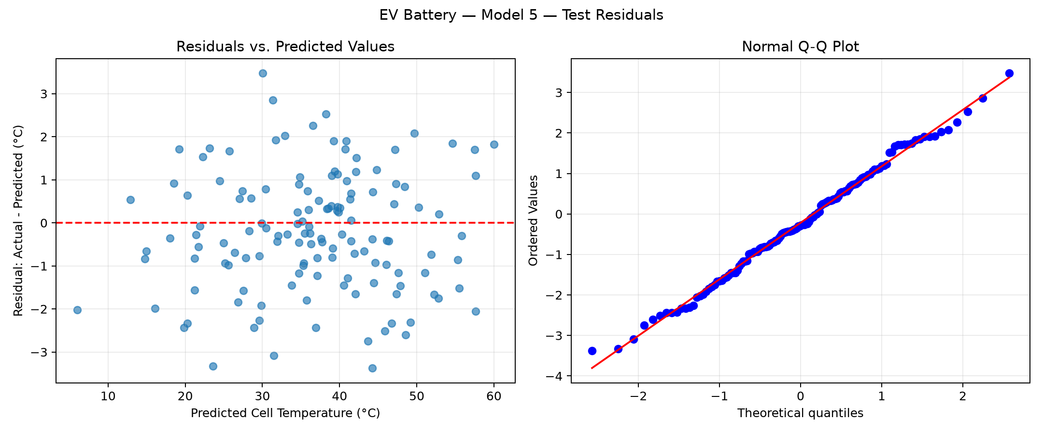
Model 4 — second-lowest test RMSE: 1.6962 °C
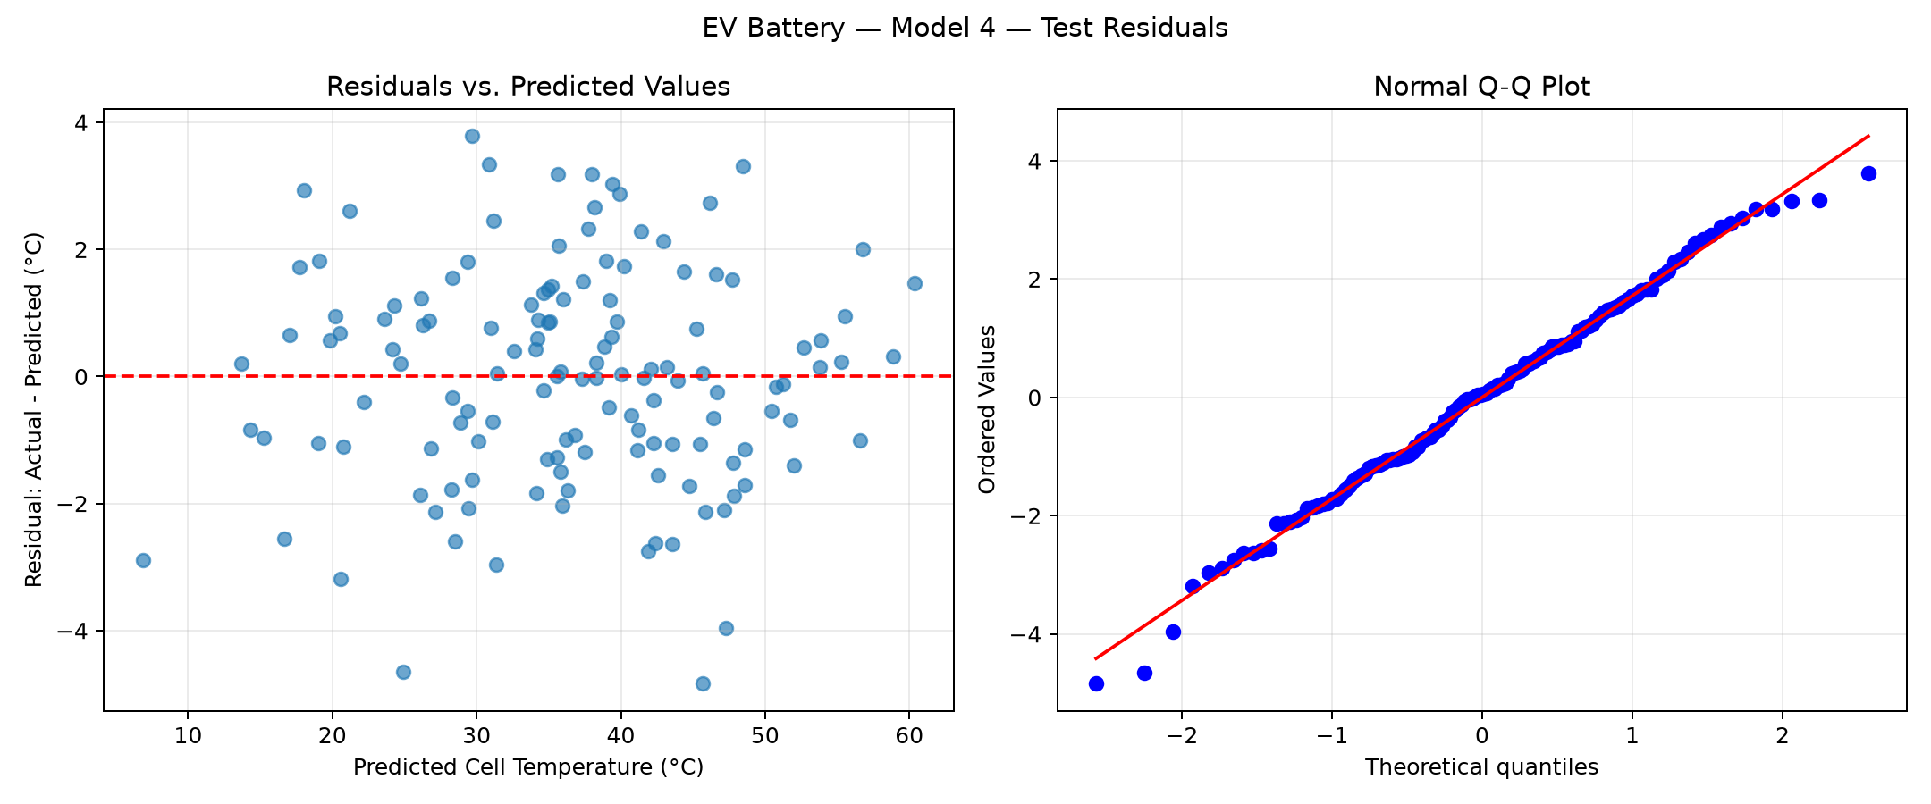
We used the same 136 test records for both figures and calculated residuals as actual minus predicted temperature. We compared the vertical scales when assessing residual spread.

Responsible AI Pair-Programming & Troubleshooting Log
AI Tooling Utilized: | ChatGPT / Codex
Verbatim Prompts Submitted: | “Ayudame a poder realizar la actividad correspondiente. Tu rol es de asesor para que pueda realizar la actividad con exito, donde me explicas paso a paso mientras voy aprendiendo sobre la marcha. No generes ni cambies nada por tu cuenta.”
AI Code Output & Suggestions: | We used AI suggestions to build the fitting and metric loop, calculate residual = y_test − prediction, and generate residual scatterplots and Q-Q plots with scipy.stats.probplot. We compared Models 4 and 5 and interpreted the plots as visual evidence rather than definitive statistical tests.
Human Audit & Verification: | We verified the 544/136 train/test split, five nested feature sets and 136 test predictions per model. We recorded training adjusted R² and test MAE/RMSE. We reviewed both diagnostic figures and observed no clear curve or funnel, with approximate Q-Q alignment and some deviations. We selected Model 5 while considering cost and validation limitations.
GitHub review and merge evidence
We submitted Pull Request #17 with one commit and four files: the Python script, the Word report and the two residual diagnostic figures. Our teammate jescalante27 approved the pull request and merged it into master on October 23, 2026.
Pull request: https://github.com/victorcardoso-uam/data-mining-202660-team3/pull/17
Our submitted commit is dd1e931. We confirmed the Merged status and reviewer approval checkmark in GitHub.

Limitations & Bugs Caught: | We initially encountered a missing sklearn dependency and subsequently ran the split successfully. We identified that the assignment lists 6 predictors but requests 5 in Model 5. We retained current, ambient temperature, resistance, coolant flow and state of charge for their thermal relevance, excluding voltage to meet that limit.

Activity Evaluation Rubric
Evaluation Pillar | Excellent | Developing | Needs Improvement
1. 5-Model Configuration & Pipeline Implementation | Successfully configures, trains, and tests all 5 regression models on identical 80/20 split. Features are logically grouped from simple baseline to full engineering model. | Configures 3-4 models, or models are fitted on inconsistent splits, making comparison partially flawed. | Fails to configure multiple models, script crashes, or only fits a single baseline regression.
2. Metric Evaluation & Comparison Table Accuracy | All metrics (Train R², Test R², Adjusted R², MAE, RMSE) are accurately computed and recorded in the comparison table with zero calculation errors. | Metrics are recorded, but 1-2 numbers are miscalculated (e.g., using train error instead of test, or omitting Adjusted R²). | Comparison table is incomplete, missing error metrics, or values are clearly fabricated without script execution.
3. Residual Diagnostics & Best Model Defense | Generates clean Fitted vs. Residuals and Q-Q plots. Identifies whether assumptions hold. Provides a compelling 2-3 paragraph defense of the winning model. | Residual plots generated but lack clear labels or interpretation. Defense is brief or focuses only on raw R² without considering trade-offs. | No residual diagnostics provided, or team cannot articulate why their selected model was chosen.
4. Git Architecture & Responsible AI Log | Clean feature branch in VS Code GUI, atomic conventional commit (feat:), PR opened and approved by teammate, merged to main. AI log is thoroughly documented. | Code pushed to GitHub, but committed directly to main, generic commit message, or AI log lacks specific prompt auditing. | Code missing from remote GitHub repository, merge conflicts unresolved, or AI log is blank.

