UNIVERSIDAD ANÁHUAC MAYAB • DIVISION OF ENGINEERING

LABORATORY ACTIVITY 16: MULTI-MODEL REGRESSION COMPARISON & DIAGNOSTICS BAKE-OFF
Predictive Modeling: OLS Fitting, Multi-Model Selection, & Residual Health Checks

Course & Period: | Data Mining & Modern AI Systems (IIND4417) — Academic Period: 202660
Class Session Alignment: | Session 19: Unit 5.2 Optimization & 5.3 Assumption Diagnostics
Instructor: | Dr. Víctor Cardoso
Team Assigned Database: | Team 3 — EV Battery
Student Names & IDs: | Eduardo Gallegos Bolaños - Cacho  Student ID: 00474516

🎯 THE MULTI-MODEL BAKE-OFF CHALLENGE: In real-world data science and AI engineering, you never fit just one model and blindly trust it. Today, your team will configure 5 distinct regression models on your assigned industry database. You will evaluate their R², Adjusted R², MAE, and RMSE metrics, examine their residual diagnostic health checks, and defend which model represents the true 'Best Fit' for your client.

Objective & Engineering Mission
As we transition into predictive modeling for continuous numerical outcomes (regression), engineers must balance two competing forces: explanatory power versus model complexity. Adding more variables to a linear model will almost always increase the raw R² score—even if those variables are completely irrelevant noise! To prevent building overcomplicated models, engineers evaluate Adjusted R² (which penalizes useless predictors) and inspect residual health checks.

By the end of this laboratory activity, your team will:
  - Ingest your team's assigned domain database and understand its continuous target variable.
  - Configure 5 distinct candidate regression models with varying feature combinations.
  - Train all 5 models using an identical 80/20 train/test split to guarantee fair, rigorous benchmarking.
  - Log R², Adjusted R², MAE, and RMSE across all 5 models in a clean comparison table.
  - Generate residual diagnostic plots (Fitted vs. Residuals and Q-Q plots) to verify regression health.
  - Defend the single 'Best-Fit' model based on statistical evidence, physical interpretability, and client ROI.

Team Database Assignment Reference Table
To emulate specialized engineering squads and prevent cross-team code sharing, each team is assigned a completely distinct real-world telemetry dataset. Download your assigned CSV file from the course repository or Brightspace:

Team # & Domain | Assigned CSV File | Target Variable (y) | Predictor Pool (Features X)
Team 1: Solar Power | regression_team1_solar.csv | power_output_kw (Kilowatt output) | solar_irradiance_w_m2, ambient_temp_c, wind_speed_m_s, panel_temp_c, sun_elevation_deg, dust_accumulation_pct
Team 2: Semiconductor | regression_team2_semiconduc tor.csv | wafer_yield_pct (Yield %) | rf_power_watts, chamber_pressure_torr, etching_time_sec, gas_flow_sccm, wafer_temp_c, cleanroom_humidity_pct
Team 3: EV Battery | regression_team3_ev_battery.c sv | battery_cell_temp_c (Cell temp °C) | discharge_current_a, ambient_temp_c, state_of_charge_pct, internal_resistance_mohm, coolant_flow_l_min, cell_voltage_v
Team 4: Biomedical ICU | regression_team4_biomedical. csv | cardiac_output_l_min (Blood flow L/min) | heart_rate_bpm, stroke_volume_ml, systolic_bp_mmhg, mean_arterial_pressure_mmhg  , systemic_vascular_resistance, blood_oxygen_pct
Team 5: Smart Grid | regression_team5_smartgrid.cs v | active_power_load_mw (Grid load MW) | industrial_consumption_mw, ambient_heat_index_c, residential_meter_count, transformer_temp_c, reactive_power_mvar,  grid_frequency_hz

The 5-Model Candidate Architecture
Your team must configure, fit, and evaluate the following 5 distinct candidate regression models on your assigned dataset. Notice how each model progressively expands in complexity:

  - Model 1 (Simple Baseline — 1 Feature): Select the single feature you believe has the strongest physical impact on the target. This establishes your performance baseline floor.
  - Model 2 (Primary Operational Pair — 2 Features): Add the second most important physical driver. Observe how much variance is explained by this core operational pair.
  - Model 3 (Tri-Variate Core — 3 Features): Incorporate a third variable (such as an environmental or process control factor). Check if the addition produces a noticeable drop in RMSE.
  - Model 4 (Operational Multi-Variable — 4 Features): Add a fourth auxiliary variable. Watch what happens to the gap between raw R² and Adjusted R².
  - Model 5 (Full Engineering Model — 5 Features): Include all 5 primary continuous engineering predictors. Evaluate whether the added complexity is justified by a statistically meaningful improvement in test error.

Step-by-Step Laboratory Execution Guide
  - Step 1: Feature Branching in VS Code GUI: Open VS Code and navigate to your team repository. In the bottom-left status bar, click on 'main' and select 'Create new branch'. Name your branch: feature/activity-16-regression-models. Open the Source Control panel (Ctrl+Shift+G).
  - Step 2: Ingest Assigned Dataset & Split (80/20): Load your team's assigned CSV file into pandas. Separate your feature matrix X and target vector y. Execute an 80/20 train/test split using train_test_split(X, y, test_size=0.20, random_state=42). Note: random_state=42 is mandatory so all 5 models are evaluated on the exact same test records!
  - Step 3: Fit All 5 Regression Models: Using Scikit-Learn's LinearRegression(), fit each candidate model on X_train[selected_features] and y_train. Generate predictions on both the training set and the test set.
  - Step 4: Compute Fit Statistics & Error Metrics: For every model, calculate: (1) Training R², (2) Testing R², (3) Adjusted R² (penalized for feature count), (4) Mean Absolute Error (MAE), and (5) Root Mean Squared Error (RMSE).
  - Step 5: Visual Residual Diagnostics (Health Checks): For your top 2 candidate models, compute the test residuals (Residual = y_test - y_pred). Create a 2-panel diagnostic chart: (a) Fitted Values vs. Residuals scatter plot to check for homoscedasticity (equal variance) and linearity, and (b) Residual Histogram or Q-Q plot to verify normality.
  - Step 6: Defend the Winning Model & Sync with GitHub: Compare your 5 models in the deliverable table. Write a 2-3 paragraph technical defense justifying your chosen 'Best-Fit' model. Stage your script, commit with message 'feat(regression): complete 5-model bake-off comparison', publish branch, open a GitHub PR, have a teammate review and approve, and merge into main.

Student Results Workspace & 5-Model Comparison Table
I: current; Ta: ambient temperature; R: resistance; F: coolant flow; SOC: state of charge. Adjusted R² uses training data; MAE and RMSE use test data (°C).
Model | Features Selected | Train R² | Test R² | Adjusted R² | MAE | RMSE
Model 1 | I | 0.2378 | 0.3136 | 0.2364 | 7.3462 | 8.9847
Model 2 | I, Ta | 0.7229 | 0.7708 | 0.7219 | 4.2614 | 5.1917
Model 3 | I, Ta, R | 0.8001 | 0.8307 | 0.7990 | 3.6399 | 4.4621
Model 4 | I, Ta, R, F | 0.9733 | 0.9755 | 0.9731 | 1.3574 | 1.6962
Model 5 | I, Ta, R, F, SOC | 0.9813 | 0.9835 | 0.9811 | 1.1355 | 1.3936
🏆 WINNING MODEL SELECTION & CLIENT DEFENSE
Which of the 5 models does your team designate as the 'Best Fit' for production deployment? Explain your reasoning in 2-3 paragraphs below. Address: (1) Why did this model beat the others? (2) Is the gain in Adjusted R² worth the cost of collecting and maintaining those additional sensor features? (3) Did the residual plots confirm that the model satisfies linearity and equal spread?
We select Model 5 as the best fit among the five candidates in this laboratory comparison. Using discharge current, ambient temperature, internal resistance, coolant flow and state of charge, it achieved a training R² of 0.9813, test R² of 0.9835, training adjusted R² of 0.9811, test MAE of 1.1355 °C and test RMSE of 1.3936 °C. Model 4 achieved an RMSE of 1.6962 °C; adding state of charge reduced this error by 0.3026 °C, approximately 17.8%. The small train/test R² difference does not suggest a large generalization gap on this split.
The adjusted R² increased from 0.9731 for Model 4 to 0.9811 for Model 5, while both test error measures decreased. This supports retaining state of charge when its measurement or estimation is already available from the battery management system. The added integration and maintenance cost must still be weighed against the value of the improved temperature estimates. No sensor cost data or operational temperature tolerances were supplied, so the economic benefit cannot be quantified. Model 4 remains a simpler alternative if state of charge is costly or unreliable.
For both models, test residuals lie around zero without a clear curved trend or funnel pattern. Model 5 has a narrower observed residual range, approximately −3.4 to +3.5 °C, compared with roughly −4.8 to +3.8 °C for Model 4. The Model 5 Q-Q plot follows the reference line approximately, with local and tail deviations; Model 4 also follows the line centrally but departs at the extremes. These visual checks are compatible with approximate linearity, constant variance and normality, rather than proof of those assumptions. Because the same test split was used for model selection, an independent evaluation would be needed before a production deployment claim.
📈 RESIDUAL DIAGNOSTIC DASHBOARD (PASTE SCREENSHOTS)
Model 5 — lowest test RMSE: 1.3936 °C
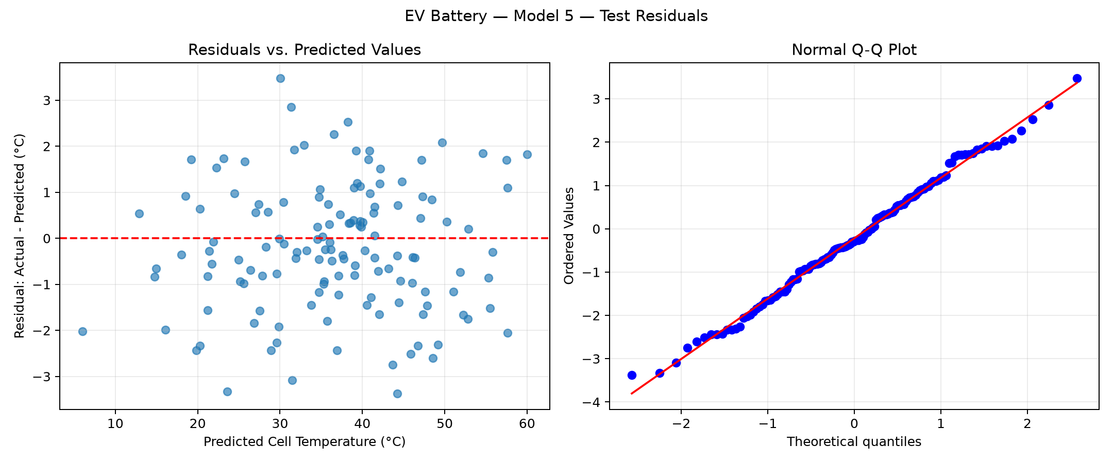
Model 4 — second-lowest test RMSE: 1.6962 °C
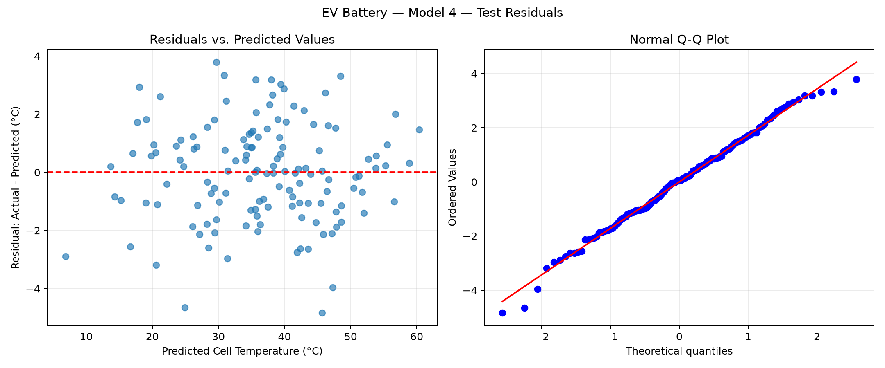
Both figures use the same 136 test records. Residual = actual − predicted temperature. Inspect the vertical scales when comparing residual spread.

Responsible AI Pair-Programming & Troubleshooting Log
AI Tooling Utilized: | ChatGPT / Codex
Verbatim Prompts Submitted: | “Ayudame a realizar la actividad 16 que te adjunte”
AI Code Output & Suggestions: | AI suggested the fitting and metric loop, residual = y_test − prediction, residual scatterplots and scipy.stats.probplot. The interpretation compared Models 4 and 5 and avoided treating visual diagnostics as definitive statistical tests.
Human Audit & Verification: | Eduardo verified the 544/136 split, five nested feature sets and 136 test predictions per model. The reported metrics were recorded with training adjusted R² and test MAE/RMSE. The two diagnostic figures were reviewed: no clear curve or funnel; approximate Q-Q alignment with deviations. Model 5 was selected subject to cost and validation limitations.

Limitations & Bugs Caught: | Missing sklearn initially blocked execution; the subsequent split succeeded after installation was recommended. The assignment lists 6 predictors but requests 5 in Model 5. We retained current, ambient temperature, resistance, coolant flow and state of charge for their thermal relevance; voltage was excluded to meet that limit.

Activity Evaluation Rubric
Evaluation Pillar | Excellent | Developing | Needs Improvement
1. 5-Model Configuration & Pipeline Implementation | Successfully configures, trains, and tests all 5 regression models on identical 80/20 split. Features are logically grouped from simple baseline to full engineering model. | Configures 3-4 models, or models are fitted on inconsistent splits, making comparison partially flawed. | Fails to configure multiple models, script crashes, or only fits a single baseline regression.
2. Metric Evaluation & Comparison Table Accuracy | All metrics (Train R², Test R², Adjusted R², MAE, RMSE) are accurately computed and recorded in the comparison table with zero calculation errors. | Metrics are recorded, but 1-2 numbers are miscalculated (e.g., using train error instead of test, or omitting Adjusted R²). | Comparison table is incomplete, missing error metrics, or values are clearly fabricated without script execution.
3. Residual Diagnostics & Best Model Defense | Generates clean Fitted vs. Residuals and Q-Q plots. Identifies whether assumptions hold. Provides a compelling 2-3 paragraph defense of the winning model. | Residual plots generated but lack clear labels or interpretation. Defense is brief or focuses only on raw R² without considering trade-offs. | No residual diagnostics provided, or team cannot articulate why their selected model was chosen.
4. Git Architecture & Responsible AI Log | Clean feature branch in VS Code GUI, atomic conventional commit (feat:), PR opened and approved by teammate, merged to main. AI log is thoroughly documented. | Code pushed to GitHub, but committed directly to main, generic commit message, or AI log lacks specific prompt auditing. | Code missing from remote GitHub repository, merge conflicts unresolved, or AI log is blank.

