Cluster configuration for ssh access

In order to enable access to the cluster master node via ssh, it is necessary to add an inbound rule to the <ElasticMapReduce-master> security group. As shown in the picture below.

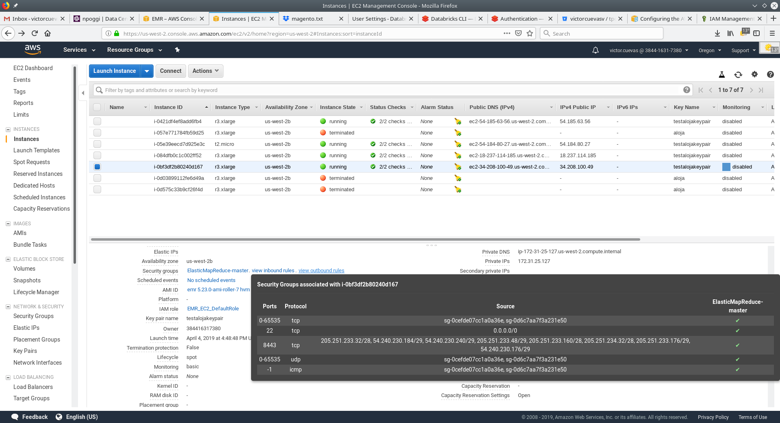
The concrete parameters are:
-Port: 22
-Protocol: tcp
-Source: 0.0.0.0/0

To view the inbound rules from the cluster <Summary> page go to the <Hardware> tab, then select the master node <ID>, followed by the <EC2 Instance ID>. In the <Description>, under the <Security groups>, the <inbound> and <outbund> rules can be viewed.

In order to edit or add a new rule select the <ElasticMapReduce-master> security group, then go to the <Inbound> tab and click the <Edit> button. Scroll down to find the <Add Rule> button.

Once enabled it is possible to login with a commando of the form:

ssh -i id_rsa hadoop@ec2-18-237-94-60.us-west-2.compute.amazonaws.com
where <id_rsa> is the private key matching the public key of the keypair that was used to create the cluster (the file has to be accesible or an adequate path provided). Note that the login takes place under the username <hadoop>, which has <sudo> capabilities.

Deply the benchmarking application

The source code repository is stored in bitbucket.com. Since the EMR machine instances do not have git installed it is necessary to add it with the command:
sudo yum install git

For an <user> with access enabled, the application code repository can be downloaded with the command:

git clone https://user@bitbucket.org/victorcuevasv/tpcdsbench.git

To build and run the application it is necessary to use docker. The EMR nodes have docker installed, but the <hadoop> user is not a member of the docker group, so to add it use the command:

sudo usermod -aG docker $USER

Logout and then login for the change to take effect.

Enter the <tpcdsbench> directory. To build the application type the command:

bash emr/BuildAll.sh

This command will generate the container images and also a <vols> directory with subdirectories for the required files, these are:
<data>: create table statements, queries, plans, results, logs
<hive>: TPC-DS raw data files (.dat extension)
<warehouse>: to save the database if desired
<ivyuser> and <ivyroot>: unused when running on EMR, meant to cache dependencies
<metastore>: unused in EMR, indicates if the metastore has been created.

The container images generated are:
REPOSITORY TAG
clientbuilder dev
tpcds dev
ubuntujava dev
ubuntu 16.04

Generate the SQL files

To generate the SQL files, once the container images have been generated. Use the command:

bash CreateSQLFiles.sh

This command will generate the following subdirectories inside the <vols/data> directory:

<QueriesNetezza>: queries in the Netezza SQL dialect supported directly by the TPC-DS toolkit.
<QueriesPresto>: queries generated from the Netezza templates with modifications to run on presto.
<QueriesSpark>: queries generated from the Netezza templates with modifications to run on Spark.
<tables>: files with create table statements to create the TPC-DS tables generated from the tpcdsvarchar.sql file discussed below.
<tpcdsvarchar.sql>: a file that includes all of the create table statements, it was created by modifying the tpcds.sql file from the TPC-DS toolkit. The modification consisted of using the <varchar> data type instead of <char>, because if the database is created in Spark with the <char> data type, the corresponding values will be padded with blank space characters, yielding wrong answers for some queries.

The modifications to the query templates can be found in the <tpcdsbench/dqgen/v2.10.1rc3> directory. Concretely, the <query_templates_presto> directory contains the templates that were modified for presto, while the <query_templates_spark> contains the analogous templates for spark.

Generating the TPC-DS raw data files

Provided enough disk space is available, and not taking advantage of multinode parallelism. The raw data files for the TPC-DS benchmark can be generated with the command:

bash CreateDataFiles.sh <scale factor>

For instance, to genrate the data files corresponding to the 10 GB scale factor type:

bash emr/generateData.sh 10

Depending on the scale factor used, the process can take a significantly long time. IMPORTANT: currently for EMR, due to space limitations, the data is generated in an alternative location (</mnt/vols/hive>). Then a symbolic link is created from the <tpcdsbench/vols/hive> directory.

The files are generated in plain text with the .dat extension. The format is csv with the caveat that the separation character is ‘\001’ in C octal notation. This character is not visible in GUI text editors but can be visualized with editors like vim, appearing as ‘^A’. The rationale for using this character for column separation instead of the comma or pipe symbol is that Presto does not allow to indicate explicitly the separator as opposed to Hive and Spark.

Create the database with Spark

First, compile the application. A single script generates the different builds to use with Spark and Presto, it is executed with

bash CompileAll.sh

The different builds are generated at the <tpcdsbench/client/project> directory, and these include.

tpcdsbench/client/project/target: build for Presto
tpcdsbench/client/project/targetspark: build for Spark
tpcdsbench/client/project/targetsparkjdbc: build for Spark on JDBC

The raw data files generated previously can be copied to HDFS with the command:
bash emr/copy_datfiles_to_hdfs.sh <scale factor>

For example, to copy the 10 GB dataset generated earlier, username

bash emr/copy_datfiles_to_hdfs.sh 10

