Step1. Install Git Extensions plugin for Visual Studio. May need to restart Studio.

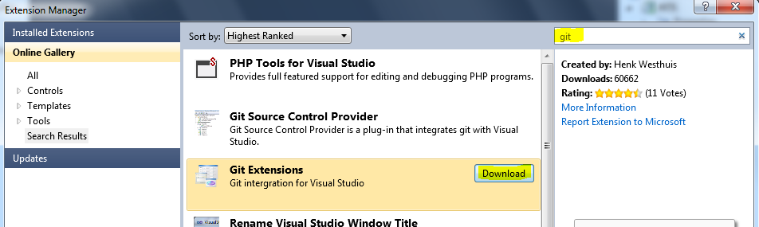

2. Clone the GitHub repo to your area. Clone the **develop** branch..

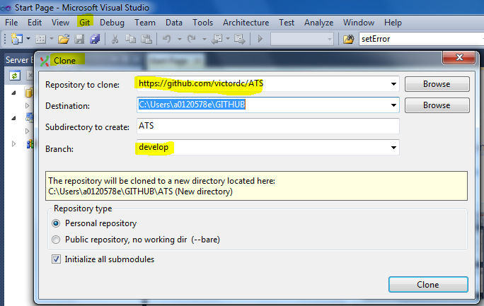

3. Open the solution inside the “Destination” folder.

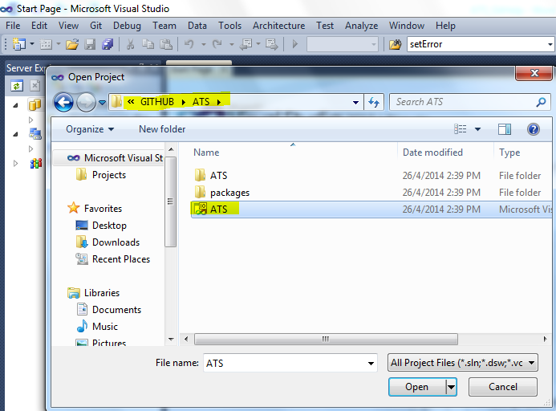

4. Make modifications.

5. Commit the changes into your local copy. Git -> Commit

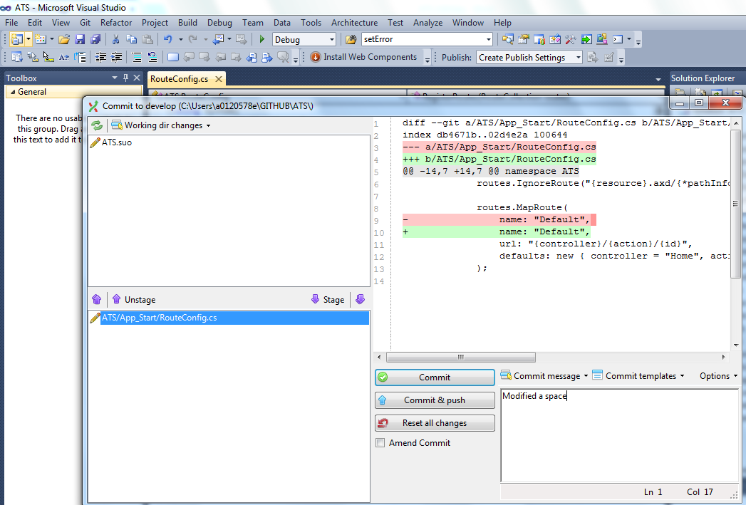

6. Repeat steps 4 and 5 for further changes.

7. Before you copy push your changes to Github, avoid conflict by doing “Pull” first. Git -> Pull

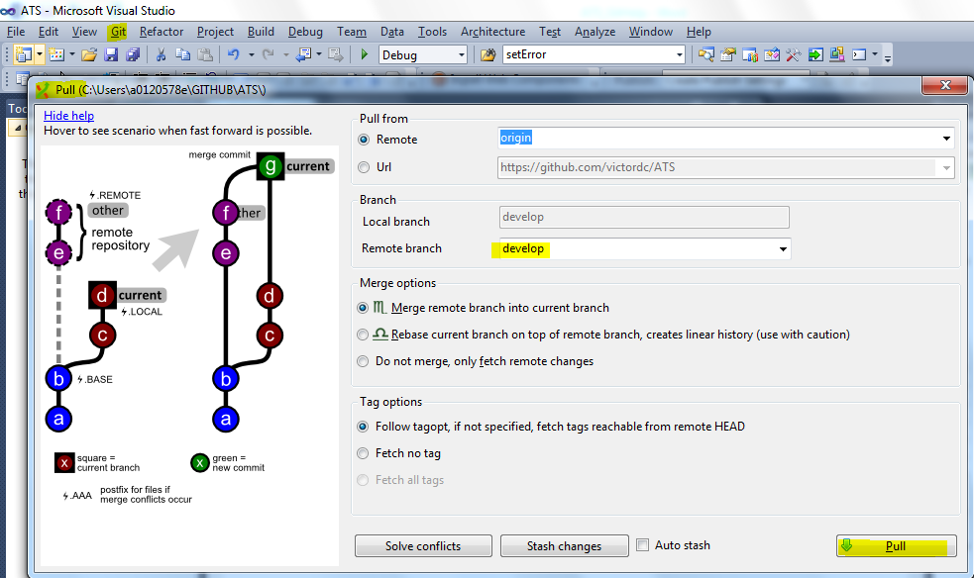

8. Immediately push your local changes to the Github repo. Git -> Push.

