Replication of Priming Addition Facts With Semantic Relations by Bassok, Pedigo & Oskarsson (2008, Journal of Experimental Psychology: Learning, Memory, and Cognition)

Introduction

Bassok, Pedigo & Oskarsson (2008) provided evidence for the semantic alignment hypothesis, an account for how semantic alignments modulate automatic activation of arithmetically related facts. More precisely, the hypothesis states that categorical semantic relation is aligned with addition, and the functional semantic relation is aligned with division. The authors conducted two experiments, categorical semantic priming and functional semantic priming, to testify whether categorical aligned semantic primes automatically activate addition facts, at which they referred to this result pattern as the sum effect. The present study attempts to replicate Experiment 1 and 2 in the original study. The authors proposed that:
“we predicted that the sum effect would be more pronounced in the semantically aligned than in the semantically misaligned priming condition. That is, we predicted that the difference between response latencies to sum and neutral targets (e.g., between 8 and 9, respectively, for cue digits 5 + 3) would be larger when the cue digits are primed with categorical primes (tulips–daisies) than when they are primed with unrelated primes (hens–radios) or with functionally related primes (birds– cages).”
Methods

Power Analysis
Given the missing of important information for calculating the actual power in the original work, the effect size and power are unknown. Despite the missing data, sample size is estimated for the hypothesis test.

Planned Sample
Following the original study, two different groups of participants were sampled. As the original power and effect size were unknown due to missing of relevant data, the required sample size is estimated by using G*Power statistical calculator. Given it is 2 X 2 within subjects repeated measures analyses of variance, estimating the effect size in a range of small to moderate level, desired power .95, significance level .05, the calculated sample size is 86. The data collection is expected to start in Spring 2014 until the end of the semester. Similar to the original study, the participants are native English speakers or at least as fluent as a native English speaker with normal or corrected vision.

Materials
We intend to mirror the experiment procedure and materials used in the original study (see Appendix A for the trial triplets). The written instructions and trial stimuli will display on a 15.4-in (39.1cm) monitor operated with an Intel Core 2 Duo computer and the trial responses will be recorded with the use of Visual Basics 2010 software (see Figure 1 for the experimental procedure). The stimuli are 80 word triplet pairs (aligned categorically related word and misaligned unrelated word triplets), and 48 digit triplet pairs in Experiment 1. The presentation time of stimuli and target will strictly follow the original study. Stimuli in Experiment 2 are identical to the triplets used for the Experiment 1 except the misaligned unrelated word triplets are replaced by the misaligned functionally related word triplets.

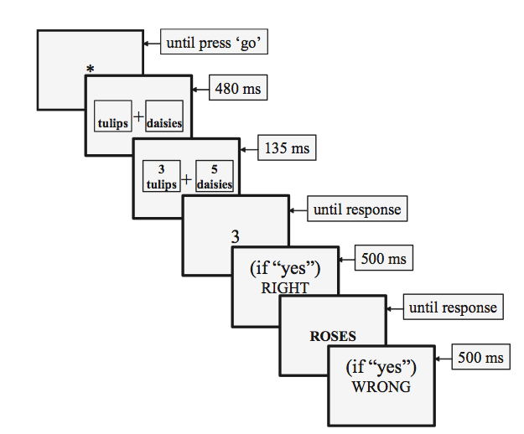
Figure 1. An illustration of the experimental procedure. Asterisk represents the prompt used at the outset of each trial.

Procedure
Experiment 1
The procedure will follow the one used in the original study in Experiment 1. The details are below:

“Each participant received a unique randomized sequence of 160 trials that had a balanced 4 (word triplet) x 4 (digit triplet) x 2 (target order) factorial design, with five trials in each experimental cell. The four word-triplet conditions were AC prime/matching target, AC prime/nonmatching target, MU prime/matching target, and MU prime/nonmatching target. The four digit-triplet conditions were sum, neutral, cue control, and target control. The two target-order conditions were digit first and word first. The word triplets were selected at random without replacement until all 80 triplets were exhausted and then sampled again for a total of 160 trials. The digit triplets were selected at random without replacement until all 48 triplets were exhausted, and this sampling was repeated for a total of 160 trials. The constraints on the random draw of the word and digit combinations were such that there were no more than two consecutive identical trial types and no more than four identical consecutive correct responses (e.g., “no”).” (pp.347)
Experiment 2
The procedure in Experiment 2 is identical to that of Experiment 1 except different word triplets are used. It will follow the one used in the original study in Experiment 2. The details are below:

“Experiment 2 replicated the design of Experiment 1, except that we replaced the MU primes used in Experiment 1 (e.g., clowns– ovens) with misaligned functionally (MF) related primes (e.g., ships–sailors).“(pp.349)
Analysis Plan
Following Bassok and colleagues (2008), the mean latencies of correct responses and mean error rates will be analyzed using within-subject repeated measures analyses of variance (ANOVAs).
Requested fund
A token of appreciation in the form of supermarket voucher, HKD50 each (equivalent to USD 6.35 each), will be distributed to the participants upon the completion of experiment. The number of participants in both experiments is 172 (86 participants each). Thus, the sum of amount requested from OSC grant is approximately USD 1091.

Reference
Bassok, M., Pedigo, S. F., & Oskarsson, A. T. (2008). Priming addition facts with semantic relations. Journal of Experimental Psychology: Learning, Memory, and Cognition, 34(2), 343-352.
Faul, F., Erdfelder, E., Buchner, A., & Lang, A.-G. (2009). Statistical power analyses using G*Power 3.1: Tests for correlation and regression analyses. Behavior Research Methods, 41, 1149-1160.

Appendix A



