Dear Victor,
Thank you for bringing your paper to the Writers Workshop! I hope we can get you in for a synchronous appointment sometime. Your paper is largely very clean, logical, and well-organized. There were only a few places where I felt confused, and I noted these in the marginal comments (with the rest of my reader response!). I know you were most concerned regarding your hypothesis, structure, and transitions, and I did not see any glaring issues within any of these categories. That said, I have a few suggestions overall:
- If you have time during future revisions, I would really recommend defining your terms earlier in the introduction rather than on the last few pages of it. (i.e. “supersire,” etc.)
- I would also recommend making a nod earlier in the paper to the link between inbreeding and cost.
- Break up run-on sentences – this will keep your meaning from being buried in extra clauses and conjunctions.
Thanks again for bringing this to the Writers Workshop – it’s a really interesting paper and I’d be happy to work with you on it further.
Happy Writing!
Liz

Introduction

This article investigates the consequences of a technological innovation: genomic selection for bulls. This new technology increased the productivity of the dairy industry as soon as it was introduced. Animal breeders and genetics companies can identify which bulls have the highest productivity and transmit it to their offspring, thus increasing the productivity of the next generation of animals. But it also had a negative consequence: increased inbreeding rates due to breeders mating more closely related animals to undercut each other and ensure a higher market share. Inbreeding is a negative externality inflicted by breeders on themselves by pursuing short-term gains in genetic performance at the cost of reducing the diversity of the gene pool. We want to uncover the causal mechanism that fuels increased inbreeding rates and creates a significant cost to the American dairy industry. Are breeders mating more heavily on famous lines? If this is the case, we should see higher inbreeding rates in animals from those well-established families than in other less famous lines. This article shows that a more intense competition to supply high-quality genetics led to higher inbreeding rates and, thus, to billions of dollars of cost for the American dairy industry.
Genomic selection was expected to help animal breeders identify the best sires since it allows for a more accurate estimation of genetic traits. This greater accuracy would enable breeders to ``discover" new potentially high-performing sires independent of their ancestry, but the opposite happened. This is the consequence of “brand loyalty” towards famous bull families from dairy farmers who are confronted with an expanding variety of animals to choose from.
Inbreeding leads to a higher prevalence of deleterious genetic conditions that inflict a very high cost on the dairy industry. Genomic selection could have helped breeders find more productive genetic resources outside their gene pool. However, it had the opposite effect since the incentive mechanism that breeders face makes them compete to supply the most productive bulls since dairy farmers only pay for those animals since their profits are a function of the productivity of their cows.
Is it the case that breeders are mating more heavily on famous lines? If this is the case, we should see higher inbreeding rates in animals from those well-established families than in other less famous lines. Genomic selection was expected to help animal breeders identify the best sires since it allows for a more accurate estimation of genetic traits. This greater accuracy would enable breeders to “discover” new potentially high-performing sires independent of their ancestry.
Genomic selection has the opposite effect; it helps breeders identify a highly productive bull when the animal is born so it can be marketed as soon as it reaches sexual maturity (one year old versus four to five years with traditional selection.) Genomic selection increased the genetic gains per year due to shortened generation intervals but also led to increased competition in the animal genetics industry; firms that supply bull genetics are under higher pressure to offer more “efficient” bulls. The most common way to breed a highly productive sire is through linebreeding, mating two related animals that are descendants of a famous sire. A consequence of the pervasive use of line breeding, the effective population size of bulls is at a historic low ranging from 43 to 66 animals.
Now all animals are, on average, more related to each other due to the pervasive use of linebreeding (Cole, 2019). According to the Holstein Association of the United States, each additional percent point of inbreeding rate leads to a $23 revenue loss per cow. We estimate that increased inbreeding has led to around one billion dollars of losses for the industry annually since 2012.
This article fills a critical gap in the literature; there are no other papers that analyze inbreeding as a network externality (Liebowitz and Margolis, 1994), (Katz and Shapiro, 1985), where companies enjoy the benefits (faster genetic gains) and suffer the costs (decreased fertility caused by the increased frequency of deleterious mutations) from changes in the number of firms that adopt the same line. In this case, the pedigree (relatedness) is the force that binds all the nodes in the network, where two animals are part of the same network (line) if they descend from the same ancestor. Similarly, all articles that analyze the market for cattle genetics, such as Kerr (1984), Melton et Al. (1994), Richards and Jeffrey (1996) or Schroeder et al. (1992) study cattle as a closed system and their objective was to determine what the implicit prices are of each genetic trait using hedonic methods. These early papers then focus on the decisions taken by individual breeders or dairy farmers without paying attention to their broader impact.
Inbreeding depression is a negative externality because it is an external cost that genetics companies inflict upon each other because of breeding more closely related bulls. In this case, the profits of genetics companies are a function of the trait levels of the animals they produce but also depend on the degree of relatedness of bulls to each other. The more genetic companies generate into a family of animals (also known as a “line”), the higher the likelihood of observing inbreeding depression in the next generation. The most important policy implication of this article is that we can use one or several solutions from the economics “toolbox” to fix the issue, such as Pigovian taxes on breeders who supply highly inbred bulls or governmental regulations to keep inbreeding levels below a certain threshold.

Conceptual Framework

Selective breeding has been practiced since prehistoric times. However, the discovery of inheritance mechanisms and genetics in the 19th and 20th centuries allowed breeders to identify the link between desired traits in animals and their inheritance mechanisms (Lush, 1937). From an economic standpoint, an animal breeder supplies a product (animal genetics), an inseparable bundle of traits embodied in a single animal. To produce such an animal, the breeder combines a set of inputs that can be split into two groups: a series of inputs exogenously supplied by the producer (labor, feed, capital, veterinary services) and a series of inputs embodied in the animal (traits.) Those inputs are combined on a production function subject to the prices of exogenous inputs (observed) and genetic inputs, whose prices are implicit but can be estimated based on the price paid for a bull's genetics using the hedonic approach (Schroeder et Al., 1992), (Sy and Faminow, 1997).
Melton et Al. (1979, 1994) add an additional element: breeders are paid based on the (positive) deviation of the trait levels of their bulls relative to the population average. Breeders compete to maximize profits; to do so, they will attempt to release into the market bulls with the highest possible trait values. Dairy farmers demand genetics to improve their productivity in the next period by choosing the bulls with the best characteristics. However, the traits that constitute an animal are marketed as a "bundle" of traits embedded in each animal. In other words, dairy farmers are only interested in the productivity of their cows because their profits depend on it; they are not directly interested in how inbred their cows are; therefore, inbreeding rates do not have a price.
Inbreeding is the mating of individuals more closely related to each other than the average for the population (Bourdon, 2000, p. 337). In the case of dairy cattle, the objective of mating a bull with a cow that is, to a degree, related is to preserve some of the characteristics of the bull or to help create a certain distance to a particular ancestor. Inbreeding has two consequences: first, it increases the likelihood that an animal's offspring will perform similarly to its ancestors; for example, if a particularly tall bull is mated with a related cow, its offspring will likely be taller than average because the genes that carry such trait are likely to be present in both parents. Second, it favors the expression of deleterious recessive alleles, since an animal carries two copies of a recessive gene from each parent, it is more likely to express any such traits than an outbred animal.

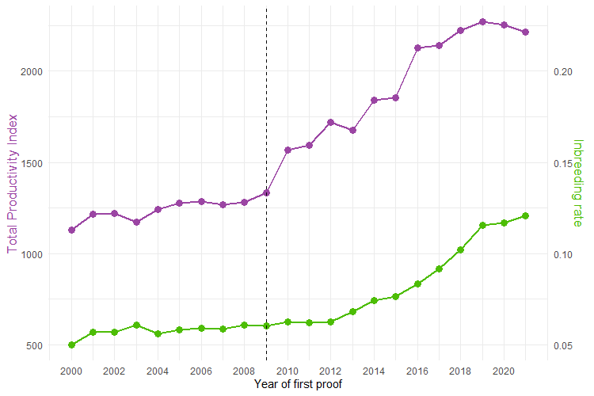
Figure 1: Average Total Performance Index of Holstein bulls
Figure1 shows the close link between the Total Performance Index (TPI), a weighted average of a series of genetic traits, and the average inbreeding rate. Genomic selection led to an immediate jump in the productivity index but to a lagged response in inbreeding rates because of the gestation length and time to reach maturity that originate the cattle cycle (Rosen et Al., 1994), breeding decisions in year t, lead to a birth of a new calf in t+1, that will be released into the market in year t+2. The increment in the rate of change in hereditary traits caused by genomic selection can be decomposed into a set of components: heritability, selection intensity, and generation interval (Kerr, 1984).
$$genetic improvement= \frac{heritability×selection intensity×trait variance}{geneation interval}$$

Heritability is a population parameter specific to each trait that measures the strength of the relationship between the genetic traits of parents and their offspring, and so is the standard deviation of the observed trait values. Selection intensity is the differential in average trait values between selected animals and the general population at a given time.
Selection intensity measures how “choosy” breeders are in deciding which individuals are selected; more intensity of selection means that only the “best” animals (according to some criterion) are selected to have offspring. If animals were randomly selected, those magnitudes would not differ. The generation interval is the time required to replace one generation with the next: the shorter the interval, the faster the genetic change. Genetic improvement is driven by two forces: selection intensity and generation interval. An increase in selectivity or a decrease in the generation interval increases genetic gains per generation.
Before 2009, it took from one to five years for a bull to give birth to a large enough number of daughters to test them for the presence of genetic traits such as milk, protein, or fat yields. With genomic testing, an animal can be tested as soon as it is born for the presence of specific traits in its genome. Consequently, the generation interval, the average age of parents when offspring are born (Wiggans and Carrillo 2022), has decreased from around five and a half years to less than two years, close to the biological minimum.

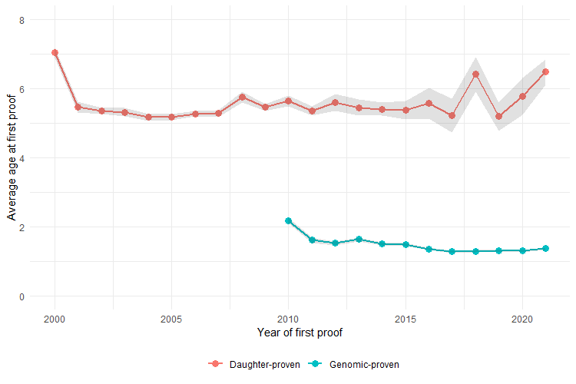
Figure 2: Average age at first proof for Holstein bulls

The most important consequence of this shorter generation interval is the increase in genetic progress. Note that Figure 2 also shows that the number of “Active” bulls has steadily decreased, and the wider confidence intervals for the average age reflect that.
A key element of our analysis is the existence of what we call “supersires”, high-prestige bulls who became the founders of lines (families). The more genetics companies breed the same lines, the more newborn bulls will be related to a specific ancestor, and the denser their networks will be. We define a bull as a supersire in terms of the size of its progeny, we have records of all male descendants from each sire that have been released on the dairy genetic market as sires. We can then identify which bulls have had the most significant number of sons; more precisely, a sire born between 1997 and 2007 is a supersire if the size of his progeny is on the 95th percentile of its distribution.
We test the hypothesis that genomic selection caused higher inbreeding rates by constructing a counterfactual line of bulls that possessed similar traits but were less popular at the introduction of genomics. We identify their descendants and respective inbreeding rates; we find that they increased disproportionately more for the descendants of supersires. A likely explanation for this process is that genetics companies did not invest in the most productive bulls, but instead in the most famous lines to gain market share. The more companies breed into those lines, the higher the inbreeding rate of the next generation of bulls. This leads to a deterioration of the expected traits of future generations of bulls and, thus, to significant losses for the dairy industry in terms of reduced productivity.

The number of individuals that an idealized population would need to have for inbreeding rates to be the same as in the actual population.

