How to get started

The tutorial is made for Windows. Do the corresponding steps for Linux.
Mac OS is not supported natively, so then you have to download the source files and run or compile the Python files yourself, from main.py. Make sure that you have Python ≥ 3.10 installed and opencv-python-headless.

- Find the package on GitHub:
- Type https://github.com/victorezeilo/image-processing/releases in your browser
- Download dist_Windows.zip
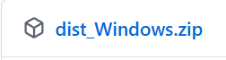
- Extract the downloaded zip file and open it

- Right click on the “dist_Windows” folder and click select “Open in Terminal”. Make sure that you are inside a folder that is also called “dist_Windows”.
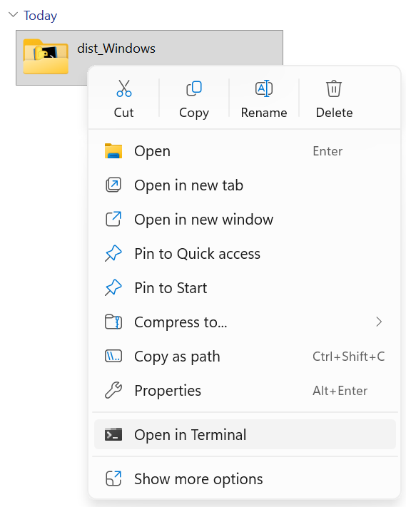

- Try it out!

- For example, paste
.\\eye.exe convert --source test.jpg --destination test_converted.png --format png --compression medium
into the terminal (if unsure, try SHIFT + INSERT och CTRL + SHIFT + V)

Then paste explorer . into the terminal to see the result. A new file named “test_converted.png” should appear.
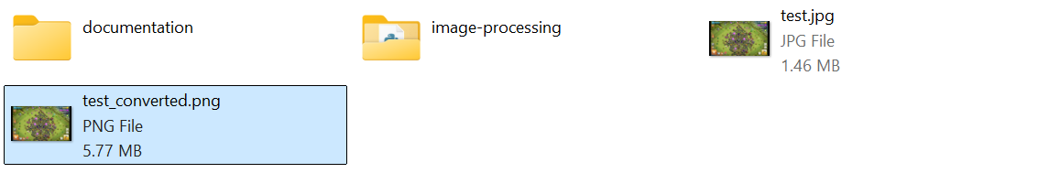
- You could also try typing:
.\\eye.exe resize --source test.jpg --destination test_resized.jpg --height 1080 --width 1920
You should then have a file called “test_resized.jpg” that is 1920 x 1080 pixels.
- Also, just type:
.\\eye.exe
To go into the interactive menu mode.

