Surivival Analysis HW Chapter 2

Victor Feagins

9/8/2021

## Exercise 2.1

Consider the survival data given in Exercise Table 2.1 and compute and plot the **estimated survivorship**, the **probability density** and the **hazard** functions.

| Initial_Time | End_Time | Number_Survivors_Initial | Number_Dying_in_Interval |
| --- | --- | --- | --- |
| 0 | 1 | 1,100 | 240 |
| 1 | 2 | 860 | 180 |
| 2 | 3 | 680 | 184 |
| 3 | 4 | 496 | 138 |
| 4 | 5 | 358 | 118 |
| 5 | 6 | 240 | 60 |
| 6 | 7 | 180 | 52 |
| 7 | 8 | 128 | 44 |
| 8 | 9 | 84 | 32 |
| 9 |  | 52 | 28 |

### Survivorship Function

Survivorship is the probability that an individual survives longer than t. It is estimated with the following equation:

$$\hat{S}(t)=\frac{number of items surviving longer than t}{total number of patients}$$

#### Calcuating Survivorship Exercise 2.1

data.2.1 <- data.2.1 %>%   
 mutate('S(t)' = Number_Survivors_Initial/max(Number_Survivors_Initial))  
data.2.1 %>%   
 select(Initial_Time, "S(t)") %>%   
 flextable() %>%   
 autofit()

| Initial_Time | S(t) |
| --- | --- |
| 0 | 1.00000000 |
| 1 | 0.78181818 |
| 2 | 0.61818182 |
| 3 | 0.45090909 |
| 4 | 0.32545455 |
| 5 | 0.21818182 |
| 6 | 0.16363636 |
| 7 | 0.11636364 |
| 8 | 0.07636364 |
| 9 | 0.04727273 |

#### Plotting Survivorship Exercise 2.1

ggplot(data.2.1, aes(`Initial_Time`, `S(t)`)) +  
 geom_line() +  
 geom_point() +  
 ylab(expression(paste(hat("S"), "(t)"))) +  
 xlab("t")

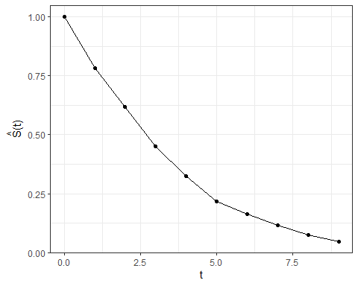

### Probability Density

#### Calcuating probability density Exercise 2.1

To estimate the probability density the following equation is used:

$$\hat{f}(t)=\frac{number of items dying in the interval beginning at time t}{(total number of items)*(interval width)}$$

This probability density is at the mid point of the interval

data.2.1 <- data.2.1 %>%   
 mutate(Mid_Time = (Initial_Time + End_Time)/2) %>%   
 mutate("f(t)" = Number_Dying_in_Interval/(max(Number_Survivors_Initial) * (End_Time - Initial_Time)))  
data.2.1 %>%   
 select(Mid_Time, "f(t)") %>%   
 flextable() %>%   
 autofit()

| Mid_Time | f(t) |
| --- | --- |
| 0.5 | 0.21818182 |
| 1.5 | 0.16363636 |
| 2.5 | 0.16727273 |
| 3.5 | 0.12545455 |
| 4.5 | 0.10727273 |
| 5.5 | 0.05454545 |
| 6.5 | 0.04727273 |
| 7.5 | 0.04000000 |
| 8.5 | 0.02909091 |
|  |  |

#### Plotting probability density Exercise 2.1

ggplot(data.2.1, aes(`Mid_Time`, `f(t)`)) +  
 geom_line() +  
 geom_point() +  
 ylab(expression(paste(hat("f"), "(t)"))) +  
 xlab("t")

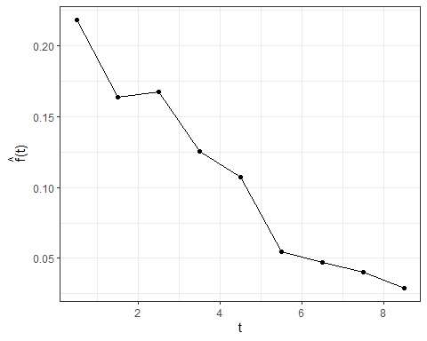

### Hazard Function

#### Calcuating Hazard Function Exercise 2.1

To estimate the hazard function the following equation can be used:

$$\hat{h}(t)=\frac{number of items dying per unit time in the interval}{(number of items surviving at t)−(number of deaths in the interval)/2}$$

data.2.1 <- data.2.1 %>%   
 mutate(Deaths_Per_Time = Number_Dying_in_Interval/(End_Time - Initial_Time),  
 "h(t)" = Deaths_Per_Time/(Number_Survivors_Initial - Number_Dying_in_Interval/2))  
  
data.2.1 %>%   
 select(Mid_Time, "h(t)") %>%   
 flextable() %>%   
 autofit()

| Mid_Time | h(t) |
| --- | --- |
| 0.5 | 0.2448980 |
| 1.5 | 0.2337662 |
| 2.5 | 0.3129252 |
| 3.5 | 0.3231850 |
| 4.5 | 0.3946488 |
| 5.5 | 0.2857143 |
| 6.5 | 0.3376623 |
| 7.5 | 0.4150943 |
| 8.5 | 0.4705882 |
|  |  |

#### Plotting Hazard Function Exercise 2.1

ggplot(data.2.1, aes(`Mid_Time`, `h(t)`)) +  
 geom_line() +  
 geom_point() +  
 ylab(expression(paste(hat("h"), "(t)"))) +  
 xlab("t")

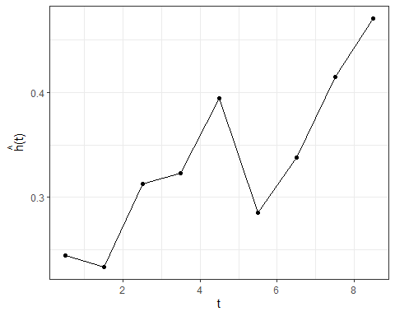

## Exercise 2.2

Table 2.2 is a life table for the total population of 100,000 live births in the United States, 1959 – 1961. Compute and plot the estimated **survivorship**, the **probability density**, and the **hazard** function.

| Initial_Time | End_Time | Number_Survivors_Initial | Number_Dying_in_Interval |
| --- | --- | --- | --- |
| 0 | 1 | 100,000 | 2,593 |
| 1 | 5 | 97,407 | 409 |
| 5 | 10 | 96,998 | 233 |
| 10 | 15 | 96,765 | 214 |
| 15 | 20 | 96,551 | 440 |
| 20 | 25 | 96,111 | 594 |
| 25 | 30 | 95,517 | 612 |
| 30 | 35 | 94,905 | 761 |
| 35 | 40 | 94,144 | 1,080 |
| 40 | 45 | 93,064 | 1,686 |
| 45 | 50 | 91,378 | 2,622 |
| 50 | 55 | 88,756 | 4,045 |
| 55 | 60 | 84,711 | 5,644 |
| 60 | 65 | 79,067 | 7,920 |
| 65 | 70 | 71,147 | 10,290 |
| 70 | 75 | 60,857 | 12,687 |
| 75 | 80 | 48,170 | 14,594 |
| 80 | 85 | 33,576 | 15,034 |
| 85 |  | 18,542 | 18,542 |

### Survivorship Function

#### Calcuating Survivorship Exercise 2.2

data.2.2 <- data.2.2 %>%   
 mutate('S(t)' = Number_Survivors_Initial/max(Number_Survivors_Initial))  
data.2.2 %>%   
 select(Initial_Time, "S(t)") %>%   
 flextable() %>%   
 autofit()

| Initial_Time | S(t) |
| --- | --- |
| 0 | 1.00000 |
| 1 | 0.97407 |
| 5 | 0.96998 |
| 10 | 0.96765 |
| 15 | 0.96551 |
| 20 | 0.96111 |
| 25 | 0.95517 |
| 30 | 0.94905 |
| 35 | 0.94144 |
| 40 | 0.93064 |
| 45 | 0.91378 |
| 50 | 0.88756 |
| 55 | 0.84711 |
| 60 | 0.79067 |
| 65 | 0.71147 |
| 70 | 0.60857 |
| 75 | 0.48170 |
| 80 | 0.33576 |
| 85 | 0.18542 |

#### Ploting Survivorship Exercise 2.2

ggplot(data.2.2, aes(`Initial_Time`, `S(t)`)) +  
 geom_line() +  
 geom_point() +  
 ylab(expression(paste(hat("S"), "(t)"))) +  
 xlab("t")

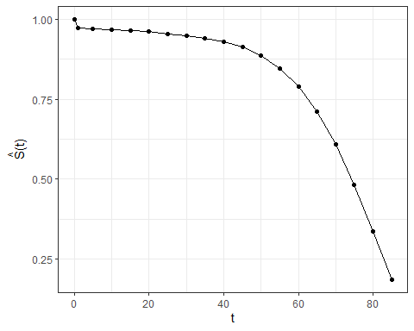

### Probability Density

#### Calcuating probability density Exercise 2.2

data.2.2 <- data.2.2 %>%   
 mutate(Mid_Time = (Initial_Time + End_Time)/2) %>%   
 mutate("f(t)" = Number_Dying_in_Interval/(max(Number_Survivors_Initial) * (End_Time - Initial_Time)))  
data.2.2 %>%   
 select(Mid_Time, "f(t)") %>%   
 flextable() %>%   
 autofit()

| Mid_Time | f(t) |
| --- | --- |
| 0.5 | 0.0259300 |
| 3.0 | 0.0010225 |
| 7.5 | 0.0004660 |
| 12.5 | 0.0004280 |
| 17.5 | 0.0008800 |
| 22.5 | 0.0011880 |
| 27.5 | 0.0012240 |
| 32.5 | 0.0015220 |
| 37.5 | 0.0021600 |
| 42.5 | 0.0033720 |
| 47.5 | 0.0052440 |
| 52.5 | 0.0080900 |
| 57.5 | 0.0112880 |
| 62.5 | 0.0158400 |
| 67.5 | 0.0205800 |
| 72.5 | 0.0253740 |
| 77.5 | 0.0291880 |
| 82.5 | 0.0300680 |
|  |  |

#### Plotting probability density Exercise 2.2

ggplot(data.2.2, aes(`Mid_Time`, `f(t)`)) +  
 geom_line() +  
 geom_point() +  
 ylab(expression(paste(hat("f"), "(t)"))) +  
 xlab("t")

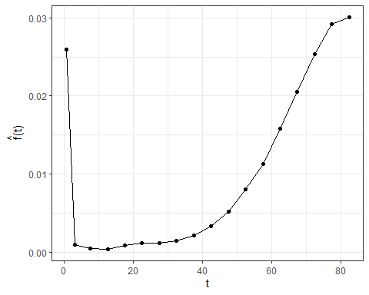

### Hazard Function

#### Calcuating Hazard Function Exercise 2.2

data.2.2 <- data.2.2 %>%   
 mutate(Deaths_Per_Time = Number_Dying_in_Interval/(End_Time - Initial_Time),  
 "h(t)" = Deaths_Per_Time/(Number_Survivors_Initial - Number_Dying_in_Interval/2))  
  
data.2.2 %>%   
 select(Mid_Time, "h(t)") %>%   
 flextable() %>%   
 autofit()

| Mid_Time | h(t) |
| --- | --- |
| 0.5 | 0.0262705983 |
| 3.0 | 0.0010519277 |
| 7.5 | 0.0004810000 |
| 12.5 | 0.0004427983 |
| 17.5 | 0.0009135169 |
| 22.5 | 0.0012399023 |
| 27.5 | 0.0012855657 |
| 32.5 | 0.0016101646 |
| 37.5 | 0.0023075937 |
| 42.5 | 0.0036564340 |
| 47.5 | 0.0058223323 |
| 52.5 | 0.0093274225 |
| 57.5 | 0.0137845132 |
| 62.5 | 0.0210899117 |
| 67.5 | 0.0311808733 |
| 72.5 | 0.0465462684 |
| 77.5 | 0.0714114452 |
| 82.5 | 0.1153843202 |
|  |  |

#### Plotting Hazard Function Exercise 2.2

ggplot(data.2.2, aes(`Mid_Time`, `h(t)`)) +  
 geom_line() +  
 geom_point() +  
 ylab(expression(paste(hat("h"), "(t)"))) +  
 xlab("t")

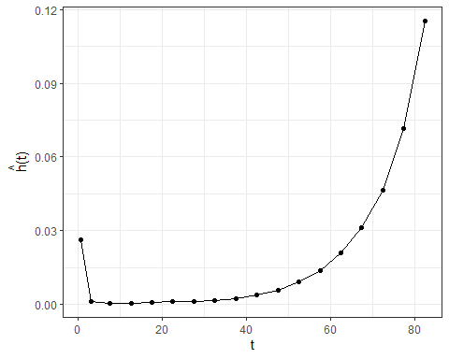

## Exercise 2.5

Given the survivorship function:

$$S(t)=exp(−t^{γ})$$

derive the probability density function and the hazard function.

### Relationships

We know that the cumulative Hazard function is the negative natural log of the survival function

$$H(t)=−log(S(t))$$

We know that the cumulative Hazard function is the integral of the hazard function

$$H(t)=\int_{0}^{t}{h}(x)dx$$

$$H^{′}(t)=h(t)$$

We also know that the probability density function can be derived as such

$$f(t)=S(t)*h(t)$$

### Deriving the cumulative hazard function

$$H(t)=−log(S(t))$$

$$H(t)=−log(exp(−t^{γ}))$$

$$H(t)=−(−t^{γ})$$

$$H(t)=t^{γ}$$

### Deriving the hazard function

$$H(t)=t^{γ}$$

$$\frac{dH(t)}{dt}=\frac{d}{dt}t^{γ}$$

$$H^{′}(t)=γt^{γ−1}$$

$$h(t)=γt^{γ−1}$$

### Deriving the probability density function

$$f(t)=S(t)*h(t)$$

$$f(t)=exp(−t^{γ})*γt^{γ−1}$$

$$f(t)=γ*t^{γ−1}*exp(−t^{γ})$$