Victor Feight

11/25/2021

Module 4 Assignment: App Screen Redesign

For my App Redesign, I have chosen the free Youtube app. Across the app, changes can be incorporated to more closely adhere to the principles of Material UI guidelines as well as Android app quality guidelines. I will be using the following screen to base my redesign:

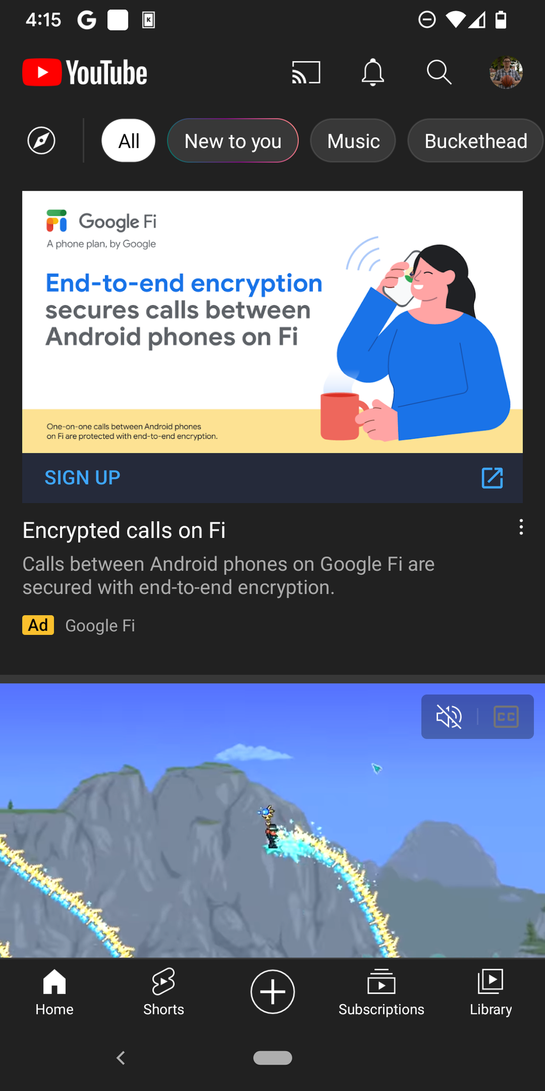

For an app under the wing of Google you’d think they’d adhere slightly more to the Material Design guidelines and aesthetic but I will be pointing out several UI/UX flaws or improvements to be had.

To ensure the Youtube layout is adaptive to user input and uses grids with padding consistently, the app should still scale with responsiveness given device dp.

At the moment, column, gutter, and margins are used innappropriately; adequate margins should be placed to each side, animated previews of the videos should be smaller and Title/uploader should be placed side by side each preview rather than below. This allows much more real estate to be used without distracting the user with a video preview that takes nearly the entire app screen, allowing more content to be displayed faster.

The following shows an image of adequate Material margins:

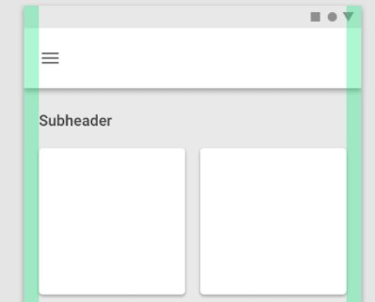

Spacing between columns on the grid should allow the eye to easily flow to similar content (further video previews). In alignment with Android style guide, Spacing between columns on the grid should be dependent on how closely the entities are related.

Surfaces can move independently of each other’s movement in Material, thus Youtube’s top action bar disappearing upon scrolling down is not necessarily the wrong choice; however, an improvement can be made by further optimizing the bottom action bar to have a navigation icon. Either 1) Pressing this navigation icon in the top action bar, or 2) swiping to the right from the left side of screen will open a sidebar that helps organize hidden menu options, allowing these options to be available to the user at any time rather than when they just scroll down the video list. In addition, I believe having too many buttons across the app bar can make it hard to press a specific one at times. Thus I opt to move all options to a navigation bar on the top of the app. It will be a diseappear on scroll navigation bar with the following components: “Sidebar Menu showing all options on side swipe button”, “Bookmark button”, notifications button, and subscriptions/history button.

I will keep only the 3 core options on the action bar: Home/Trending, Upload video/create a short button, and Search button. The “Shorts” button will be moved to the side navigation bar, along with “Cast to” button, “Subscriptions” , “Notifications”, and “History”. To further reduce visual clutter, I will compartmentalize the “Search” component into the action bar header, and move the action bar from bottom to the top. This gives more screen real estate for a cleaner UI/UX experience. When scrolling down, the search component and action bar remains but top , retrievable by either scrolling up again or side swiping the navigation bar out for all the options.

Specifically, the tiny overflow menu next to each video preview can be difficult to press at times. I opt to replace it with a tap and hold solution, bringing up a Dialog and darkening the background video overlay with a scrim, providing following options: “Add to playlist, Share, Open in browser, show channel details, cast to screen” and for Youtube pro “Play in popup” and “Play in background” as well. This tap and hold solution is more intuitive to me and reduces visual clutter, and also adheres to Google’s android style guideline. The following is a rough sketch of my visual redesign for the Youtube app:

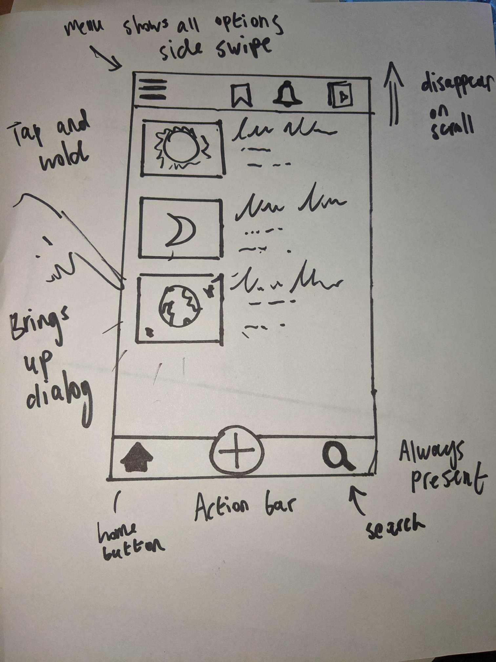

Works Cited

Google. (n.d.). *Guidelines*. Material design. Retrieved November 25, 2021, from https://material.io/design/guidelines-overview.

Google. (n.d.). *Components*. Material design. Retrieved November 25, 2021, from https://material.io/components.