1. Send message to whatsapp Number by using pyAUTOGUI.

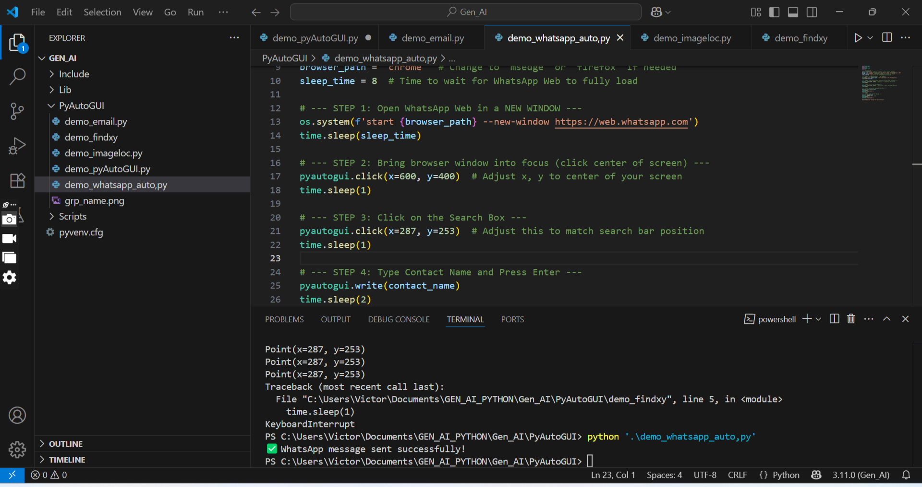

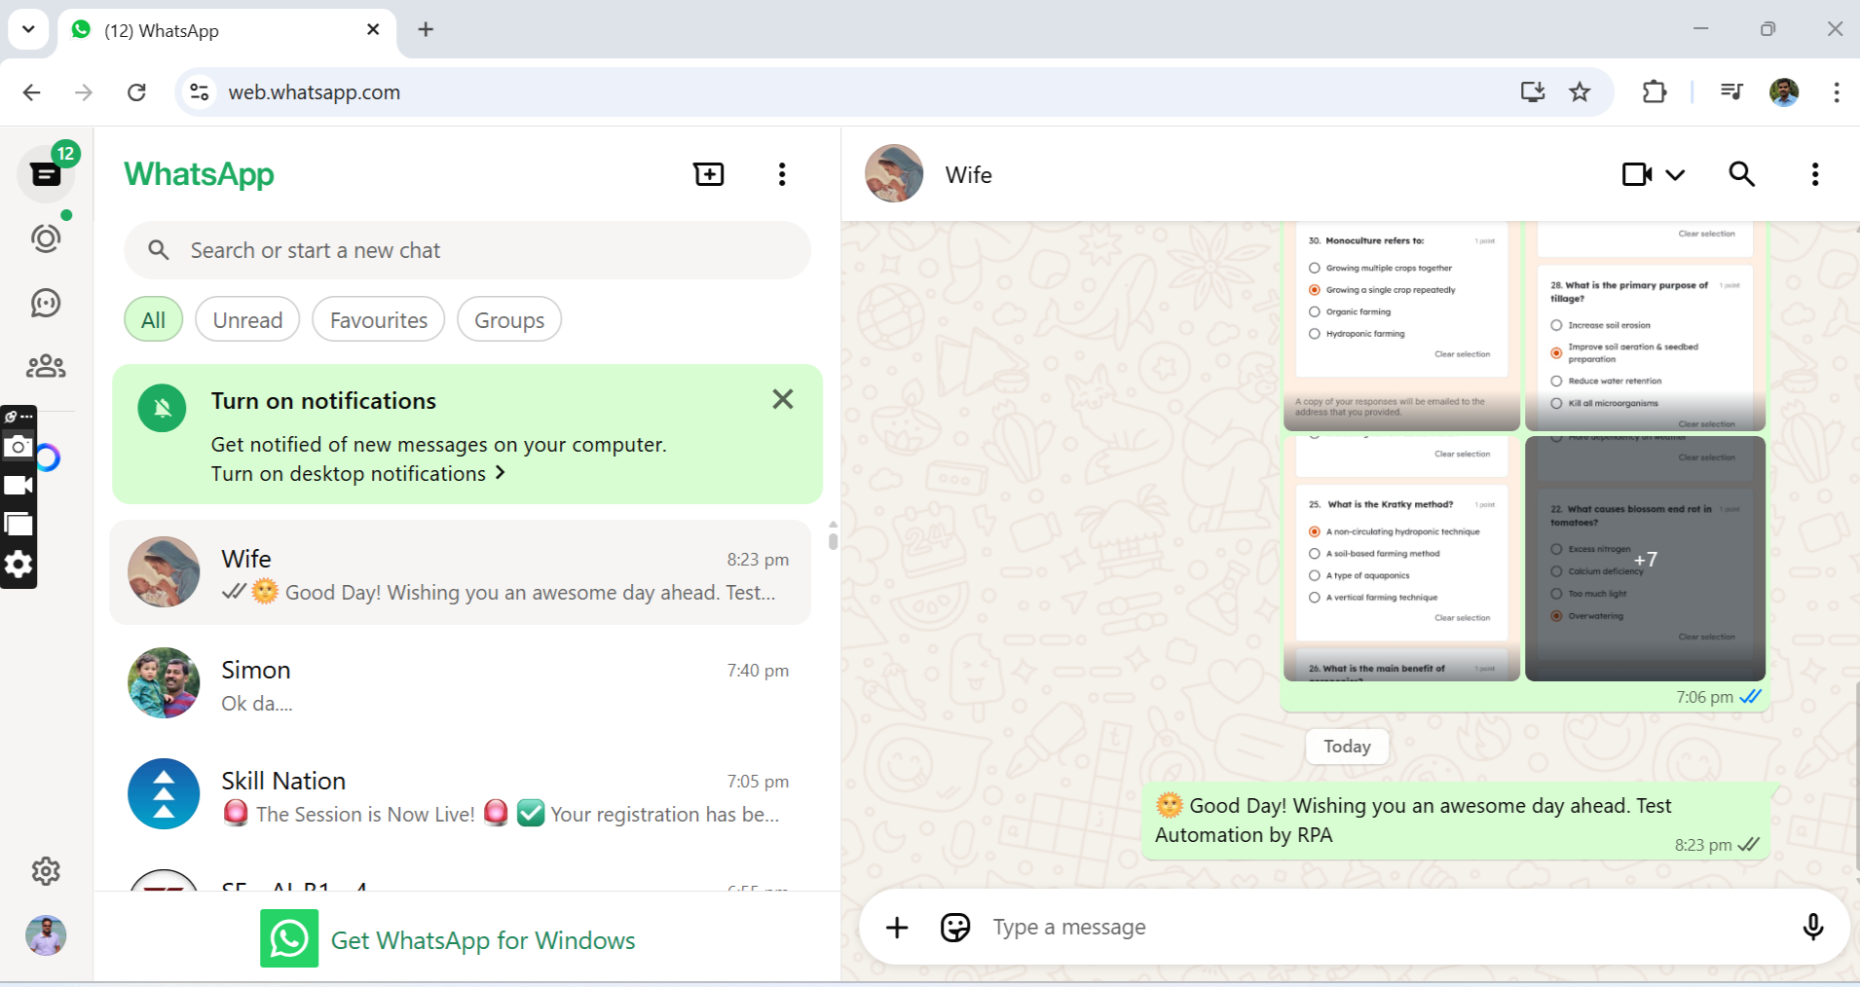

1. Weather Scrapper by using PlayWright.

