**How to login with Microsoft Account**

1. Open [www.cloudhero.me](http://www.cloudhero.me)
2. Click Login on right top.

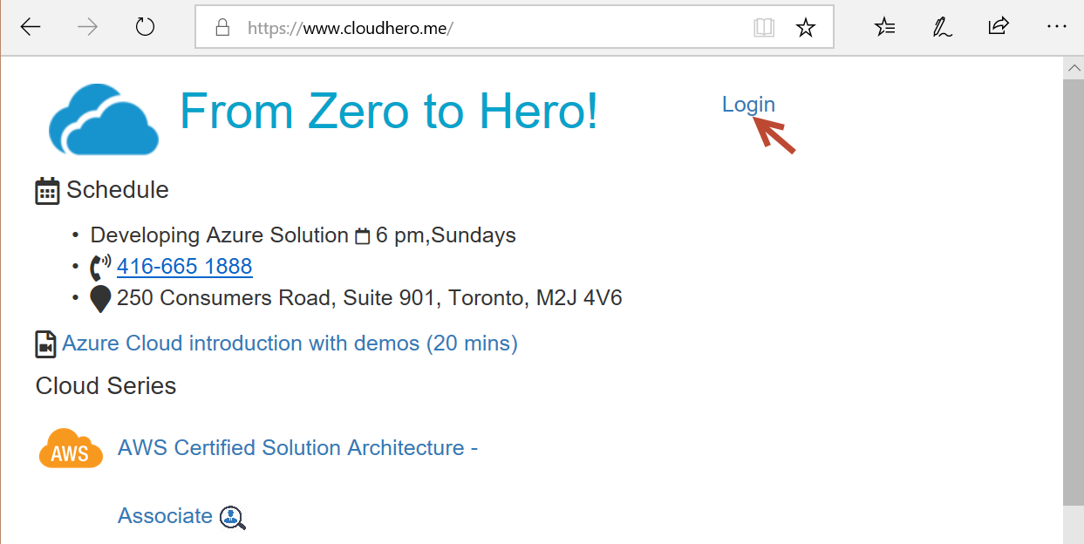

1. Login with your Microsoft Account if you have one. If not, click Create one. The follow the screen to create an account.

**You should use the same email that you have provide to the school .**

