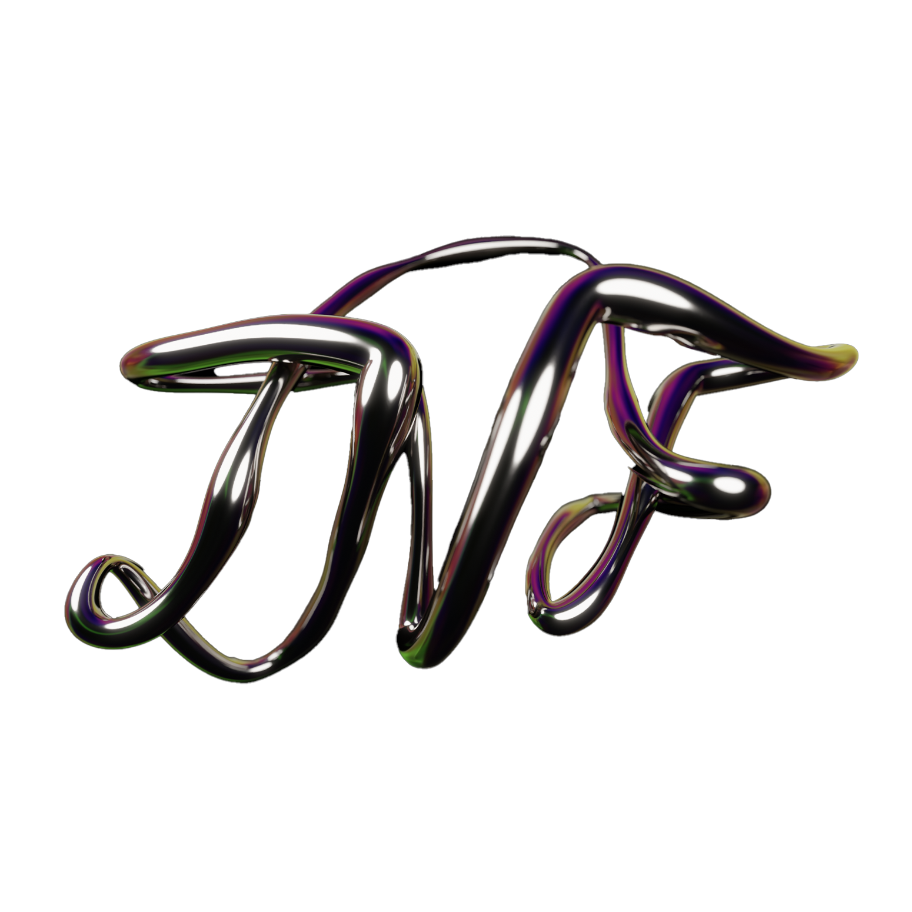

VIDEO CONTENT USAGE RIGHTS AGREEMENT

1. PARTIES
This Video Content Usage Rights Agreement (the “Agreement”) is entered into by and between:
Licensor: The New Face
Address: 23 Rue des Petits Hotels, 75010, Paris, France
and
Licensee (Client): {{CLIENT_NAME}}
Contact Person: {{CLIENT_CONTACT_NAME}}
Email: {{CLIENT_EMAIL}}
Address: {{CLIENT_ADDRESS}}
The Licensor and Licensee may each be referred to as a “Party” and collectively as the “Parties.”

2. CONTENT DESCRIPTION
Project Name: {{PROJECT_NAME}}
Content Description:
{{CONTENT_DESCRIPTION}}
Deliverables Reference (optional asset list / file references):

3. AGREEMENT DATES
Agreement Date: {{AGREEMENT_DATE}}
Rights Valid From: {{VALID_FROM}}
Rights Valid Until: {{VALID_UNTIL}} (or “Perpetual” if not specified)

4. USAGE RIGHTS
Usage rights are granted strictly as indicated below. Any usage category not explicitly granted is not permitted.
Usage Category | Granted | Type | Territories | Period
Digital (Web, Social Media, Email) | {{DIGITAL_GRANTED}} | {{DIGITAL_TYPE}} | {{DIGITAL_TERRITORIES}} | {{DIGITAL_PERIOD}}
Paid Media (Advertising, Sponsored) | {{PAID_MEDIA_GRANTED}} | {{PAID_MEDIA_TYPE}} | {{PAID_MEDIA_TERRITORIES}} | {{PAID_MEDIA_PERIOD}}
POS / Retail (In-store, Displays) | {{POS_GRANTED}} | {{POS_TYPE}} | {{POS_TERRITORIES}} | {{POS_PERIOD}}
Print (Magazines, Brochures) | {{PRINT_GRANTED}} | {{PRINT_TYPE}} | {{PRINT_TERRITORIES}} | {{PRINT_PERIOD}}
OOH (Billboards, Street Furniture) | {{OOH_GRANTED}} | {{OOH_TYPE}} | {{OOH_TERRITORIES}} | {{OOH_PERIOD}}
TV (Broadcast, Streaming) | {{TV_GRANTED}} | {{TV_TYPE}} | {{TV_TERRITORIES}} | {{TV_PERIOD}}
For reference:
- Granted = “☑ Yes” or “☐ No”
- Type = “Paid”, “Organic”, or “N/A” (as applicable)
- Territories = e.g., “Worldwide” or “Europe, North America”
- Period = date range or duration (e.g., “Jan 2026 – Dec 2026” or “12 months”)

5. TERMS AND CONDITIONS

5.1 Grant of Rights (Non-Exclusive License)
Subject to the terms of this Agreement and the Usage Rights table in Section 4, the Licensor grants the Licensee a non-exclusive, non-transferable license to use the video content and associated deliverables described in Section 2 (the “Content”) solely for the permitted usage categories, territories, and periods indicated in Section 4.
No rights are granted by implication. All rights not expressly granted to the Licensee are reserved by the Licensor.

5.2 Restrictions
Unless expressly agreed in writing by the Licensor, the Licensee shall not:
- Sublicense, assign, or otherwise transfer the rights granted under this Agreement to any third party.
- Use the Content in any unlawful, misleading, defamatory, or infringing manner.
- Use the Content outside the granted category, territory, or period specified in Section 4.

5.3 Credit / Attribution
Where reasonably practicable (e.g., online captions, video descriptions, campaign credits, press releases, or case studies), the Licensee shall include credit substantially as follows:
“Content produced by The New Face.”
If attribution is not feasible due to format constraints, the Parties may agree in writing to waive attribution for that placement.

5.4 Modifications and Formatting
The Licensee may perform technical formatting required for distribution, including cropping, resizing, compression, aspect ratio adjustments, captioning, and minor length edits (e.g., cut-downs), provided that such changes do not substantively alter the Content, misrepresent the Licensor’s work, or create a misleading context.
The Licensee shall not materially modify the Content (including altering key visuals, compositing new scenes, changing narrative meaning, removing or replacing branding elements, or using AI-based transformations) without the Licensor’s prior written consent.

5.5 Term and Expiry
This Agreement is effective from {{VALID_FROM}} and remains in effect until {{VALID_UNTIL}}, unless terminated earlier in accordance with Section 5.6.
Upon expiry (or earlier termination), the Licensee must cease new use of the Content in any category whose Period has ended and must remove/withdraw placements where reasonably possible, except for:
- archival copies retained for legal/compliance purposes; and
- non-cancellable media buys already placed in good faith prior to expiry (limited to the shortest practicable run), unless the Licensee is in breach of this Agreement.

5.6 Termination
Either Party may terminate this Agreement:
- For material breach by the other Party, if such breach is not cured within ten (10) business days of written notice; or
- Immediately if the other Party becomes insolvent, enters liquidation, or is unable to pay its debts as they fall due.
Upon termination, all licenses granted under this Agreement cease, and the Licensee must promptly discontinue use of the Content, subject to reasonable takedown periods and any exceptions expressly stated in Section 5.5.

5.7 Governing Law
This Agreement shall be governed by and construed in accordance with the laws of {{GOVERNING_LAW}}, without regard to conflict-of-law principles. The Parties agree to the exclusive jurisdiction of the competent courts as designated under {{GOVERNING_LAW}}, unless otherwise required by mandatory law.

5.8 Entire Agreement
This Agreement (including the Usage Rights table) constitutes the entire agreement between the Parties regarding the licensing of the Content and supersedes all prior discussions or understandings relating to the same subject matter.

5.9 Counterparts and Electronic Signature
This Agreement may be executed in counterparts and signed electronically. Electronic signatures (including via DocuSign or equivalent) shall be deemed original and binding.

6. SIGNATURES
IN WITNESS WHEREOF, the Parties have executed this Agreement as of the Agreement Date.
LICENSOR (The New Face) | LICENSEE (Client)
Signature: {{TNF_SIGNATURE}} | Signature: {{CLIENT_SIGNATURE}}
Printed Name: Victor Haymann | Printed Name: {{CLIENT_SIGNER_NAME}}
Title: COO | Title: {{CLIENT_SIGNER_TITLE}}
Date: {{TNF_SIGN_DATE}} | Date: {{CLIENT_SIGN_DATE}}

CONFIDENTIAL — Video Content Usage Rights Agreement — Page ___ of ___

