Housekeeping 1
Fixed Values 1
Distributions 2
1. Simulation of the Eye Position 3
Plot the scan pattern 3
2. Monte Carlo Simulations 5
3. Wind Alert Problem 7
4. Wind Alert Problem with Increased Salience 10
4. Wind Alert Problem with Increased Salience 12
% AUTHORS: Sarah Leary, Victoria Hurd, Abby Rindfuss, Lena Obaid
% DATE CREATED: 9/10/2024
% DATE LAST MODIFIED: 9/12/2024
% PROJECT: NSEEV Project
% CLASS: Human Operation of Aerospace Vehicles

Housekeeping
clear;clc;close all

Fixed Values
% 4 AOIs
% Each AOI has a salience, expectancy, and value
% A (primary display)
S_A = 2;
Ex_A = 4;
V_A = 2;
% B (monitor for water levels)
S_B = 3;
Ex_B = 2;
V_B = 1;
% C (communications display)
S_C = 1;
Ex_C = 3;
V_C = 1;
% D (emergency notification)
S_D = 2;
Ex_D = 1;
V_D = 5;
% All the combinations of transition effort:
Ef_AB = 1;
Ef_AC = 1;
Ef_AD = 5;
Ef_BC = 3;
Ef_BD = 6;
Ef_CD = 4.5;
% Also, we are assuming that effort to transition is symmetric
% meaning Ef_AB = Ef_BA, etc

Distributions
fixation --> saccadic eye movement --> fixation --> and so on
n_fix = 10; % number of fixations
% Each fixation time modeled as a random variable with lognormal
% distribution
fix_dist = makedist('Lognormal','mu', 0, 'sigma',0.5);
% The duration of each saccadic eye movement can be assumed to be normally
% distributed
sac_dist = makedist('Normal','mu',0.03,'sigma',0.003);
fix_time = random(fix_dist,n_fix,1);
% now visualizing the lognormal distribution:
fig = figure(1);
subplot(1,2,1); hold on; grid minor;
histfit(fix_time,5,'lognormal')
set(gca,'FontSize',20);
title('Fixation Time Lognormal Dist','Interpreter','latex','FontSize',25)
sac_time = random(sac_dist,n_fix,1);
% now visualizing the lognormal distribution:
subplot(1,2,2); hold on; grid minor;
histfit(sac_time,5,'normal')
set(gca,'FontSize',20);
title('Saccade Time Normal Dist','Interpreter','latex','FontSize',25)
han=axes(fig,'visible','off');
han.Title.Visible='on';
han.XLabel.Visible='on';
han.YLabel.Visible='on';
ylabel(han,'Frequency','Interpreter','latex','FontSize',25);
xlabel(han,'Time, s','Interpreter','latex','FontSize',25)
sgtitle('Distributions for 10 Random Numbers','Interpreter','latex','FontSize',30)
set(gcf,'Position',get(0,'Screensize'));
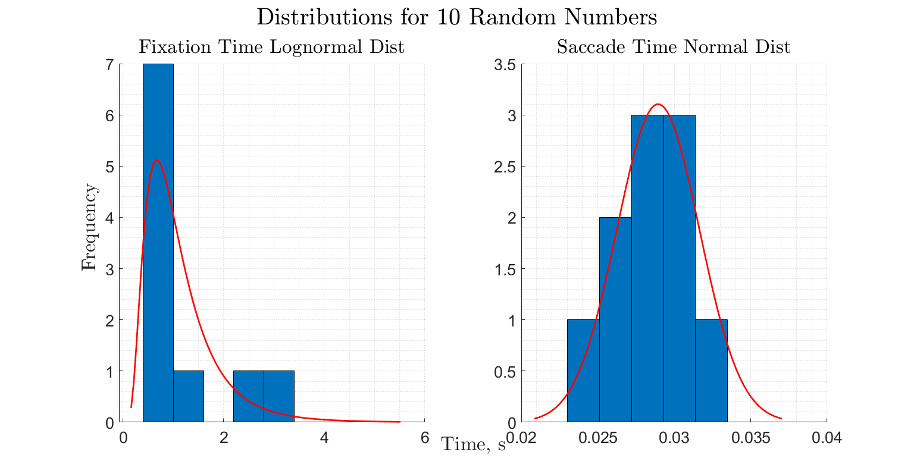

1. Simulation of the Eye Position
% Initialize time vector and eye position array
time_points = zeros(2 * n_fix-1, 1);
eye_position = zeros(2 * n_fix-1, 1);
% Start at display A
current_time = 0;
current_display=1;
for i = 1:n_fix
% Fixation on display
[~,current_display] = NextDisplay(current_display,false,false);
eye_position(2*i - 1) = current_display;
time_points(2*i - 1) = current_time;
current_time = current_time + fix_time(i);
% Saccade (if not the last fixation)
if i < n_fix+1
eye_position(2*i) = NaN; % No display viewed during saccades
time_points(2*i) = current_time;
current_time = current_time + sac_time(i);
end
end

Plot the scan pattern
figure(2)
hold on
% Plot the fixations (solid lines) using the stairs function
stairs(time_points, eye_position, 'LineWidth', 3, 'Color', 'b');
% Plot the saccades (red dashed lines)
plot([0 time_points(1)],[1 eye_position(1)],'r--', 'LineWidth', 3);
for i = 1:2:(2*n_fix-2) % Iterate over every other element for 9 saccades
% Plot the saccade as a red dashed line
plot([time_points(i+1), time_points(i+2)], [eye_position(i), eye_position(i+2)], 'r--', 'LineWidth', 3);
end
% Labels and formatting
yticks([1 2 3 4]);
yticklabels({'A', 'B', 'C', 'D'});
ylim([1 4]);
set(gca,'FontSize',20);
xlabel('Time, s','Interpreter','latex','FontSize',25);
ylabel('Display','Interpreter','latex','FontSize',25);
title('Eye Position Over Time (10 Fixations)','Interpreter','latex','FontSize',30);
grid on;
legend({'Fixations', 'Saccades'}, 'Location', 'best','Interpreter','latex','FontSize',20);
set(gcf,'Position',get(0,'Screensize'));
hold off;
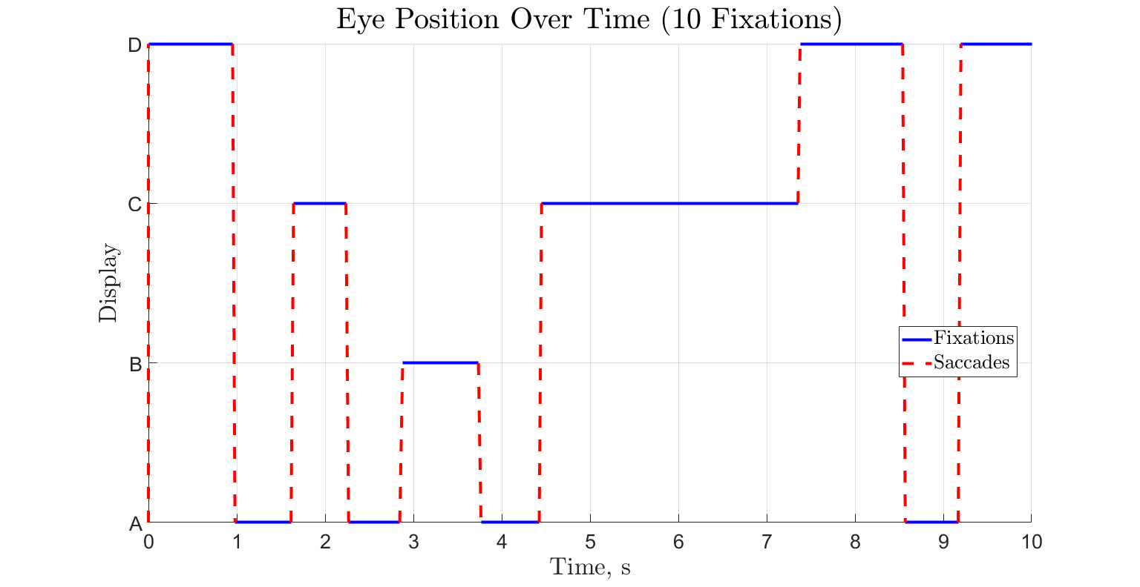

2. Monte Carlo Simulations
number of simulations
n_sim = 1000;
% number of fixations (updating)
n_fix = 100;
% initializing
current_display = 1;
current_time = 0;
% count of time spent fixating on each display
time_count_fix = zeros(1,4);
time_count_sim = zeros(n_sim,4);
for j = 1:n_sim
for i = 1:n_fix
% Fixation on display
[~,current_display] = NextDisplay(current_display,false,false);
% fixation and saccade time
fix_time = random(fix_dist,1,1);
sac_time = random(sac_dist,1,1);
current_time = current_time + sac_time + fix_time;
time_count_fix(current_display) = time_count_fix(current_display)+fix_time;
end
% finding relative time on each display
time_count_sim(j,:) = time_count_fix./current_time;
% Note that these do not add up to 1 because we're dividing by the
% TOTAL time (i.e., including the saccade time)
% resetting
time_count_fix = zeros(1,4);
current_time = 0;
current_display = 1;
end
% plotting a histogram for each display
fig = figure(); hold on;
subplot(2,2,1); hold on; grid minor;
histogram(time_count_sim(:,1));
title('Display A','Interpreter','latex')
set(gca,'FontSize',20);
hold off;
subplot(2,2,2); hold on; grid minor;
histogram(time_count_sim(:,2));
title('Display B','Interpreter','latex')
set(gca,'FontSize',20);
hold off;
subplot(2,2,3); hold on; grid minor;
histogram(time_count_sim(:,3));
title('Display C','Interpreter','latex')
set(gca,'FontSize',20);
hold off;
subplot(2,2,4); hold on; grid minor;
histogram(time_count_sim(:,4));
title('Display D','Interpreter','latex')
set(gca,'FontSize',20);
hold off;
han=axes(fig,'visible','off');
han.Title.Visible='on';
han.XLabel.Visible='on';
han.YLabel.Visible='on';
ylabel(han,'Frequency','Interpreter','latex','FontSize',25);
xlabel(han,'Relative Time','Interpreter','latex','FontSize',25)
sgtitle('Relative Time Spent on Each Display','Interpreter','latex','FontSize',25);
set(gcf,'Position',get(0,'Screensize'));
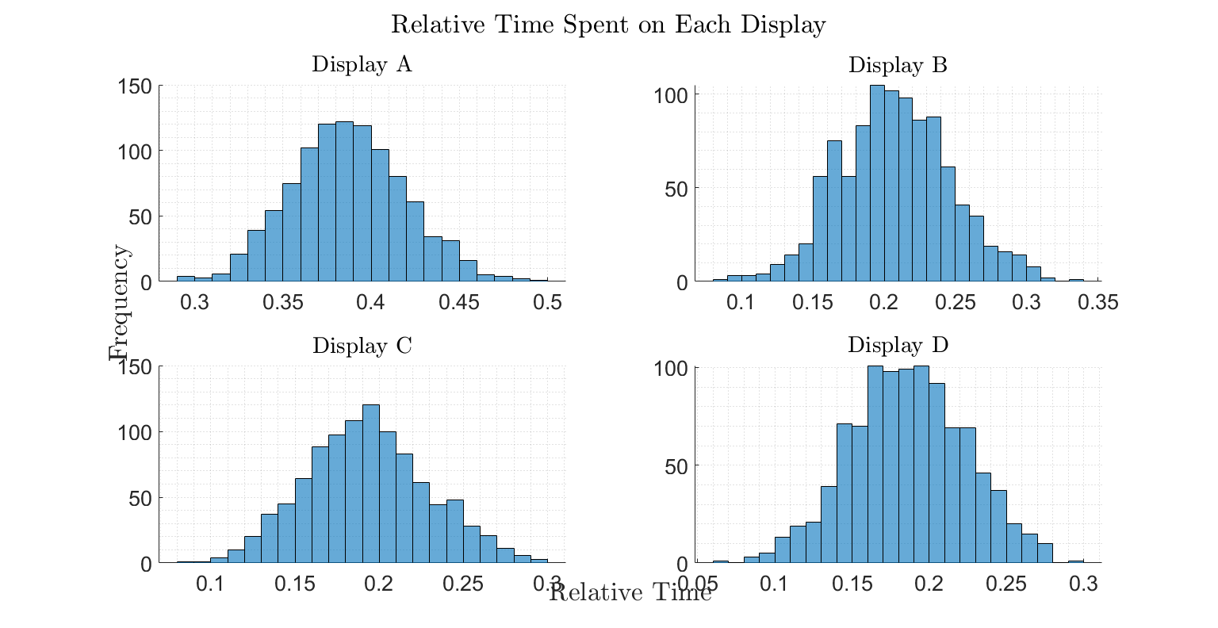

3. Wind Alert Problem
% number of simulations
n_sim = 1000;
% initializing
current_display = 1;
current_time = 0;
wind_alert_detected = 0;
% count of time spent fixating on each display
time_count_sim = zeros(n_sim,1);
for j = 1:n_sim
while wind_alert_detected == 0 % not terminating until wind alert has been detected
% fixation and saccade time
fix_time = random(fix_dist,1,1);
sac_time = random(sac_dist,1,1);
% keeping track of all time
current_time = current_time + sac_time + fix_time;
% wind alert occurs at current_time = 10
if current_time >= 10
% Fixation on display
[~,current_display] = NextDisplay(current_display,false,false);
if current_display == 4
% essentially, flipping a weighted coin where the prob
% of "success" (detecting the wind alert)=0.8
wind_alert_detected = binornd(1,0.8);
end
end
end
% time at which wind alert was detected is randomly chosen from a
% uniform distribution from 0 to the fixation time
if current_time-fix_time < 10 % if the wind alert went off while on display D
time_detected = unifrnd(0,current_time-10);
fix_time = 0;
else % if wind alert went off while on any other display
time_detected = unifrnd(0,fix_time);
end
% we already added the fixation time, so we have to subtract out the
% fixation time and add the time within the fixation that the wind
% alert was detected
current_time = current_time - fix_time + time_detected;
% finding time it takes to detect the wind alarm
time_count_sim(j) = current_time-10;
if time_count_sim(j) < 0
disp(j)
end
% resetting
current_time = 0;
current_display = 1;
wind_alert_detected = 0;
end
% calculating the 50th (median), 5th, and 95th percentiles
ques_3_50prctile = prctile(time_count_sim,50);
ques_3_5prctile = prctile(time_count_sim,5);
ques_3_95prctile = prctile(time_count_sim,95);
% plotting a histogram for each display
figure(); hold on; grid minor;
subtitle('Question 3','FontSize',15,'Interpreter','latex');
xline(ques_3_5prctile,'--','LineWidth',3,'Color','r')
xline(ques_3_50prctile,'--','LineWidth',3,'Color','g')
xline(ques_3_95prctile,'--','LineWidth',3,'Color','m')
histogram(time_count_sim,NumBins=30);
legend(strcat('5th \%-ile= ',num2str(round(ques_3_5prctile,2))),...
strcat('Median=',num2str(round(ques_3_50prctile,2))),...
strcat('95th \%-ile=',num2str(round(ques_3_95prctile,2))),'Data',...
'Interpreter','latex');
set(gca,'FontSize',20);
title('Time to Detect Wind Alert','Interpreter','latex','FontSize',25)
xlabel('Time, s','Interpreter','latex','FontSize',25);
ylabel('Frequency','Interpreter','latex','FontSize',25)
set(gcf,'Position',get(0,'Screensize'));
hold off;
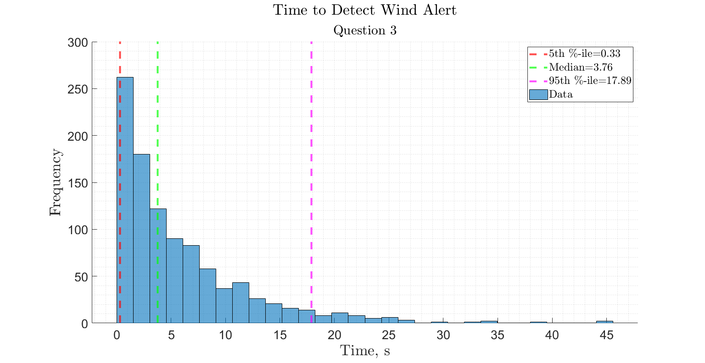

4. Wind Alert Problem with Increased Salience
% number of simulations
n_sim = 1000;
% initializing
current_display = 1;
current_time = 0;
wind_alert_detected = 0;
% count of time spent fixating on each display
time_count_sim = zeros(n_sim,1);
for j = 1:n_sim
while wind_alert_detected == 0 % not terminating until wind alert has been detected
% fixation and saccade time
fix_time = random(fix_dist,1,1);
sac_time = random(sac_dist,1,1);
% keeping track of all time
current_time = current_time + sac_time + fix_time;
% wind alert occurs at current_time = 10
if current_time >= 10
% Fixation on display
[~,current_display] = NextDisplay(current_display,true,false);
if current_display == 4
% essentially, flipping a weighted coin where the prob
% of "success" (detecting the wind alert)=0.8
wind_alert_detected = binornd(1,0.8);
end
end
end
% time at which wind alert was detected is randomly chosen from a
% uniform distribution from 0 to the fixation time
if current_time-fix_time < 10 % if the wind alert went off while on display D
time_detected = unifrnd(0,current_time-10);
fix_time = 0;
else % if wind alert went off while on any other display
time_detected = unifrnd(0,fix_time);
end
% we already added the fixation time, so we have to subtract out the
% fixation time and add the time within the fixation that the wind
% alert was detected
current_time = current_time - fix_time + time_detected;
% finding time it takes to detect the wind alarm
time_count_sim(j) = current_time-10;
if time_count_sim(j) < 0
disp(j)
end
% resetting
current_time = 0;
current_display = 1;
wind_alert_detected = 0;
end
% calculating the 50th (median), 5th, and 95th percentiles
ques_4_50prctile = prctile(time_count_sim,50);
ques_4_5prctile = prctile(time_count_sim,5);
ques_4_95prctile = prctile(time_count_sim,95);
% plotting a histogram for each display
figure(); hold on; grid minor;
subtitle('Increase Salience','FontSize',15,'Interpreter','latex');
xline(ques_4_5prctile,'--','LineWidth',3,'Color','r')
xline(ques_4_50prctile,'--','LineWidth',3,'Color','g')
xline(ques_4_95prctile,'--','LineWidth',3,'Color','m')
histogram(time_count_sim,NumBins=30);
legend(strcat('5th \%-ile= ',num2str(round(ques_4_5prctile,2))),...
strcat('Median=',num2str(round(ques_4_50prctile,2))),...
strcat('95th \%-ile=',num2str(round(ques_4_95prctile,2))),'Data',...
'Interpreter','latex');
set(gca,'FontSize',20);
title('Time to Detect Wind Alert','Interpreter','latex','FontSize',25)
xlabel('Time, s','Interpreter','latex','FontSize',25);
ylabel('Frequency','Interpreter','latex','FontSize',25)
set(gcf,'Position',get(0,'Screensize'));
hold off;
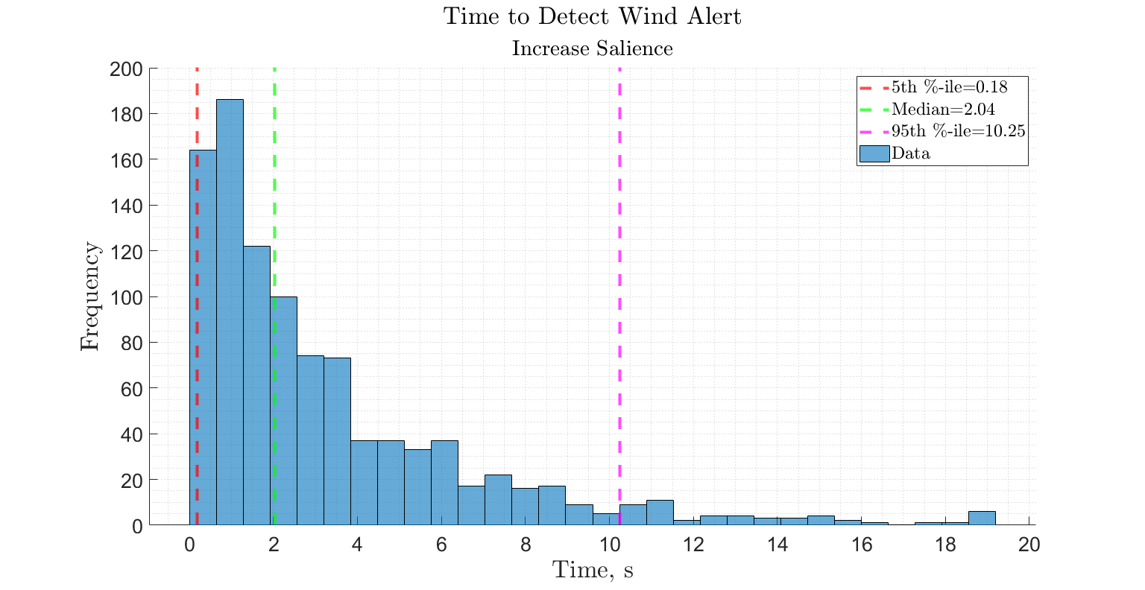

4. Wind Alert Problem with Increased Salience
% number of simulations
n_sim = 1000;
% initializing
current_display = 1;
current_time = 0;
wind_alert_detected = 0;
% count of time spent fixating on each display
time_count_sim = zeros(n_sim,1);
for j = 1:n_sim
while wind_alert_detected == 0 % not terminating until wind alert has been detected
% fixation and saccade time
fix_time = random(fix_dist,1,1);
sac_time = random(sac_dist,1,1);
% keeping track of all time
current_time = current_time + sac_time + fix_time;
% wind alert occurs at current_time = 10
if current_time >= 10
% Fixation on display
[~,current_display] = NextDisplay(current_display,false,true);
if current_display == 4
% essentially, flipping a weighted coin where the prob
% of "success" (detecting the wind alert)=0.8
wind_alert_detected = binornd(1,0.8);
end
end
end
% time at which wind alert was detected is randomly chosen from a
% uniform distribution from 0 to the fixation time
if current_time-fix_time < 10 % if the wind alert went off while on display D
time_detected = unifrnd(0,current_time-10);
fix_time = 0;
else % if wind alert went off while on any other display
time_detected = unifrnd(0,fix_time);
end
% we already added the fixation time, so we have to subtract out the
% fixation time and add the time within the fixation that the wind
% alert was detected
current_time = current_time - fix_time + time_detected;
% finding time it takes to detect the wind alarm
time_count_sim(j) = current_time-10;
if time_count_sim(j) < 0
disp(j)
end
% resetting
current_time = 0;
current_display = 1;
wind_alert_detected = 0;
end
% calculating the 50th (median), 5th, and 95th percentiles
ques_5_50prctile = prctile(time_count_sim,50);
ques_5_5prctile = prctile(time_count_sim,5);
ques_5_95prctile = prctile(time_count_sim,95);
% plotting a histogram for each display
figure(); hold on; grid minor;
subtitle('Decrease Effort','FontSize',15,'Interpreter','latex');
xline(ques_5_5prctile,'--','LineWidth',3,'Color','r')
xline(ques_5_50prctile,'--','LineWidth',3,'Color','g')
xline(ques_5_95prctile,'--','LineWidth',3,'Color','m')
histogram(time_count_sim,NumBins=30);
legend(strcat('5th \%-ile= ',num2str(round(ques_5_5prctile,2))),...
strcat('Median=',num2str(round(ques_5_50prctile,2))),...
strcat('95th \%-ile=',num2str(round(ques_5_95prctile,2))),'Data',...
'Interpreter','latex');
set(gca,'FontSize',20);
title('Time to Detect Wind Alert','Interpreter','latex','FontSize',25)
xlabel('Time, s','Interpreter','latex','FontSize',25);
ylabel('Frequency','Interpreter','latex','FontSize',25)
set(gcf,'Position',get(0,'Screensize'));
hold off;
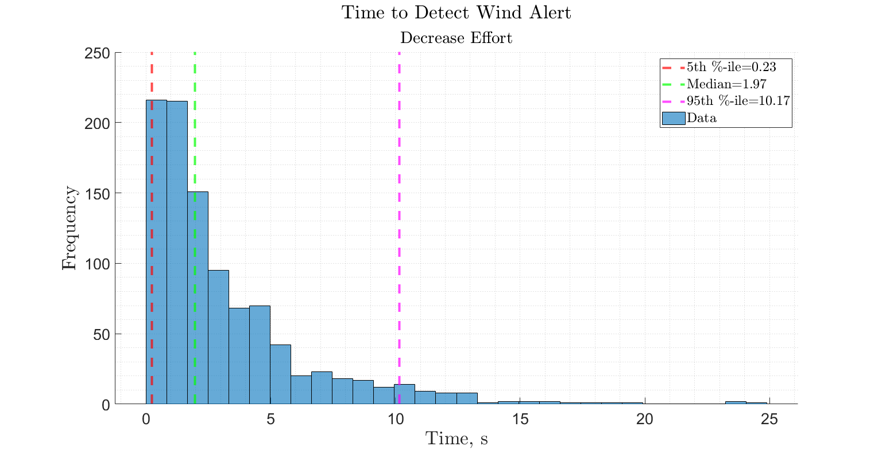
Published with MATLAB® R2023b

