'FTES-Full_Test_1sec_system_processed.csv' data explanation

The 'FTES-Full_Test_1sec_system_processed.csv' data file contains data for water flow rate, water temperature, water pressure, and water electrical conductivity measured at each minute of DEMO-FTES test 1 between December 10th, 2024, to March 24th, 2025.
- There were two main phases of the test. Hot water was injected through TC and produced out of TN and TL from approximately 12/13/2024, 20:00:00 to 02/23/2025, 11:00:00. Ambient temperature water was injected through TN and TS and produced out of TC from approximately 03/12/2025, 13:00:00 to 03/24/2025, 22:00:00. Before and in-between these periods were periods of testing and maintenance.
- Data is measured at the collar, interval, and/or bottom of each well in the test bed (Fig 1). Some data (i.e. flow) is measured at all three points for each well. Other data (i.e. temperature) is only measured at a subset of points for each well (interval and bottom).
- In 'FTES-Full_Test_1sec_system_processed.csv', most data columns are labelled to be self-descriptive. For example, ‘TX interval flow’ is the production flow rate measured in the TX interval). ‘TX interval pressure’ is the water pressure in TX interval.
- ‘Net Flow’ is the flow rate in L/min of water being injected into the system.
- ‘TEC’ stands for thermocouple.
- 'TX injecting triplex interval (True/False)' denotes whether water is being injected into TX interval using the triplex pump. 'TX producing interval (True/False)' denotes whether TX interval is open for water production. 'TX producing bottom (True/False)' denotes whether TX bottom is open for water production.
- If 'TX injecting triplex interval (True/False)' = True (this will be TC during hot water injection and TN during ambient water injection): ‘Net Flow’ is the injection flow rate through that interval, 'TX interval pressure’ is the injection pressure, and 'TX-TEC-INT-U' and 'TX-TEC-INT-L' is the injection temperature.
- Pressure is in psi. Flow rate is in L/min. Temperature is in C. Depth is in Feet.
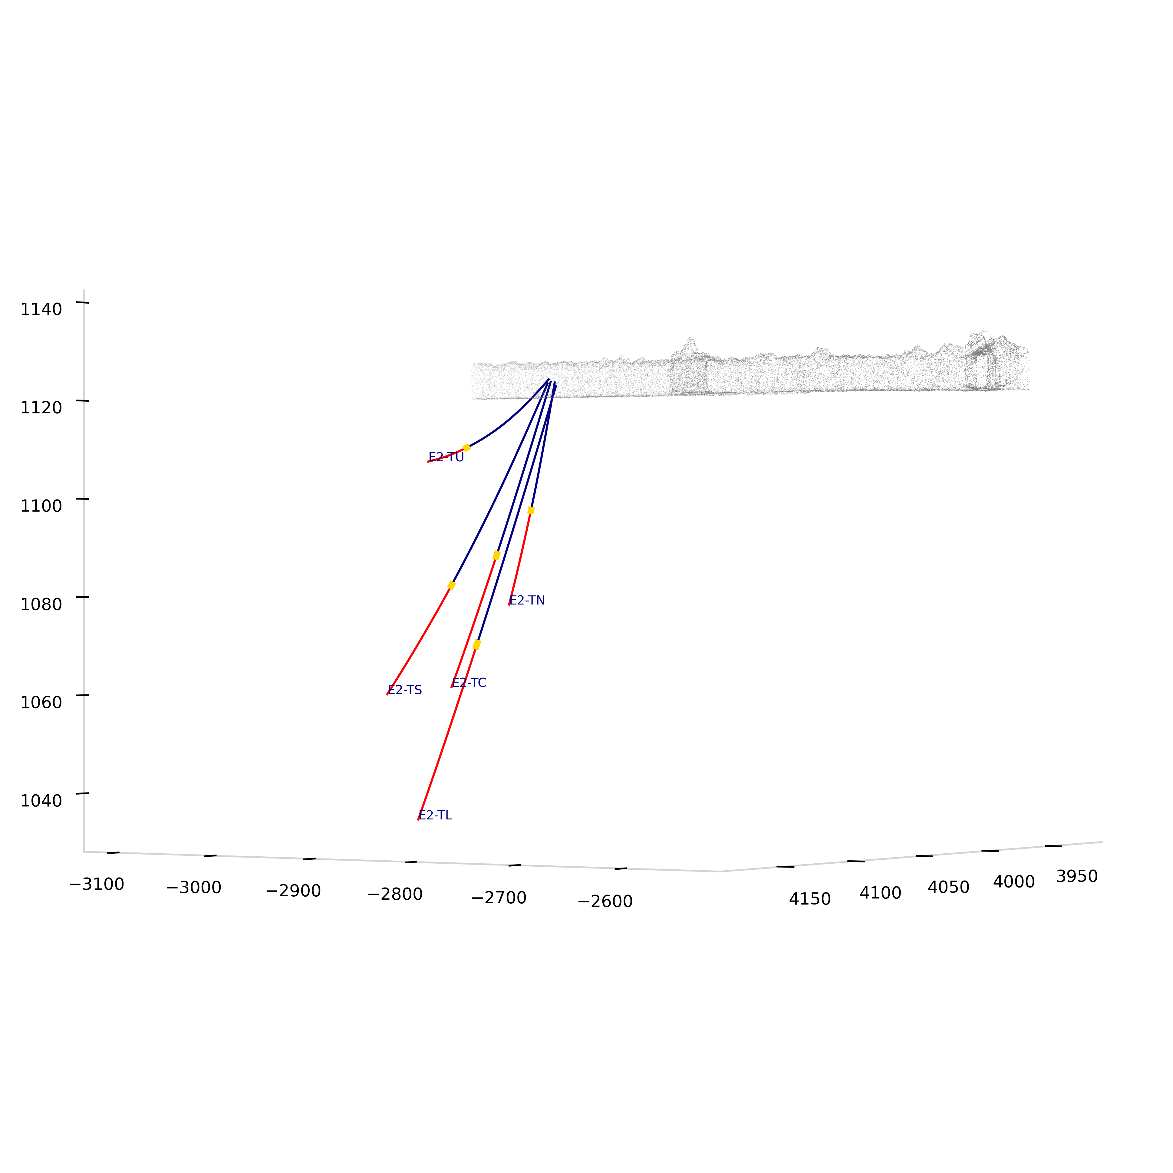
Figure 1. Test bed showing the different sections of each well. Data measured at the collar reflects the region from the collar (at the drift) to the packer above the interval (blue zone). Data measured at the interval reflects the ~26-inch interval between the upper and lower packers (yellow zone). Data measured at the bottom reflects the region from lower packer to the bottom of the borehole (red zone).

Column description
Column Name | Description
'Time', | Date
'Triplex On/Off', | Triplex water pump on or off
'Net Flow', | Injection water flow rate from Triplex pump
'TL Interval Flow', | Production water flow rate TL interval
'TL Bottom Flow', | Production water flow rate TL bottom
'TL Collar Flow', | Production water flow rate TL collar
'TL Interval EC', | Water EC TL interval
'TL Bottom EC', | Water EC TL bottom
'TL Interval Pressure', | Water pressure TL interval
'TL Bottom Pressure', | Water pressure TL bottom
'TL Packer Pressure', | Packer pressure TL
'TL-TEC-INT-U', | Temperature TL interval upper
'TL-TEC-INT-L', | Temperature TL interval lower
'TL-TEC-BOT-U', | Temperature TL bottom upper
'TL-TEC-BOT-L', | Temperature TL bottom lower
'TN Interval Flow', | Production water flow rate TN interval
'TN Bottom Flow', | Production water flow rate TN bottom
'TN Collar Flow', | Production water flow rate TN collar
'TN Interval EC', | Water EC TN interval
'TN Bottom EC', | Water EC TN bottom
'TN Interval Pressure', | Water pressure TN interval
'TN Bottom Pressure', | Water pressure TN bottom
'TN Packer Pressure', | Packer pressure TN
'TN-TEC-INT-U', | Temperature TN interval upper
'TN-TEC-INT-L', | Temperature TN interval lower
'TN-TEC-BOT-U', | Temperature TN bottom upper
'TN-TEC-BOT-L', | Temperature TN bottom lower
'TC Interval Flow', | Production water flow rate TC interval
'TC Bottom Flow', | Production water flow rate TC bottom
'TC Collar Flow', | Production water flow rate TC collar
'TC Interval EC', | Water EC TC interval
'TC Bottom EC', | Water EC TC bottom
'TC Interval Pressure', | Water pressure TC interval
'TC Bottom Pressure', | Water pressure TC bottom
'TC Packer Pressure', | Packer pressure TC
'TC-TEC-INT-U', | Temperature TC interval upper
'TC-TEC-INT-L', | Temperature TC interval lower
'TC-TEC-BOT-U', | Temperature TC bottom upper
'TC-TEC-BOT-L', | Temperature TC bottom lower
'TU Interval Flow', | Production water flow rate TU interval
'TU Bottom Flow', | Production water flow rate TU bottom
'TU Collar Flow', | Production water flow rate TU collar
'TU Interval EC', | Water EC TU interval
'TU Bottom EC', | Water EC TU bottom
'TU Interval Pressure', | Water pressure TU interval
'TU Bottom Pressure', | Water pressure TU bottom
'TU Packer Pressure', | Packer pressure TU
'TU-TEC-INT-U', | Temperature TU interval upper
'TU-TEC-INT-L', | Temperature TU interval lower
'TU-TEC-BOT-U', | Temperature TU bottom upper
'TU-TEC-BOT-L', | Temperature TU bottom lower
'TS Interval Flow', | Production water flow rate TS interval
'TS Bottom Flow', | Production water flow rate TS bottom
'TS Collar Flow', | Production water flow rate TS collar
'TS Interval EC', | Water EC TS interval
'TS Bottom EC', | Water EC TS bottom
'TS Interval Pressure', | Water pressure TS interval
'TS Bottom Pressure', | Water pressure TS bottom
'TS Packer Pressure', | Packer pressure TS
'TS-TEC-INT-U', | Temperature TS interval upper
'TS-TEC-INT-L', | Temperature TS interval lower
'TS-TEC-BOT-U', | Temperature TS bottom upper
'TS-TEC-BOT-L', | Temperature TS bottom lower
'TL Packer Center Depth', | Depth along borehole TL packer
'TN Packer Center Depth', | Depth along borehole TN packer
'TC Packer Center Depth', | Depth along borehole TC packer
'TU Packer Center Depth', | Depth along borehole TU packer
'TS Packer Center Depth', | Depth along borehole TS packer
'TL injecting triplex interval (True/False)', | TL injecting water through interval w/ Triplex
'TL producing interval (True/False)', | TL interval open for production
'TL producing bottom (True/False)', | TL bottom open for production
'TN injecting triplex interval (True/False)', | TN injecting water through interval w/ Triplex
'TN producing interval (True/False)', | TN interval open for production
'TN producing bottom (True/False)', | TN bottom open for production
'TC injecting triplex interval (True/False)', | TC injecting water through interval w/ Triplex
'TC producing interval (True/False)', | TC interval open for production
'TC producing bottom (True/False)', | TC bottom open for production
'TU injecting triplex interval (True/False)', | TU injecting water through interval w/ Triplex
'TU producing interval (True/False)', | TU interval open for production
'TU producing bottom (True/False)', | TU bottom open for production
'TS injecting triplex interval (True/False)', | TS injecting water through interval w/ Triplex
'TS producing interval (True/False)', | TS interval open for production
'TS producing bottom (True/False)' | TS bottom open for production

