**Test scans at TUBRIC**

1. Please download the updated folder (TUBRIC_test) including the codes for three tasks (reward, finger and mid) at:
   * <https://github.com/DVS-Lab/TUBRIC_test>
2. Drag this folder to Desktop
3. Launch Matlab
4. Locate folder “TUBRIC_test” (should be on desktop), and right-click the folder. You should choose “Add to Path” and “Selected Folders and Subfolders”.

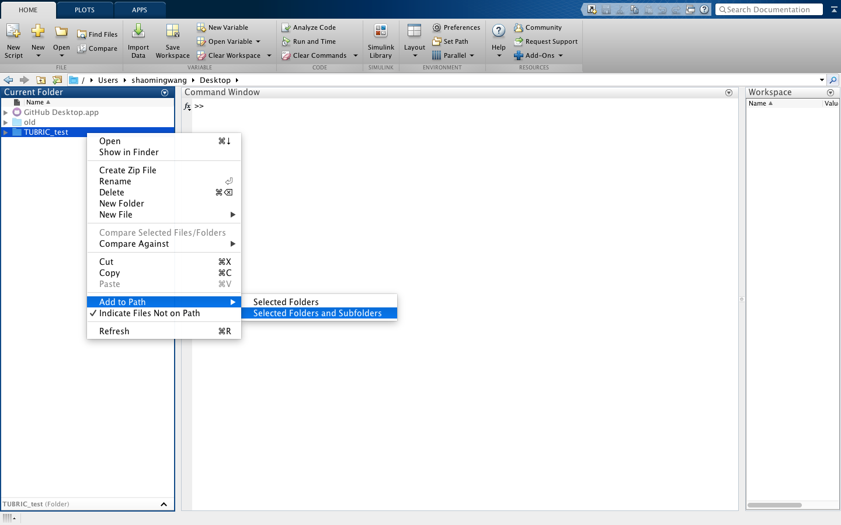

1. There are three subfolders for each of the three tasks: reward, finger and mid.

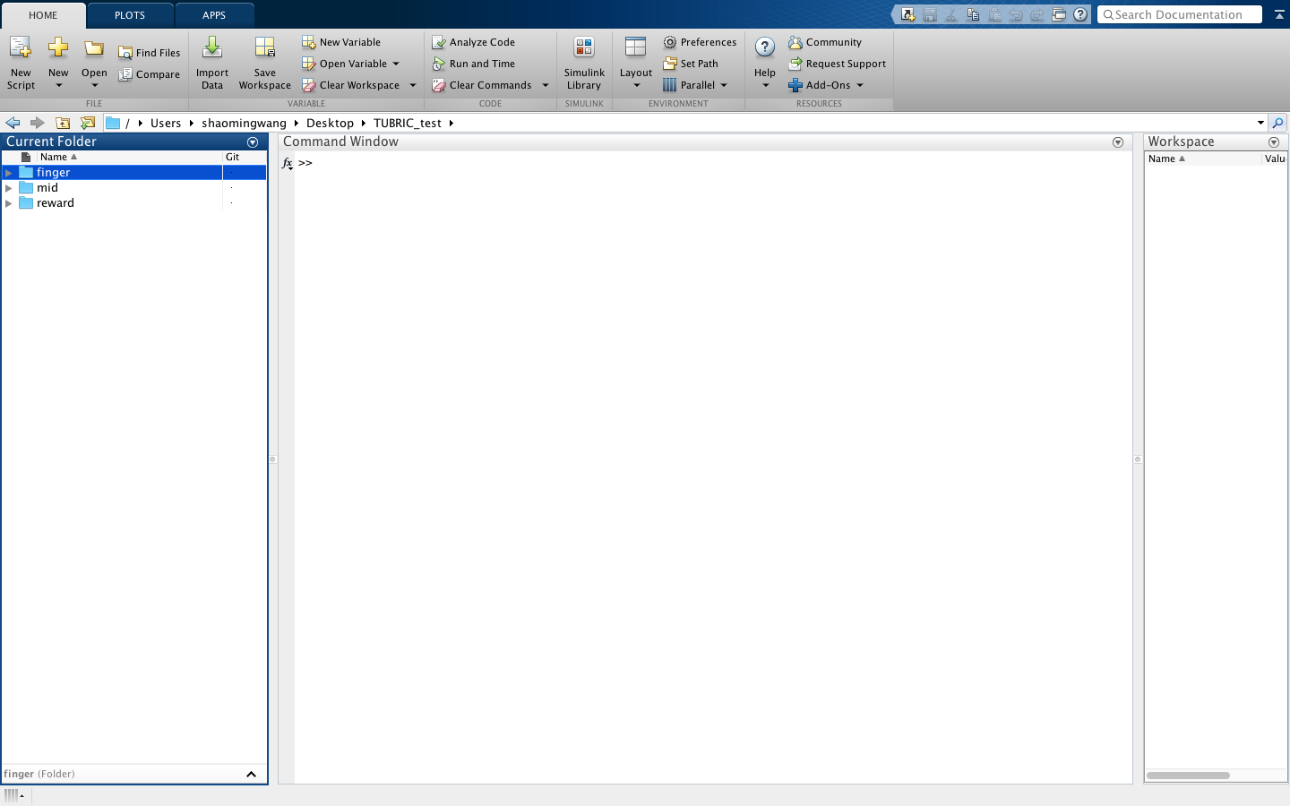

1. You should open the folder of the task you are running. For example, if you want to run finger task, open the folder “finger” and you will see:

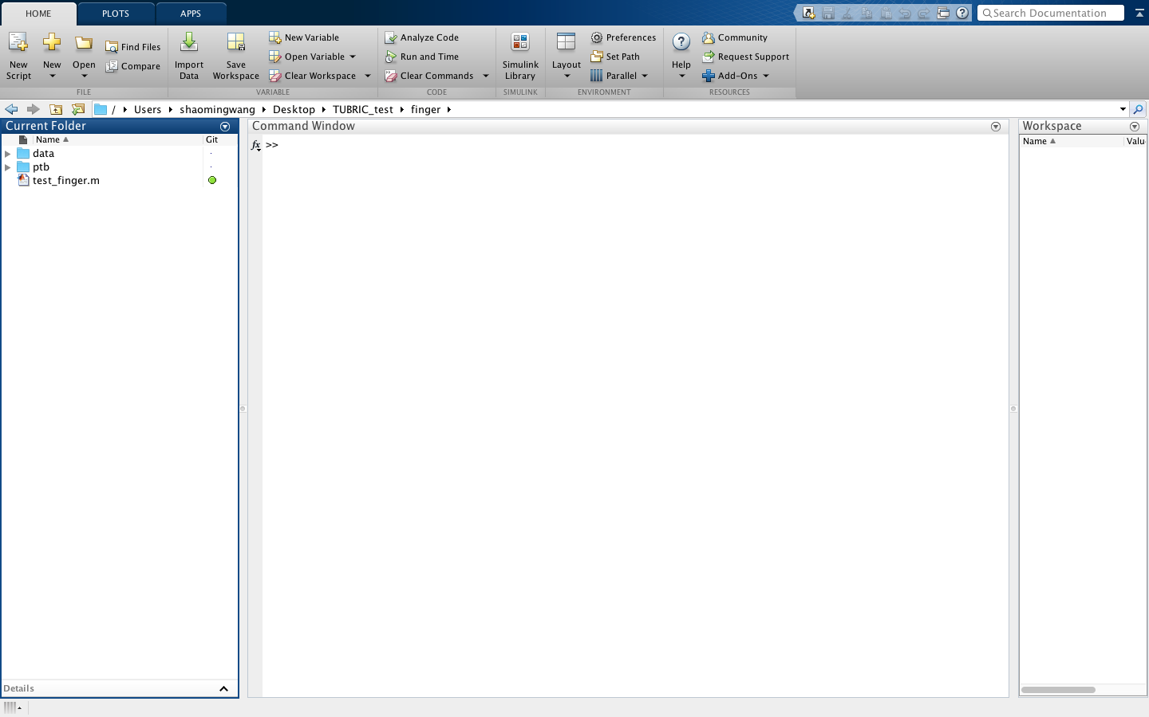

1. For the finger tapping task, type “test_finger” in the command line and hit “Enter”:

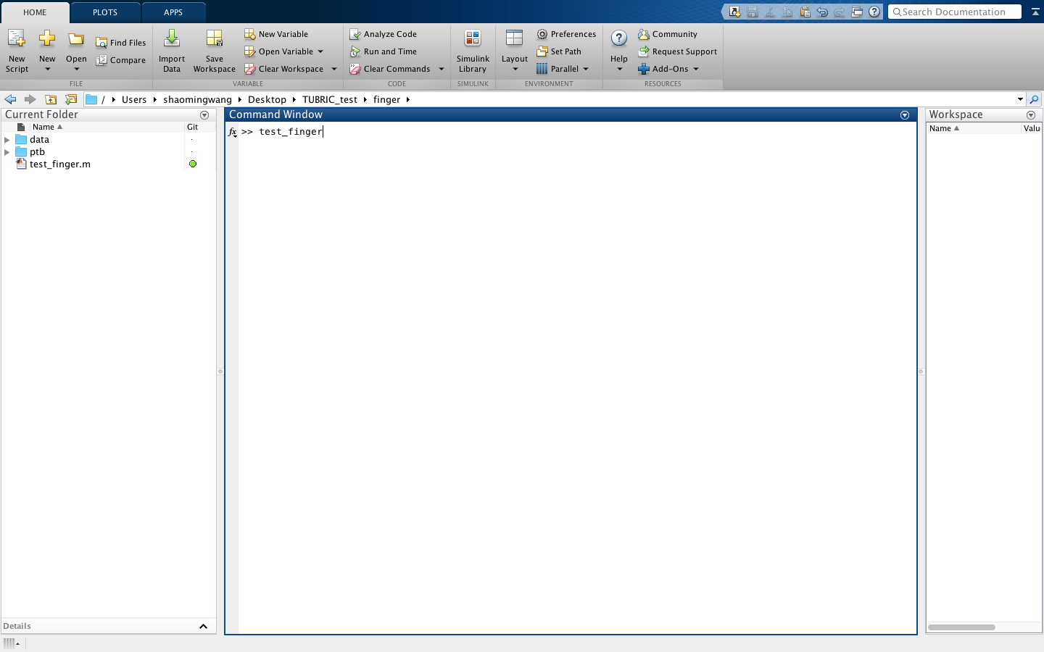

1. You should enter subject name (e.g.: Shaoming) and #blocks (e.g. 1) and hit enter. The task will begin running.:

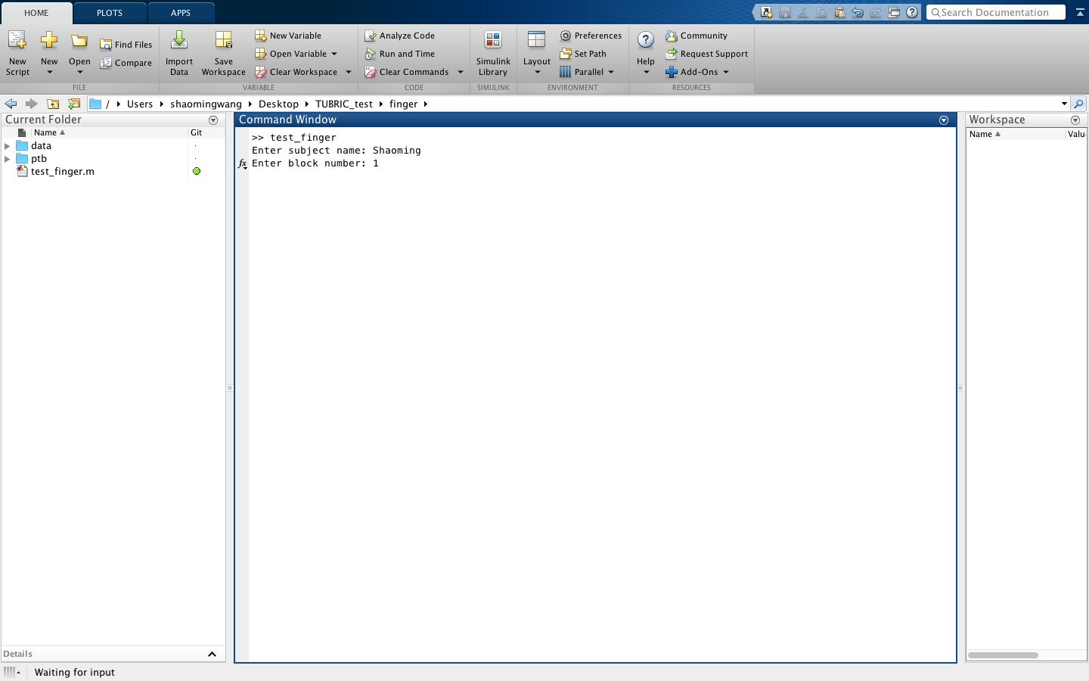

1. For the MID task, you should first go to the mid folder:

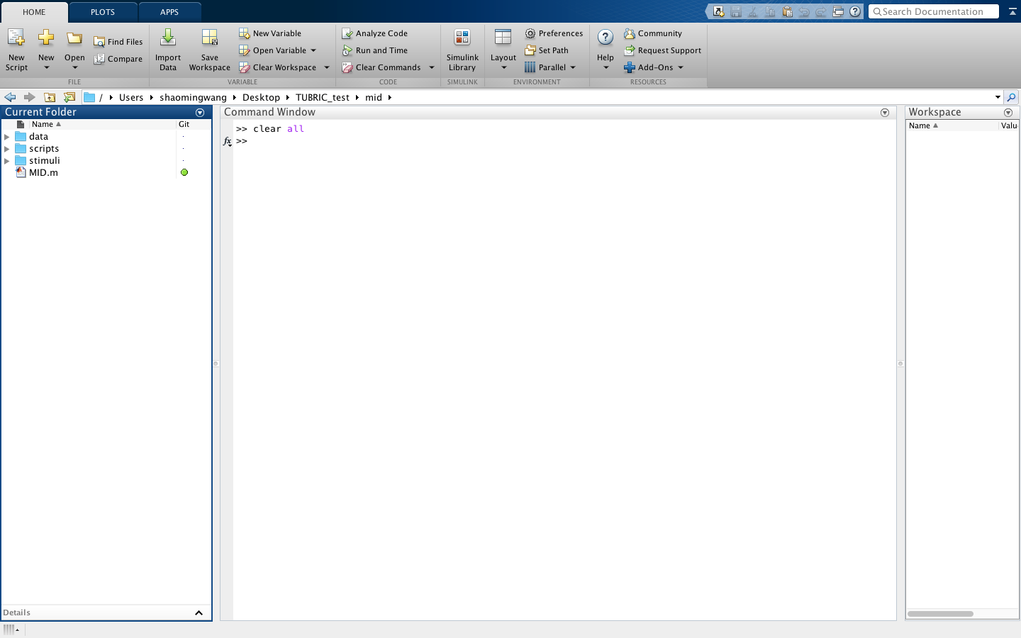

1. You should type “MID” in the command line and hit enter:

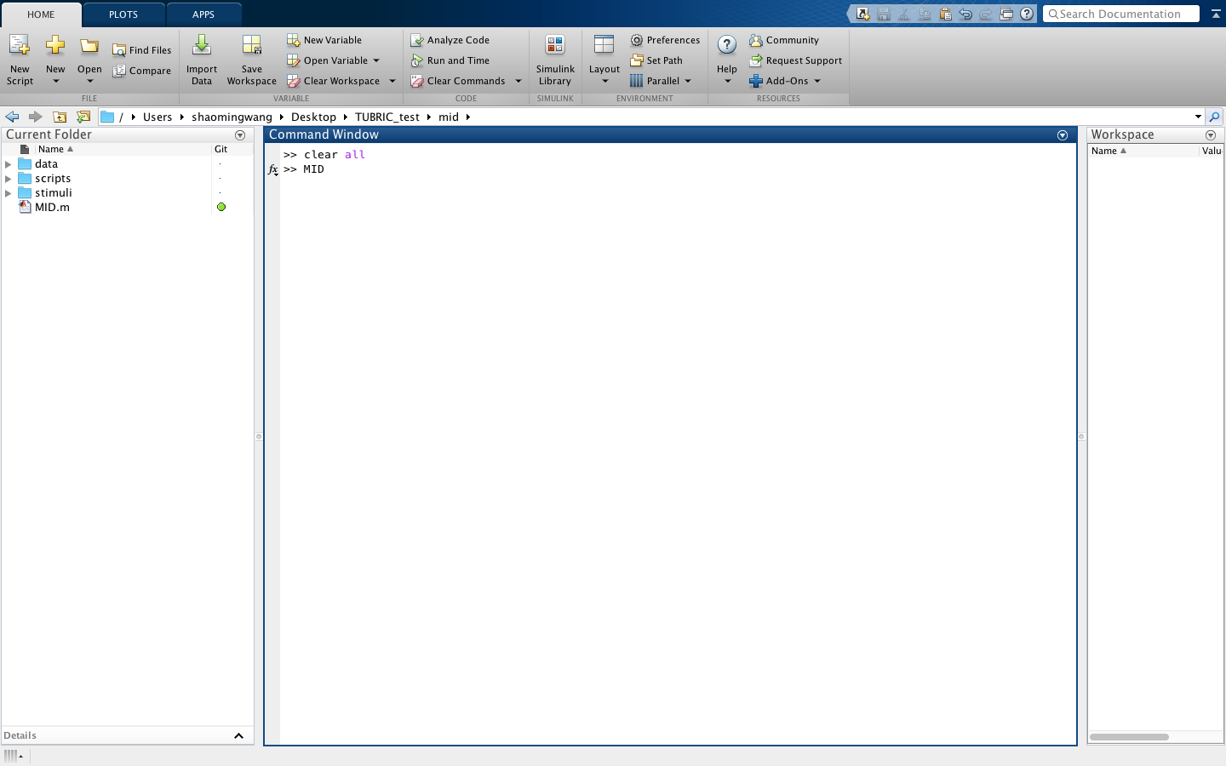

1. You will be asked to enter the subject name and runs. Each subject should start with a practice run (which you should enter “0”) and subsequent runs are numbers from 1-4:

