BREAST CANCER ANALYTICS
Oncology Patient Outcomes Dashboard
PROJECT DOCUMENTATION
Prepared by: Victoria Benjamin
Role: Data Analyst
Tools Used: MySQL / SQL and Microsoft Power BI
Project Date: August 2026

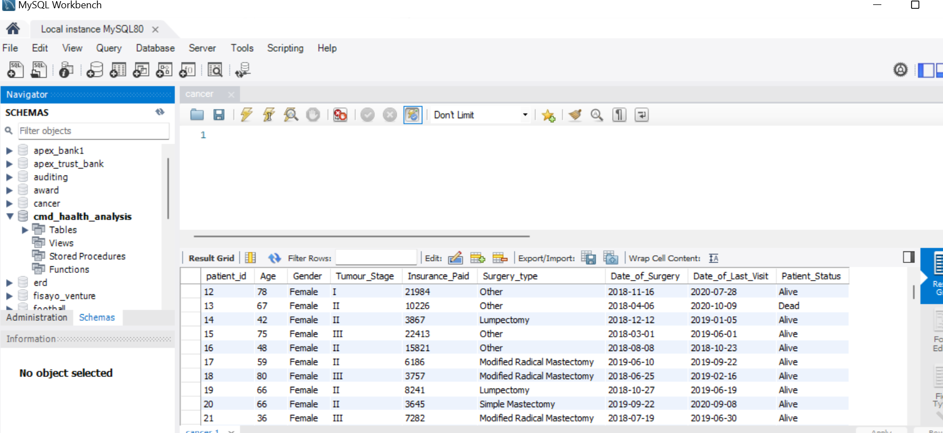
Dashboard Preview — Breast Cancer Analytics Dashboard

Table of Contents
1. Executive Summary
2. Business Background
3. Business Problem
4. Project Objectives
5. Business Questions
6. Dataset Overview
7. Data Cleaning and Preparation
8. SQL Data Cleaning Process
9. Data Validation
10. Power BI Development
11. KPI Development
12. Dashboard Visuals
13. Filters and Interactivity
14. Key Findings
15. Business Recommendations
16. Conclusion
17. Tools Used
18. Skills Demonstrated
19. Project Files

1. Executive Summary
A multi-specialty oncology hospital collects patient information over time to support treatment, follow-up, and healthcare planning. However, large volumes of patient records can make it difficult for decision-makers to quickly identify patterns in tumour stages, patient outcomes, treatment methods, survival, demographics, and healthcare costs.
This project focuses on transforming breast cancer patient records into an interactive analytical dashboard. The raw dataset contained 1,338 records and 16 fields. SQL was used to clean and prepare the data, after which the final analytical dataset contained 334 patient records and 9 fields used for the dashboard.
Power BI was then used to create an interactive dashboard showing patient volume, survival outcomes, average age, insurance expenditure, tumour-stage distribution, surgery types, and patient status across age groups. The final dashboard provides a centralized view that can help hospital stakeholders monitor patient outcomes and identify areas requiring attention.
The dashboard reports 334 patients, 255 alive patients, 66 deceased patients, an average patient age of 59 years, approximately ₦4.7 million in insurance payments, and a survival rate of 79.4% when calculated from patients with specified outcomes.

2. Business Background
Healthcare organizations generate large amounts of patient information through diagnosis, treatment, surgery, follow-up visits, and financial records. Turning this information into a clear analytical view can support better resource planning and more informed clinical and operational decisions.
The project is designed around an oncology hospital that wants to improve patient outcomes, optimize treatment planning, and manage healthcare resources more effectively. The accompanying business brief identifies the need to monitor disease progression, treatment methods, survival outcomes, and healthcare costs through a centralized reporting view.
The dashboard is therefore positioned as a self-service analytical tool that models the type of reporting a hospital analytics team could use for ongoing monitoring.

3. Business Problem
The hospital has patient records but lacks a simple centralized analytical view for answering important questions about the population being treated. Without such a view, management may find it harder to identify high-volume age groups, understand tumour-stage distribution, compare surgery types, monitor survival outcomes, and assess insurance expenditure.
- Which age groups are most represented among the patients?
- Which tumour stages are most common?
- Which surgical procedures are performed most frequently?
- What proportion of patients survive after treatment?
- How much has been paid through insurance?
- Which patient groups may require closer monitoring?

4. Project Objectives
- Clean and prepare the patient dataset using SQL.
- Validate the final analytical records before dashboard development.
- Analyze patient demographics and identify the age groups most represented in the dataset.
- Monitor tumour-stage distribution to support understanding of disease presentation.
- Evaluate the frequency of different surgical procedures.
- Measure patient survival and mortality outcomes.
- Analyze insurance expenditure to support financial planning.
- Build an interactive Power BI dashboard for self-service analysis.
- Provide business recommendations based on the observed patterns.

5. Business Questions
- How many breast cancer patients were included in the final analysis?
- What proportion of patients are alive, deceased, or have an unspecified status?
- What is the survival rate among patients with a specified outcome?
- Which tumour stage has the highest number of patients?
- Which age groups contain the largest number of patients?
- Which surgery types are performed most frequently?
- What is the total insurance expenditure represented in the final dataset?
- What is the average age of the patients?
- How do patient outcomes vary across age groups?
- What actions could help hospital management improve monitoring and resource planning?

6. Dataset Overview
The raw CSV dataset contained 1,338 rows and 16 columns. The supplied cleaned dataset contains 334 rows and 9 columns. The final dataset was used as the analytical source for the Power BI dashboard.

Raw Dataset Fields
Age, Gender, Protein1, Protein2, Protein3, Protein4, Tumour_Stage, Insurance_Paid , Histology, ER status, PR status, HER2 status, Surgery_type, Date_of_Surgery, Date_of_Last_Visit, Patient_Status.

Final Analytical Fields
patient_id, Age, Gender, Tumour_Stage, Insurance_Paid, Surgery_type, Date_of_Surgery, Date_of_Last_Visit, Patient_Status.

Dataset Quality Observations
Area | Observation
Raw size | 1,338 rows × 16 columns
Final size | 334 rows × 9 columns
Rows not carried into final dataset | 1,004 rows
Raw exact duplicate rows detected | 23
Final patient IDs | 334 unique IDs
Final missing values | No missing values in the 9 final analytical fields

The raw file also contained several fields that were not retained in the final dashboard dataset, including Protein1–Protein4, Histology, ER status, PR status, and HER2 status. The final analytical table was narrowed to the fields used for the portfolio dashboard.

7. Data Cleaning and Preparation
The data preparation stage was completed before Power BI visualization. SQL was used as the main cleaning and preparation tool. The objective was to produce a reliable analytical table with consistent field names, usable data types, complete records for the selected dashboard fields, and standardized categories.
Comparison of the supplied raw and clean files shows a reduction from 1,338 source rows to 334 final patient records. The final table contains no missing values across its nine analytical fields.

8. SQL Data Cleaning Process

Database and Table Setup
The cancer dataset was stored in MySQL and made available through a dedicated cancer schema/table for SQL-based exploration and preparation.

Data Exploration
The source table was inspected to understand its columns, record structure, categories, dates, patient outcomes, and financial fields before dashboard development.

Record and Duplicate Validation
Duplicate checks were performed on the raw data. The raw file contains 23 exact duplicate rows; the final analytical table contains 334 unique patient_id values.

Blank and NULL Value Checks
The raw dataset contained a large block of incomplete records. The final analytical table contains complete values for patient_id, age, gender, tumour stage, insurance paid, surgery type, surgery date, last visit date, and patient status.

Column Selection
The final analytical table was reduced to the nine fields required for the Power BI dashboard. Source fields not used in the final dashboard were not retained in the clean analytical table.

Field Name Standardization
The final table uses consistent field names such as Insurance_Paid, Tumour_Stage, Surgery_type, Date_of_Surgery, and Date_of_Last_Visit.

Insurance Amount Preparation
The raw Insurance_Paid field was stored as formatted currency text, while the final dataset contains numeric insurance amounts, making aggregation possible in Power BI.

Date Preparation
Surgery and last-visit dates were standardized in the final dataset to an ISO-style YYYY-MM-DD format for reliable time analysis.

Patient Status Validation
The final patient-status categories are Alive, Dead, and Non_specified, allowing the dashboard to distinguish confirmed outcomes from unspecified records.

Final Validation
The final dataset was checked to confirm the record count, uniqueness of patient IDs, completeness of the selected fields, and suitability for Power BI analysis.

9. Data Validation
The final dataset was validated before being used to build the Power BI dashboard.
Validation Check | Final Result
Final patient records | 334
Unique patient IDs | 334
Missing values in final fields | 0
Tumour stages | I, II, III
Patient status | Alive, Dead, Non_specified
Surgery types | 4 categories
Insurance paid | Numeric field suitable for aggregation
Surgery date | Valid date field
Last visit date | Valid date field

10. Power BI Development
After SQL preparation, the cleaned dataset was loaded into Microsoft Power BI. The dashboard was designed as an interactive oncology patient outcomes report, combining KPI cards, categorical charts, an age-group analysis, and slicers.
The dashboard layout was organized into four main analytical areas:
- Executive KPIs for fast monitoring.
- Patient and tumour-stage distribution.
- Surgery and treatment-pattern analysis.
- Age-group and patient-status analysis with interactive filters.

11. KPI Development
KPI | Dashboard Result | Purpose
Total Patients | 334 | Measures the total patient population in the final analytical dataset.
Alive Patients | 255 | Shows the number of patients with an Alive status.
Dead Patients | 66 | Shows the number of patients with a Dead status.
Average Age | 59 | Provides a quick view of the average age of patients.
Insurance Paid | ₦4.7M | Shows the total insurance expenditure represented in the dashboard.
Survival Rate | 79.4% | Shows the proportion of patients with an Alive outcome among patients with specified Alive/Dead outcomes.

Note: the 79.4% survival rate corresponds to 255 Alive patients divided by the 321 patients with a specified Alive or Dead status. The 13 Non_specified records are therefore excluded from this particular rate calculation.

12. Dashboard Visuals

Tumour Stage
Donut chart showing the distribution of patients across Stage I, Stage II, and Stage III.

Patient Status
Donut chart showing Alive, Dead, and Non_specified outcomes.

Surgery Type
Column chart comparing the frequency of Other, Modified Radical Mastectomy, Simple Mastectomy, and Lumpectomy.

Age Group and Patient Status
Stacked bar chart showing patient outcomes across age groups.

Key Insights Panel
A narrative section summarizing the most important observations from the dashboard.
Analysis | Observed Result
Tumour Stage II | 189 patients — largest stage category
Tumour Stage III | 81 patients
Tumour Stage I | 64 patients
Other surgery | 105 procedures — most frequent category
Modified Radical Mastectomy | 96 procedures
Simple Mastectomy | 67 procedures
Lumpectomy | 66 procedures

13. Filters and Interactivity
The dashboard includes slicers that allow users to interactively filter the analysis by:
- Surgery Type
- Patient Status
- Age Group
- Tumour Stage
- Date of Surgery
These filters allow hospital stakeholders to move from the overall patient population to a more focused view of specific procedures, outcomes, age groups, tumour stages, or surgery periods.

14. Key Findings
- The final analysis contains 334 breast cancer patients.
- 255 patients are recorded as Alive and 66 as Dead, while 13 records have a Non_specified status.
- The survival rate is 79.4% among patients with specified Alive/Dead outcomes.
- Stage II is the dominant tumour stage with 189 patients, followed by Stage III with 81 and Stage I with 64.
- The 50–59 age group is the largest age group in the dashboard analysis, indicating a concentration of patients in this age range.
- Other is the most frequent surgery category with 105 procedures, followed by Modified Radical Mastectomy with 96.
- Total insurance payments in the final dataset amount to approximately ₦4.7 million.
- The dashboard shows that patient outcomes vary across age groups, making age-based monitoring useful for management and clinical review.

15. Business Recommendations

Strengthen early detection and monitoring
Because Stage II represents the largest share of patients, the hospital should continue emphasizing early screening, referral, and monitoring programs that can help identify cases before more advanced stages.

Prioritize outcome monitoring
The hospital should track Alive, Dead, and unspecified outcomes regularly and investigate records with missing or unspecified status to improve the completeness of outcome reporting.

Use age-based resource planning
The concentration of patients in the 50–59 age group suggests that age-specific education, screening, follow-up, and resource planning may be useful.

Monitor surgical demand
The high frequency of Other and Modified Radical Mastectomy procedures can help management anticipate surgical capacity, staffing, theatre scheduling, and post-operative support requirements.

Track healthcare expenditure
Insurance expenditure should be monitored over time and by treatment or surgery category where additional data is available, helping management understand financial pressure and plan resources.

Maintain an interactive reporting process
The Power BI dashboard should be refreshed regularly as new patient records become available so that decision-makers can monitor changes rather than relying on static reports.

16. Conclusion
This project demonstrates how SQL and Power BI can be combined to transform raw healthcare records into a structured business intelligence solution. The raw dataset was explored and prepared in SQL before the final analytical dataset was loaded into Power BI.
The completed dashboard provides a concise view of patient volume, survival outcomes, tumour stages, surgery patterns, age groups, and insurance expenditure. The analysis highlights Stage II as the largest tumour-stage category, a high representation of patients aged 50–59, and the frequent use of Other and Modified Radical Mastectomy procedures.
Beyond the dashboard itself, the project demonstrates the importance of data cleaning, validation, KPI design, interactive visualization, and translating analytical results into practical business recommendations.

17. Tools Used
- MySQL / SQL — database setup, data exploration, cleaning, validation, and preparation.
- Microsoft Power BI — data modeling, KPI creation, interactive visualization, slicers, and dashboard development.
- CSV — source and cleaned data storage format.

18. Skills Demonstrated
- SQL data cleaning and validation
- Data quality assessment
- Data transformation and field standardization
- Healthcare data analysis
- KPI development
- Power BI dashboard development
- Data visualization
- Interactive filtering and report design
- Business insight generation
- Business recommendations
- Analytical storytelling
- Portfolio project documentation

19. Project Files
The recommended portfolio folder structure for this project is:
- 01_Business_Brief
- 02_Raw_Data
- 03_Clean_Data
- 04_SQL_Cleaning
- 05_PowerBI_Dashboard
- 06_Dashboard_Screenshot
- 07_Project_Documentation
Recommended files include the raw dataset, cleaned dataset, SQL cleaning script (if recovered or recreated), Power BI .pbix file, dashboard preview image, business brief, and this project documentation.

End of Project Documentation

