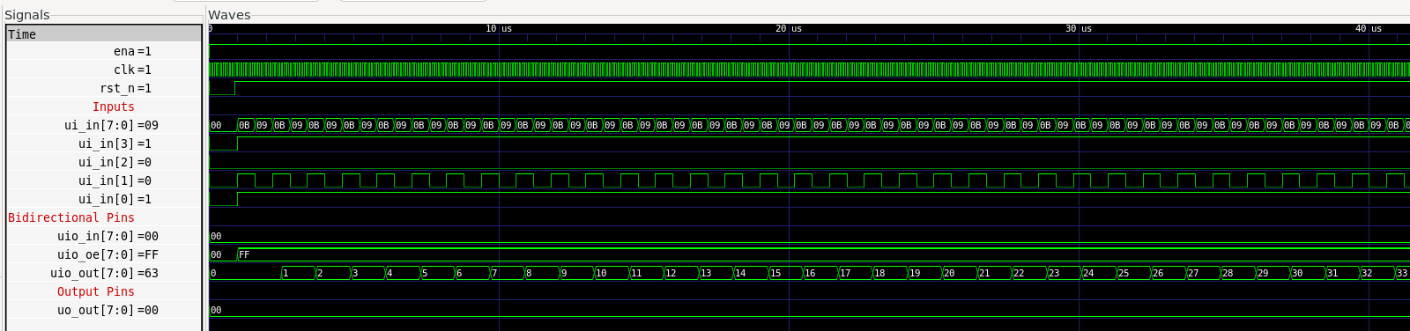

Fig. 1: Counting up from 0 at the speed of the clock inputted at ui_in[1]. 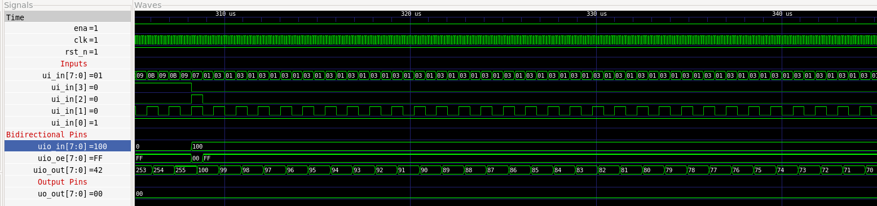

Fig. 2: Load in 100 from uio_in[7:0] when ui_in[2] is 1 to represent loading input. Count down from 100 when ui_in[3] is 0 (representing count down).

Fig. 3: Demonstrate high Z for the bidirectional I/O when uio_oe[7:0] is 0x00. This is done when ui_in[0] is 0 (which represents enable as 0).