

Your thesis title

Victoria Gillman
[Last degree, University, Country (e.g MSci Marine Biology, University of Southampton, UK)]

A thesis presented for the degree of
Doctor of Philosophy
at the University of Aberdeen

Year

Declaration
Everyone’s declaration on Aberdeen’s library repo reads very similarly to this “I declare that the work presented in this thesis was composed by me, is my own and has not been submitted for any previous application for a degree.
Each thesis chapter has been the result of collaboration with different researchers whose names are listed at the beginning of the relevant chapters. Below are their names, affiliation and summary of contribution:”- this second para may vary slightly between people- some people say the contributions are detailed at the start of the chapter. Some people do both. I stuck with only writing contribution details in this section.
[Supervisor 1 name] – [Address]
Summary of their contribution.
[Supervisor 2 name]- [Address]
Sumary of their contribution.
[If you have published any chapters write it here e.g “A version of Chapter 1 has been published in [Journal] as:
Citation ]

[Your Name] | 07.04.2026
[Your Signature]

Acknowledgements
This is where you thank all the people who’ve helped you- start with supervisors, then collaborators and academic help, then move to peers and then have friends, family etc at the bottom. Looking at thesis on Primo, people style it based on their preferences- some keep it really professional, some make it really personal, some people thank their study system at the end. Some people also include proverbs/ cool quotes. Some keep it short, mine was quite long in the end!

Thesis Summary
A bigg abstract summarising your thesis in its entirety. Some people have a thesis abstract and thesis summary, technically they are different things… but I didn’t and neither do many people in the thesis I looked at on Primo. This is often written late, though drafting earlier can be helpful to help you zoom out for your general discussion.

Contents
Declaration i
Acknowledgements ii
Thesis Summary iii
Contents iv
General Introduction 1
Template created by Victoria Gillman (2026)- feel free to use and adapt! 1
Aims and objectives 2
1 Chapter One: Title of chapter 1 3
1.1 Abstract 3
1.2 Introduction 4
1.3 Methods 4
1.3.1 Subheading for methods 4
1.4 Results 4
1.4.1 Subheading 4
1.5 Discussion 4
1.5.1 I like subheadings in the discussion too 4
1.5.2 Conclusions 4
1.6 Figures and Tables 5
1.7 Supplementary Materials: 6
2 Chapter Two: Title 10
2.1 Abstract 10
2.2 Introduction 11
2.3 Methods 11
2.3.1 Data collection 11
2.4 Results 11
2.4.1 Subheadings 11
2.5 Discussion 11
2.5.1 I like subheadings in a discussion 11
2.6 Figures and Tables 12
2.7 Supplementary Materials 13
3 Chapter 3: title 14
3.1 Abstract- 14
3.2 Introduction 15
3.3 Methods 15
3.3.1 Subheading 15
3.4 Results 15
3.4.1 Subheading 15
3.5 Discussion 15
3.6 Figures and Tables 16
3.7 Supplementary Materials 17
4 General Discussion 18
5 References 19

General Introduction

Template created by Victoria Gillman (2026)- feel free to use and adapt!
(Find me on - Victoria (@vicgillman.bsky.social) — Bluesky)
Aberdeen official guidance I found includes library thesis submittance guidance, the pgr code of practice. I also recommend asking your supervisor and labmates for advice.
In your doc properties I recommend telling word to not compress images so they are nice and crispy- people will generally read the thesis on their computer so will want to zoom in to a nice high resolution image -- so File-Options-Advanced-Image quality- click “Do not compress image files” so your images as saved in the file nice and crispy When you ggsave them in R I use 600dpi as that is what some journals ask for! Better high-res and make them lower res than having to go back and remake!
When you are ready to submit, double check your intent to submit form for the file type but it is often a PDF- make sure to keep your file navigation in for ease of reading. Click File->Export->PDF->Options-> Create bookmarks using headings/ Retain structure for accessibility.
Finally, I found it really helpful to print my thesis out for annotation for the viva. I did this on a uni printer, then took it to Repro Overflow in Aberdeen where they can comb bind it for ~£3.
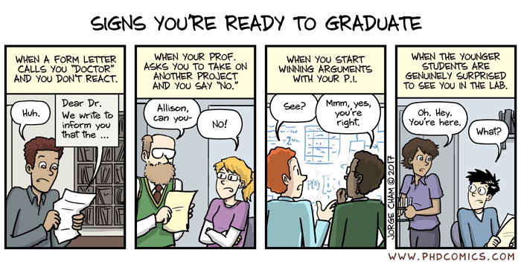
Figure 0.1. Figures can also be nice in the general intro to break up the text. I put figures in table cells to stop them jumping around as much. I also right click->Insert caption to get auto figure numbering- to use them in text- its References->Cross-reference-Make sure you select only label and number!!
When adding a caption you can change the label – so I did “Figure” and “Figure S”( for supplementary) and Table” and “Table S”. Then I click on the Numbering box and I have got numbering to match my Section numbers (and I set my general intro as Section 0- this is why this one is Fig 0.1)

Aims and objectives
Sum up your argument, give thesis overarching aim, then give chapter by chapter aims.
Chapter 1 uses…..
Chapter 2 combines ….evaluates.
Chapter 3 examines …. tests .
Then reiterate the central aim of the thesis. I used library thesises as a general guide for this!

Chapter One: Title of chapter 1
Here add authors of the chapter, also if its published give its citation. Some people also do author contributions/affiliation here….

Abstract

Introduction
I was told to maybe page break after the abstract? I agree it looks neater/like a cover page but I also think without the break, its equally fine!

Methods

Subheading for methods

I used an unnumbered sub-subheading so my ToC didn’t get too cluttered by 1.1.1.2 etc

Results

Subheading

Discussion

I like subheadings in the discussion too

Conclusions

Figures and Tables
Personally I like figures and tables out of the main text body- it makes it easier to read imo- no random scrolling back/forth- you can just split the page or have a print-out of just the images to refer to. See how I used a Section break (not just a page break) so this meant I could have different margins and also make it landscape if I wanted
Table 1.1. Notice I use the cross-ref feature in MS-Word so the tables/figures are auto-numbered here and in text.

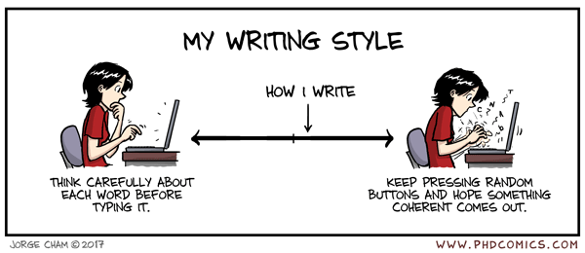
Figure 1.1.(a) note how I put figures in table cells- this stops the figures jumping around. Make the cell lines invisible and toggle “View Gridlines” on to visualise them

Supplementary Materials:

Figure S 1.1. More legends…

Table S 1.1. Text….

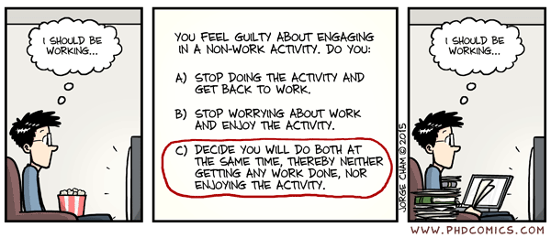
Figure S 1.2. To make the page landscape for wide figures/tables use a Section Break- so Layout tab-Breaks->Section break. That should allow you to toggle just that section landscape

Table S 1.2..

Table S 1.3.

Chapter Two: Title
Authors.

Abstract

Introduction

Methods

Data collection

Presence data

Results

Subheadings

Discussion

I like subheadings in a discussion

Figures and Tables

Supplementary Materials

Chapter 3: title
Authors.

Abstract-
Your choice whether to add page-breaks between abstracts and introductions- I have seen both.

Introduction

Methods

Subheading

Sub-sub heading

Results

Subheading

Discussion

Figures and Tables

Supplementary Materials

General Discussion
I really struggled with this- trying to avoid parroting back the abstracts or conclusions of each individual chapter. After looking at many many different thesises on our library thesis repository I concluded everyone approaches it differently. If your PhD is really applications or methods focussed then you could focus in on this- what does your thesis contribute as a whole to your area of research, how can it be applied, how did your methods dev help as a whole…I have heard some examiners like subheadings- esp some phrased as specific questions the thesis answered, however I also heard some examiners didn’t particularly like that approach. Mine wasn’t particularly methods focused- in the end I went with short/sweet as is my style and a wall of text because I couldn’t think of any subsection headers! This was my roughest bit of work, and I think its common that the general discussion is written quite quickly at the end- I am not saying that is the wisest thing to do but I am just saying so maybe you give yourself a break. This was my structure, however I think each examiner and supervisor likes different things so please bear that in mind!
Briefly recapping the gap in the literature (aka my intro in one paragraph)
Briefly recapping the results/findings of each chapter in one paragraph
Then not mentioning chapters specifically (although some people do…but I found by doing this I ended up parroting the details of chapters and not wider findings/themes) but three central questions of the thesis explain what you think of how you’ve answered them? Or what you’ve learned? A good way could be phrasing the subheadings as questions with yes/nos/probablies at the end….I wanted to do this but I couldn’t think of a way to make it fit for my thesis- I went with a wall of text approach which looking at other thesis on Primo seem equally valid….
Then go wider still- how does the thesis as a whole contribute to the wider scientific community?
Pull in some issues/limitations/caveats and what you hope for the future.
Then summarise and conclude

References
Some people have references at the end of each chapter- I think this is from if they convert each indi-chapter doc to a pdf and combine pdfs to make a thesis…or when submitting papers to journals they often make you remove your ref manager links BUT doing it in one word doc with Zotero ref manager, it was easiest to add in all refs at the end in one mega ref section. Double check with your supervisor if they have a preference.

