# Species Plots

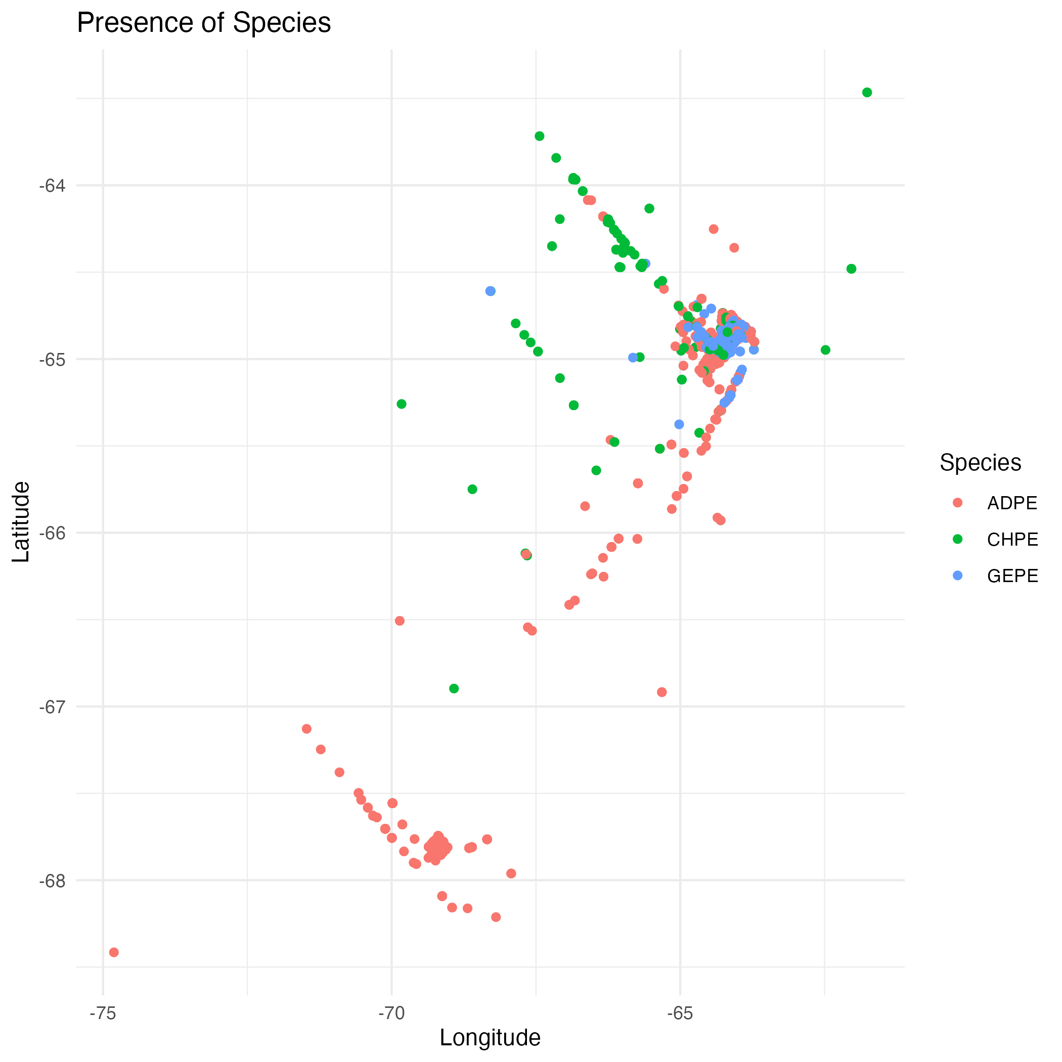

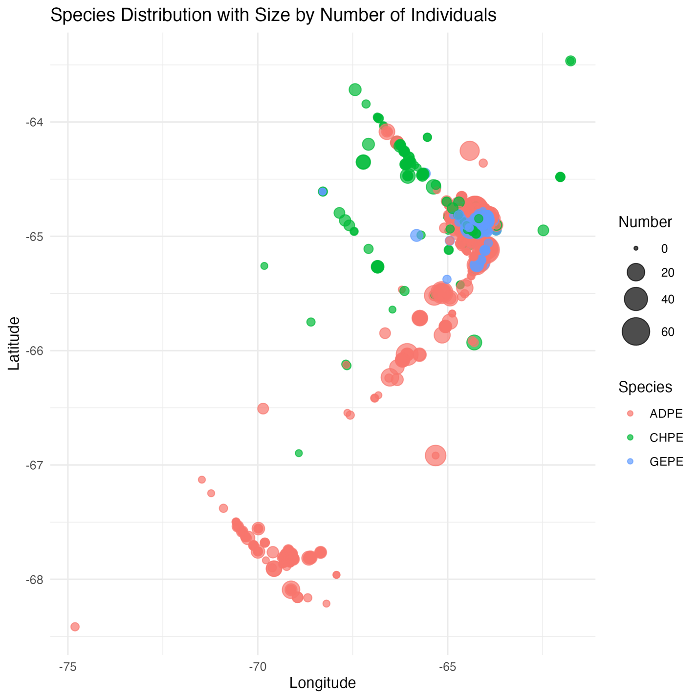

|  |  |  |  |  |  |  |  |  |
| --- | --- | --- | --- | --- | --- | --- | --- | --- |
|  |  |  |  |  |  |  |  |  |
| Survey distance, minutes, and ship speed plotsDistance Removed outliers for total distance covered       Survey Time    Ship Speed          Summary stats Table: Summary Statistics of Ship Speed and Count Minute by Year | | | | | |  |  |  |
|  |  |  |  |  |  |  |  |  |
| | Cruise| Mean_Ship_Speed| Median_Ship_Speed| SD_Ship_Speed| Mean_Count_Minute| Median_Count_Minute| SD_Count_Minute| | | | | | | | | |
| |------:|---------------:|-----------------:|-------------:|-----------------:|-------------------:|---------------:| | | | | | | | |  |
| | 1993| 5.999192| 6.0| 0.1584223| 14.70208| 15.0| 9.120081| | | | | | | | |  |
| | 1994| 6.878235| 6.4| 2.2277317| 15.10235| 15.0| 10.340498| | | | | | | | |  |
| | 1995| 7.664944| 6.7| 2.2465353| 13.99936| 11.0| 13.484333| | | | | | | | |  |
| | 1996| 6.449542| 5.3| 2.4371145| 14.48654| 13.0| 10.390601| | | | | | | | |  |
| | 1997| 5.827312| 4.6| 2.3315049| 15.47047| 14.0| 12.131314| | | | | | | | |  |
| | 1998| 8.393110| 10.5| 3.3171506| 29.24716| 24.0| 38.659024| | | | | | | | |  |
| | 1999| 7.077994| 4.5| 3.0613227| 19.17639| 15.0| 23.742919| | | | | | | | |  |
| | 2000| 7.693397| 9.2| 2.8750682| 12.05841| 10.0| 10.538084| | | | | | | | |  |
| | 2001| 8.198354| 9.1| 2.0505374| 13.07158| 12.0| 10.229839| | | | | | | | |  |
| | 2002| 7.393046| 9.1| 2.7200857| 14.11474| 13.0| 10.435609| | | | | | | | |  |
| | 2003| 7.548091| 9.0| 2.5079335| 14.98555| 14.0| 11.847943| | | | | | | | |  |
| | 2004| 8.678404| 9.5| 2.0688464| 14.33012| 12.0| 10.827649| | | | | | | | |  |
| | 2005| 8.768905| 10.0| 2.4481069| 16.00584| 14.0| 11.586313| | | | | | | | |  |
| | 2006| 7.384277| 8.0| 2.7798639| 14.69707| 13.0| 10.437917| | | | | | | | |  |
| | 2007| 8.269853| 10.0| 2.6204556| 16.86250| 16.0| 9.252460| | | | | | | | |  |
| | 2008| 8.997387| 10.0| 2.8190089| 16.35763| 15.0| 10.813275| | | | | | | | |  |
| | 2009| 10.545783| 10.9| 0.9473181| 15.73092| 15.0| 9.036881| | | | | | | | |  |
| | 2010| 10.108442| 10.2| 0.9416958| 14.68182| 14.0| 9.060944| | | | | | | | |  |
| | 2011| 10.521858| 10.4| 0.4794260| 15.88525| 14.0| 9.927924| | | | | | | | |  |
| | 2012| 10.258750| 10.4| 1.6152019| 14.83333| 12.0| 10.501909| | | | | | | | |  |
| | 2013| 30.253165| 30.0| 4.1586128| 15.27848| 15.0| 8.539406| | | | | | | | |  |
| | 2014| 29.985294| 30.0| 2.0450058| 15.68627| 16.5| 11.039544| | | | | | | | |  |
| | 2015| 30.000000| 30.0| 0.0000000| 13.51807| 10.0| 11.400812| | | | | | | | |  |
| | 2016| 30.000000| 30.0| 0.0000000| 14.81280| 14.0| 10.414476| | | | | | | | |  |
| | 2017| 29.661137| 30.0| 5.7374344| 14.86493| 15.0| 10.307540| | | | | | | | |  |
| | 2018| 34.209366| 30.0| 15.0832028| 16.34160| 15.0| 13.541999| | | | | | | | |  |
| | 2019| 33.870159| 30.0| 11.8186061| 16.78588| 15.0| 13.504935| | | | | | | | |  |
| | 2021| 46.173020| 31.0| 34.2631165| 23.87390| 18.0| 27.167973| | | | | | | | |  |
| | 2022| 9.825246| 9.8| 1.6589228| 13.87869| 11.0| 12.810680| | | | | | | | |  |
| | 2023| 7.663931| 9.1| 3.1293775| 15.61555| 14.0| 12.295035| | | | | | | | |  |
| | 2024| 8.961783| 10.0| 2.9806197| 15.25076| 15.0| 12.567899| | | | | | | | |  |

Summary stats **with outliers** per event, per year

|  |  |  |
| --- | --- | --- |
| Duration_minutes | With outliers | No outliers (this code was not working) |
| Min | 0 | 0 |
| 1st quantile | 19.00 | 19.00 |
| Median | 29.00 | 29.00 |
| Mean | 27.21 | 26.82 |
| 3rd quantile | 30.00 | 30.00 |
| Max | 901.00 | 901.00 |

|  |  |  |
| --- | --- | --- |
| Distance_km | With outliers | No outliers |
| Min | 0 | 0 |
| 1st quantile | 4.63 | 4.57 |
| Median | 8.72 | 8.62 |
| Mean | 10.34 | 8.22 |
| 3rd quantile | 10.35 | 10.28 |
| Max | 440.37 | 49.77 |

# Trackline plots

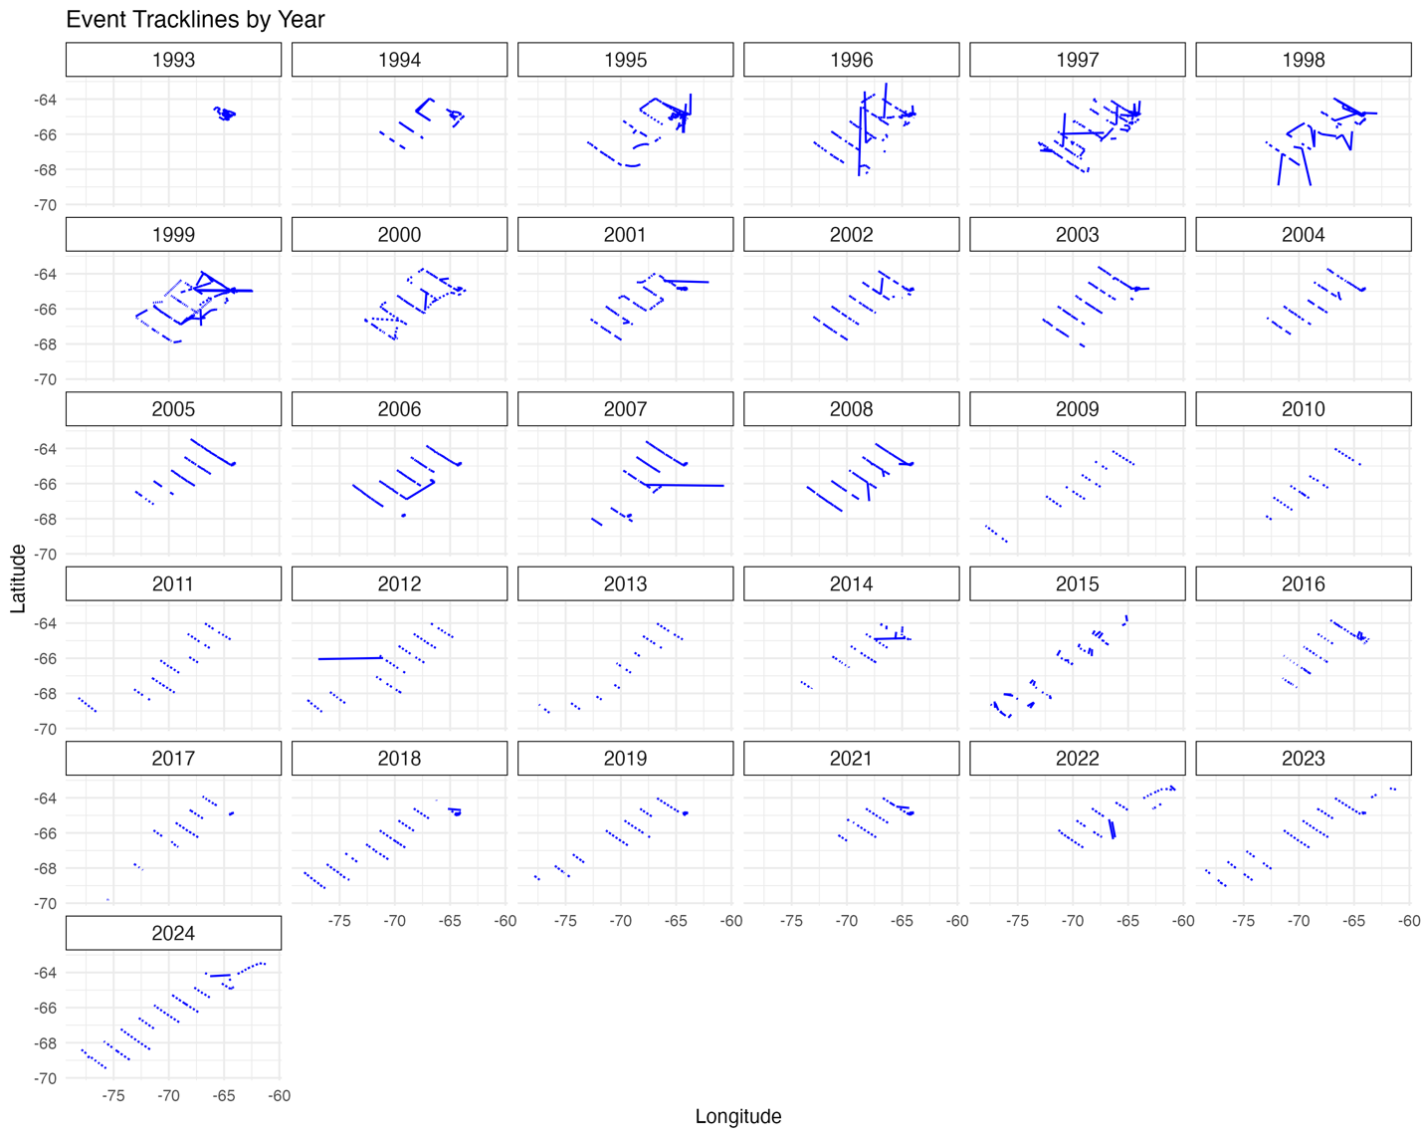

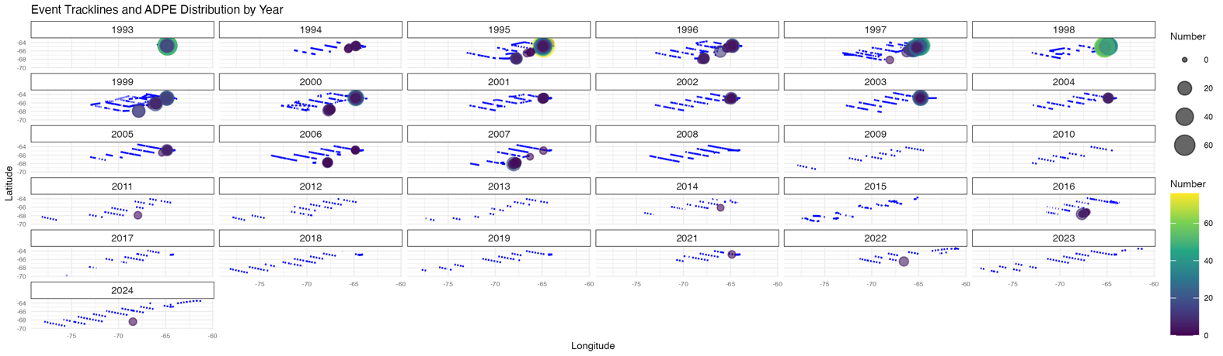

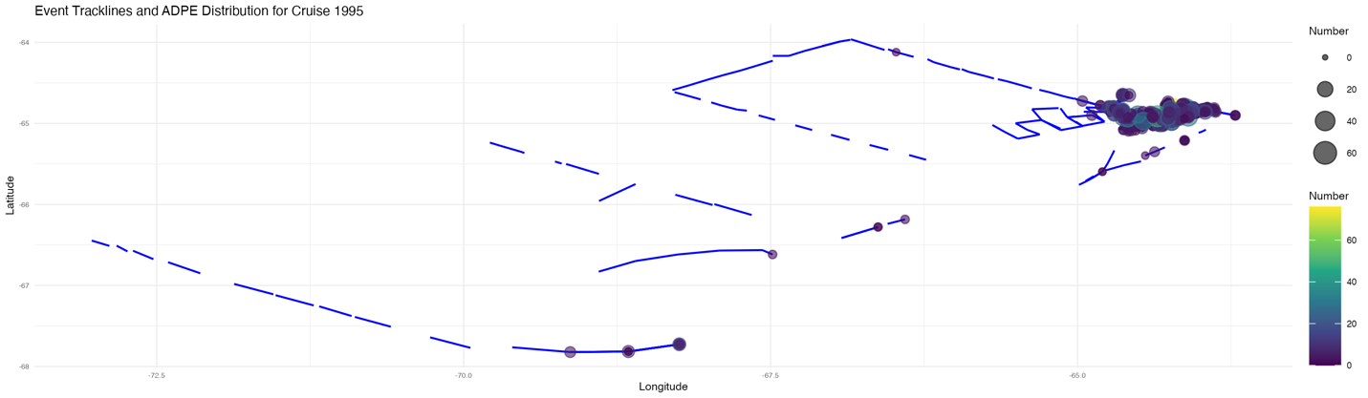

Examples with spp distribution

