ACTIVITY 2

Optimization with Genetic Algorithms
Job Shop Scheduling Problem
(by Victoria Joven)

https://github.com/victoriajoven/NeuronalActivity_2

Index
1. Chromosome and Algorithmic Adaptations 3
1.1 Chromosome 3
1.2 Fitness Evaluation 4
1.3 Selection tecniques 4
1.3.1 Tournament Selection 4
1.3.2 Roulette Wheel Selection 5
1.4 Crossover tecnhniques 6
1.4.1 Precedence Preserving Crossover (PPX) 6
1.4.2 Job-Based Crossover (JBX) 7
1.5 Mutation Operators 8
1.5.1 Swap Mutation 8
1.5.2 Insertion Mutation 8
1.6 Elitism 9
1.7 Convergence and stationary state detection 9
2. Experimental results 10
2.1 Small Instance (3–5 Machines) 10
2.2 Medium instance (around 10 machines) 12
2.3 Large instance (15 or more machines) 15
2.4 Conclusions 17
3. Second optimization method (optional) 18
3.1 SA components 18
3.2 Simulated Annealing 18
3.3 Parameters 18
3.4 Comparison with the Genetic Algorithm 19

1. Chromosome and Algorithmic Adaptations
This section explains Genetic Algorithm (GA) implemented in this project adapts the classical formulation taught in the course to the specific requirements of the Job Shop Scheduling Problem (JSSP). The content follows the theoretical foundations introduced in the lectures—population-based search, selection pressure, recombination, mutation, elitism, and convergence—while explicitly linking each concept to the corresponding Python implementation.

1.1 Chromosome

Definition
In the course (Neuronal and Evolutionary Computation), chromosomes are defined as vectors of genes, typically binary strings c∈{0,1}m. Evolutionary algorithms are not limited to binary chromosomes and can be different parameters as integer sequences, trees, or similar structures. This change is necessary when a problem requires other representations that binary encodings cannot represent.
In JSSP each job consists of a fixed sequence of operations, and the chromosome must encode an ordering of operations that respects job precedence while allowing the GA has to use relationships between jobs.
The implementation use a job-based permutation encoding, where the chromosome is a sequence of job identifiers. If job j has k operations, it appears k times in the chromosome. The position of each occurrence determines the order in which its operations are scheduled.

Code implementation
The chromosome and population representation is implemented in:
- src/ga/chromosome.py
- src/ga/population.py → Population.initialize()
The initialization procedure constructs the base sequence of job identifiers and shuffles it to generate the initial population, following the “random initialization”.

1.2 Fitness Evaluation

Definition
Fitness is defined as a non-negative value that quantifies the quality of an individual. Fitness can also be defined as a numerical score that measures how good a solution (individual) is at solving a problem (as in the evolution of species, survival, and reproduction).
GA can solve minimization problems by transforming the fitness or adapting the selection operator.

Code implementation
The fitness function is the makespan, computed by simulating the schedule.
The simulation is implemented in:
- src/evaluation/makespan.py → compute_makespan()

1.3 Selection tecniques
In the NEC course, we have seen four selection schemes: roulette wheel, rank selection, tournament selection, and stochastic universal sampling. Two of these are implemented in this project (tournament and roulette wheel).
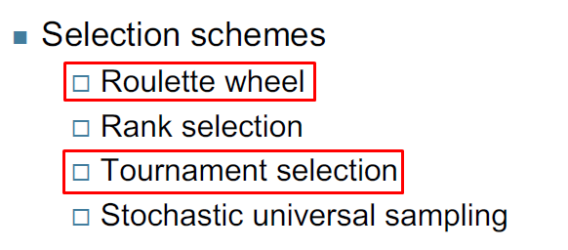
Figure 1. Selection techniques used on experiments

1.3.1 Tournament Selection

Definition
Tournament selection:
- Selects K individuals at random,
- Chooses the best among them,
- Maintains diversity,
- Is robust to fitness scaling,
- Avoids the sensitivity issues (random of roulette wheel selection).

Code implementation
Implemented in:
- src/ga/techniques/selection.py → TournamentSelection
The method samples a subset of individuals and selects the one with the lowest makespan, consistent with the minimization objective.

1.3.2 Roulette Wheel Selection

Definition
Roulette wheel selection assigns a probability proportional to fitness:
- Its sensitivity to fitness distribution,
- The requirement of non-negative fitness values,
- Its tendency to reduce diversity when fitness values differ greatly.

Code implementation
Implemented in:
- src/ga/techniques/selection.py → RouletteWheelSelection
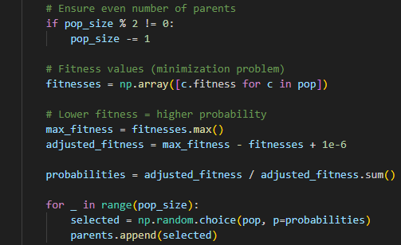
The code adapts the method for minimization by inverting fitness values. The comments indicate the algorithm applied. I have also added validation preconditions to minimize errors.

1.4 Crossover tecnhniques
In unit 6, we looked at the concept of the crossover with techniques one-point, two-point and uniform for binary encodings, but also states that for non-binary or permutation encodings, crossover must be adapted.
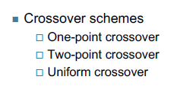
Figure 2. Crossover schemes seen in NEC classes
While researching, I have seen crossover algorithms that I will explain below, already implemented in Python with very optimal results.

1.4.1 Precedence Preserving Crossover (PPX)

Definition
For permutation-based problems, crossover complies with:
- Mimics reproduction (genetic recombination),
- Create two offspring from two parents
- Used to create next generation population

Code implementation
Implemented in:
- src/ga/techniques/crossover.py → PrecedencePreservingCrossover
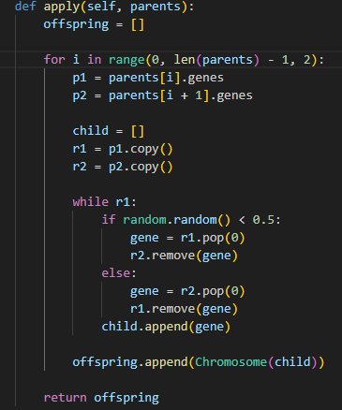
The PPX technique selects genes alternately from the parents while removing them from both lists, ensuring feasibility and previous premises of crossover.

1.4.2 Job-Based Crossover (JBX)

Definition
This tecnique preserves positional information for a subset of jobs and fills remaining positions from the other parent. It follows the course’s principle that crossover must recombine genetic material without violating the constraints of the encoding.

Code implementation
Implemented in:
- src/ga/techniques/crossover.py → JobBasedCrossover
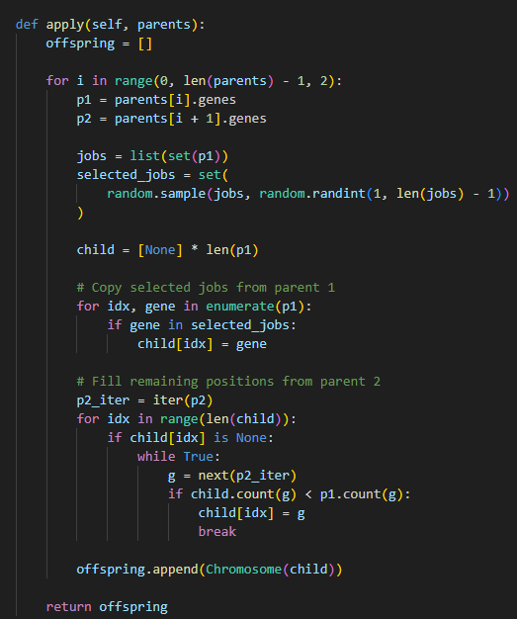
Randomly selects a subset of jobs from parent 1 and preserves their positions. Remaining genes are filled from parent 2.

1.5 Mutation Operators
Mutation as a mechanism to explore local neighborhoods of the search space. For binary encodings, mutation flips bits; for permutations, mutation must preserve feasibility.

1.5.1 Swap Mutation

Definition
Swap mutation exchanges two genes, producing a small perturbation analogous to bit-flip mutation in binary encodings.

Code implementation
Implemented in:
- src/ga/techniques/mutation.py → SwapMutation
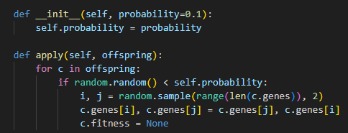

1.5.2 Insertion Mutation

Definition
Insertion mutation removes a gene and reinserts it elsewhere, producing a larger structural change and helping escape local minima.

Code implementation
Implemented in:
- src/ga/techniques/mutation.py → InsertionMutation
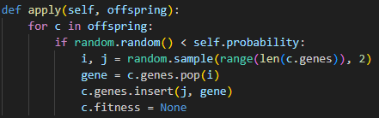

1.6 Elitism

Definition
Elitism copy one (or more) the best individuals to the next generation (ensure high-quality not lost)

Code implementation
Implemented in:
- src/ga/population.py → replace()
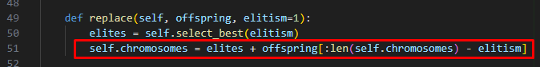
The method preserves the top individual before inserting offspring.

1.7 Convergence and stationary state detection

Definition
Convergence occurs when the population becomes homogeneous and fitness no longer improves. Monitoring fitness evolution is a standard method for detecting stationary states.

Code implementation
Implemented in:
- src/ga/population.py → is_converged()
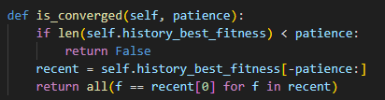
The method checks whether the best fitness has remained constant for a fixed number of generations (patience), implementing the stationary-state criterion described in the lectures.

2. Experimental results
This section presents the results obtained by executing the Genetic Algorithm on three Job Shop Scheduling Problem instances of increasing size: SMALL (6×6), MEDIUM (10×10), and LARGE (20×20). For each instance, we include a description of the dataset, a comparison of six or more parameter configurations, and an analysis of the best solution’s evolution over generations. All experiments were conducted using a population size of 50 and a fixed number of generations per run.

2.1 Small Instance (3–5 Machines)

Dataset description
The ft06 dataset is a classical benchmark from the OR-Library, containing 6 jobs and 6 machines. Each job is defined by a sequence of operations, where each operation specifies the required machine and its processing time. The dataset was retrieved from:
https://people.brunel.ac.uk/%7Emastjjb/jeb/orlib/files/jobshop1.txt
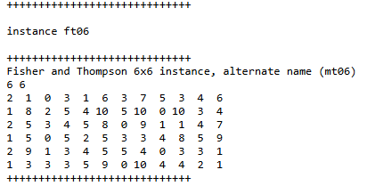
Figure 3. Instance ft06
This instance is suitable for validating the convergence behavior and correctness of the algorithm on small-scale problems.

Results for six parameter configurations
Config | Selection | Crossover | Mutation | Best makespan (fitness)
C1 | Tournament | PPX | Swap | 64
C2 | Tournament | PPX | Insert | 61
C3 | Tournament | JBX | Swap | 59
C4 | Roulette | PPX | Swap | 62
C5 | Roulette | PPX | Insert | 60
C6 | Roulette | JBX | Insert | 64
Analysis:
Although the best result in this particular execution (makespan = 59) was obtained using Tournament+JBX+Swap, the ft06 instance is small and highly sensitive to variation.
In general, tournament selection tends to provide more stable convergence due to its controlled selection pressure, while roulette wheel selection may occasionally outperform it when the initial population happens to contain promising individuals (as casino games, very random).
PPX crossover consistently showed robust performance, and JBX sometimes produced competitive results depending on the run.
Swap mutation remained the most effective mutation operator, leading to faster convergence than Insertion in most cases.

Evolution of the Best Solution
C1 Tournament_PPX_Swap | C2  Tournament_PPX_Insert | C3  Tournament_JBX_Swap
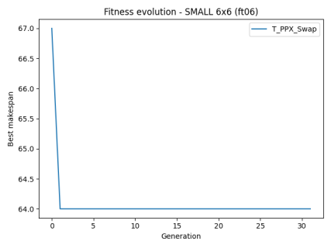 | 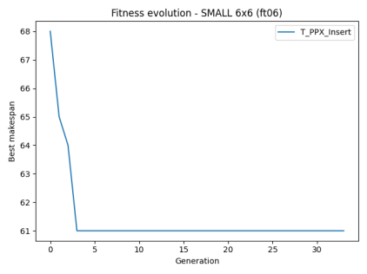 | 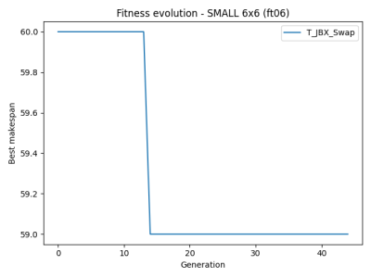
C4  Roulette_PPX_Swap | C5  Roulette_PPX_Insert | C6  Roulette_JBX_Swap
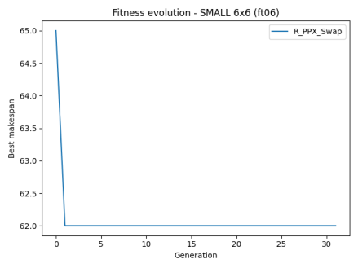 | 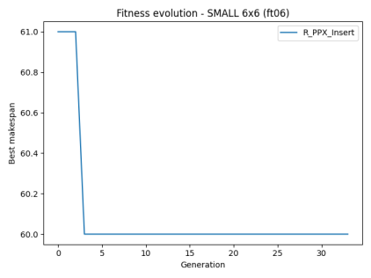 | 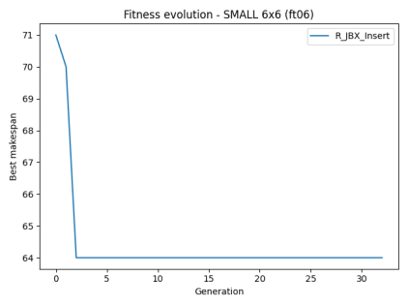

Each plot shows the best makespan over generations. Configurations using tournament selection converged faster and more effectively. Some roulette-based runs showed no improvement, indicating poor exploration.

Comparative plot
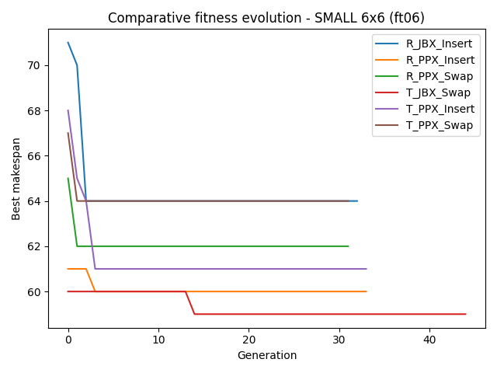
Figure 4. Comparative fitness evolution SMALL

2.2 Medium instance (around 10 machines)

Dataset Description
The la19 dataset contains 10 jobs and 10 machines, with each job defined by a sequence of 10 operations. It was retrieved from the OR-Library and is commonly used to evaluate the scalability of scheduling algorithms.
https://people.brunel.ac.uk/%7Emastjjb/jeb/orlib/files/jobshop1.txt
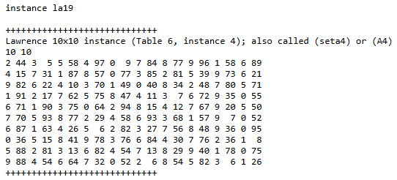
Figure 5. Instance la19
This instance represents a medium-sized problem with increased combinatorial complexity.

Results for six parameter configurations
Config | Selection | Crossover | Mutation | Best makespan (fitness)
C1 | Tournament | PPX | Swap | 982
C2 | Tournament | PPX | Insert | 1164
C3 | Tournament | JBX | Swap | 1193
C4 | Roulette | PPX | Swap | 1072
C5 | Roulette | PPX | Insert | 1116
C6 | Roulette | JBX | Insert | 1128
Analysis:
The best result (makespan = 982) was achieved with Tournament selection, PPX crossover, and Swap mutation. Roulette selection combined with PPX and Swap also performed well (1072), and I think that mutation type is important in medium-scale problems. JBX crossover and roulette selection showed limited improvement.

Evolution of the Best Solution
C1 Tournament_PPX_Swap | C2  Tournament_PPX_Insert | C3  Tournament_JBX_Swap
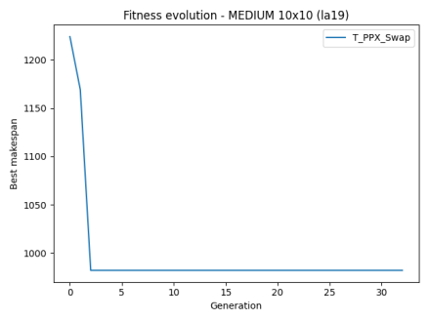 | 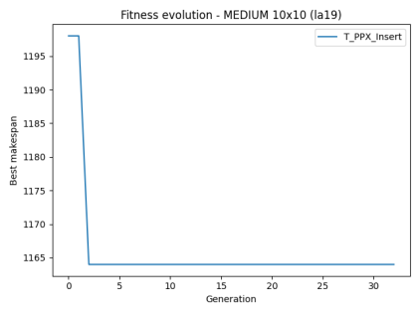 | 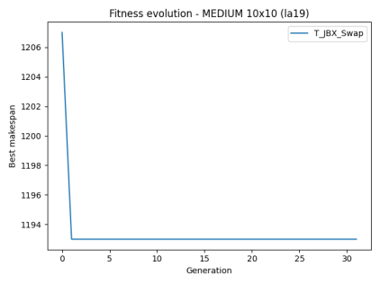
C4  Roulette_PPX_Swap | C5  Roulette_PPX_Insert | C6  Roulette_JBX_Swap
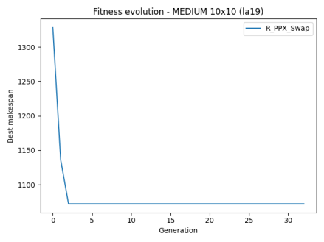 | 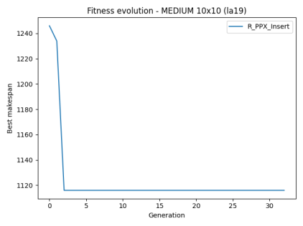 | 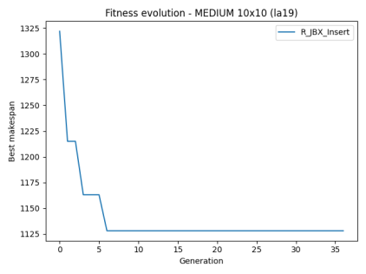
The evolution curves show that most configurations converge within the first 10–15 generations. Tournament selection combined with Insertion mutation leads to faster and deeper convergence.

Comparative Plot
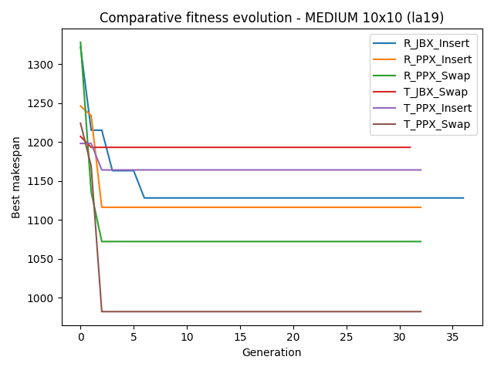
Figure 6. Comparative fitness evolution MEDIUM

2.3 Large instance (15 or more machines)

Dataset Description
The yn1 dataset contains 20 jobs and 20 machines, with each job defined by 20 operations. This instance represents a large-scale scheduling problem with high dimensionality and complex precedence constraints.
https://people.brunel.ac.uk/%7Emastjjb/jeb/orlib/files/jobshop1.txt
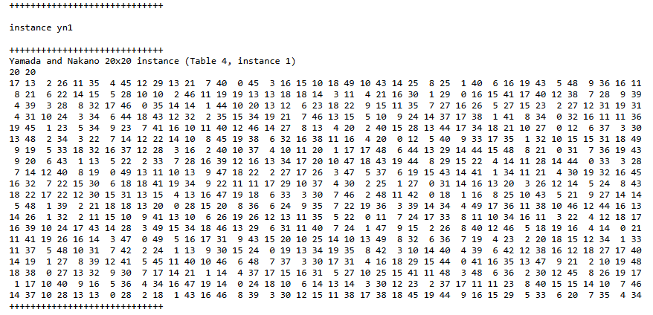
Figure 7. Instance yn1

Results for six parameter configurations
Config | Selection | Crossover | Mutation | Best makespan (fitness)
C1 | Tournament | PPX | Swap | 1427
C2 | Tournament | PPX | Insert | 1422
C3 | Tournament | JBX | Swap | 1484
C4 | Roulette | PPX | Swap | 1410
C5 | Roulette | PPX | Insert | 1429
C6 | Roulette | JBX | Insert | 1551
Analysis:
The results obtained for the large-scale instance (20×20) shows important information about the behavior of the Genetic Algorithm under different operator configurations. The best makespan achieved across all runs was 1410, obtained using roulette selection, PPX crossover, and Swap mutation (configuration C4). This is a notable difference from the SMALL and MEDIUM instances, where tournament selection tended to dominate..

Evolution of the Best Solution
C1 Tournament_PPX_Swap | C2  Tournament_PPX_Insert | C3  Tournament_JBX_Swap
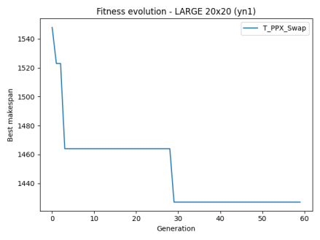 | 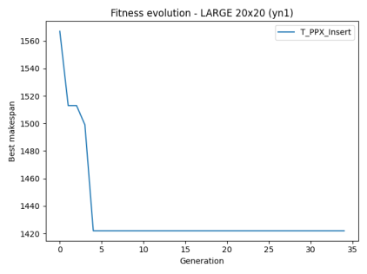 | 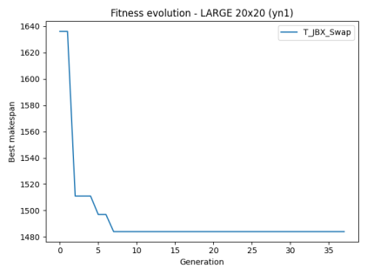
C4  Roulette_PPX_Swap | C5  Roulette_PPX_Insert | C6  Roulette_JBX_Swap
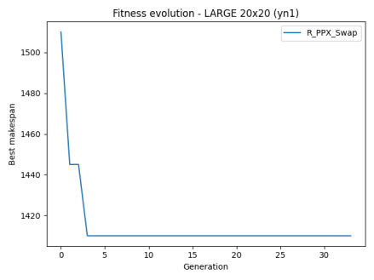 | 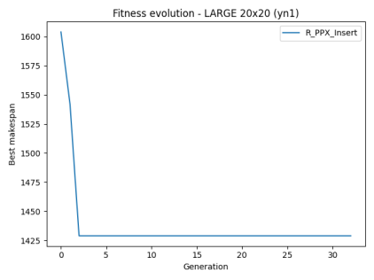 | 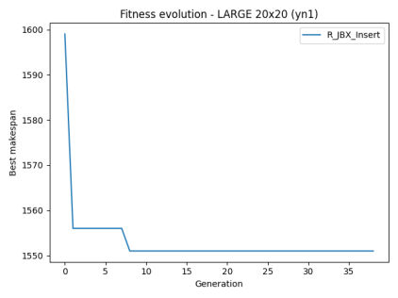
Most configurations converge within 10–15 generations. The best-performing configuration (R_PPX_Swap) shows a steep drop in the first few generations and stabilizes early.

Comparative Plot
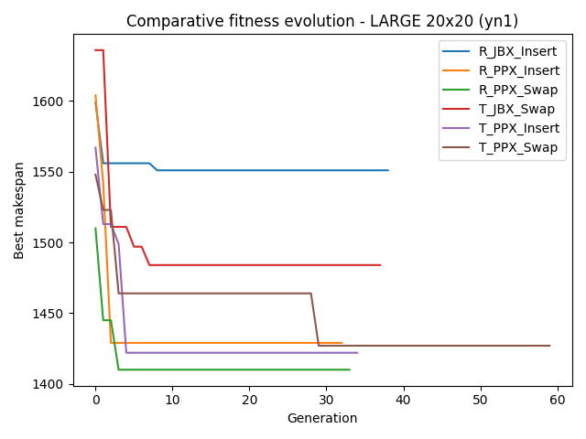

2.4 Conclusions

The results obtained across the three instances confirm that the way the problem is encoded, validated, and evaluated has a direct impact on how the Genetic Algorithm behaves.
The choice of techniques (selection, crossover, and mutation) affects the results and also changes depending on the size of the instance.

SMALL instance (6x6)
In the SMALL instance, several configurations reached similar makespans, and the best result changed between runs. This shows that the search space is small enough for different operator combinations to work well, and randomness plays a significant role. Even so, Tournament selection tended to converge more steadily, while Roulette occasionally matched it when the initial population was favourable, but very randomly.

MEDIUM instance (10x10)
In the MEDIUM instance, the algorithm behaved more predictably. Tournament selection combined with PPX crossover and Swap mutation produced the best results, showing that as the problem grows, the algorithm benefits from techniques that preserve structure and guide the search more consistently. The PPX crossover proved especially effective at maintaining valid operation sequences, which is essential given the codification used.

LARGE instance (20x20)
The LARGE instance keeps diversity. Roulette selection achieved the best makespan when paired with PPX and Swap. In very large search spaces, too much selection pressure (as in Tournament) can lead to premature convergence, while roulette’s stochastic nature helps explore more of the solution space before settling. PPX remained the most reliable crossover technique, and Swap mutation continued to introduce small but useful changes without breaking feasibility.
The experiments show that there is no single “best” configuration for every case, but the codification and validation strategy used in the project works well across all sizes. PPX crossover and Swap mutation stand out as the most robust techniques, while the best selection method depends on the scale of the problem: tournament is more effective in small and medium instances, whereas roulette becomes advantageous in large ones (but ramdom). These results reinforce the importance of adapting the GA’s components to the characteristics of the problem and the structure of the chromosome.

3. Second optimization method (optional)
A second optimization method was implemented: Simulated Annealing (SA). I tried to reuse the same problem encoding, the same makespan evaluation, and the same instance structure already used in the GA.

3.1 SA components
Simulated Annealing works with exactly the same elements as the GA:
- Same chromosome representation: A solution is a list of job IDs, one per operation.
- Same fitness function: SA use the same compute_makespan function used in the GA, so results are directly comparable.
- Same instance structure: The JobShopInstance class is reused without changes.
- Initial solution from the GA: SA starts from the best chromosome of an initial GA population

3.2 Simulated Annealing
Simulated Annealing explores one solution at a time:
- Start from a valid solution (taken from the GA).
- Create a small variation of it (a neighbor) by swapping two positions in the chromosome.
- Evaluate the new solution using the same makespan function.
- If the new solution is better, keep it.
- If it is worse, sometimes keep it anyway, depending on a “temperature” value that decreases over time.
- Repeat until the temperature is very low or the iteration limit is reached.

3.3 Parameters
The following parameters were used:
- Initial temperature: 1000
- Final temperature: 1
- Cooling rate: 0.95
- Max iterations: 2000
- Neighbor operator: swap between two random positions

3.4 Comparison with the Genetic Algorithm
Both algorithms use the same encoding and fitness function, so their results can be compared directly.
In general:
- SA is faster because it works with a single solution instead of a population.
- It depends more on the initial solution, which is why starting from the GA’s best individual helps.
- The GA tends to perform better on larger instances (population).

