Victoria Larrazolo Lesson 4 Hands- on

Create a view named "initialCustomers" that shows the first name, last name, and email address of customers that have an id of less than 100.

Once that is complete, select and view your newly created view.

Create a table named "ProductList"

Next, insert one product into the table following the given guidelines when the table was created. When inserting the data, don't include the ProductId or the DateAdded

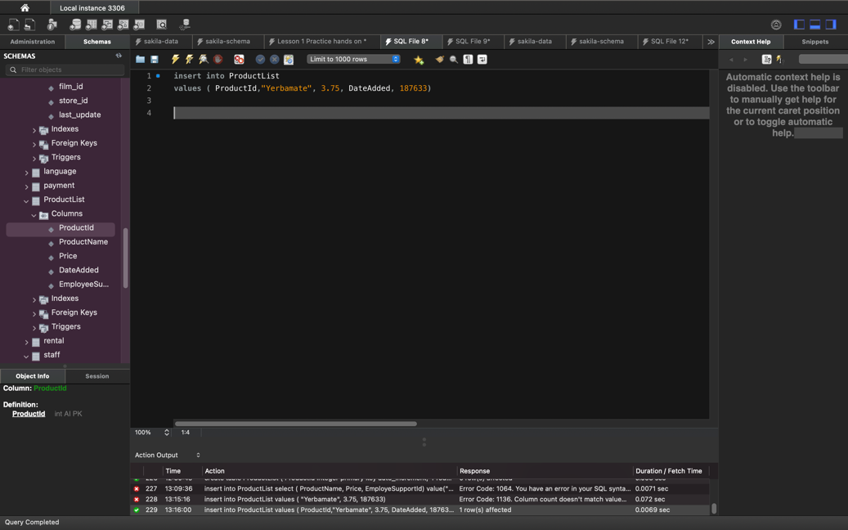

Finally, run a query to see the single product in your table.

