**Push Docker Images into Azure Public Container Registries**

Create ACR Repository

1. Log in to the Azure portal, find the ACR by searching for Container registries and click on Create 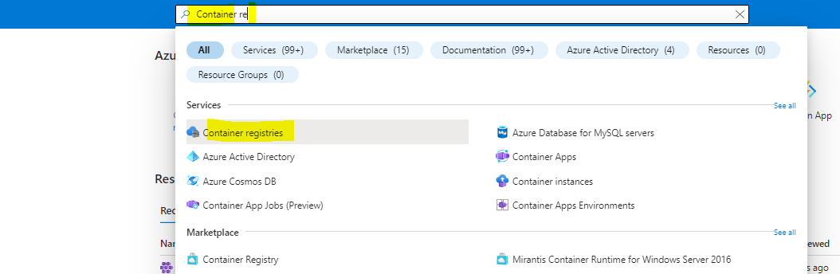

1. Basic settings

Push Image to the ECR

1. Login to ECR server  
   docker login practicaldevops.azurecr.io

You can get Username and password in Settings/Access keys

1. Let’s say we have a hello-world docker image. Now we push hello-world into ACR.  
   Check images we have

Tag hello-world

Push practicaldevops.azurecr.io/hello-world image



Now check the registry

