**Create AKS Using GUI**

Create Master Node

Go to the Azure Portal and search for Kubernetes Service in the search bar and click on it.

Once you reach the Kubernetes Services page, click on Create and then Create Kubernetes Cluster.

Once you click on add Kubernetes cluster, the next step is to update the specifications of the cluster. So, click on Basics.

* Give the Resource Group name as per your requirement. You can create a new one or choose an existing one.
* Specify a name for your cluster in the Kubernetes cluster name field.
* Choose a Region in which you want to create your AKS cluster. In the specified region, our master node will be created.
* Based on the region select the availability zones.
* Select the Kubernetes Version. Here I am choosing the default, i.e., 1.25.6

Next, comes the size and count of the nodes of the AKS cluster that we are going to create. These can be updated as per the requirements.

* Select the Node Size. We are choosing Standard Ds2 v2 which has the following configuration: 2 vCPUs, 7 GiB RAM, 8 Data Disks, 14 GiB Temp Storage.
* Give the Node Count value which specifies how many Worker Nodes we want.

Next comes the Node Pools, follow the steps given below:

* In Azure Kubernetes Service (AKS), nodes of the same configuration are grouped together into node pools. Node pools contain the underlying VMs that run your applications.
* The Virtual nodes are a type of Serverless container instance. As we want to create the Worker nodes as Virtual Machines, so we won’t enable this option.

Next is to click on Access.

Next is the Networking part.

* Select the **Network Configuration.**I will be choosing**Azure CNI**
* The **Cluster Subnet**option is to choose which Subnet you want the Nodes and Containers to be placed in.
* **Kubernetes service address range**is the CIDR notation IP range from which to assign server cluster IPs.
* **Docker Bridge address**is the IP address assigned to Docker Bridge. The Bridge Network is for the container-to-container communication.
* In a **Private Cluster**, the communication between the nodes and the API server happens internally.
* So, I am **Disabling**the Private Cluster.
* Keep the Network Policy to **Azure**.
* Do not enable**HTTP**application routing.

Next is the Integration.

Here we keep all settings to default and move to the next step.

The final step is to click on Review & Create. If you click on Create, it will first Validate your AKS Cluster and if everything is fine then the cluster will be created.

You can see that our new Azure Kubernetes cluster has been successfully created.

To view the cluster, go to Kubernetes services and there you can access the AKS cluster.

Connect to the Azure Kubernetes Cluster

There are two ways to connect the AKS cluster:

I) Using Cloud Shell

II) Using Azure CLI

Cloud Shell: we can see the option on top of our screen.

Run the following command, on the Azure bash shell:

az aks get-credentials --resource-group practical-devops --name practical-devops

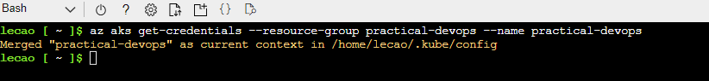

To get the Nodes running in our cluster, run the following command, and you will see all the nodes in your AKS cluster.

kubectl get nodes

Azure CLI

Login to your commands

az login

Download cluster credentials .

az aks get-credentials --resource-group practical-devops --name practical-devops

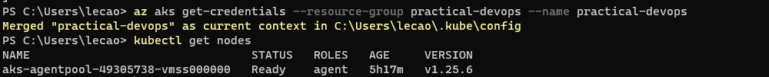  
Deploy app to the Azure Kubernetes Cluster

Refer to Refer to Application_deployed_EKS.pdf file

(We don’t need to set EBS driver)