EPI 590R Surveillance Assignment 3

Victoria Ngo

2024-10-28

## Tables and Figures for Dataset B

# Filtering out unknown or NA values for gender  
datab_filtered <- dataB %>%  
 filter(!is.na(case_gender), case_gender != "Unknown")  
  
# Calculating total number of patients for each gender  
total_by_gender <- datab_filtered %>%  
 group_by(case_gender) %>%  
 summarise(Total = n())  
  
# Summarizing the count of each symptom by gender  
symptom_counts <- datab_filtered %>%  
 group_by(case_gender) %>%  
 summarise(  
 Fever = sum(sym_fever == "Yes", na.rm = TRUE),  
 Subjective_Fever = sum(sym_subjfever == "Yes", na.rm = TRUE),  
 Myalgia = sum(sym_myalgia == "Yes", na.rm = TRUE),  
 Loss_Taste_Smell = sum(sym_losstastesmell == "Yes", na.rm = TRUE),  
 Sore_Throat = sum(sym_sorethroat == "Yes", na.rm = TRUE),  
 Cough = sum(sym_cough == "Yes", na.rm = TRUE),  
 Headache = sum(sym_headache == "Yes", na.rm = TRUE)  
 ) %>%  
 ungroup()  
  
# Merging the total counts and calculate percentages for each gender  
symptom_counts_with_percent <- symptom_counts %>%  
 left_join(total_by_gender, by = "case_gender") %>%  
 mutate(  
 Fever_Percentage = round((Fever / sum(Fever)) * 100, 2),  
 Subjective_Fever_Percentage = round((Subjective_Fever / sum(Subjective_Fever)) * 100, 2),  
 Myalgia_Percentage = round((Myalgia / sum(Myalgia)) * 100, 2),  
 Loss_Taste_Smell_Percentage = round((Loss_Taste_Smell / sum(Loss_Taste_Smell)) * 100, 2),  
 Sore_Throat_Percentage = round((Sore_Throat / sum(Sore_Throat)) * 100, 2),  
 Cough_Percentage = round((Cough / sum(Cough)) * 100, 2),  
 Headache_Percentage = round((Headache / sum(Headache)) * 100, 2)  
 )  
  
# Reshaping the table to have symptoms as rows and gender as columns  
transposed_table <- symptom_counts_with_percent %>%  
 select(case_gender, Fever_Percentage:Headache_Percentage) %>%  
 pivot_longer(cols = -case_gender, names_to = "Symptom", values_to = "Percentage") %>%  
 pivot_wider(names_from = case_gender, values_from = Percentage)  
  
# View the final transposed table  
print(transposed_table)

## # A tibble: 7 × 3  
## Symptom Female Male  
## <chr> <dbl> <dbl>  
## 1 Fever_Percentage 47.7 52.3  
## 2 Subjective_Fever_Percentage 52.1 47.9  
## 3 Myalgia_Percentage 54.4 45.6  
## 4 Loss_Taste_Smell_Percentage 64.2 35.8  
## 5 Sore_Throat_Percentage 55.6 44.4  
## 6 Cough_Percentage 52.4 47.6  
## 7 Headache_Percentage 59.3 40.7

|  |  |  |
| --- | --- | --- |
| Symptom | Female (%) | Male (%) |
| Fever | 638 (47.7) | 699 (52.3) |
| Subjective Fever | 560 (52.1) | 514 (47.9) |
| Myalgia | 684 (54.4) | 574 (45.6) |
| Loss of Taste and Smell | 68 (64.2) | 38 (35.8) |
| Sore Throat | 397 (55.6) | 317 (44.4) |
| Cough | 820 (52.4) | 745 (47.6) |
| Headache | 678 (59.3) | 465 (40.7) |

Table 1. Gender and percentages by symptom

# Summarizing the data by city, gender, and race, excluding "Unknown" and NA values for gender  
city_summary <- dataB %>%  
 filter(confirmed_case == "Yes",   
 !is.na(case_gender),   
 case_gender != "Unknown") %>%  
 group_by(case_city, case_gender, case_race) %>%  
 summarise(Case_Count = n()) %>%  
 ungroup()

## `summarise()` has grouped output by 'case_city', 'case_gender'. You can  
## override using the `.groups` argument.

# Plotting a bar chart to visualize the disease burden by city, gender, and race  
ggplot(city_summary, aes(x = case_gender, y = Case_Count, fill = case_race)) +  
 geom_bar(stat = "identity", position = "dodge") +  
 facet_wrap(~ case_city) +  
 labs(title = "Disease Burden by City, Gender, and Race",  
 x = "City",  
 y = "Number of Confirmed Cases",  
 fill = "Race") +  
 theme_minimal() +  
 theme(axis.text.x = element_text(angle = 45, hjust = 1))

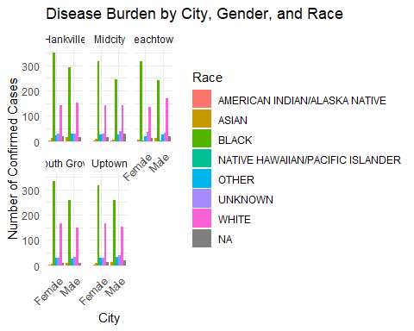

Figure 1. Disease Burden by Case City, Gender, and Race