Density-Aware Loss Weighting for NMS-Free YOLO26 with ByteTrack for Real-Time Vehicle Counting in Dense Heterogeneous Traffic
Naufal Firdaus*1, Sandfreni2
^{1,2}Master of Computer Science, Universitas Esa Unggul, Indonesia

Email: ¹naufalfirdaus282@gmail.com
Phone Number: (+62) 87838882802
Abstract
Automatic vehicle counting from surveillance cameras supports data-driven traffic management, but dense heterogeneous traffic remains hard because two-wheelers dominate the flow, appear as small objects, and occlude one another. YOLO26 introduces an NMS-free detector whose Small-Target-Aware Label Assignment considers object size but ignores how crowded the neighbourhood of an object is. This study proposes Density-Aware Loss Weighting (DALW), which scales the training loss of every object by a weight derived from its local density, and investigates empirically how the added components interact with one-to-one matching. A full factorial ablation of eight variants was trained on 3,389 self-collected CCTV images from Jakarta covering four classes, using group-based splitting to prevent leakage. Detection quality was evaluated per class and per stratum of size, occlusion and density, and differences were tested with Wilcoxon signed-rank tests, Holm correction, rank-biserial effect sizes and bootstrap confidence intervals. The full configuration reached 53.75% mAP@0.5:0.95. Density-Aware Loss Weighting did not improve the baseline alone and was significantly harmful on vehicle-only cells, yet on top of the architectural instruments its contribution was significant across all four classes (unadjusted p = 0.037, r = 0.487, bootstrap interval +1.26 to +3.53 percentage points), concentrated on small objects and on proxy-flagged partial occlusion. The end-to-end system reached a mean absolute error of 1.972 vehicles per interval at 20.47 frames per second, below the 30 frames per second source rate. In this setting, the instrumentation shows that the NMS-free paradigm relocates rather than removes the duplication problem.
Keywords: ByteTrack, density-aware loss weighting, NMS-free detection, small object detection, vehicle counting, YOLO26
This work is an open access article licensed under a Creative Commons Attribution 4.0 International License.
- INTRODUCTION
Traffic congestion in large Indonesian cities keeps growing faster than road capacity, and reliable volume data is the first requirement for any evidence-based mitigation. Records from the Indonesian National Police traffic corps show 168,275,423 registered motor vehicles in April 2025, of which roughly 140.9 million units or 83.7% are motorcycles [1]. The same registry lists about 24.5 million vehicles in the jurisdiction of the Jakarta Metropolitan Police, close to 14.6% of the national fleet, of which about 19.5 million are motorcycles [1]. Congestion in Indonesian cities is severe enough that its mitigation is now a recognised research priority, and recent surveys of machine-learning approaches to traffic management treat reliable volume measurement as the first input any such approach requires [2]. Inductive loop detectors buried under the pavement are expensive to install, damage the road structure, and cannot classify vehicle types, so camera-based counting built on the surveillance infrastructure that already exists is the more practical option.
The technical difficulty of camera-based counting in this setting comes from the traffic composition rather than from exotic vehicle types. Two-wheelers seen at a distance occupy only 8 to 16 pixels in a 640-pixel input, which is at the lower end of the range over which detector accuracy has been shown to degrade sharply with object size [3], and below the resolution that a finest detection scale of P3 with stride eight can represent comfortably. Riding behaviour is tight, so motorcycles frequently slip between larger vehicles and produce heavy mutual occlusion, a difficulty that a dedicated review of motorcycle detection in urban traffic identifies as the dominant failure mode for this class [4], and that persists even in detectors designed specifically for motorbikes on embedded hardware [5]. During peak hours a single frame can contain more than 25 objects, which is exactly the regime where Non-Maximum Suppression tends to suppress valid neighbouring detections.
The YOLO family has evolved quickly since the first single-stage formulation [6], whose successive versions have been surveyed in detail [7], through the spatial attention block of YOLOv11 [8] and the attention-centric design of YOLOv12 [9]. A parallel line of work removed Non-Maximum Suppression from the pipeline itself. YOLOv10 introduced consistent dual assignments, in which a one-to-many branch supervises training while a one-to-one branch serves inference, and reported a latency reduction of 4.63 milliseconds on its small variant while keeping competitive accuracy [10]. YOLO26 continues that design [11], [11]. Its inference head is designed to emit a single prediction per object without post-processing, and it adds Small-Target-Aware Label Assignment, which raises recall on small objects during label assignment. Two gaps remain. First, the reported performance of YOLO26 was validated on a general-purpose benchmark [12], so its behaviour on dense heterogeneous traffic cannot be assumed. Second, Small-Target-Aware Label Assignment reasons only about object size, so a small vehicle standing alone and an equally small vehicle buried in a crowd receive the same treatment even though their detection difficulty differs sharply.
Architectural remedies for small objects are well documented. CRL-YOLOv5 combines the Convolutional Block Attention Module [13] with a P2 detection layer and reports a 5.4% gain in mAP@0.5 on an aerial benchmark [14], MST-YOLO couples mixed local channel attention with a P2 neck and reports a 70.97% relative improvement in small-object average precision [15], and HIC-YOLOv5 adds a P2 head for the same purpose [16]. Attention-based fusion has also been used to strengthen detection of small road users under difficult illumination [17], and fuzzy attention has been applied to vehicle detection specifically [18]. Deep detectors in traffic scenes more broadly have been surveyed from both an algorithmic [19] and a monocular surveillance perspective [20]. All of these were built on NMS-based backbones. Whether the same recipe transfers to an NMS-free detector is an open question, because a high-resolution head multiplies the number of prediction points and may disturb the one-to-one matching that the paradigm depends on. Transformer-based end-to-end detectors such as RT-DETR [21] also remove Non-Maximum Suppression, and open-vocabulary detectors such as YOLO-World [22] and YOLOE [23] extend the recognisable label space. Neither family, however, offers a mature small-object modification ecosystem for a closed set of four traffic classes on a mid-range GPU. YOLO26 was therefore selected over those alternatives and over two-stage detectors such as Faster R-CNN [24].
Using local density to steer training is not itself new, and the position of this study within that literature should be stated precisely. Density maps have been used to compute anchor assignments and to reweight them, and to adapt the suppression threshold at inference, and a query-based detector has been refined specifically so that the one-to-one assignment rule stops emitting several predictions for one object in crowded scenes [25]. What distinguishes the present proposal is neither the use of density nor the attention to crowding, but the point of application and the setting. The weighting acts on the loss of an object that has already been assigned, so it leaves the assignment rule of the host detector untouched and adds nothing to inference, and it is evaluated inside a detector that has no suppression stage to adapt, which is where the interaction question that forms the second contribution arises.
On the tracking side, Simple Online and Realtime Tracking [26] and its appearance-based extension [27] are widely used, while ByteTrack associates every detection box including low-confidence ones [28], which suits occlusion-heavy scenes and avoids a separate re-identification network. Pairing a detector with a tracker is now the common recipe for flow measurement, an approach established with earlier YOLO versions [29] and formalised into a full counting, speed and classification pipeline [30], and pairing specifically with ByteTrack is now widespread, for example an improved YOLOv8n coupled with ByteTrack for vehicle flow detection and counting [31] and a monitoring system that adds speed and size estimation on top of the same pairing [32]. Deployment on constrained hardware has likewise been demonstrated for roundabout supervision [33]. Recent Indonesian work on vehicle counting has stayed with NMS-based detectors: counting on a toll road with YOLOv8 [34], a performance evaluation of YOLOv8 under varying environmental conditions [35], and a web-based traffic density service built on YOLOv8 [36]. Counting accuracy around 90% has been reported for YOLO-based counting on pre-recorded video in a less congested setting [37].
This study makes two contributions. The methodological contribution is Density-Aware Loss Weighting (DALW), a per-object weighting scheme that operates during loss computation and is driven by local density, so it complements rather than duplicates the size-driven mechanism already present in YOLO26. The analytical contribution is a systematic empirical study of how the added components interact with one-to-one matching, measured through the mean number of matched predictions per object, the confidence margin and the stability of the assignment across epochs. A hybrid attention module (HAM) and a P2 detection layer are used as supporting instruments that make the two contributions testable, not as claims of novelty in themselves. The objectives are therefore to implement the proposal within the NMS-free paradigm, to quantify the contribution of each component through a full factorial ablation with formal statistical testing, to map the interaction with one-to-one matching, and to measure the accuracy and speed of the complete counting pipeline.
- METHOD
The work follows five stages: dataset construction and leakage-free splitting, implementation of the proposed weighting together with its supporting instruments, a full factorial ablation over eight variants, instrumentation of the one-to-one matching behaviour, and end-to-end counting evaluation. Figure 1 shows where each component enters the detection pipeline.
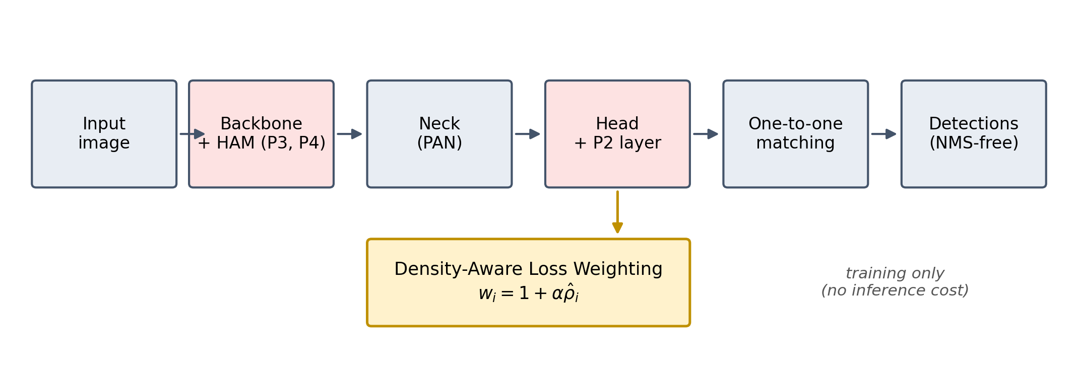
Figure 1. Insertion points of the proposed components in the YOLO26 pipeline
  - Dataset and Leakage-Free Splitting
The dataset consists of 3,389 images recorded from urban traffic surveillance cameras in Jakarta and annotated into four classes, namely two-wheeler, car, big vehicle covering buses and trucks, and pedestrian as a non-vehicle context class [38]. Pedestrians are detected because they contribute to the local density estimate, but they are excluded from the vehicle counts. An initial export showed leakage across subsets, with byte-identical image pairs appearing in different splits, so the split was rebuilt at group level. A group is a proxy for one camera, scene and recording session, derived from the original file names and reinforced by a union-find pass that forces byte-identical images into the same group. Groups are ordered by size and by a stable name digest, then assigned greedily to the subset that minimises the joint deviation from the target image proportion and from the per-class instance proportion, followed by a single-group local search. The procedure uses no random number generator, so it reproduces exactly. Table 1 reports the resulting composition.
Table 1. Dataset composition after group-based splitting
Subset | Images (share) | Big vehicle | Car | Pedestrian | Two-wheeler
Train | 2,372 (70%) | 1,916 | 3,971 | 5,207 | 5,692
Validation | 679 (20%) | 397 | 839 | 1,640 | 1,218
Test | 338 (10%) | 332 | 765 | 638 | 865
Total | 3,389 (100%) | 2,645 | 5,575 | 7,485 | 7,775
Images are letterboxed to 640 by 640 pixels. Augmentation is applied to the training subset only and covers mosaic, horizontal flip, hue-saturation-value jitter, scaling and translation. Density attributes used for stratified reporting are computed from the original annotations and not from augmented images, whereas the density used for loss weighting is recomputed on each augmented image so that the weight always matches the geometry the network actually sees.
  - Density-Aware Loss Weighting
The proposed weighting has three steps: estimate the local density of every object, map that density to a bounded weight, and modulate the per-object loss contribution with the weight. Local density of object i is defined by a Gaussian kernel over the distances between box centres, as in Equation 1, so that the influence of a neighbour decays smoothly with distance.
$ρ_{i}=\sum_{j≠i}{exp\left(\frac{−{\left.‖c_{i}−c_{j}‖\right.}^{2}}{2σ^{2}}\right)}$ (1)
Here cᵢ and cⱼ are the centre coordinates of objects i and j, and σ is the kernel width that controls the neighbourhood radius. The raw density is squashed into the unit interval by Equation 2 so that weights cannot grow without bound in extremely crowded images. Centre coordinates are normalised to the unit square, the summation runs over all annotated objects of any class within the same image, and σ is therefore expressed in normalised units.
$\hat{ρ_{i}}=\frac{ρ_{i}}{ρ_{i}+1}$ (2)
The mapping saturates by design, since a raw density of three yields 0.75 and a raw density of nine yields 0.90. The intention is to raise attention on crowded regions in a controlled way rather than to let a handful of objects in an extreme cluster dominate the whole training loss. The per-object weight follows Equation 3, which guarantees a minimum weight of one in sparse areas and a maximum approaching one plus alpha.
$w_{i}=1+α·\hat{ρ_{i}}$ (3)
The strength parameter α controls how much crowding is emphasised. The weights then modulate the total training loss through Equation 4, where N is the number of objects and Lᵢ is the native YOLO26 loss of object i, including its classification and regression components.
$L=\frac{1}{N}\sum_{i}{w_{i}L_{i}}$ (4)
Because density is computed from ground-truth boxes that are fixed within an iteration, the weight is a per-object constant evaluated before gradient computation and recomputed for augmented images, so it adds no gradient complexity and no inference cost. In YOLO26 the loss is computed per assigned prediction rather than directly per object, so the weight of object i is propagated to every prediction assigned to it, on both branches of the dual head. Background predictions keep a weight of one. This is precisely why the scheme complements Small-Target-Aware Label Assignment instead of duplicating it: the native mechanism acts at label assignment time on the basis of size, while the proposed weighting acts at loss computation time on the basis of crowding. Dividing by the number of objects rather than by the sum of weights lets the total loss scale up on crowded images, which is the intended amplification, and a sum-of-weights variant is reported later as a robustness check. In the implementation the sum in Equation 4 runs over assigned predictions rather than over objects, each prediction carrying the weight of the object it is assigned to, while the divisor remains the number of ground-truth objects.
  - Supporting Architectural Instruments
A hybrid attention module (HAM) is inserted at the P3/8 and P4/16 levels of the backbone, that is after the third and fourth backbone stages, where features still balance spatial detail and semantic content. It applies channel attention followed by spatial attention in cascade, following the principle of the Convolutional Block Attention Module [13] and of squeeze-and-excitation channel recalibration [39], within the broader family of attention mechanisms surveyed in [40]. A P2 detection layer with stride four and a 160 by 160 feature map is added to the head so that objects of 8 to 16 pixels obtain a finer representation. Both are treated as instruments. Their role is to provide the representational capacity that makes the weighting testable and to serve as the subject of the interaction analysis, and the adaptive weighting itself follows the logic of emphasising hard samples at loss computation time that underlies Focal Loss [41]. The P5 head is retained, so the detection head changes from three levels to four. Adding the P2 level reduces the parameter count by 0.29 M, or 2.87%, rather than increasing it. The reduction originates in the detection head: Ultralytics derives the internal head width from the channel count of the finest level entering the head, so introducing a stride-four level lowers that value from 128 to 64 and halves the internal width across all four levels, an effect counted twice because the end-to-end head duplicates its branches for one-to-one prediction. The head loses 452,464 parameters while the new neck branch adds 166,528. The same sign is observed between the official yolo26 and yolo26-p2 configurations. Parameter count is therefore a poor proxy for the cost of the P2 layer, whereas computation and memory are accurate ones.
  - Ablation Design and Training Configuration
A full factorial design over three binary factors produces the eight variants in Table 2. This design was chosen over the more common one-component-at-a-time ablation because interaction effects are part of the research question and cannot be observed otherwise.
Table 2. Full factorial ablation design
Variant | Hybrid attention | P2 layer | DALW | Role
V1 | no | no | no | baseline YOLO26
V2 | yes | no | no | attention only
V3 | no | yes | no | P2 only
V4 | no | no | yes | weighting only
V5 | yes | yes | no | architectural foundation
V6 | yes | no | yes | attention and weighting
V7 | no | yes | yes | P2 and weighting
V8 | yes | yes | yes | full configuration
All variants use identical settings: small model scale, input 640 by 640 pixels, batch size 16, mixed precision, MuSGD optimiser with an initial learning rate of 0.01 and cosine decay, a maximum of 300 epochs with early stopping at patience 50, and a fixed seed. Training ran on a single NVIDIA RTX 4060 Ti with 8 GB of memory using Ultralytics 8.4.92 [42], PyTorch 2.11.0 and Python 3.11.9. The strength and width parameters of the weighting were selected by a three by three grid search on the validation subset with shortened training, using V8 as the search variant. The comparison is deliberately confined to variants of a single detector so that every observed difference can be attributed to the manipulated component rather than to architectural differences between detector families.
  - Counting Pipeline
Detections are passed to ByteTrack [28] through the supervision library [43], which assigns a persistent identity to every vehicle across frames. A virtual line is defined per clip, and a crossing event is recorded together with its direction and class whenever the centre of a tracked box moves from one side of the line to the other. Counts are accumulated in 60-second intervals so that each clip yields ten observations per class and direction. Four ten-minute clips at 30 frames per second were used, three of which entered the evaluation. The virtual lines are defined by the pixel endpoints (1919, 926) and (119, 1) for clip 2, (1280, 668) and (0, 317) for clip 3, and (1919, 784) and (348, 739) for clip 4, at 1920 by 1080 pixels for clips 2 and 4 and 1280 by 720 for clip 3. The endpoints are stored in reversed order relative to the geometric line so that the inbound and outbound directions of the line-crossing counter align with the convention used by the manual counter, in which inbound means moving towards the lower left of the frame. The geometry is unaffected by the reversal.
  - Evaluation Protocol and Statistical Testing
Detection is evaluated with precision, recall, F1, mAP@0.5 and mAP@0.5:0.95 on the test subset, and additionally per cell formed by class and stratum along three dimensions: object size, occlusion level and local density. Cells with fewer than 30 ground-truth objects are excluded from testing and the excluded cells are listed rather than dropped silently. Three primary hypotheses are tested with the Wilcoxon signed-rank test [44] over the per-cell average precision values: the full configuration against the baseline, the weighting alone against the baseline, and the full configuration against the architectural foundation. Effect size is reported as the rank-biserial correlation [45], [46]. The three primary hypotheses were specified before the analysis was carried out and are reported without multiplicity adjustment, while all remaining pairwise comparisons form a secondary family controlled with the Holm procedure. Holm-adjusted values for the primary family are reported alongside the unadjusted values in Table 4 so that both readings are available to the reader. A percentile bootstrap over images with 1,000 resamples provides confidence intervals on the aggregate difference, so that consistency of direction and magnitude of difference are reported side by side. Interaction with the NMS-free mechanism is measured with three quantities. The mean matched predictions per ground-truth object, abbreviated MMP and defined in Equation 5, is the mean number of matched predictions above the reporting threshold per object, where M is the number of ground-truth objects and Nₖ(τ) is the number of predictions above threshold τ matched to object k. Because a missed object contributes zero and a duplicated object contributes two or more, this quantity decreases when misses increase and increases when duplicates increase. It is therefore reported alongside the missed fraction and the duplicate fraction, which separate the two directions, and it should not be read as a duplication indicator on its own. A prediction is matched to object k when their intersection over union is at least 0.50 and object k is the highest-overlap ground truth of the same class for that prediction. Predictions whose class differs from the ground truth are never matched, each prediction is assigned to exactly one object, and several predictions may point at the same object, which is precisely the duplication these metrics quantify. Matched coverage is the proportion of ground-truth objects that receive at least one such matched prediction irrespective of confidence. It is therefore not comparable with the complement of the missed fraction, which is computed at the reporting threshold of 0.25, and it should not be read as recall: it is an upper bound on what the one-to-one head has localised before ranking is applied. Because the three stratification dimensions partition the same test set, a single object contributes to one cell in each dimension, so the per-cell average precision values are not fully independent. The tests are therefore treated as supporting evidence alongside the bootstrap intervals and the stratified differences rather than as the sole basis for any claim. This quantity is denoted Duplicate Rate in the source implementation and in the thesis on which this article is based; it is renamed here because its empirical value is below one for every variant, which makes the original name misleading.
$MMP\left(τ\right)=\frac{1}{M}\sum_{k}{N_{k}\left(τ\right)}$ (5)
Confidence margin, in Equation 6, is the confidence gap between the best and the second-best prediction for an object, so a large margin indicates a clear winner. The reported confidence margin is the mean of CMₖ over all ground-truth objects that receive at least one matched prediction, computed without applying the reporting threshold. When an object receives only one matched prediction the runner-up confidence is taken as zero, so its margin equals the confidence of that single prediction rather than a separation between competitors. This case is common, which is why the margin is reported alongside the duplicate fraction rather than on its own.
${CM}_{k}=conf\left({p_{k}}^{\left(1\right)}\right)−conf\left({p_{k}}^{\left(2\right)}\right)$ (6)
Assignment stability, in Equation 7, measures how often the anchor chosen for an object by the one-to-one head stays the same between consecutive epochs, evaluated on a fixed probe set of validation images processed without augmentation. The assignment aₖ(t) may be empty when no anchor is selected for object k; an empty assignment matched with an empty assignment counts as stable, whereas any transition between an empty and a non-empty assignment counts as unstable. S(t) is undefined at the first epoch because it requires a preceding measurement.
$S\left(t\right)=\frac{1}{M_{probe}}\sum_{k}{𝟙\left[a_{k}\left(t\right)=a_{k}\left(t−1\right)\right]}$ (7)
Counting accuracy is measured per interval with mean absolute error, root mean squared error and mean absolute percentage error, the latter computed only on intervals with a non-zero reference count, with the excluded proportion reported. Pipeline speed is measured end-to-end, covering detection, tracking and counting logic, rather than detection alone.
- RESULT
  - Hyperparameter Search
The grid search over strength values of 0.5, 1.0 and 2.0 and kernel widths of 0.05, 0.10 and 0.20 produced a best validation mAP@0.5:0.95 of 0.6670 at a strength of 1.0 and a width of 0.10. The spread across the nine configurations was only 0.0302, which indicates that the method is not brittle with respect to these two parameters within the range explored. These values were used for every variant that includes the weighting. The best validation value of 0.6670 is not comparable with the test values reported later, which peak at 53.75%, because the grid search used shortened training on the validation subset, whose class and stratum composition differs from that of the test subset. The gap therefore reflects the search protocol rather than overfitting to the validation data.
  - Overall Detection Performance
Table 3 reports global test metrics for the eight variants and Figure 2 shows the mAP@0.5:0.95 ranking. The full configuration attains the highest value at 53.75%, followed by the weighting-only variant at 53.66% and the baseline at 53.56%. The baseline nevertheless remains the best variant on precision, recall, F1 and mAP@0.5, and the full configuration leads only on mAP@0.5:0.95 and only by 0.19 percentage points. Global averages therefore separate no configuration decisively, which is precisely why the analysis proceeds per class and per stratum. The spread across all eight variants is 1.59 percentage points, which is narrow and already suggests that global averages alone will not separate the variants convincingly.
The per-class picture behind these aggregates explains why they are so close together. Two-wheelers are the hardest class for every variant, since they combine the smallest pixel footprint with the highest mutual occlusion, and they also carry the largest share of test instances at 865 of 2,600 objects. Pedestrians, which enter the model only as a context class and never as a counted vehicle, are the easiest. Because the four classes are so unevenly difficult and so unevenly represented, a single mean average precision over all classes can move by a few tenths of a percentage point for reasons that have nothing to do with the manipulated component, which is the second reason the analysis is carried out per cell rather than on the aggregate alone.
The per-class averages make that unevenness concrete. On mAP@0.5:0.95 the baseline reaches 63.84% on big vehicles, 62.88% on cars, 42.69% on two-wheelers and 42.67% on pedestrians, so the gap between the easiest and the hardest class is 21.17 percentage points, more than thirteen times the 1.59 point spread that separates the eight variants. The full configuration reaches 63.19%, 62.95%, 42.38% and 47.64% on the same four classes. Read against the baseline, it loses 0.65 points on big vehicles, gains 0.07 on cars, loses 0.31 on two-wheelers and gains 4.97 on pedestrians, so its 0.19 point advantage on the overall mean is carried almost entirely by the one class that is never counted as a vehicle. That is a further reason not to rest any claim on the global mean. Read instead against the architectural foundation, which is the comparison the third hypothesis actually tests, the weighting gains on every class without exception, by 4.10 points on cars, 2.71 on pedestrians, 1.98 on two-wheelers and 0.38 on big vehicles. The contrast between the two readings is the clearest single illustration of why the contribution of the weighting is described here as complementary: it is consistently positive when the instruments are present and inconsistent when it is measured against a baseline that lacks them. The same asymmetry is visible on mAP@0.5, where the full configuration reaches 80.28% on big vehicles, 82.89% on cars, 78.77% on pedestrians and 71.26% on two-wheelers against 79.73%, 84.06%, 75.22% and 70.65% for the baseline, so it leads on two classes and trails on one while the fourth is almost unchanged.
Table 3. Global detection performance on the test subset
Variant | Precision (%) | Recall (%) | F1 (%) | mAP@0.5 (%) | mAP@0.5:0.95 (%)
V1 | 79.44 | 68.93 | 73.81 | 78.61 | 53.56
V2 | 78.44 | 68.36 | 73.05 | 77.72 | 53.04
V3 | 77.75 | 68.05 | 72.57 | 76.79 | 52.16
V4 | 79.11 | 68.60 | 73.48 | 78.28 | 53.66
V5 | 78.17 | 68.19 | 72.84 | 77.31 | 52.47
V6 | 77.94 | 68.11 | 72.69 | 77.09 | 52.83
V7 | 77.60 | 67.98 | 72.47 | 76.63 | 52.19
V8 | 78.06 | 68.44 | 72.94 | 77.97 | 53.75
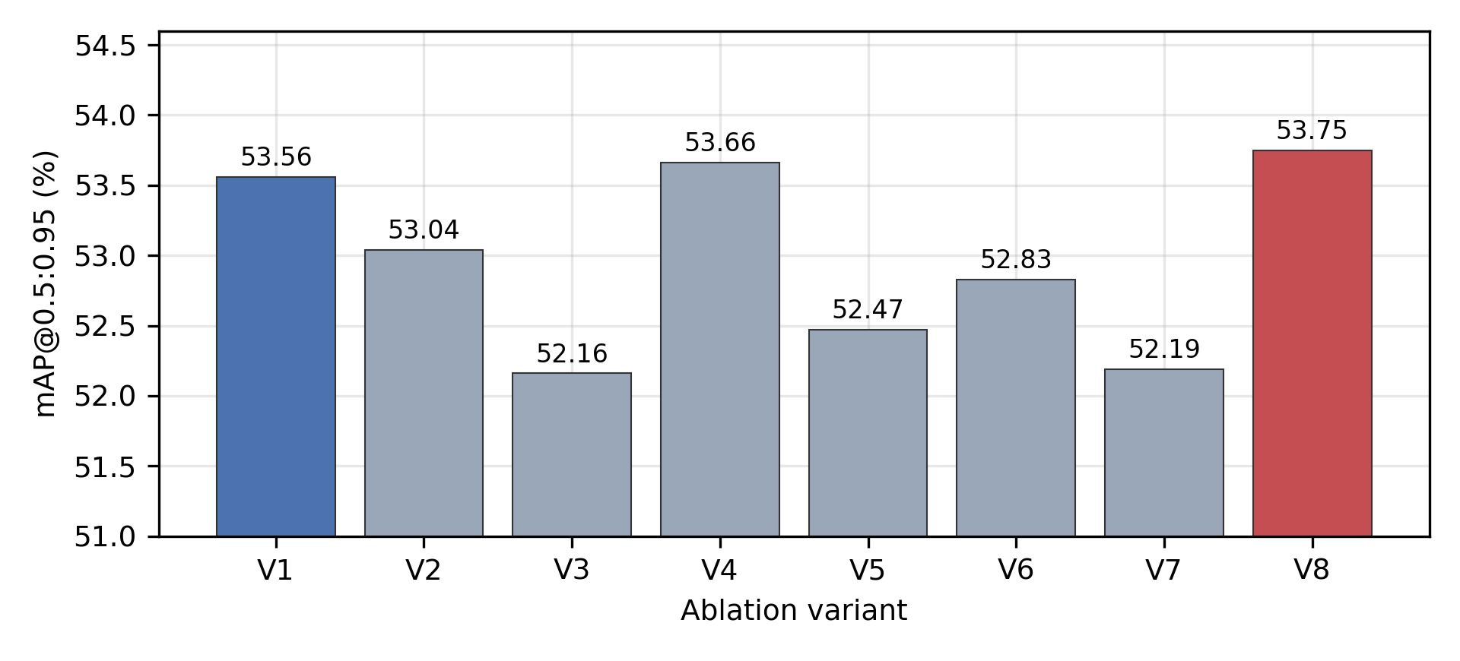
Figure 2. mAP@0.5:0.95 of the eight ablation variants on the test subset. The vertical axis is truncated at 51.0% so that the 1.59 percentage point spread remains legible. Colour marks the baseline and the full configuration.
The ranking also carries a warning. The three lowest positions are occupied by variants that contain the P2 layer, which is the opposite of what the small-object literature would predict, and the reason becomes visible only in the stratified and interaction analyses.
  - Hypothesis Testing
Table 4 summarises the three primary hypotheses on 24 valid class and stratum cells. The full configuration is not significantly better than the baseline, with p = 0.565 and a median difference close to zero, even though the bootstrap interval on the aggregate is positive and narrowly excludes zero. The weighting applied alone is not supported either, and its effect direction is negative, with a rank-biserial correlation of −0.300, so it cannot be described as a positive trend that failed to reach significance. The contribution of the weighting on top of the architectural foundation is significant, with p = 0.037, a moderate to strong effect size of 0.487 and a bootstrap interval of +1.26 to +3.53 percentage points that does not contain zero. The same ordering holds on mAP@0.5, where the third hypothesis reaches p = 0.025 with an effect size of 0.520. Under the pre-specified plan the three primary hypotheses were tested without multiplicity adjustment, and on that basis the V8 against V5 comparison is significant at p = 0.037. If the three primary hypotheses are instead treated as a single family, the Holm-adjusted value is 0.111 and none of the three reaches significance. The effect size of 0.487 and the bootstrap interval of +1.26 to +3.53 percentage points are unaffected by the choice of adjustment, and the result is therefore reported as an indication whose statistical support depends on the multiplicity framework adopted.
The 24 cells are what remains of the 36 potential combinations of four classes and nine strata after the minimum cell rule of 30 ground-truth objects is applied. The twelve excluded cells are, in the density dimension, big vehicles in the dense tier with one object, cars in the dense tier with eleven, two-wheelers in the dense tier with 21 and pedestrians in the sparse tier with 21; in the occlusion dimension, big vehicles under heavy occlusion with two objects, pedestrians under heavy occlusion with two, cars and two-wheelers under heavy occlusion with none at all, and big vehicles under partial occlusion with 27; and in the size dimension, big vehicles in the small tier with 17, pedestrians in the large tier with one and two-wheelers in the large tier with one. Two patterns in that list matter for the interpretation. All four heavy-occlusion cells are excluded, so the heavy tier disappears entirely from the analysis, and three of the four dense cells are excluded, leaving only pedestrians with 77 objects, so the extreme density tier is never tested on a vehicle class. The list also shows that the threshold was not chosen to suit the outcome, since the partial-occlusion cell for big vehicles missed the cut by three objects and was excluded anyway.
Table 4. Primary hypothesis tests and bootstrap confidence intervals
Comparison | n cells | Unadjusted p | Holm-adjusted p | Rank-biserial r | Median difference (pp) | Bootstrap 95% CI (pp) | Supported (α = 0.05)
V8 vs V1 | 24 | 0.565 | 1.000 | +0.140 | −0.02 | +0.05 to +2.08 | no
V4 vs V1 | 24 | 0.208 | 0.416 | −0.300 | −1.33 | −1.21 to +1.00 | no
V8 vs V5 | 24 | 0.037 | 0.111 | +0.487 | +2.07 | +1.26 to +3.53 | yes
Note: pp denotes percentage points. The signed-rank test operates on paired per-cell average precision values, whereas the bootstrap interval is computed on the aggregate difference resampled over test images; the two can therefore differ in direction of conclusion, as they do for V8 against V1.
Two robustness checks support this reading. Removing the pedestrian class, which leaves 18 vehicle-only cells, keeps the third comparison at the edge of significance with p = 0.054 and an unchanged effect size of 0.520, while the second comparison becomes significantly negative with p = 0.021 and an effect size of −0.614. Replacing the normalisation by the sum of weights changes the test mAP@0.5:0.95 only from 53.75% to 53.62%, and the difference is not significant with p = 0.944, so the gain does not come from a change in loss scale. Varying the strength parameter for the weighting-only variant gives 54.00% at 0.5, 53.66% at 1.0 and 54.96% at 2.0, which shows that a single grid search performed on the full configuration is not optimal for every variant. The last figure deserves emphasis because it works against the interpretation this study adopts: at a strength of 2.0 the weighting-only variant exceeds every configuration in Table 3, including the full configuration, on the global mean. It does so without the P2 layer and therefore at roughly a seventh of the training cost and with a detection-only frame rate close to the baseline. The conclusion that the weighting is complementary rather than standalone is thus conditional on the frozen hyperparameter setting, and a per-variant search remains the most likely source of a stronger standalone result.
The secondary family on mAP@0.5 yields five significant pairs after Holm correction, and all five involve the same variant losing: attention combined with the weighting but without the P2 layer. The strongest is V1 against V6 with a corrected p of 0.0001 and an effect size of +0.933. This anomaly indicates that density weighting without sufficient spatial resolution is associated with degraded detection quality, which is consistent with the interaction analysis reported later. The instrumentation explains that anomaly rather than merely recording it. Among the eight variants, V6 has both the highest duplicate fraction at 0.1146, which is more than three times the baseline value, and the lowest confidence margin at 0.4578. It is therefore the configuration in which the largest number of competing predictions survive with the least separation between them, which is precisely the failure mode that a detector without Non-Maximum Suppression cannot repair after inference. Since V6 is the only variant that combines the weighting with attention while omitting the P2 layer, the pattern also supports the reading that the weighting needs the finer detection scale to convert its emphasis on crowded regions into usable predictions rather than into competing ones.
  - Stratified Performance
Figure 3 shows where the differences actually sit. Against the architectural foundation, the weighting adds 5.37 percentage points on partially occluded objects and 3.02 percentage points on small objects, and it is positive on 18 of the 24 cells. Against the baseline, the full configuration gains 3.72 percentage points on partial occlusion and 0.87 on small objects, but it loses ground on medium density and on sparse scenes, which explains why the first hypothesis fails despite the positive aggregate. The extreme density tier could not be tested for vehicles at all, because after applying the minimum cell rule only the pedestrian class survived in that tier, so the very condition that motivates the method remains untested on the target classes.
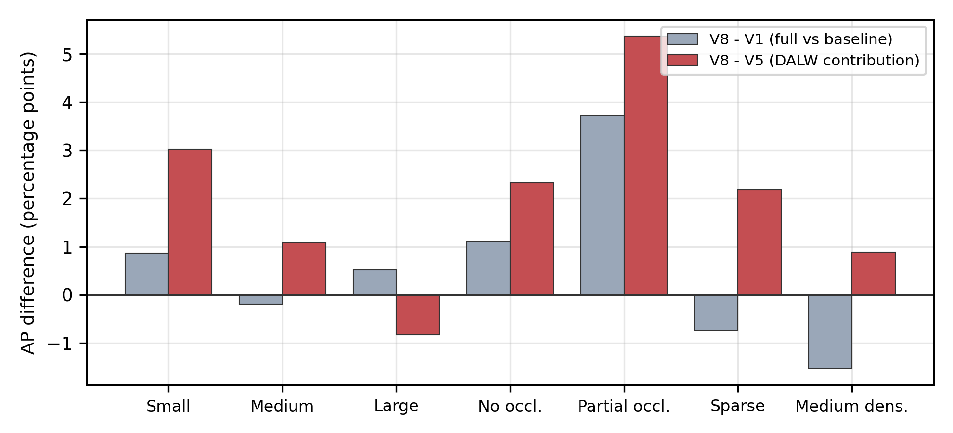
Figure 3. Stratified average precision differences, averaged over classes within each stratum, after applying the minimum cell rule. The dense tier and the heavy occlusion tier are absent because no vehicle cell survived the rule in those tiers.
  - Computational Cost
Table 5 separates the cost of each component. The weighting adds no parameters, no floating point operations and no inference latency, since it exists only in the loss. The P2 layer accounts for the entire cost increase, raising the computational cost from 22.51 to 26.42 GFLOPs, an increase of 17.4%, and raising peak allocated training memory from 5.04 to 8.64 GB, which is 71%. Wall-clock training time rose far more steeply than either figure suggests: per-epoch time was between 59 and 64 seconds for the four variants without the P2 layer and between 317 and 417 seconds for the four variants containing it, a factor of between five and seven against a computational increase of only 17%. Two effects contribute. The stride-four head multiplies the number of anchor points by roughly four, which raises the cost of label assignment rather than of convolution. In addition, the allocated memory of these variants exceeds the 8 GB of physical device memory of the device used here, so part of the working set was served from shared system memory across the PCIe bus. The training times reported here are therefore specific to this hardware configuration and should not be read as an intrinsic property of the P2 layer. The wall-clock figures are further confounded by early stopping, which terminated different variants at different epochs: V1 and V4 share the same parameter count and GFLOPs yet differ by 11% in training time, and V5 and V8 share parameters, GFLOPs and memory yet differ by 12%. The analytical estimate of 30% to 40% that is commonly assumed for an extra detection scale therefore overstates the measured cost for this configuration. Comparing the full configuration with the weighting-only variant makes the trade-off concrete: 0.09 percentage points of mAP@0.5:0.95 are bought with 17.4% more operations, a 23.6% lower frame rate, and 8.2 times the training time.
Table 5. Model complexity and efficiency
Variant | Params (M) | GFLOPs | Peak allocated memory (GB) | Peak reserved memory (GB) | Epochs | Seconds per epoch | Train time (h) | Detection-only FPS
V1 | 9.951 | 22.51 | 5.04 | 6.40 | 96 | 59.2 | 1.58 | 32.39
V2 | 9.968 | 22.54 | 5.17 | 6.37 | 112 | 61.4 | 1.91 | 29.02
V3 | 9.665 | 26.40 | 8.52 | 11.67 | 100 | 316.8 | 8.80 | 24.15
V4 | 9.951 | 22.51 | 5.05 | 6.38 | 84 | 60.1 | 1.40 | 30.51
V5 | 9.682 | 26.42 | 8.64 | 11.79 | 98 | 376.2 | 10.24 | 22.52
V6 | 9.968 | 22.54 | 5.17 | 6.37 | 52 | 63.8 | 0.92 | 28.72
V7 | 9.665 | 26.40 | 8.52 | 11.67 | 97 | 341.9 | 9.21 | 23.85
V8 | 9.682 | 26.42 | 8.64 | 11.80 | 99 | 417.2 | 11.47 | 23.31
  - Interaction with One-to-One Matching
Note: memory is reported as the peak value returned by the CUDA allocator. The physical device memory of the GPU used here is 8 GB, so the four variants containing the P2 layer exceeded it and completed only because the driver spilled the excess into shared system memory. Detection-only FPS excludes tracking and counting; the end-to-end figure is 20.47 frames per second and is reported in the counting subsection.
Table 6 and Figure 4 report the instrumentation at a confidence threshold of 0.25. The P2-only variant lowers MMP by 0.0577 and narrows the confidence margin by 0.0427 relative to the baseline, and the same pattern appears when P2 is combined with the weighting. The decomposition shows that this movement is driven by a rise in the missed fraction from 0.2565 to 0.3208 rather than by fewer duplicates, since the duplicate fraction of the P2-only variant rises from 0.0346 to 0.0408. Adding hybrid attention reverses the direction, lifting MMP by 0.0465 and the confidence margin by 0.0449 above the baseline for the architectural foundation, and by 0.0546 and 0.0310 for the full configuration, in both cases by recovering coverage rather than by suppressing duplicates. Read on the duplicate fraction alone, the clearest pattern is not architectural but methodological: in all four controlled pairs, adding DALW raises the duplicate fraction, from 0.0346 to 0.0465 against the baseline, from 0.0227 to 0.1146 on top of attention, from 0.0408 to 0.0523 on top of the P2 layer, and from 0.0458 to 0.0654 in the full configuration, a mean increase of a factor of 1.94. Neither instrument shows a consistent direction. The weighting therefore appears to concentrate confident predictions in the crowded regions it upweights, which is a plausible mechanism for its harmful effect when applied alone. The ordering is stable across thresholds of 0.10, 0.25 and 0.40, so the relative behaviour of the variants does not depend on the operating point chosen for reporting. Matched coverage, reported in the last column of Table 6, stays between 95.54% and 97.81% for every variant, so the one-to-one head localises almost every object before ranking is applied. The gap between that figure and the complement of the missed fraction, which ranges from 67.12% to 77.85% at the reporting threshold, is the more informative quantity: for the baseline it reaches 22.5 percentage points, meaning that roughly 22 of every 100 objects are correctly localised and correctly classified by the one-to-one head yet fall below the operating threshold. That is a calibration and ranking deficit rather than a localisation failure. The gap is narrowest for the two variants that combine attention with the P2 layer, at 19.4 and 20.2 percentage points, and widest for the two variants without attention at 28.7 and 29.1, which supports the reading that attention sharpens the decision boundary through evidence independent of the confidence margin. Figure 5 extends the comparison over twelve thresholds and shows that the two curve groups never cross, so the conclusion does not depend on the choice of a single operating point. Because the three fractions partition the set of ground-truth objects exactly at the reporting threshold, the proportion of objects that receive exactly one matched prediction follows as one minus the missed fraction minus the duplicate fraction. That proportion is 0.7089 for the baseline and ranges from 0.6366 to 0.7327 across the eight variants, with the architectural foundation highest and the attention-plus-weighting variant lowest. The ordering of that quantity is not the ordering of either component fraction, which is why it is worth stating separately: the two variants at the extremes reach their positions for opposite reasons, the foundation by missing fewer objects and the attention-plus-weighting variant by duplicating more of them. The median confidence margin behaves consistently with the mean but separates the variants more sharply, running from 0.4665 for the attention-plus-weighting variant to 0.7360 for the architectural foundation against 0.6659 for the baseline. The distance between mean and median in every variant reflects the left-skewed shape of the margin distribution, which follows from the convention that an object with a single matched prediction contributes that prediction confidence rather than a separation between competitors. The magnitude of that effect is not uniform, ranging from a 28.2% rise on top of the P2 layer to a 404.8% rise on top of attention alone, so the direction is consistent while the size depends strongly on what the weighting is combined with.
Table 6. NMS-free interaction metrics at a confidence threshold of 0.25. MMP denotes the mean number of matched predictions per ground-truth object, the quantity called Duplicate Rate in the source implementation.
Variant | MMP (mean matched predictions) | Missed fraction | Duplicate fraction | Confidence margin | Matched coverage | Δ MMP vs V1 | Δ CM vs V1
V1 | 0.7781 | 0.2565 | 0.0346 | 0.5484 | 0.9685 | – | –
V2 | 0.6938 | 0.3288 | 0.0227 | 0.5243 | 0.9619 | −0.0843 | −0.0241
V3 | 0.7204 | 0.3208 | 0.0408 | 0.5057 | 0.9658 | −0.0577 | −0.0427
V4 | 0.8054 | 0.2435 | 0.0465 | 0.5561 | 0.9781 | +0.0273 | +0.0077
V5 | 0.8246 | 0.2215 | 0.0458 | 0.5933 | 0.9723 | +0.0465 | +0.0449
V6 | 0.8746 | 0.2488 | 0.1146 | 0.4578 | 0.9750 | +0.0965 | −0.0906
V7 | 0.7612 | 0.2927 | 0.0523 | 0.5241 | 0.9554 | −0.0169 | −0.0243
V8 | 0.8327 | 0.2350 | 0.0654 | 0.5794 | 0.9665 | +0.0546 | +0.0310
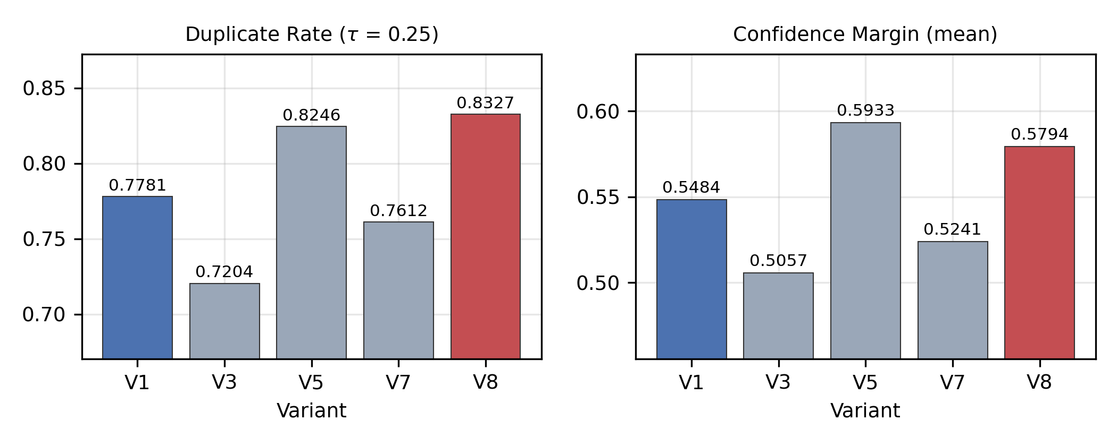
Figure 4. Mean matched predictions per ground-truth object (MMP), labelled duplicate rate in the panel titles because the figure retains the source naming, and confidence margin across variants with and without the P2 layer.
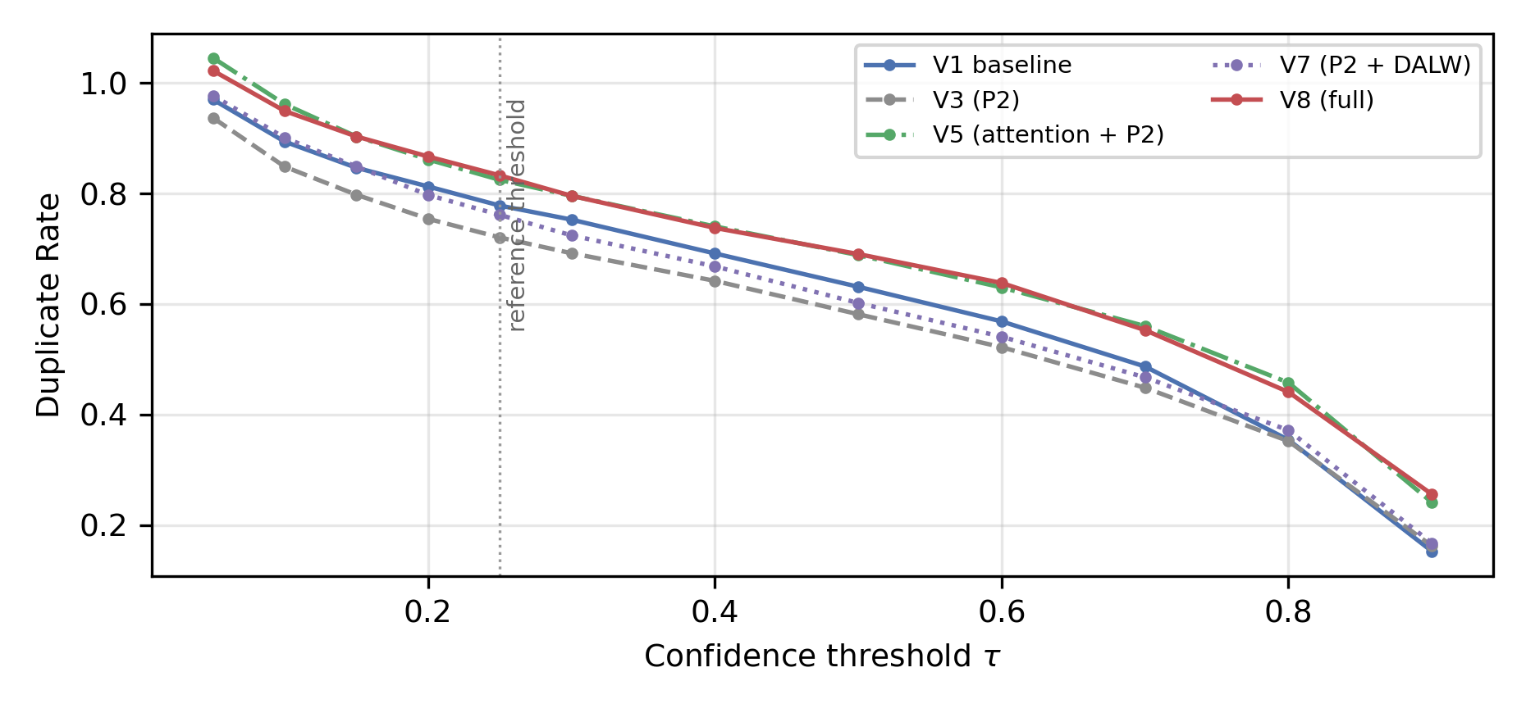
Figure 5. Mean matched predictions per ground-truth object (MMP), labelled duplicate rate on the vertical axis because the figure retains the source naming, across twelve confidence thresholds. The curves without attention are V3 and V7, the curves with attention are V5 and V8, and V1 is the baseline reference between them.
Assignment stability adds a second view of the same phenomenon, shown in Figure 6. Every variant rises quickly during the first epochs and then settles between 0.6 and 0.8, with per-variant means from 0.63 to 0.69 and no further upward trend, so matching is not fully converged and roughly one third of the probe objects still change anchor between epochs at the end of training. The value of one recorded in the final probe row of every run is a measurement artefact rather than convergence, because all companion metrics in that row are identical to the previous row across all runs, which means the last measurement was taken on unchanged weights. The informative difference sits at the beginning: the four variants that contain the P2 layer start between 0.20 and 0.27, while the variants without it start between 0.46 and 0.65, and both groups then meet at a comparable level. Denser predictions do disturb one-to-one matching, but the disturbance is transient.
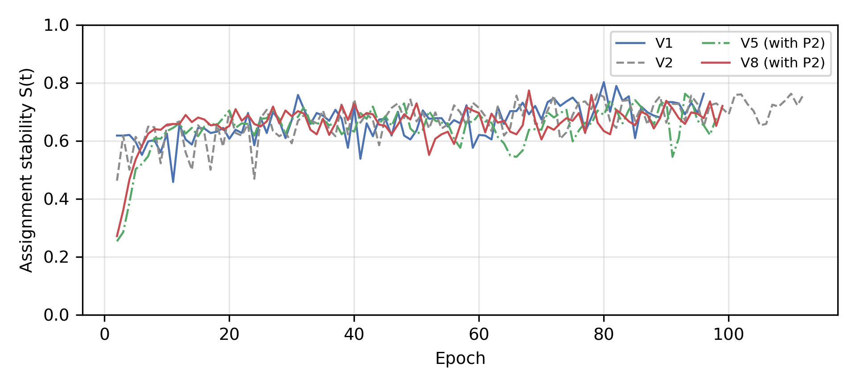
Figure 6. Assignment stability during training for four representative variants. The final probe row of every run is excluded because it repeats the preceding row and reflects an unchanged set of weights. The starting values quoted in the text are computed over all eight runs.
  - End-to-End Counting
One of the four clips was excluded on a measurement-validity criterion applied at the preparation stage rather than on a comparison against the manual counts. Its virtual line terminates at y = 839 and does not reach the lanes used by cars, so a diagnostic pass over 80 seconds produced 24 car tracks of which only two changed side of the line and none generated a crossing event, while a perpendicular control line recovered the manual count for the first minute exactly. The same criterion does not apply to the busiest clip, whose line spans the full width of the carriageway, which is why that clip is retained despite contributing most of the counting deficit. The raw evidence for the excluded clip is retained. On the three remaining clips the system produced 180 interval observations. Table 7 reports the results and Figure 7 compares system counts with the manual reference per interval.
Table 7. Counting performance per clip and in aggregate
Clip | MAE | RMSE | MAPE (%) | System total | Manual total | Deviation (%)
Clip 2 | 0.717 | 1.478 | 39.28 | 79 | 116 | −31.9
Clip 3 | 1.050 | 1.522 | 26.78 | 259 | 296 | −12.5
Clip 4 | 4.150 | 8.302 | 54.33 | 684 | 931 | −26.5
Combined | 1.972 | 4.947 | 37.17 | 1,022 | 1,343 | −23.9
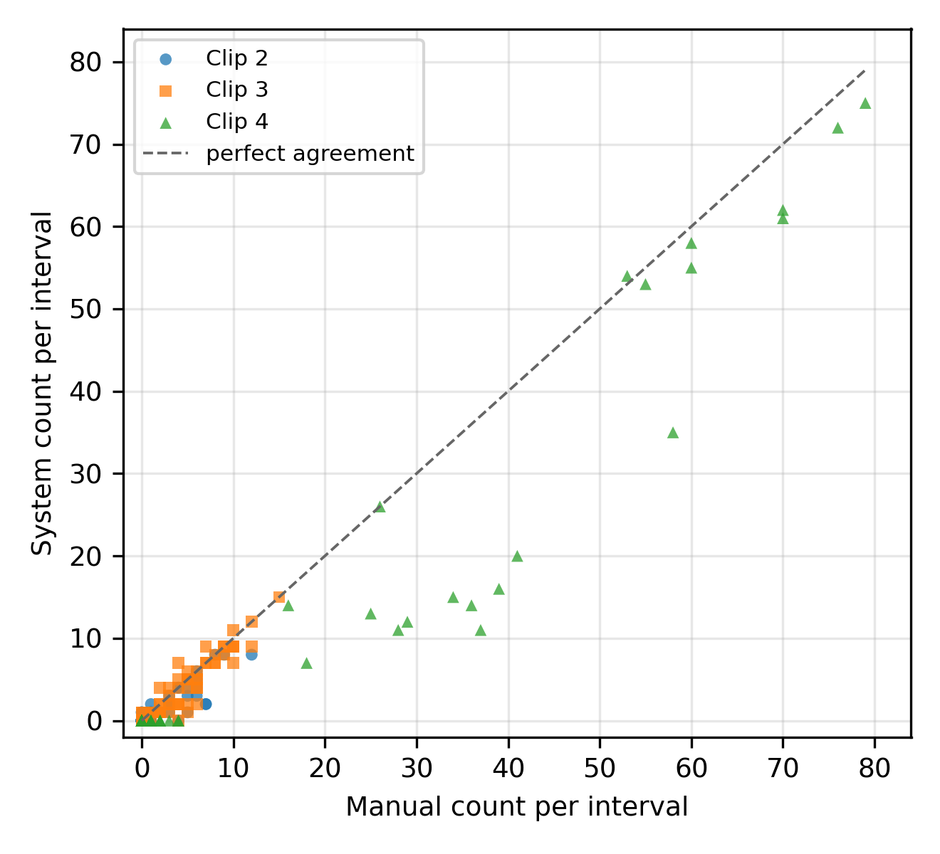
Figure 7. System counts against the manual reference for every 60-second interval
Note: Clip 1 is not listed because it was excluded after diagnosis of its virtual line placement. Combined MAPE is computed over the pooled set of eligible intervals rather than as the mean of the per-clip values.
Mean absolute percentage error was computed on 112 intervals, since 68 of the 180 intervals have a zero reference count and were excluded, which is 37.8% of the observations. Reliability varies strongly by class: two-wheelers reach 87.6% of the manual total, cars 59.5% and big vehicles only 31.2%. The aggregate count ratio, defined as the total system count divided by the total manual count, reached 76.1%. This quantity does not penalise errors that cancel between intervals, so it is reported alongside the mean absolute error and the root mean squared error, which do. The per-cell breakdown locates the deficit precisely. Of the 321 missing crossings, 170 come from inbound cars and 21 from inbound big vehicles in the busiest clip, which is 59.5% of the total deficit concentrated in two cells whose pattern points to line geometry rather than to a general detection failure. End-to-end throughput was 20.47 frames per second with a confidence interval of 19.45 to 21.49, against a source rate of 30 frames per second, and no variant reached the real-time threshold when the full pipeline was measured.
The class ordering of counting reliability follows the class ordering of detection difficulty only in part. Two-wheelers, which are the hardest class to detect, are the most reliably counted at 87.6% of the manual total, whereas big vehicles, which are among the easiest to detect, are the least reliably counted at 31.2%. The explanation is not detection but geometry and trajectory. Two-wheelers cross the virtual line in dense but regular streams that the tracker follows well, while big vehicles are few, move through the lanes furthest from the line in the busiest clip, and occupy enough of the frame that a single missed association removes a large share of their total. This is the clearest demonstration in the study that counting performance cannot be inferred from detection performance, and it is the reason both are reported separately. A second consequence follows for deployment. Because the deficit is concentrated in two cells of one clip rather than spread across the observations, the aggregate figures understate how well the system performs where its geometry is correct and overstate how well it would perform if that geometry were replicated blindly at a new site. Removing the two affected cells from the pooled totals leaves a residual deficit of 130 crossings out of 1,343, so on the remaining sixteen cells the system recovers about 90% of the manual total. That figure is reported here not as a headline result, since removing the worst cells after seeing them is not a legitimate way to report accuracy, but as the quantity a practitioner needs in order to decide whether the remaining error is worth engineering effort on the detector or on the line placement. On this evidence it is the line placement.
  - Error Analysis
The full configuration reduces missed objects in every stratum relative to the baseline, from 614 to 541 out of 2,600 test objects. The reduction is paid for with more false positives, which rise from 553 to 638 on small objects and from 624 to 696 in medium-density scenes, and this is the mechanistic explanation for the slightly lower precision of the full configuration despite its higher mAP@0.5:0.95. It is also consistent with what density weighting is supposed to do, namely raise sensitivity in crowded regions. By class, two-wheelers remain the weakest with 31.21% of objects missed, followed by cars at 17.39%, big vehicles at 15.96% and pedestrians at 13.32%. Illumination is the strongest single factor: night scenes contribute 1,880 of the 2,600 test objects, or 72.3%, from only 38.2% of the images, and the miss rate at night is 24.73% against 10.56% during the day. All three worst-performing images come from the same night recording. Validation of the occlusion proxy against manual annotation of 200 objects in 150 images gives 68.0% agreement with a weighted kappa of 0.427, and the proxy never assigns the heavy tier, so the occlusion findings should be read as a lower bound. Figure 8 summarises the two dominant error patterns, namely the day and night gap across variants and the per-class miss rate of the full configuration.
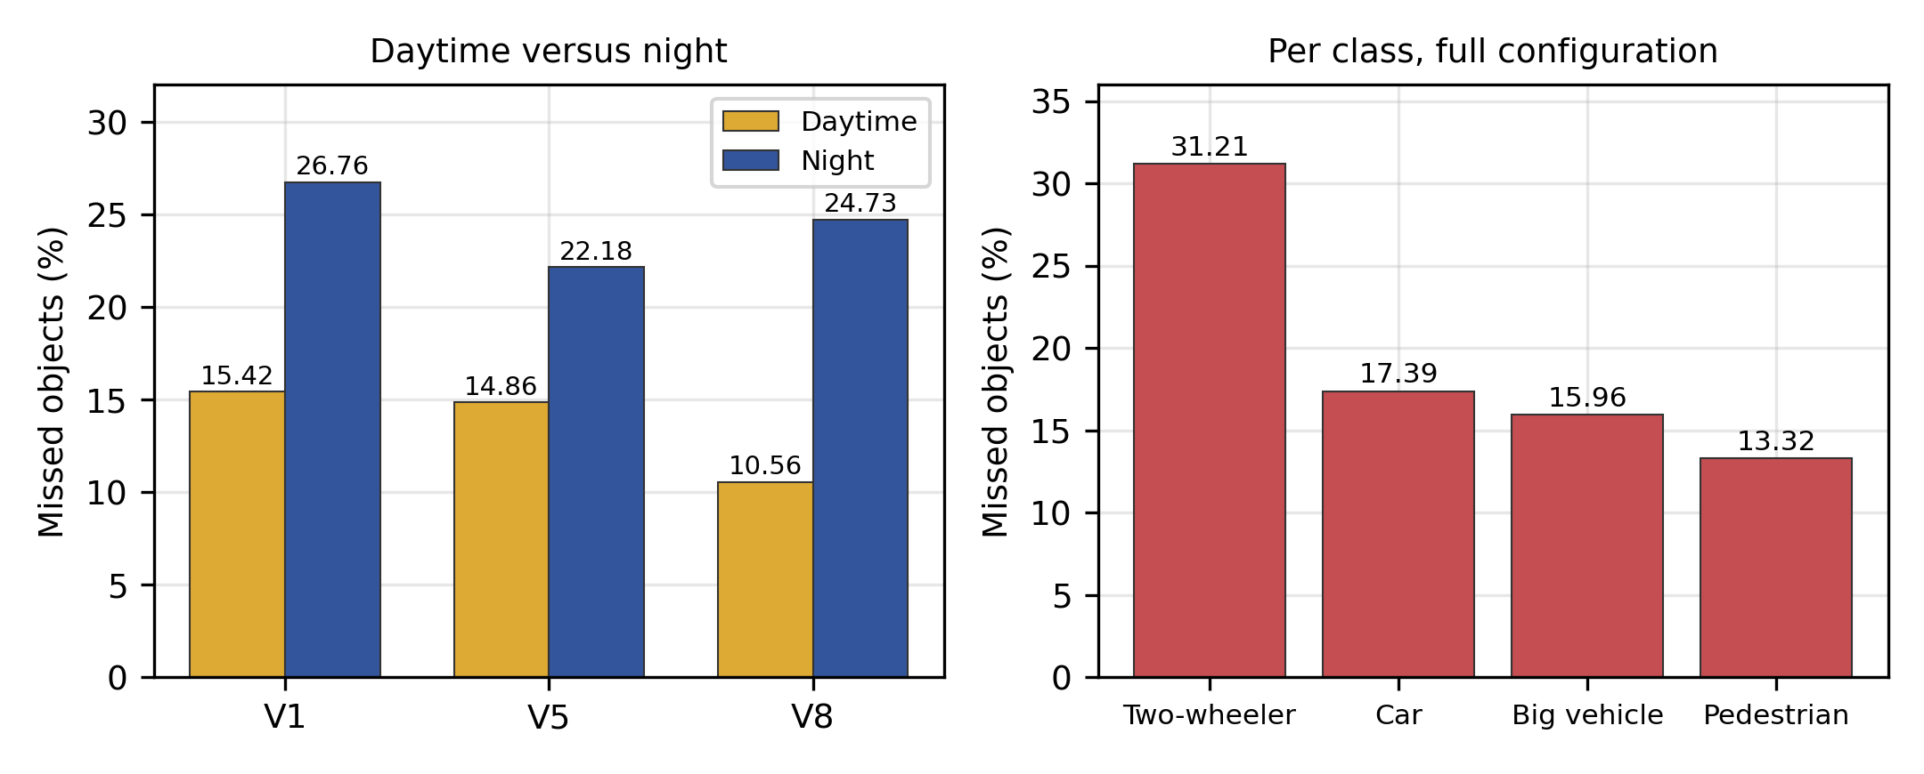
Figure 8. Missed objects by illumination condition and by class
- DISCUSSIONS
The central result is that density-aware weighting is a complementary component rather than a standalone improvement. Its contribution is significant only when a hybrid attention module and a P2 layer are already present, and applied alone on vehicle-only cells it is significantly harmful. A plausible mechanism is that weighting redistributes learning capacity toward crowded regions, and a model without the resolution to represent small crowded objects cannot convert that redistribution into better detections. The anomaly of the variant that combines attention with weighting but omits the P2 layer, which loses to five other variants after correction with effect sizes up to 0.933, points in the same direction from the opposite side. The three components can therefore be summarised as a division of labour, where the P2 layer supplies resolution at the cost of a higher missed fraction, attention sharpens the decision margin and recovers coverage, and the weighting directs learning. None of the instruments reduces duplication: across the four controlled pairs in which DALW is added, the duplicate fraction rises every time, which is the clearest evidence in this study that removing Non-Maximum Suppression relocates the duplication problem into training-time matching rather than eliminating it. On the per-cell evidence the incremental benefit of the weighting appears only when both instruments are present, although global averages do not reproduce this ordering.
The interaction analysis produces a result that is not visible in aggregate metrics and that has practical value for anyone modifying an NMS-free detector. Removing Non-Maximum Suppression does not remove duplication, it moves the problem into the training-time matching process. The P2 layer lowers both MMP and the confidence margin, hybrid attention restores them by recovering coverage rather than by suppressing duplicates, and matching stability under a P2 head starts far lower than without it. Practitioners adding a high-resolution head to an NMS-free detector should therefore expect a transient matching penalty and should pair the head with a mechanism that sharpens the decision margin.
Compared with previous work, the gains reported here are smaller than the 5.4% mAP@0.5 improvement of CRL-YOLOv5 [14] and the relative small-object gain of MST-YOLO [15]. Three differences make a direct comparison unfair. Those studies used aerial benchmarks with a different size distribution, they modified NMS-based backbones with more headroom for improvement, and they report aggregate rather than stratified results. This study takes the stricter route of reporting per-cell tests with a minimum cell rule, and under that rule the honest statement is that only the third hypothesis holds. On the counting side, the aggregate count ratio of 76.1% is below the roughly 90% reported for YOLO-based counting on pre-recorded video in a less congested setting [37], below the accuracy reported for an improved YOLOv8n paired with ByteTrack on highway flow [31] and for the vision-based counting pipeline of Liu and colleagues [30], and below the 90% and 95% thresholds used for short-count traffic monitoring equipment [47]. Those comparisons are made on freer flow with fewer two-wheelers, so the gap reflects scene difficulty as much as model quality. Interpreting the mean absolute percentage error of 37.17% with the conventional forecasting scale [48] would place it in the reasonable band, but that scale was developed for forecasting rather than for counting, and the more useful reading is that per-interval per-class per-direction error is a much harsher measure than aggregate counting accuracy, so cross-study comparison must state the evaluation unit. The same caution applies in the other direction. The aggregate count ratio used here is the quantity most often reported as counting accuracy in the studies cited above, yet it is also the quantity least sensitive to error, because overcounts in one interval cancel undercounts in another. Reporting it beside the mean absolute error, as done here, is the minimum needed for a comparison to carry meaning.
Several limitations bound these conclusions. All results come from a single training run with a fixed seed, because repeating the eight variants across three seeds would have required roughly 49 additional GPU hours, so conclusions about small differences carry unquantified uncertainty. The extreme density tier, which motivates the method most directly, could not be tested on vehicle classes for lack of volume. The occlusion proxy underestimates occlusion and never reaches the heavy tier. The manual counting reference came from a single counter, so inter-rater reliability is unmeasured, and one clip had to be excluded because of line geometry while a similar pattern affects part of the busiest clip. Finally, the data covers one city, one camera viewpoint style, and a test subset dominated by night scenes, and the implementation is tied to one library version because the loss layer copies an internal method of that version. Four further limitations follow from the analysis itself. The support for the third hypothesis depends on the multiplicity framework adopted, since the same comparison is significant at an unadjusted p of 0.037 but not at a Holm-adjusted p of 0.111. The 24 test units are not fully independent, because the three stratification dimensions partition the same test set and a single object contributes to one cell in each of them. The strength and width parameters were selected on the full configuration and then frozen, which favours that configuration over the other weighting variants; the sensitivity analysis makes the consequence concrete, since the weighting-only variant reaches 54.96% at a strength of 2.0 and thereby exceeds every variant in Table 3, so the conclusion that the weighting is complementary rather than standalone is conditional on the frozen setting. Finally, the support for the third hypothesis falls to p = 0.054 when the non-vehicle context class is removed from the test units.
- CONCLUSION
This study implemented density-aware loss weighting inside the NMS-free YOLO26 detector and evaluated it through a full factorial ablation with formal statistical testing, together with an empirical study of how the added components interact with one-to-one matching. The proposal is compatible with the paradigm, since all eight variants trained to convergence on a single consumer GPU with a fixed batch size of sixteen and matched coverage stayed above 95%. The four variants containing the P2 layer nevertheless exceeded the 8 GB of physical device memory, reserving up to 11.80 GB, and completed only because the driver spilled the excess into shared system memory. Its contribution is complementary rather than standalone: stacked on the architectural instruments it reaches an unadjusted p of 0.037, an effect size of 0.487 and a bootstrap interval of +1.26 to +3.53 percentage points, concentrated on small objects and on proxy-flagged partial occlusion, while applied alone it produces no aggregate gain and is significantly harmful on vehicle-only cells. Because the same comparison falls to p = 0.054 when the non-vehicle context class is removed, and to a Holm-adjusted p of 0.111 if the three primary hypotheses are treated as one family, the result is reported as an indication rather than a settled effect. The interaction analysis shows that the weighting, not the architectural instruments, is what consistently raises duplication: the duplicate fraction increases in all four controlled pairs in which it is added, while neither the attention module nor the P2 layer shows a consistent direction. Matching stability plateaus around 0.65 instead of converging. Together these indicate that the NMS-free paradigm relocates the duplication problem into training-time matching rather than eliminating it. The complete counting system reached a mean absolute error of 1.972 vehicles per interval, a root mean squared error of 4.947, a mean absolute percentage error of 37.17% and an aggregate count ratio of 76.1%. End-to-end throughput was 20.47 frames per second against a source rate of 30. The prototype therefore suits monitoring with frame skipping and per-class reporting, but it does not yet replace calibrated counting equipment. Future work should prioritise multi-seed replication, data collection with sufficient extreme-density volume, per-variant hyperparameter search, targeted handling of night scenes, and a standard procedure that verifies virtual line placement against the trajectory of every class before reference data is collected.

CONFLICT OF INTEREST
The authors declare that there is no conflict of interest between the authors or with the research object in this paper.

ACKNOWLEDGEMENT
The authors thank the Master of Computer Science programme, Faculty of Computer Science, Universitas Esa Unggul, for the academic support provided during this research.

REFERENCES
[1] Korps Lalu Lintas Polri, "Data Electronic Registration Identification (ERI) Kendaraan Bermotor Indonesia," Apr. 2025. [Online]. Available: https://korlantas.polri.go.id (accessed Aug. 12, 2026)
[2] H. Almukhalfi, A. Noor, and T. H. Noor, "Traffic management approaches using machine learning and deep learning techniques: A survey," Engineering Applications of Artificial Intelligence, vol. 133, p. 108147, 2024, doi: 10.1016/j.engappai.2024.108147.
[3] S. Ma, H. Lu, J. Liu, Y. Zhu, and P. Sang, "LAYN: Lightweight Multi-Scale Attention YOLOv8 Network for Small Object Detection," IEEE Access, vol. 12, pp. 29294-29307, 2024, doi: 10.1109/ACCESS.2024.3367648.
[4] J. E. Espinosa, S. A. Velastin, and J. W. Branch, "Detection of Motorcycles in Urban Traffic Using Video Analysis: A Review," IEEE Transactions on Intelligent Transportation Systems, vol. 22, no. 10, pp. 6115-6130, 2021, doi: 10.1109/TITS.2020.2997084.
[5] A. Akhtar, R. Ahmed, M. H. Yousaf, and S. A. Velastin, "Real-Time Motorbike Detection: AI on the Edge Perspective," Mathematics, vol. 12, no. 7, p. 1103, Apr. 2024, doi: 10.3390/math12071103.
[6] J. Redmon, S. Divvala, R. Girshick, and A. Farhadi, "You Only Look Once: Unified, Real-Time Object Detection," in Proceedings of the IEEE Conference on Computer Vision and Pattern Recognition (CVPR), Las Vegas, NV, USA: IEEE, 2016, pp. 779-788, doi: 10.1109/CVPR.2016.91.
[7] T. Diwan, G. Anirudh, and J. V. Tembhurne, "Object Detection Using YOLO: Challenges, Architectural Successors, Datasets and Applications," Multimedia Tools and Applications, vol. 82, no. 6, pp. 9243-9275, 2023, doi: 10.1007/s11042-022-13644-y.
[8] R. Khanam and M. Hussain, "YOLOv11: An Overview of the Key Architectural Enhancements," arXiv preprint arXiv:2410.17725, Oct. 2024, doi: 10.48550/arXiv.2410.17725.
[9] Y. Tian, Q. Ye, and D. Doermann, "YOLOv12: Attention-Centric Real-Time Object Detectors," arXiv preprint arXiv:2502.12524, Feb. 2025, doi: 10.48550/arXiv.2502.12524.
[10] A. Wang, H. Chen, L. Liu, K. Chen, Z. Lin, J. Han, et al., "YOLOv10: Real-Time End-to-End Object Detection," in Advances in Neural Information Processing Systems (NeurIPS), vol. 37, Vancouver, Canada, 2024, doi: 10.48550/arXiv.2405.14458.
[11] R. Sapkota, R. H. Cheppally, A. Sharda, and M. Karkee, "YOLO26: Key Architectural Enhancements and Performance Benchmarking for Real-Time Object Detection," arXiv preprint arXiv:2509.25164, 2025, doi: 10.48550/arXiv.2509.25164.
[12] T.-Y. Lin, M. Maire, S. Belongie, J. Hays, P. Perona, D. Ramanan, et al., "Microsoft COCO: Common Objects in Context," in Proceedings of the European Conference on Computer Vision (ECCV), Zurich, Switzerland: Springer, 2014, pp. 740-755, doi: 10.1007/978-3-319-10602-1_48.
[13] S. Woo, J. Park, J.-Y. Lee, and I. S. Kweon, "CBAM: Convolutional Block Attention Module," in Proceedings of the European Conference on Computer Vision (ECCV), Munich, Germany: Springer, 2018, pp. 3-19, doi: 10.1007/978-3-030-01234-2_1.
[14] Z. Wang, S. Men, Y. Bai, Y. Yuan, J. Wang, K. Wang, and L. Zhang, "Improved Small Object Detection Algorithm CRL-YOLOv5," Sensors, vol. 24, no. 19, p. 6437, 2024, doi: 10.3390/s24196437.
[15] M. Li, X. Liu, S. Chen, L. Yang, Q. Du, Z. Han, and J. Wang, "MST-YOLO: Small Object Detection Model for Autonomous Driving," Sensors, vol. 24, no. 22, p. 7347, Nov. 2024, doi: 10.3390/s24227347.
[16] S. Tang, S. Zhang, and Y. Fang, "HIC-YOLOv5: Improved YOLOv5 for Small Object Detection," in Proceedings of the IEEE International Conference on Robotics and Automation (ICRA), Yokohama, Japan: IEEE, 2024, pp. 6614-6619, doi: 10.1109/ICRA57147.2024.10610273.
[17] Y. Chen, J. Ye, and X. Wan, "TF-YOLO: A Transformer-Fusion-Based YOLO Detector for Multimodal Pedestrian Detection in Autonomous Driving Scenes," World Electric Vehicle Journal, vol. 14, no. 12, p. 352, 2023, doi: 10.3390/wevj14120352.
[18] L. Kang, Z. Lu, L. Meng, and Z. Gao, "YOLO-FA: Type-1 Fuzzy Attention Based YOLO Detector for Vehicle Detection," Expert Systems with Applications, vol. 237, p. 121209, 2024, doi: 10.1016/j.eswa.2023.121209.
[19] A. Boukerche and Z. Hou, "Object Detection Using Deep Learning Methods in Traffic Scenarios," ACM Computing Surveys, vol. 54, no. 2, pp. 1-35, 2021, doi: 10.1145/3434398.
[20] X. Zhang, Y. Feng, P. Angeloudis, and Y. Demiris, "Monocular Visual Traffic Surveillance: A Review," IEEE Transactions on Intelligent Transportation Systems, vol. 23, no. 9, pp. 14148-14165, 2022, doi: 10.1109/TITS.2022.3147770.
[21] Y. Zhao, W. Lv, S. Xu, J. Wei, G. Wang, Q. Dang, et al., "DETRs Beat YOLOs on Real-Time Object Detection," in Proceedings of the IEEE/CVF Conference on Computer Vision and Pattern Recognition (CVPR), Seattle, WA, USA: IEEE, 2024, pp. 16965-16974, doi: 10.1109/CVPR52733.2024.01605.
[22] T. Cheng, L. Song, Y. Ge, W. Liu, X. Wang, and Y. Shan, "YOLO-World: Real-Time Open-Vocabulary Object Detection," in Proceedings of the IEEE/CVF Conference on Computer Vision and Pattern Recognition (CVPR), Seattle, WA, USA: IEEE, 2024, pp. 16901-16911, doi: 10.1109/CVPR52733.2024.01599.
[23] A. Wang, L. Liu, H. Chen, Z. Lin, J. Han, and G. Ding, "YOLOE: Real-Time Seeing Anything," in Proceedings of the IEEE/CVF International Conference on Computer Vision (ICCV), Honolulu, HI, USA: IEEE, 2025, pp. 24591-24602, doi: 10.48550/arXiv.2503.07465.
[24] S. Ren, K. He, R. Girshick, and J. Sun, "Faster R-CNN: Towards Real-Time Object Detection with Region Proposal Networks," in Advances in Neural Information Processing Systems (NeurIPS), Montreal, Canada, 2015, pp. 91-99, doi: 10.1109/TPAMI.2016.2577031.
[25] A. Zheng, Y. Zhang, X. Zhang, X. Qi, and J. Sun, "Progressive End-to-End Object Detection in Crowded Scenes," in Proceedings of the IEEE/CVF Conference on Computer Vision and Pattern Recognition (CVPR), New Orleans, LA, USA: IEEE, 2022, pp. 857-866, doi: 10.1109/CVPR52688.2022.00093.
[26] A. Bewley, Z. Ge, L. Ott, F. Ramos, and B. Upcroft, "Simple Online and Realtime Tracking," in Proceedings of the IEEE International Conference on Image Processing (ICIP), Phoenix, AZ, USA: IEEE, 2016, pp. 3464-3468, doi: 10.1109/ICIP.2016.7533003.
[27] N. Wojke, A. Bewley, and D. Paulus, "Simple Online and Realtime Tracking with a Deep Association Metric," in Proceedings of the IEEE International Conference on Image Processing (ICIP), Beijing, China: IEEE, 2017, pp. 3645-3649, doi: 10.1109/ICIP.2017.8296962.
[28] Y. Zhang, P. Sun, Y. Jiang, D. Yu, F. Weng, Z. Yuan, et al., "ByteTrack: Multi-Object Tracking by Associating Every Detection Box," in Proceedings of the European Conference on Computer Vision (ECCV), Tel Aviv, Israel: Springer, 2022, pp. 1-21, doi: 10.1007/978-3-031-20047-2_1.
[29] M. A. Bin Zuraimi and F. H. Kamaru Zaman, "Vehicle Detection and Tracking Using YOLO and DeepSORT," in Proceedings of the IEEE 11th Symposium on Computer Applications and Industrial Electronics (ISCAIE), Penang, Malaysia: IEEE, 2021, pp. 23-29, doi: 10.1109/ISCAIE51753.2021.9431784.
[30] C. Liu, D. Q. Huynh, Y. Sun, M. Reynolds, and S. Atkinson, "A Vision-Based Pipeline for Vehicle Counting, Speed Estimation, and Classification," IEEE Transactions on Intelligent Transportation Systems, vol. 22, no. 12, pp. 7547-7560, 2021, doi: 10.1109/TITS.2020.3004066.
[31] J. Liu, Y. Xie, Y. Zhang, and H. Li, "Vehicle Flow Detection and Tracking Based on an Improved YOLOv8n and ByteTrack Framework," World Electric Vehicle Journal, vol. 16, no. 1, p. 13, 2025, doi: 10.3390/wevj16010013.
[32] S. B. Neamah and A. A. Karim, "Real-Time Traffic Monitoring System Based on Deep Learning and YOLOv8," ARO-The Scientific Journal of Koya University, vol. 11, no. 2, pp. 137-150, 2023, doi: 10.14500/aro.11327.
[33] I. Elmanaa, M. A. Sabri, Y. Abouch, and A. Aarab, "Efficient Roundabout Supervision: Real-Time Vehicle Detection and Tracking on Nvidia Jetson Nano," Applied Sciences, vol. 13, no. 13, p. 7416, Jun. 2023, doi: 10.3390/app13137416.
[34] D. Darmadi, Pratikso, and M. Rahmat, "Traffic Counting Using YOLO Version-8 (Case Study of Jakarta-Cikampek Toll Road)," ASTONJADRO: Jurnal Rekayasa Sipil, vol. 13, no. 1, pp. 115-124, Jan. 2024, doi: 10.32832/astonjadro.v13i1.14489.
[35] D. J. Marcelleno and M. P. K. Putra, "Performance Evaluation of YOLOv8 in Real-Time Vehicle Detection in Various Environmental Conditions," Jurnal Teknik Informatika (JUTIF), vol. 6, no. 1, pp. 269-279, 2025, doi: 10.52436/1.jutif.2025.6.1.3916.
[36] R. Juliansyah, M. A. M. Ar Rachman, M. Al Amin, A. Tyanafisya, N. A. Hanifah, E. P. Giri, and G. P. Mindara, "Development of a Real-Time Traffic Density Detection Website Using YOLOv8-Based Digital Image Processing with OpenCV," Journal of Information Systems and Informatics, vol. 6, no. 4, pp. 2649-2678, Dec. 2024, doi: 10.51519/journalisi.v6i4.912.
[37] M. Majumder and C. Wilmot, "Automated Vehicle Counting from Pre-Recorded Video Using You Only Look Once (YOLO) Object Detection Model," Journal of Imaging, vol. 9, no. 7, p. 131, 2023, doi: 10.3390/jimaging9070131.
[38] N. Firdaus, "traffic-merged Dataset," Roboflow Universe, Jan. 2026. [Online]. Available: https://universe.roboflow.com (accessed Aug. 12, 2026)
[39] J. Hu, L. Shen, and G. Sun, "Squeeze-and-Excitation Networks," in Proceedings of the IEEE Conference on Computer Vision and Pattern Recognition (CVPR), Salt Lake City, UT, USA: IEEE, 2018, pp. 7132-7141, doi: 10.1109/CVPR.2018.00745.
[40] M.-H. Guo, T.-X. Xu, J.-J. Liu, Z.-N. Liu, P.-T. Jiang, T.-J. Mu, et al., "Attention Mechanisms in Computer Vision: A Survey," Computational Visual Media, vol. 8, no. 3, pp. 331-368, 2022, doi: 10.1007/s41095-022-0271-y.
[41] T.-Y. Lin, P. Goyal, R. Girshick, K. He, and P. Dollar, "Focal Loss for Dense Object Detection," in Proceedings of the IEEE International Conference on Computer Vision (ICCV), Venice, Italy: IEEE, 2017, pp. 2999-3007, doi: 10.1109/ICCV.2017.324.
[42] G. Jocher, J. Qiu, and A. Chaurasia, "Ultralytics YOLO," version 8.4.92, 2023. [Online]. Available: https://github.com/ultralytics/ultralytics (accessed Aug. 12, 2026)
[43] Roboflow, "Supervision: Reusable Computer Vision Tools," version 0.29.1, 2024. [Online]. Available: https://github.com/roboflow/supervision (accessed Aug. 12, 2026)
[44] F. Wilcoxon, "Individual Comparisons by Ranking Methods," Biometrics Bulletin, vol. 1, no. 6, pp. 80-83, Dec. 1945, doi: 10.2307/3001968.
[45] E. E. Cureton, "Rank-Biserial Correlation," Psychometrika, vol. 21, no. 3, pp. 287-290, 1956, doi: 10.1007/BF02289138.
[46] D. S. Kerby, "The Simple Difference Formula: An Approach to Teaching Nonparametric Correlation," Comprehensive Psychology, vol. 3, p. 11.IT.3.1, 2014, doi: 10.2466/11.IT.3.1.
[47] New York State Department of Transportation, "Traffic Monitoring Standards for Short Count Data Collection," EB 23-032, 2023. [Online]. Available: https://www.dot.ny.gov (accessed Aug. 12, 2026)
[48] C. D. Lewis, Industrial and Business Forecasting Methods: A Practical Guide to Exponential Smoothing and Curve Fitting. London: Butterworth Scientific, 1982.

SUBMISSION CHECK-LIST (MUST BE INCLUDED IN ARTICLE FILE)
All items must be YES before submitting to Jurnal Teknik Informatika (JUTIF) in order to make sure a manuscript well-prepared within a high standard. Please put X in column Yes after checking each item

General Format
No | Item | Yes | No
1 | I have prepared the manuscript using “JUTIF-Template.docx” | Yes
2 | The manuscript is written in single or double column using Times New Roman 11 pt font | Yes
3 | Title is matching with the focus of the manuscript | Yes
4 | I have complete authors information: | Yes
 | a. Affiliation of all authors
 | b. Indicate one of the authors is the corresponding author
 | c. Email of corresponding author
5 | The length of the manuscript is not less than 3500 words (excluding abstract, author information and reference list) | Yes
6 | The manuscript contains the core contents: introduction with literature review, method, results, discussion, conclusion, conflict of interest, references | Yes
7 | Contains maximum 2 level of sections | Yes
Abstract
No | Item | Yes | No
1 | The abstract is written between 150 – 250 words | Yes
2 | contains the purpose | Yes
3 | contains the method / research approach | Yes
4 | contains the results / conclusion | Yes
5 | contains novelty/originality/important findings/impact | Yes
6 | The abstract is completed with keywords | Yes
Figures (if applicable)
No | Item | Yes | No
1 | All figures are clear and readable (image, text and legend) with high resolution | Yes
2 | All figures are in formal style, without redundant title | Yes
3 | All information in the figure are in English and all decimal written in international standard, using point (.) not comma (,) | Yes
4 | All figures have captions (at the bottom) with consecutive numbers | Yes
5 | All figures are cited in the text using consistent citation style | Yes
6 | Never citing figure using below and above, but using the number of figure | Yes
Tables (if applicable)
No | Item | Yes | No
1 | All texts in tables are clear and readable | Yes
2 | All tables are in formal style | Yes
3 | All information in the table are in English and all decimal written in international standard, using point (.) not comma (,) | Yes
4 | All tables are captioned on top with consecutive numbers | Yes
5 | All tables are cited in the text using consistent citation | Yes
6 | Never citing table using below and above, but using the number of table | Yes
Equations (if applicable)
No | Item | Yes | No
1 | All equations are written using editor tool (editable), not a cropped image | Yes
2 | All equations are captioned on top with consecutive numbers | Yes
3 | All equations are cited in the text using consistent citation | Yes
4 | Never citing equation using below and above, but using the number of equation | Yes
References
No | Item | Yes | No
1 | Reference list and citation consistently follows the IEEE style | Yes
2 | Journal names in the reference list are not in abbreviated format, but it should be in full name format | Yes
3 | All references are cited in the text | Yes
4 | Citation in the text follows general consistent citation rules | Yes
5 | Paper cites at least 25 references | Yes
6 | Book sources are not more than 20% of the reference list | Yes
7 | 80% of references should came from journals/conferences | Yes
8 | If references comes from journals, it should mention name of journal, volume, no, page, and DOI. | Yes
9 | Self-citation in the list is not more than 3 | Yes
10 | Write all authors in the reference list unless authors more than 7 (Write the first 6, then et al.) | Yes

