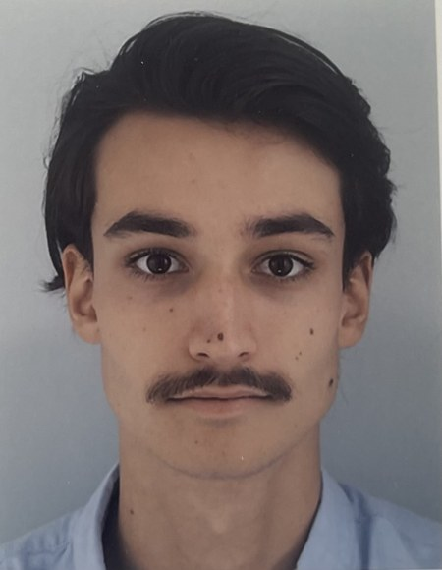
Victorien THOMAS
Aerospace engineering student — Simulation & modelling of space systems
+33 6 40 22 71 76 · victorienthomas71@gmail.com · Terrassa, Spain
portfolio1-umber-beta.vercel.app · Open to international mobility
Seeking a PhD in space engineering — available from July 2027
EDUCATION
Master in Space and Aeronautical Engineering (MASE) — double degree 2026 – 2027
UPC – ESEIAAT · Terrassa, Spain
Exchange semester Jul. – Nov. 2025
Universidad EIA · Medellín, Colombia
Master’s-level Engineering Degree in Aerospace — Space Systems major 2022 – 2027
IPSA · Paris, France
EXPERIENCE
Research internship — Laser beam propagation through the atmosphere Jun. – Aug. 2026
NCSR “Demokritos” · Athens, Greece
- Python simulation of laser propagation at 7 wavelengths (UV to CO₂), from 1 to 100 km
- Modelling of scattering (Rayleigh, Mie), absorption (HITRAN) and turbulence
- Wrote a detailed technical report (model, methods, results)
Internship — 3D modelling of an orbital propellant depot 2024 · 6 weeks
European Space Agency (ESA) · Paris, France
- Detailed Blender modelling of the components of an in-orbit refuelling concept, within a technical team
Student job — Quality control in an industrial environment 2023 · 1 month
Schneider Electric · Grenoble, France
- Quality control of finished products and verification of compliance with technical standards
PROJECTS
Eco-design of the landing system of a reusable launcher — IPSA / CNES 2025 – 2026
- Technical and economic feasibility study in a team of 6, supervised by CNES
- Trade-off between 11 concepts, preliminary sizing, LCA, mass and cost budgets
Earth–Neptune mission STK / Astrogator
- Jupiter gravity assist: patched-conic calculation, then simulation
Stabilisation of an inverted pendulum (Segway) MATLAB / Simulink
- Nonlinear model, cascaded PID with anti-windup, pole placement
Satellite image classification with deep learning Python
- Trained a ResNet network on the EuroSAT dataset to recognise land-cover types
TECHNICAL SKILLS
Simulation & analysis MATLAB / Simulink, STK / Astrogator, Python
Control Discrete PID, state-space representation, pole placement, Kalman filter
Programming Python, C / C++, VHDL / FPGA, Arduino
CAD & structures CATIA V5, Creo, Blender, strength of materials
LANGUAGES & ACTIVITIES
Languages French (native) · English B2 (TOEIC 830) · Spanish B2
Student club IPSA F1 (2023 – 2026): treasurer, head of design, chassis assembly

