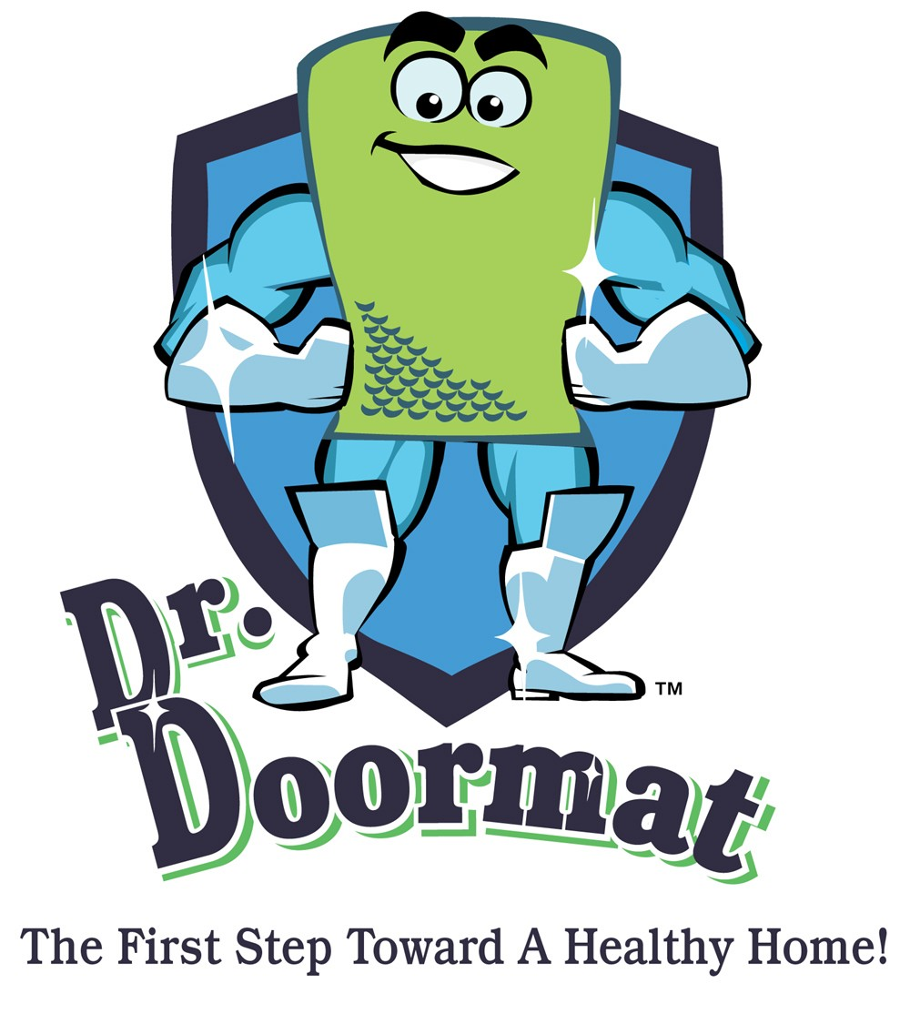

ABOUT THE PRODUCT

Dr. Doormat Antimicrobial Treated Mat
Dr. Doormat is the first antimicrobial treated doormat designed for home use. The mat is infused during the manufacturing process with a special antimicrobial treatment that permanently bonds to the fibers of the doormat and cannot be tracked through your house. Dr. Doormat goes to work for you the moment your shoe makes contact, instantly penetrating the cell membrane of the invading microbe and rendering it harmless. We recommend that your family and guests wipe their shoes twice on Dr. Doormat before entering the house to guarantee the greatest results. This antimicrobial technology has been verified by its use in consumer and medical goods including diapers, socks and medical drapes for the past 25 years. Dr. Doormat is protected by AEM 5700 Antimicrobial, EPA Registration No. 64881-1. The chemistry has been accepted and registered with the EPA, EU and other regulatory agencies for this specific application.

Mat Specifications
- Made in the USA.
- 5 year free manufacturer's warranty.
- Surface area is made of stain resistant "Decalon" fiber, its thick and plush berber design is denser than most mats
- Elegant bubble pattern scrapes dirt and grit off shoes while removing moisture at the same time.
- Thick rubber backing with molded rubber nibs reduces mat movement.
- One piece construction features a patented raised perimeter which forms a tray that traps water and dirt, preventing them from draining onto the floor.
EPA-Accepted Antimicrobial Technology:
- Never depletes and keeps its active level for the life of product.
- Doesn’t come off and distribute itself through environment it permanently bonds to the fibers of surface of the mat and can’t track through your house.
- No exposure to chemicals, Doesn’t pollute home environment, Green friendly.
- Penetrates cell membrane of microbes on contact by a physical mode of action without poisoning the microbe.
- Prevents degradation of mat extending the life and prevents odors.

Care Instructions

To get the most out of your mat and to maintain its appearance and usefulness over the longest period of time the manufacturer suggests the following: Dr. Doormat is designed for indoor use and will work effectively outdoors providing the mat is not directly exposed to the elements. An entrance way that is covered with a portico or some kind of protection would be fine. Shake the mat out, outside your home (NEVER INSIDE THE HOME). Vacuum the mat twice a week especially in heavy traffic areas. If carpet is embedded with excessive soil, shampooing is recommended. Mild liquid detergent (1/4 cup per gallon of water) mixed with tepid water. Hand brush method will yield good results. Rinse with cool water or hose down to remove dirt and excess detergent and place in an inclined position to drain dry. DO NOT USE BLEACH. Steam cleaning or professionally cleaning is allowed. Remember to benefit from Dr. Doormat’s antimicrobial features, the surface area of the mat needs to be completely exposed to make contact with the surface areas of the bottom of the shoes or paws stepping on the mat. There is never a need to re-treat the mat, no filters to change and no batteries required.

Warranty

Dr. Doormat comes with a free 5 year manufacturers warranty against defects that are due to faulty material or workmanship. The antimicrobial treated surface area will remain effective for the life of the product providing the owner follows the proper care instructions provided. This warranty does not include damage to the product resulting from accident or misuse. If the product should become defective within the warranty period, we will replace it free of charge.

Dr. Doormat, Inc. • 11508 Cushman Road, Rockville, MD 20852
Phone: 301-770-2002 • Fax: 301-770-9421 • www.drdoormat.com

