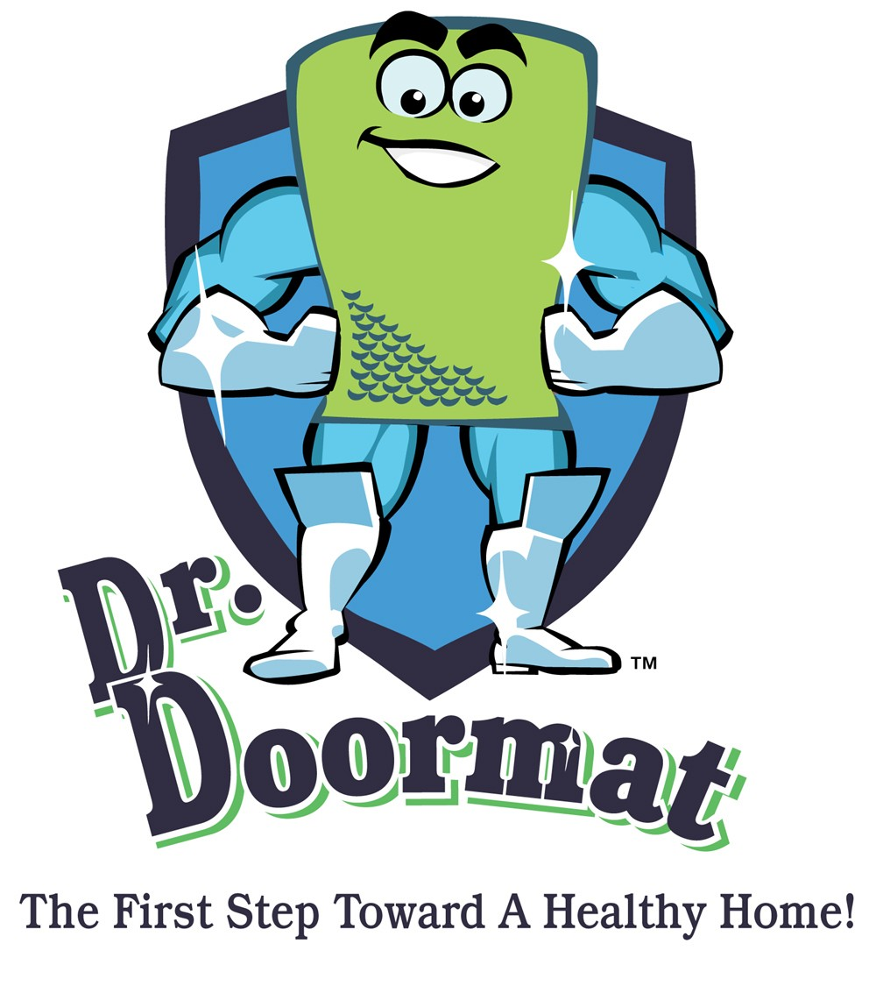

WHAT DOCTORS, SCIENTISTS AND HOME ENVIRONMENTALISTS ARE SAYING ABOUT DR. DOORMAT
"So many of my patients live in the suburbs and suffer from allergy problems and skin conditions caused by household dust, molds and other skin irritants. Dr. Doormat is an inexpensive and effective way to improve your home environment with little to no effort on the homeowners part. What a terrific product."
--Dr. David Green, MD
Dermatologist
Bethesda, MD
"A typical doormat becomes a growth site or reservoir for microbes and can contaminate the sole of a shoe prior to entering a home. Dr. Doormat effectively inhibits the growth of microbes on the surface of the doormat minimizing the transference of pollutants into the home, helping to support a healthy home environment."
--Dr. Ernest Crutcher
Microbiologist
Redmond, WA
"Pre-school children, who ingest the most dust, have low body weight, and lack fully developed organs and immune and nervous systems are at the highest risk from dust and dirt track-in. Pollutants in carpet dust contribute to the total exposure of nearly all people, but especially to infants and toddlers. Soil sticks to the shoes, is carried into the house onto your floors and rugs, to the hands of a toddler and finally to their mouth.
Wiping your shoes twice on Dr. Doormat and using an efficient vacuum cleaner with a dirt finder can reduce dust levels in the rugs by 99%, or 100 times. These same procedures can reduce lead levels by 95%, or 20 times."
--John Roberts, M.S., P.E.
Home Environmental Expert
Sammamish, WA

Dr. Doormat, Inc. • 11508 Cushman Road, Rockville, MD 20852
Phone: 301-770-2002 • Fax: 301-770-9421 • www.drdoormat.com

