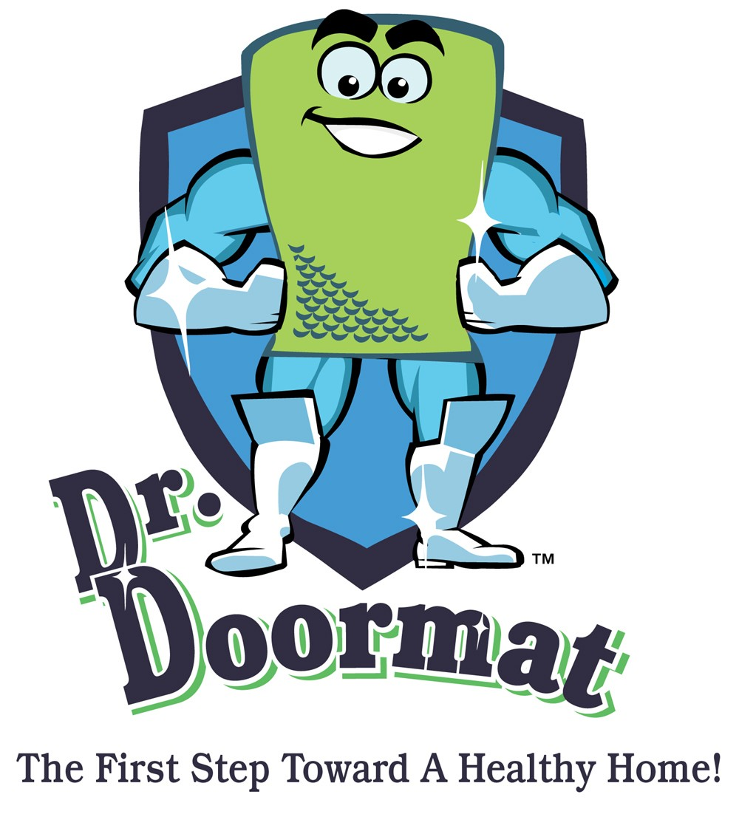

Dust, Toxins, Pesticides & Harmful Pollutants!
What You Should Know To Protect Your Family

When we conducted our research to develop Dr. Doormat we consulted with several organizations and experts including the American Lung Association, seasoned home environmental expert’s, microbiologists and engineers. For over 30 years, hundreds of field studies have been conducted on this subject and the results published. We have combed through volumes of data and created a list of meaningful information that an average consumer can use to educate their family members and friends on the subject of track-in and the health risks associated with house dust, toxins, pesticides and harmful pollutants. Credit for the data and research includes the following organizations: The Environmental Protection Agency, The American Lung Association, Southwest Research Institute, Clemson University, Microlabs Northwest, Engineering Plus, National Exposure Research Laboratory, Envirometrics, Harvard University School of Public Health.

Dust/Toxins

Tracked in carpet dust is one of the major sources of home exposure to lead, allergen, bacteria, fungi, volatile organic compounds and pesticides.
Track-in from shoes is the largest source of home dust in most U.S. Homes
Road dust is a large source of house dust.
Some 94% of the mass that sticks to the shoe after two steps on road dust was tracked off by two steps on a clean carpet.
Up to 95% of house dust and some toxics found in rugs appear to be tracked in on shoes.
The most powerful weapons against dirt and dust are a doormat to keep dust from being tracked in and a high quality vacuum cleaner to remove dust and dirt in the home, Roberts advises.
Removing shoes before entering the home, wiping your feet on a quality doormat, and using an efficient vacuum cleaner can reduce fine dust levels in the rugs by 99%, or 100 times.
Both road & carpet dust contain probable human (B-2) carcinogens.
Benzo(a)pyrene was found in house dust in 89% of 362 homes that participated in the field study.
PAHs (polycyclic aromatic hydrocarbons) & other pollutants in road & house dust may cause gene mutations & cancer.
Dust from 12 out of 29 Seattle homes was mutagenic & 20 out of 29 dust samples interfered with DNA repair
A large number of metals, organic compounds, bacteria, and viruses in house dust are known or suspected of being carcinogens, allergens, neurotoxicants, and endocrine modifiers.
70% of mice exposed to road dust on their cage floor and in the air developed skin cancer during their lifetime; 74% developed lung cancer. When the study was repeated & the organics removed from road dust, skin cancer was eliminated & the lung cancer rate dropped to 45%
“Children injest 12 times as much dust as adults, weight for weight.” John Roberts, Engineer and Home Environmental Expert.
The temperature, moisture, and nutrients in carpets may also magnify dust mites, gram negative bacteria from tracked in fecal material, & molds. Viruses may also survive for days in moist fecal material in dust.
The pollutants found in urban soil, road dust, and house dust include lead (chemical symbol Pb), bacteria, viruses, allergens, pesticides, and other toxic chemicals.
Americans spend 95% of their time inside
Infants & Toddlers receive a broad & significant range of exposures to many pollutants in house dust. We hypothesize that the control of dust track-in, track-off, and track-on of small particles in the house will be cost effective in reducing the total exposure, risks, and health effects for preschool children. Reducing toddlers’ exposure to lead (Pb), carcinogens, bacteria, molds and allergens will reduce risk of (Pb) poisoning, cancer, infections, allergy, and asthma.
Infants & Toddlers receive a broad & significant range of exposures to many pollutants in house dust. Many of the metals are respiratory irritants, carcinogens, endocrine modifiers, or neurotoxins. Exposures of a fetus or infant to Pb or Hg can cause profound and irreversible effects on the nervous system as well as the physical and mental health of children such as lower I.Q. and growth, attention deficit, poor hearing, memory loss, and psychiatric disorders. The development of the human nervous system is an integrated and sequential process which begins in the first trimester of pregnancy and continues for years after birth. Interference with any of the stages of development can alter subsequent processes since the nervous system has limited ability to repair the damage done at an earlier stage. We hypothesize that the control of track-in, inside sources, and accumulation of metals in house dust will be cost effective in reducing the total exposure, risks, disease, and health costs for preschool children. Reducing toddlers’ exposure to Pb, As, Cd, Cr, Hg, Ti, and other metals will reduce risk of Lead poisoning, cancer, nervous system disorders, and modification of the endocrine system.

Dr. Doormat, Inc. • 11508 Cushman Road, Rockville, MD 20852
Phone: 301-770-2002 • Fax: 301-770-9421 • www.drdoormat.com

