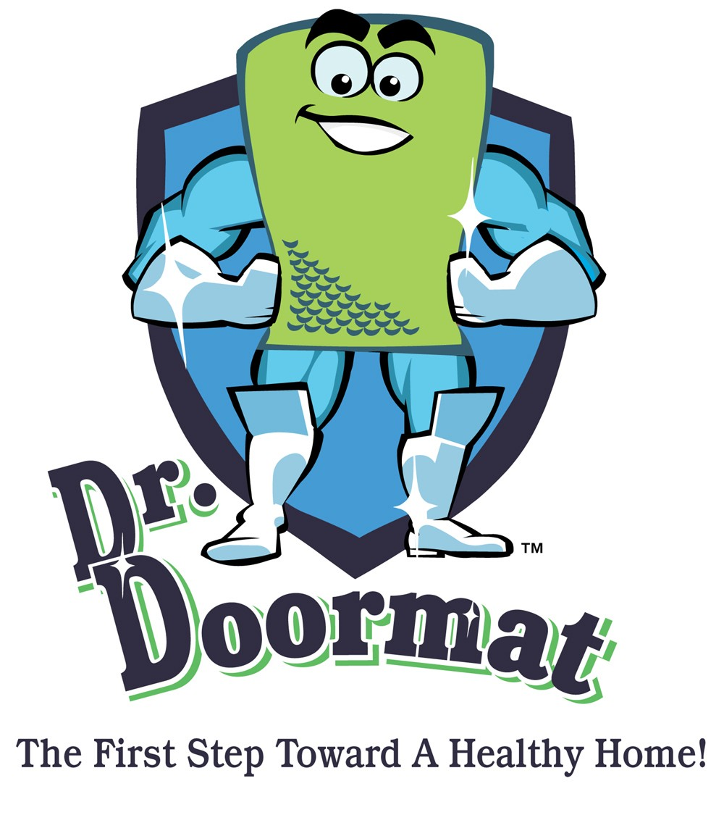

CONCERNED MOM CREATES THE WORLD’S FIRST ANTIMICROBIAL-TREATED DOORMAT FOR HOME USE

DR. DOORMAT IS MAJOR BREAKTHROUGH IN BATTLE TO
KEEP HOMES SAFE FROM HARMFUL MICROBES AND TOXINS

June 9, 2010 – BETHESDA, MD.- If you had a safe, effective and affordable way to protect yourself and the ones you love from dangerous microbes and toxins in your home…
would you do it?
If your answer is “yes,” then it is time to see the “Doctor.” Dr. Doormat is the world’s first antimicrobial-treated doormat designed for home use. Every day, millions of undetectable microbes enter your home on the bottom of your shoes. Common “welcome mats” may look inviting to human visitors, but they are even more welcoming to dangerous microbes and toxins. They provide an ideal breeding ground for fungus, bacteria, mold, mildew, yeast, algae and more, offering these most unwelcome guests a springboard straight into the home.
Dr. Doormat (www.drdoormat.com) is the result of the inspired vision of company Founder and President Debbie Estis Greenspan, a former hotel industry executive and a lifetime allergy sufferer. When she became a mother in 2002, Greenspan immediately began researching ways to make her home environment healthy and was shocked by how many harmful pollutants were literally arriving underfoot.
“I would watch my daughter crawling on the floor and putting things in her mouth and I felt like I had to do something,” she said. “So I began thinking about creating a line of defense to try and make my home the sanctuary we all want for our children.”
Greenspan’s quest took her to the home environmental research community, where she employed science to effect a potent new product, one that has been received with an enthusiastic thumbs-up from this sector. According to microbiologist Dr. Ernest Crutcher,
"a typical doormat becomes a growth site or reservoir for microbes and can contaminate the sole of a shoe prior to entering a home. Dr. Doormat effectively inhibits the growth of microbes on the surface of the doormat, minimizing the transference of pollutants into the home, helping to support a healthy home environment.”
Dr. Doormat’s special antimicrobial treatment permanently bonds to the fibers of the doormat and cannot be tracked through the house. Wiping shoes at least twice on the mat can remove up to 99 percent of debris and destroys micro-organisms on contact, according to tests performed by research lab, Microlab Northwest. The mat goes to work the instant a shoe makes contact as the treatment acts as a microscopic layer of swords and spikes that penetrates the cell membranes of the unwanted microbes, instantly rendering them harmless.
Dr. Doormat’s technology has been verified by 30 years of use in both consumer and medical applications, from diapers to socks to medical drapes. The chemistry has been accepted and registered by with the EPA, EU and other regulatory agencies for this specific application.
Dr. Doormat has also received enthusiastic support from the medical community. Bethesda, MD-based Dermatologist Dr. David Green, called it “a terrific product,” adding that “Dr. Doormat is an easy, inexpensive and effective way to improve your home.”
Dr. Doormat was first introduced in 2004 and was produced in the U.S. to an enthusiastic media response and brisk sales. However, Ms. Greenspan stopped manufacturing after two years while she searched for a new manufacturer with two goals in mind. First, try and secure manufacturing to bring the cost of goods down to an affordable price for a wider audience of customers. Second, to make her product sustainable and environmentally responsible without compromising quality, durability, and consistency. The textile surface of the new Dr. Doormat is made of 95% recycled plastic bottle lids. The 5% remaining from the surface ingredients include resins along with the color pigments. The bottom surface is made of 100% virgin rubber. The local rubber plantation saps the trees, similar to the way maple syrup is produced, therefore no trees are cut down or harmed in the process.
The formidable substance of Dr. Doormat involves no sacrifice to style. The attractive design comes in a variety of appealing colors and features an elegant bubble pattern that serves the dual purpose of scraping off dirt while simultaneously removing moisture.
Dr. Doormat can be purchased at www.drdoormat.com. The 2 x 3 mat is $34.99 and the new 24” x 18” size, ideal for apartments, is $24.99. The price includes a free 2-year warranty. The mats can be washed in a washing machine up to 50 times and retain their efficacy.
To receive a press kit or sample product, please contact Benita Gold at
benita @benitagoldpr.com or 617/489-1208.

Dr. Doormat, Inc. • 11508 Cushman Road, Rockville, MD 20852
Phone: 301-770-2002 • Fax: 301-770-9421 • www.drdoormat.com

