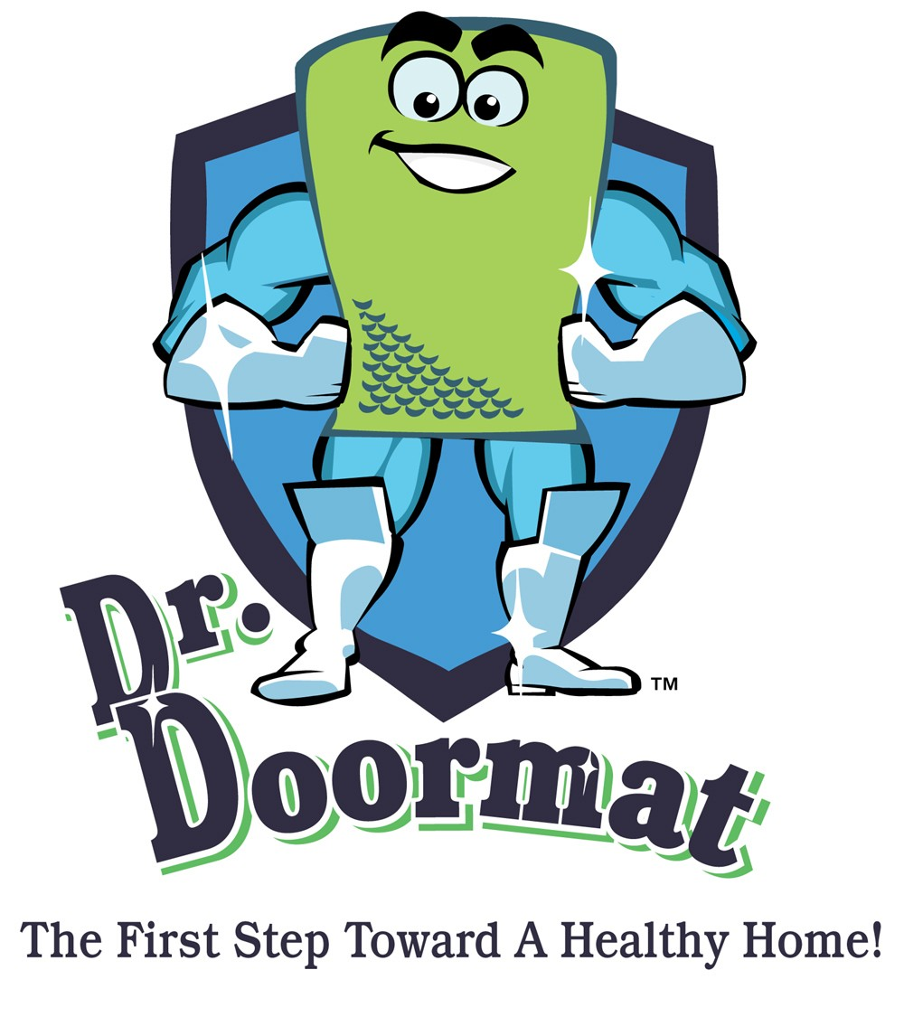

DR. DOORMAT… THE FIRST STEP TOWARD A HEALTHY HOME!

NEW PRODUCT IS WORLD’S FIRST ANTIMICROBIAL-TREATED DOORMAT FOR HOME USE; MAJOR BREAKTRHOUGH IN BATTLE TO
KEEP HOMES SAFE FROM HARMFUL MICROBES AND TOXINS

September, 2004 – WASHINGTON, D.C. – If you had a safe, effective and affordable way to protect yourself and the ones you love from dangerous microbes and toxins in your home…would you do it?
If your answer is “yes,” then it is time to see the “Doctor.” Dr. Doormat is the world’s first antimicrobial-treated doormat designed for home use. Each and every day, millions of microbes enter your homes right on the bottom of your shoes. Common “welcome mats” may look inviting to human visitors, but they are even more welcoming to dangerous microbes. They provide an ideal breeding ground for fungus, bacteria, mold, mildew, yeast, algae and more and offer these most unwelcome guests a springboard straight into the home.
Dr. Doormat (manufactured in the USA), is infused during the manufacturing process with a special antimicrobial treatment that permanently bonds to the fibers of the doormat and cannot be tracked through the house. The mat goes to work the instant a shoe makes contact as the treatment acts like a microscopic layer of swords and spikes that penetrates the cell membranes of the unwanted microbes, instantly rendering them harmless.
Dr. Doormat’s antimicrobial technology has been verified by 25 years of use in both consumer and medical applications, from diapers to socks to medical drapes and more. The chemistry has been accepted and registered by with the EPA, EU and other regulatory agencies for this specific application.

Dr. Doormat (currently available for $59 on www.drdoormat.com) is the result of the inspired vision of company Founder and President Debbie Estis Greenspan. When she became a mother in 2002, Greenspan immediately began researching ways to make her home environment healthy and was shocked by just how many harmful pollutants were literally arriving underfoot.
“I felt like I had to do something,” she said. “So I began thinking about creating a line of defense to try and make my home the sanctuary we all would like our homes to be for our families, and especially our children.”
Greenspan’s quest took her to the home environmental research community, with whom she teamed on the scientific end of the project. The final product has received an enthusiastic thumbs-up from this sector. According to microbiologist Dr. Ernest Crutcher, "a typical doormat becomes a growth site or reservoir for microbes and can contaminate the sole of a shoe prior to entering a home. Dr. Doormat effectively inhibits the growth of microbes on the surface of the doormat minimizing the transference of pollutants into the home, helping to support a healthy home environment," Crutcher said.
Dr. Doormat has also received enthusiastic support from the medical community. Bethesda, MD-based Dermatologist Dr. David Green, M.D. called it “a terrific product,” and added that “Dr. Doormat is an inexpensive and effective way to improve your home environment with little or no effort on the homeowner’s part.”
The formidable substance of Dr. Doormat involves no sacrifice to style. The attractive 2x3 berber design comes in a variety of appealing colors and features an elegant bubble pattern that serves the dual purpose of scraping off dirt and grit off shoes while simultaneously removing moisture.
Dr. Doormat’s $59 price includes a free 5-year warranty. The antimicrobial-treated surface area is designed to remain effective throughout this period. Should the product become defective during the warranty period, it will be replaced free of charge.
For more information on Dr. Doormat, including video demonstrations detailing the science behind the product, visit www.drdoormat.com.
# # #

Dr. Doormat, Inc. • 11508 Cushman Road, Rockville, MD 20852
Phone: 301-770-2002 • Fax: 301-770-9421 • www.drdoormat.com

