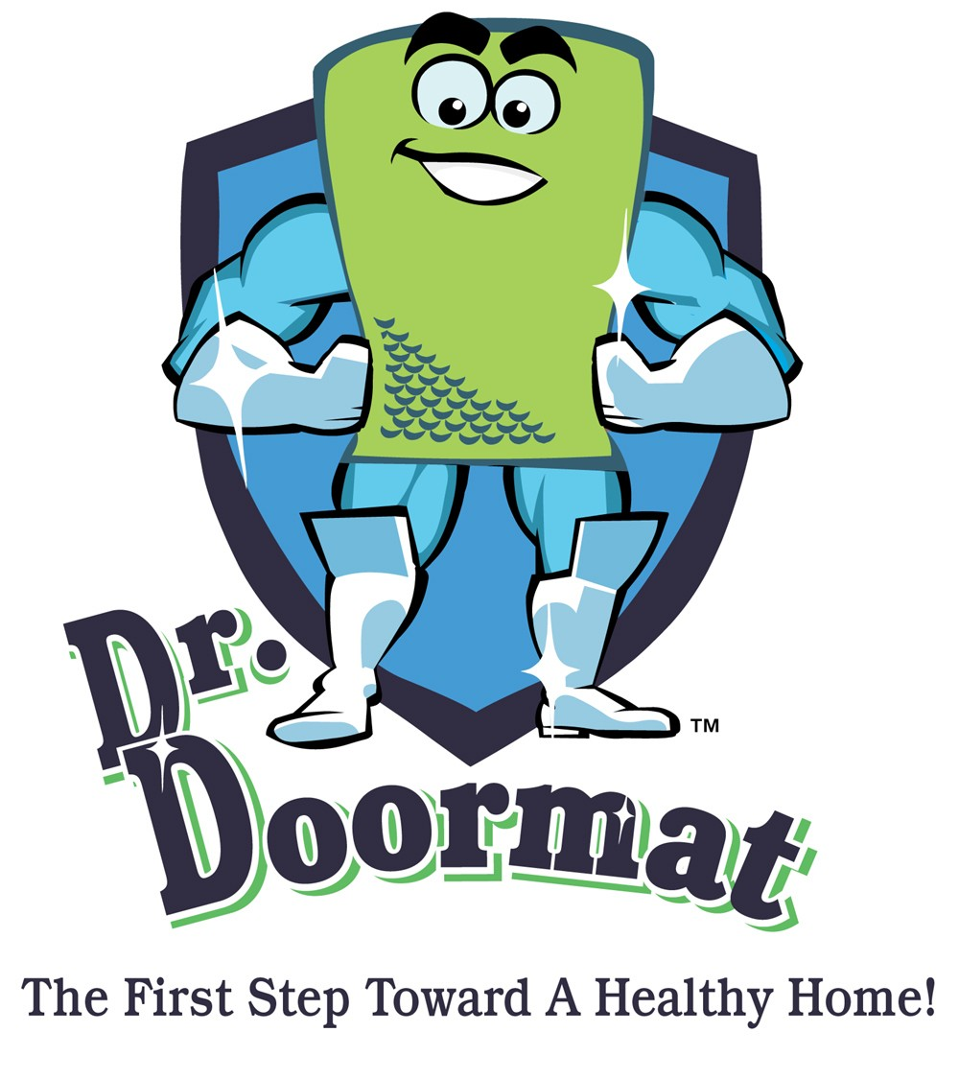

Story Behind Dr. Doormat

Dr. Doormat is the product of a single question.

If you could do something to protect yourself and your family from allergens and pollutants that have the potential to cause them harm…would you?

Debbie Estis Greenspan would. And she did. The Founder and President of the company behind this exciting new advance in home and health protection first came upon her idea after becoming a first-time mother in 20__.

“It Must Be The Shoes…”

A lifelong allergy sufferer herself, Debbie began researching ways to make her home environment as safe as possible for herself and for her growing family. What she found surprised her…and will probably surprise you too. She learned that 80% of the harmful allergens and bacteria that enter your house do so right on the bottom of your shoes!

Just stop and think for a moment about all the places those soles of yours go in a single day. By the time you walk through that door, you are providing a red-carpet treatment welcome for an infinite number of harmful microbes from your office, your car, stores, your gym, public restrooms…the list goes on and on. But we think you get the point.

“Paging Dr. Doormat…”

So what is a concerned mother to do? Greenspan sprung into action.

“I felt like I had to do something,” she said. “So I began thinking about creating a line of defense to try and make my home the sanctuary we all would like our homes to be for our families, and especially our children.”

Her search took her far and wide…then literally landed her right on her own doorstep.

“I looked at my doormat,” she said, and thought, “hmmmmm.”

That thought sprung her into further action, with more research and phone calls and legwork that led her to expand her network of business contacts into the scientific realm and resulted in the first-ever antimicrobial doormat designed for private residences.

“On Call…24/7”

Germs don’t sleep, and neither should you.

Dr. Doormat provides ‘round the clock protection for the members of your family who need it most. Leading health experts and prominent cleaning studies regularly point to babies, pregnant women, allergy and asthma sufferers, people with compromised immune systems and the elderly as prime germ targets.

Visit us at www.doctordoormat.com to learn more about this invaluable first line of defense in the war against germs…because there is no such thing as being overprotective when it comes to the ones we love.

Dr. Doormat, Inc. • 11508 Cushman Road, Rockville, MD 20852
Phone: 301-770-2002 • Fax: 301-770-9421 • www.drdoormat.com

