**Intentionality of Mind-Wandering as Reflected in Measures of Executive Control and Behavioral Variability: a TMS Study**

**Abstract**

1. **Introduction**

Humans spend a substantial amount of their waking lives engaged in spontaneous, self-generated thoughts that are decoupled from an ongoing activity or the current surroundings (Killingsworth & Gilbert, 2010; Seli, Beaty, et al., 2018). This mental phenomenon has been studied under the umbrella term of “mind-wandering” (MW) (Kane et al., 2007; Killingsworth & Gilbert, 2010; Klinger & Cox, 1987). Over the past two decades, cognitive neuroscientists have increasingly gained interest in elucidating the basic neurocognitive mechanisms and physiological underpinnings of MW (Callard et al., 2013). Interestingly, whilst MW has been associated with future planning and creative problem-solving (Mooneyham & Schooler, 2013), it has also been shown to interfere with task performance (Smallwood & Schooler, 2015) and negatively impact emotional well-being (Hoffmann et al., 2016).

Despite the ubiquity of MW in daily life, its operationalization constitutes a challenge for the field in virtue of its complexity. Recently, the family-resemblance framework for MW was put forth (Seli, Kane, Metzinger, et al., 2018; Seli, Kane, Smallwood, et al., 2018) which views MW as a heterogenous construct graded along multiple dimensions (e.g. task-relatedness, intentionality (Seli et al., 2016), metacognition (Christoff et al., 2009) etc.). Although, all the dimensions suggested are of interest to MW research, it is not feasible to investigate all of them at once. However, we deem intentionality particularly worth investigation since it has been attributed great explanatory power for MW states (Golchert et al., 2017; Robison et al., 2020; Seli, Beaty, et al., 2019; Seli, Schacter, et al., 2019). Intentional MW typically occurs when the task at hand isn’t compelling or does not require an individual’s full attention. Under these circumstances the person may decide to engage in task-unrelated thoughts intentionally or a spontaneously arising train might win the competition for attention (Murray et al., 2020). Although there exists a consensus that executive control plays a role in the onset and maintenance of MW, it remains unclear whether MW is a result of failure of executive control or a competition for the same resources (McVay & Kane, 2010). In this study, we will investigate the relationship between MW and executive control with respect to intentionality.

Another line of work closely related to the present study is on neuromodulation of MW. To this day, several studies have attempted to influence the propensity to mind-wander by means of transcranial direct current stimulation (tDCS). The yielded results are inconclusive: whilst some studies reported that anodal (excitatory) tDCS over left dorso-lateral prefrontal cortex (dlPFC) induced an increase in MW (Axelrod et al., 2015, 2018), others reported the same effect for cathodal (inhibitory) tDCS over the same region (Filmer et al., 2019), yet others showed no effect of anodal tDCS on MW likely caused by the weak modulatory effect of brain polarization procedures modulating regional excitability rather than operating on brain rhythms (Nya Mehnwolo Boayue et al., 2019). Here, we aim to elucidate the relationship between non-invasive brain stimulation (NIBS) and MW by testing the ability of transcranial magnetic stimulation (TMS) to modulate MW states. To our knowledge, our study is the first in MW research to use TMS. We attempted to answer the following questions: can TMS over left dlPFC modulate MW propensity and, by extension, task performance? Can it reduce the propensity to engage in MW? Is there a causal relation between executive control and spontaneous MW, underpinned by activity in the dlPFC?

Thus, the objective of the project is two-fold. Firstly, we will attempt to entrain theta-band oscillatory activity in the left DLPFC and probe the causal relation between the entrained oscillations and MW. Secondly, we aim to dissociate intentional and spontaneous MW by demonstrating that only the former draws on executive resources. To this end, will conduct an online TMS study involving the finger-tapping random sequence generation task (FT-RSGT) designed and validated by (Nya M. Boayue et al., 2021).

With this study, we will test the following hypotheses:

* H1. Based on the correlation of fronto-medial theta oscillations with sustained attention (Clayton et al., 2015) and cognitive control (Cavanagh & Frank, 2014), we expect participants to mind-wander less when subjected to active rhythmic TMS compared to arrhythmic control TMS, sham and baseline. Quantitatively, we expect a positive effect of active rhythmic TMS on task scores (a higher score corresponds to less MW) as reflected in the coefficient value within the fitted model.
* H1.1. By extension, we expect subjects to more accurately emulate the rhythm of the metronome with with finger taps during active rhythmic TMS compared to other conditions. This would reflect in lower behavioral variability (BV).
* H2. We hypothesize an increase in executive control during active rhythmic TMS compared to other conditions. Quantitatively, this would manifest in an increase in approximate entropy (AE).
* H2.1. As an extension of hypothesis 2, building upon the literature linking higher executive control and intentional MW (Golchert et al., 2017; Seli, Kane, Smallwood, et al., 2018), we hypothesize lower rates of spontaneous MW during active rhythmic TMS compared to other conditions. On the computational level, we would expect a positive effect of active rhythmic TMS on intentionality scores whereby a higher intentionality score stands for higher intentional control of one's attention.

The outcome measures, experimental design and operational definitions are outlined hereunder. This study was preregistered on OSF platform: <https://osf.io/2wszr>.

1. **Methods**

***2.1. Participants***

We conducted an a-priori power analysis for a repeated-measure, within-factor ANOVA using G*Power (also implemented in (Gouraud et al., 2018). To reach the minimum acceptable power of 0.8 and to detect a medium effect (f = 0.25), a sample of 21 participants would be required (N of measures = 5). However, due to feasibility concerns and time constraints, we ran the analyses on a subset of subjects. We prioritized those subjects whose T1 MRI scans had already been acquired. Our target population is in good health, right-handed, aged between 18 and 65 years old, fluent in written French or English and eligible according to MRI and TMS international safety guidelines.

However, we did not include people to whom at least one of the following pertains:

* currently participating in another study (< 24 hours or 1 week for studies involving brain stimulation or any other intervention affecting brain excitability);
* presenting or having a history of a psychiatric or neurological disorder or evolutive disease that interferes with the study tests;
* reported consumption of psychotropic substances (except nicotine and caffeine);
* taking central nervous medications (e.g. antidepressants, antiepileptic drugs) under benzodiazepines, anticonvulsants or neuroleptics treatment;
* pregnant, breastfeeding or has recently given birth;
* presenting a contra-indication to MRI.

In addition, we excluded people who ask to stop the experiment or fail to cooperate and/or comply with the procedures during the experiment.

***2.2. Behavioral Task***

This study involves a novel task – the Finger-Tapping Random Sequence Generation Task (FT-RSGT: (Boayue et al., 2021). FT-RSGT is a combination of a modified version of the random generation task (Baddeley et al., 1998; Towse, 1998) and a finger-tapping task (Kucyi et al., 2016; Seli et al., 2013). This task consists of two sub-tasks: i. rhythmic finger-tapping in response to an ongoing metronome and ii. the generation of irregular sequences by pressing one of the two available response-buttons (“S”, left key and “L”, right key). Subjects were instructed to emulate the rhythm of the metronome as accurately as possible with their finger taps and, simultaneously, to try and render every button press as unpredictable for the external observer as possible. To ensure that the participants understand the task, we provided ample examples of how an irregular sequence would compare to a regular sequence (e.g. “right-left-right-left” is more regular than “right-right-left-right”) and emphasized that each press must be difficult to predict for an external party. The subjects also underwent a training upon which they were asked to retrospectively assess the tapping sequences they had produced and to provide examples thereof.

Given that the generation of irregular sequences draws heavily on executive resources, the randomness of the generated sequence is related to their deployment. This has been confirmed by the finding that sequences generated during MW are typically less random (Boayue et al., 2020; Teasdale et al., 1995). In addition, the behavioral variability as measured by deviation of the taps from the on-going metronome in the finger-tapping studies have been shown to be an indicator of MW (Kucyi et al., 2016; Seli et al., 2013).

***2.3. Experimental Procedure***

Participants were seated in a comfortable chair, with their head resting on a chinrest at a distance of 57 cm from the screen. The task script ran on PsychoPy. The same script was used to trigger TMS pulses. The task began with instructions during which participants were encouraged to ask questions if anything was unclear. Participants were instructed to place their index fingers on two keyboard keys (“S” and “L”) and to fixate the cross in the centre of the screen throughout the entire experiment.

Each trial began with a tone of 440 Hz lasting for 75 ms. The tone repeated every 750 ms (= inter-stimulus interval; ISI) until the appearance of a thought-probe (see methods). The ISI of 750 ms was validated by (Nya Mehnwolo Boayue et al., 2019) whereby they demonstrated that this interval was long enough for the executive control to be deployed, but also short enough so that the attention is maintained. The schematic representation of the task is depicted in figure 1 (A). The experiment consisted in two visits whereby the subject completed 14 blocks of FT-RSGT in total. The following section provides a detailed overview of the block design.

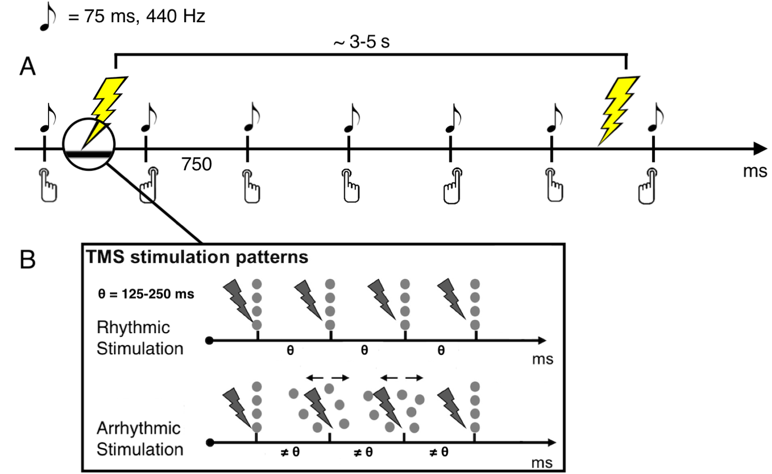

**Figure 1.** **A**: FT-RSGT: participants are instructed to press the right (L) or left (S) key in an irregular order simultaneously with the rhythm of the metronome. The tone of the metronome has a frequency of 440 Hz and its duration is 75 ms. TMS is administered every 3 to 5 s. **B**: Every TMS burst consisted of four pulses. Two stimulation patterns were implemented: rhythmic (rhTMS, top) and arrhythmic (arrhTMS, bottom). The inter-pulse interval (IPI: θ) was set based on the frequency of pulses. The latter was determined for each subject separately: an individual theta-peak frequency was extracted from the EEG recording of the first baseline. As a result, the IPI fell in the range of 125-250 ms (4-8 Hz). In the case of the arrhTMS, the IPI ≠ θ, but the total duration of the burst (3 * θ) was identical for both patterns. However, IPI was always greater than 20 ms.

EEG data were also collected during the experiment. However, they were not analyzed in the context of this study.

***2.4. Stimulation Protocol***

The participants were subjected to 5 conditions in total over the course of two visits: baseline, sham rhythmic TMS (rhTMS), sham arrhythmic TMS (arrhTMS), active rhTMS and active arrhTMS. The condition of interest being active rhTMS, the other conditions serve as controls: while sham stimulation controls for the side effects of active stimulation only, the arrhythmic TMS allows to control for the potential effect of the frequency of the entrained oscillation and keep the side-effects accompanying active TMS (possible muscle twitching, noise etc.). The arrhythmic control condition thus allows to isolate the variable of interest (theta oscillations) and to preserve participant blinding. It has been also argued that sham stimulation on its own lacks specificity to be regarded as a full-fledged control condition (Duecker & Sack, 2015).

The subjects were sequentially randomized and assigned to either the rhythmic or the arrhythmic group. The rhythmic group was exposed to rhTMS during the first visit and to arrhTMS during the second visit. The order was reversed for the arrhythmic group. The experimental protocol is outlined in table 1.

**Table 1.** Experimental protocol of the study. The subjects underwent two sessions of FT-RSGT and online TMS. The block order was the same for both sessions. The subjects in the rhythmic group were administered rhythmic TMS during blocks 2 and 3 and arrhythmic TMS during blocks 5 and 6 at the first visit. In the arrhythmic group and for the second visit the order was reversed. In total, the protocol yielded 150 mins of task time (12000 trials).

|  |  |  |
| --- | --- | --- |
| **Block** | **Visit 1 or 2 ≈ 2h** | **Duration** |
| 1 | Baseline | 5’ |
| 2 | Sham rh/arrhTMS | 15’ |
| 3 | Active rh/arrhTMS | 15’ |
| 4 | Baseline | 5’ |
| 5 | Sham rh/arrhTMS | 15’ |
| 6 | Active rh/arrhTMS | 15’ |
| 7 | Baseline | 5’ |

TMS was applied with a biphasic TMS device (Magstim Super Rapid) equipped with a figure-of-eight coil (Double 70-mm Alpha Coil; The Magstim Company Ltd, UK). All TMS applications followed the updated safety guidelines and recommendations of the international TMS community (Rossi et al., 2021).

*2.4.1. ROI Definition*

We used a frameless stereotactic system (*Brainsight TMS Navigation*) to identify the cerebellar location of dlPFC and to minimize any deviations of the coil from the targeted site. The ROI was marked with SPM (Matlab) on the subject’s T1 scan in the native space based on the MNI coordinates derived by (Groot et al., 2020): x = -37, y = 41, z = 22.

*2.4.2.TMS Parameters*

A fixed intensity of 55% of the machine stimulator output (MSO) was set for all subjects. Stimulation was delivered in bursts of four pulses. For rhTMS, the pulse frequency corresponded to the peak theta (4-8 Hz; inter-pulse interval (IPI) = 125-250 ms) frequency extracted from the EEG recording of the first baseline block (figure 1B, top). Thus, TMS was individualized in terms of each subject’s peak theta frequency.

In the case of arrhTMS, the total duration of the burst was the same as for rhTMS, however the IPI was jittered so as to prevent the burst from having any particular frequency (figure 1B, bottom). The inter-stimulation delay varied from 3 to 5 seconds throughout the experiment to avoid carry-over effects.

***2.5. Measures***

*2.5.1. Mind-Wandering*

In this study, MW is defined as engagement in task-unrelated thoughts (TUT). Quantitatively, it was assessed via task-embedded experience sampling: during the task, participants were interrupted by thought-probes which appeared every 30 to 60 seconds. Thought-probes asked them to evaluate some aspects of their MW. Over the course of two visits, participants responded to 110 probes. Each probe included the following questions each yielding a score out of 4 on a Likert scale:

1. *“Just prior to interruption, your attention was…”*

The questions were accompanied by instructions providing specific examples of mental states to which the ratings would pertain (figure 2).

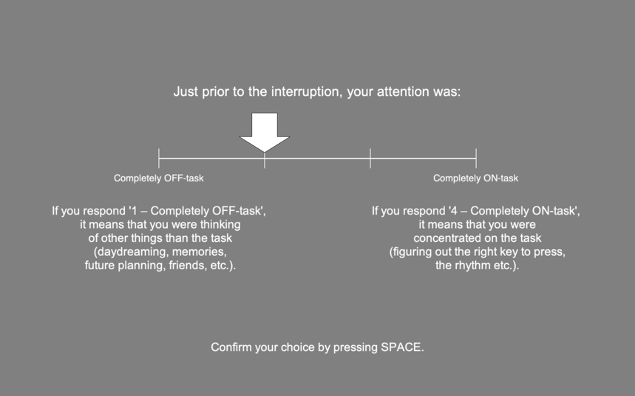

*2.5.2. Behavioral Variability*

Behavioral variability (BV) is used in this study as a measure reflecting task performance. BV is measured as the deviation of the rhythm of button presses from the metronome. BV has been previously associated with increased MW (Nya M. Boayue et al., 2021; Kucyi et al., 2016; Seli et al., 2013).

*2.5.3. Approximate Entropy*

Approximate Entropy (AE; (Pincus, 1991) is a measure of randomness of a finite sequence of elements and, in this study, represents executive control. We used AE as the measure of the irregularity of the sequence of left-right presses produced by participants. Mathematically, AE(*i*) is a function of the number of elements (*i*) in the sequence. It yields the frequency with which blocks of length *i* remain close to each other. This frequency reflects the predictability of the sequence which changes with time as more elements are fed into the sequence. From a practical standpoint, AE is an inference of the predictability of the *i*th item in the sequence based on the predictability of [*i – 1*] items.

***2.7. Data Analysis***

Our study, akin to a great number of others in psychology, used an ordinal scale to assess the construct of interest, MW. It has been pointed out, however, that the treatment of such scales as metric is still not a rare strategy among academics (Bürkner & Vuorre, 2019; Liddell & Kruschke, 2018). Applying metric methods to ordinal variables may lead to distorted effect-size estimations, discarding of intra-individual variability and inflated Type I errors, among other issues. Also, the assumptions underlying metric methods are clearly not satisfied by ordinal variables: the scale categories are not equidistant for every subject and the resulting distribution is frequently non-normal due to responders’ unique perception of the distance between categories. Therefore, we favored the hierarchical ordered probit regression model to test the hypothesis on MW propensity. This analysis has been previously implemented in MW literature (Boayue et al., 2021; Filmer et al., 2019, 2021) and proven useful when the outcome is influenced by co-variates (e.g. total time on task). Also, this model treats the dependent variable (MW, in our case) as a rank-ordered variable and allows for the resulting hierarchically ordered data to have a non-normal distribution (Kruschke, 2014).

Similarly, task performance was modeled with hierarchical Baeysian methods: we fitted a number of models on BV and AE separately. In contrast to the model used to test MW propensity, the underlying distribution of task performance models (Student-t) treats the dependent variable as a continuous, unbounded metric variable. The workflow included model selection based on leave-one-out cross-validation (LOO-CV: Vehtari et al., 2017) which measures out-of-sample prediction accuracy and non-linear hypothesis testing on the dependent variables (MW, BV and AE). Baeysian analyses were implemented with brms package in R (Bürkner, 2017) which uses Stan in the back-end. To accommodate those readers who are more accustomed to null-hypothesis testing, we conducted a one-way repeated-measures ANOVA on the aforementioned variables.

1. **Results**

***3.1. MW Score: Hierarchical Ordered Probit Model***

*3.1.1 Model Selection*

We fitted eight models of increasing complexity involving the following independent variables: BV, AE, the interaction thereof, trial and condition (baseline vs. active rhTMS vs. sham rhTMS vs. active arrhTMS vs. sham arrhTMS). Since hierarchical models allow to account for nested effects within groups or individuals, each model includes an effect of condition nested within subjects. By introducing this effect, we explicitly acknowledge that TMS exerts an effect characterized by large intra-subject variability which cannot be ignored. The winning model as indicated by LOO-CV (fig. X) featured AE, BV, condition, block number, probe number and the effect of the 2nd visit.

*3.1.2. Hypothesis Testing*

***3.2. Task Performance: Hierarchical Student’s-t Model***

*3.1.1 Model Selection*

Four models of increasing complexity were fitted on BV and AE metrics separately. Whilst the most complex model was clearly favored by LOO-CV in the case of BV, the said models all had similar predictive performance when fitted on AE to the extent that the difference in the estimate of log probability density for all models was less than 4. It has been maintained that in the latter instance, any model can be selected for further testing since the estimation of uncertainty of models’ predictions is uninformative (Sivula et al., 2020). Therefore, the model selected for both measures featured the following independent variables:

***3.3. ANOVA***

1. **Results**

**REFERENCES**

Axelrod, V., Rees, G., Lavidor, M., & Bar, M. (2015). Increasing propensity to mind-wander with transcranial direct current stimulation. *Proceedings of the National Academy of Sciences of the United States of America*, *112*(11), 3314–3319.

Axelrod, V., Zhu, X., & Qiu, J. (2018). Transcranial stimulation of the frontal lobes increases propensity of mind-wandering without changing meta-awareness. *Scientific Reports*, *8*(1), 15975.

Baddeley, A., Emslie, H., Kolodny, J., & Duncan, J. (1998). Random generation and the executive control of working memory. *The Quarterly Journal of Experimental Psychology. A, Human Experimental Psychology*, *51*(4), 819–852.

Boayue, Nya M., Csifcsák, G., Kreis, I. V., Schmidt, C., Finn, I., Hovde Vollsund, A. E., & Mittner, M. (2021). The interplay between executive control, behavioural variability and mind wandering: Insights from a high-definition transcranial direct-current stimulation study. *The European Journal of Neuroscience*, *53*(5), 1498–1516.

Boayue, Nya Mehnwolo, Csifcsák, G., Aslaksen, P., Turi, Z., Antal, A., Groot, J., Hawkins, G. E., Forstmann, B., Opitz, A., Thielscher, A., & Mittner, M. (2019). Increasing propensity to mind-wander by transcranial direct current stimulation? A registered report. *The European Journal of Neuroscience*, *51*(3), 755–780.

Bürkner, P.-C. (2017). Brms: An R package for Bayesian multilevel models using Stan. *Journal of Statistical Software*, *80*(1). https://doi.org/10.18637/jss.v080.i01

Bürkner, P.-C., & Vuorre, M. (2019). Ordinal Regression Models in Psychology: A Tutorial. *Advances in Methods and Practices in Psychological Science*, *2*(1), 77–101.

Callard, F., Smallwood, J., Golchert, J., & Margulies, D. S. (2013). The era of the wandering mind? Twenty-first century research on self-generated mental activity. *Frontiers in Psychology*, *4*, 891.

Cavanagh, J. F., & Frank, M. J. (2014). Frontal theta as a mechanism for cognitive control. *Trends in Cognitive Sciences*, *18*(8), 414–421.

Christoff, K., Gordon, A. M., Smallwood, J., Smith, R., & Schooler, J. W. (2009). Experience sampling during fMRI reveals default network and executive system contributions to mind wandering. *Proceedings of the National Academy of Sciences*, *106*(21), 8719–8724.

Clayton, M. S., Yeung, N., & Cohen Kadosh, R. (2015). The roles of cortical oscillations in sustained attention. *Trends in Cognitive Sciences*, *19*(4), 188–195.

Duecker, F., & Sack, A. T. (2015). Rethinking the role of sham TMS. *Frontiers in Psychology*, *6*, 210.

Filmer, H. L., Griffin, A., & Dux, P. E. (2019). For a minute there, I lost myself … dosage dependent increases in mind wandering via prefrontal tDCS. *Neuropsychologia*, *129*, 379–384.

Filmer, H. L., Marcus, L. H., & Dux, P. E. (2021). Stimulating task unrelated thoughts: tDCS of prefrontal and parietal cortices leads to polarity specific increases in mind wandering. *Neuropsychologia*, *151*, 107723.

Golchert, J., Smallwood, J., Jefferies, E., Seli, P., Huntenburg, J. M., Liem, F., Lauckner, M. E., Oligschläger, S., Bernhardt, B. C., Villringer, A., & Margulies, D. S. (2017). Individual variation in intentionality in the mind-wandering state is reflected in the integration of the default-mode, fronto-parietal, and limbic networks. *NeuroImage*, *146*, 226–235.

Gouraud, J., Delorme, A., & Berberian, B. (2018). Out of the Loop, in Your Bubble: Mind Wandering Is Independent From Automation Reliability, but Influences Task Engagement. *Frontiers in Human Neuroscience*, *12*, 383.

Groot, J. M., Boayue, N. M., Csifcsák, G., Boekel, W., Huster, R., Forstmann, B. U., & Mittner, M. (2020). Probing the neural signature of mind wandering with simultaneous fMRI-EEG and pupillometry. *NeuroImage*, *224*, 117412.

Hoffmann, F., Banzhaf, C., Kanske, P., Bermpohl, F., & Singer, T. (2016). Where the depressed mind wanders: Self-generated thought patterns as assessed through experience sampling as a state marker of depression. In *Journal of Affective Disorders* (Vol. 198, pp. 127–134). https://doi.org/10.1016/j.jad.2016.03.005

Kane, M. J., Brown, L. H., McVay, J. C., Silvia, P. J., Myin-Germeys, I., & Kwapil, T. R. (2007). For whom the mind wanders, and when: an experience-sampling study of working memory and executive control in daily life. *Psychological Science*, *18*(7), 614–621.

Killingsworth, M. A., & Gilbert, D. T. (2010). A wandering mind is an unhappy mind. *Science*, *330*(6006), 932.

Klinger, E., & Cox, W. M. (1987). Dimensions of Thought Flow in Everyday Life. *Imagination, Cognition and Personality*, *7*(2), 105–128.

Kruschke, J. (2014). *Doing Bayesian Data Analysis: A Tutorial with R, JAGS, and Stan*. Academic Press.

Kucyi, A., Hove, M. J., Esterman, M., Hutchison, R. M., & Valera, E. M. (2016). Dynamic Brain Network Correlates of Spontaneous Fluctuations in Attention. *Cerebral Cortex* . https://doi.org/10.1093/cercor/bhw029

Liddell, T. M., & Kruschke, J. K. (2018). Analyzing ordinal data with metric models: What could possibly go wrong? *Journal of Experimental Social Psychology*, *79*, 328–348.

McVay, J. C., & Kane, M. J. (2010). Does mind wandering reflect executive function or executive failure? Comment on Smallwood and Schooler (2006) and Watkins (2008) [Review of *Does mind wandering reflect executive function or executive failure? Comment on Smallwood and Schooler (2006) and Watkins (2008)*]. *Psychological Bulletin*, *136*(2), 188–197; discussion 198-207.

Mooneyham, B. W., & Schooler, J. W. (2013). The costs and benefits of mind-wandering: a review. *Canadian Journal of Experimental Psychology = Revue Canadienne de Psychologie Experimentale*, *67*(1), 11–18.

Murray, S., Krasich, K., Schooler, J. W., & Seli, P. (2020). What’s in a Task? Complications in the Study of the Task-Unrelated-Thought Variety of Mind Wandering. *Perspectives on Psychological Science: A Journal of the Association for Psychological Science*, *15*(3), 572–588.

Pincus, S. M. (1991). Approximate entropy as a measure of system complexity. *Proceedings of the National Academy of Sciences of the United States of America*, *88*(6), 2297–2301.

Robison, M. K., Miller, A. L., & Unsworth, N. (2020). A multi-faceted approach to understanding individual differences in mind-wandering. *Cognition*, *198*, 104078.

Rossi, S., Antal, A., Bestmann, S., Bikson, M., Brewer, C., Brockmöller, J., Carpenter, L. L., Cincotta, M., Chen, R., Daskalakis, J. D., Di Lazzaro, V., Fox, M. D., George, M. S., Gilbert, D., Kimiskidis, V. K., Koch, G., Ilmoniemi, R. J., Lefaucheur, J. P., Leocani, L., … Hallett, M. (2021). Safety and recommendations for TMS use in healthy subjects and patient populations, with updates on training, ethical and regulatory issues: Expert Guidelines. *Clinical Neurophysiology: Official Journal of the International Federation of Clinical Neurophysiology*, *132*(1), 269–306.

Seli, P., Beaty, R. E., Cheyne, J. A., Smilek, D., Oakman, J., & Schacter, D. L. (2018). How pervasive is mind wandering, really?,. *Consciousness and Cognition*, *66*, 74–78.

Seli, P., Beaty, R., Marty-Dugas, J., & Smilek, D. (2019). Depression, anxiety, and stress and the distinction between intentional and unintentional mind wandering. *Psychology of Consciousness: Theory Research, and Practice*, *6*(2), 163–170.

Seli, P., Cheyne, J. A., & Smilek, D. (2013). Wandering minds and wavering rhythms: linking mind wandering and behavioral variability. *Journal of Experimental Psychology. Human Perception and Performance*, *39*(1), 1–5.

Seli, P., Kane, M. J., Metzinger, T., Smallwood, J., Schacter, D. L., Maillet, D., Schooler, J. W., & Smilek, D. (2018). The Family-Resemblances Framework for Mind-Wandering Remains Well Clad [Review of *The Family-Resemblances Framework for Mind-Wandering Remains Well Clad*]. *Trends in Cognitive Sciences*, *22*(11), 959–961. cell.com.

Seli, P., Kane, M. J., Smallwood, J., Schacter, D. L., Maillet, D., Schooler, J. W., & Smilek, D. (2018). Mind-Wandering as a Natural Kind: A Family-Resemblances View. *Trends in Cognitive Sciences*, *22*(6), 479–490.

Seli, P., Risko, E. F., Smilek, D., & Schacter, D. L. (2016). Mind-Wandering With and Without Intention. *Trends in Cognitive Sciences*, *20*(8), 605–617.

Seli, P., Schacter, D. L., Risko, E. F., & Smilek, D. (2019). Increasing participant motivation reduces rates of intentional and unintentional mind wandering. *Psychological Research*, *83*(5), 1057–1069.

Sivula, T., Magnusson, M., Matamoros, A. A., & Vehtari, A. (2020). Uncertainty in Bayesian Leave-One-Out Cross-Validation Based Model Comparison. In *arXiv [stat.ME]*. arXiv. http://arxiv.org/abs/2008.10296

Smallwood, J., & Schooler, J. W. (2015). The science of mind wandering: empirically navigating the stream of consciousness. *Annual Review of Psychology*, *66*, 487–518.

Towse, J. N. (1998). On random generation and the central executive of working memory. *British Journal of Psychology* , *89 ( Pt 1)*, 77–101.

Vehtari, A., Gelman, A., & Gabry, J. (2017). Practical Bayesian model evaluation using leave-one-out cross-validation and WAIC. *Statistics and Computing*, *27*(5), 1413–1432.