React Js

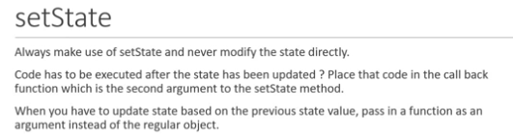

Class Components Lifecycle methods

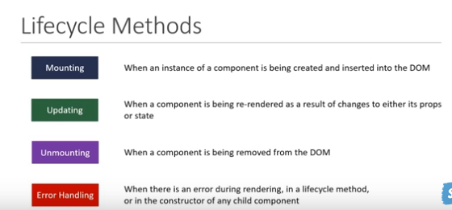

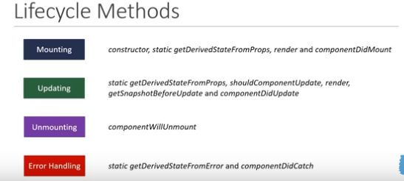

Mounting lifecycle methods

There are several methods that are run during this phase.They include:
1.Constructor(props) – a special function that will get called when a new component is created.
-It is used for initializing state or binding the event handlers to the class instance.
-Do not make http requests inside a constructor.
- Two points to keep in mind when defining your own constructor:
1. You have to call a special function called super.This call the base constructor.
2. The constructor is the only place you are expected to change or set the state by directly overwriting the this.state fields.

2.static getDerivedStateFromProps(props,state)
-Used when the state of the component depends on changes in props overtime
-Dont make api calls inside ie side effects.
-set state
- Doesn’t have access to this keyword since its static.
3.render()
-Read props & state and returns JSX
-Do not change state or interact with Dom or make ajax calls
-Children components lifecycle methods are also executed.

4.componentDidMount()
-Invoked immediately after a component and all its children components have been rendered to the DOM.
-In here one can interact with the DOM or perform any api calls to load data.

Updating Lifecycle Methods
1.static getDerivedStateFromProps(props,state) – its called everytime a component is re-rendered
-its used when the state depends on the props of the component.
-do not cause side effects e.g Http requests

2.shouldComponentUpdate(nextProps,nextState) – dictates if the component should re-render or not.
- do not cause side effects e.g Http requests or call the setState method.
- By default all class components will re-render whenever the props they receive or their state changes.This method can prevent that default behavoiur by returning false.
- Compare the existing props and state values with the next props and state values and return true or false to let react know whether the component should update or not.
3.render()
-Read props & state and returns JSX.
-Do not change state or interact with Dom or make ajax calls.

4.getSnapshotBeforeUpdate(prevProps,prevState)
-Called right b4 changes from the virtual DOM are reflected in the DOM.
-It can be used to Capture some info from the DOM.
-Returns a value or null.
- Used to read the current dom state.

5.componentDidUpdate(prevProps,prevState,snapshot)
-Called after the render is finished in the re-render cycles
-its suitable for making ajax calls based on the previous and current props value
- Its guaranteed to be called once in each re-render cycle.
- Called once after the component has re-rendered and is suitable to make ajax calls based on previous and current props value.

Unmounting phase method
componentWillUnmount()
-Is invoked immediately b4 a component is unmounted and destroyed.
-Cancelling network requests,removing event handlers,cancelling and subscriptions and invalidating timers from setTimeout or setInterval
-do not call the setState method.
- performs necessary cleanup.

Error Handling Phase Method
static getDeriveStateFromError(error)
componentDidCatch(error,info)

-Methods are called when there is an error either during rendering,in a lifecycle method,or in constructor of any child component.

Advanced React
1.Fragments

- They let you group a list of children elements without adding extra nodes to the DOM.

2. PureComponent

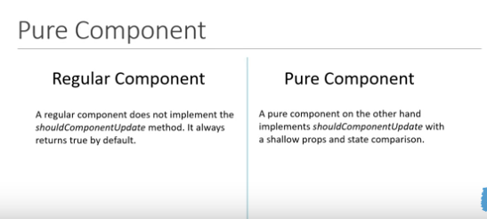

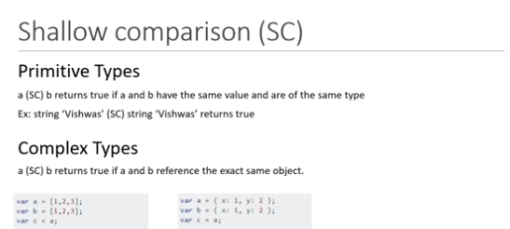

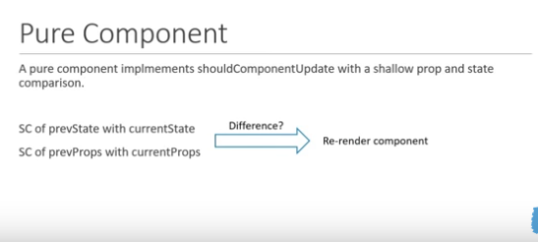

-A PureComponent implements the shouldComponentUpdate lifecycle method by performing a shallow comparison on the props and state of the component.
- If there is no difference, the component is not re-rendered (performance boost).
- When creating a PureComponent, it is a good idea to ensure that all the children components are also pure to avoid unexpected behaviour.
-Never mutate the state e.g pushing to an array.Use setState.Always return a new object that reflects the new state.
- Pure components by preventing unnecessary renders can give you a performance boost in certain scenarios.
- You should not mutate objects or arrays in props or state.If you want to add a new item to a list you should not mutate it by pushing into the list.Reference to the array never changes and the component will not change even if there is a difference.
-Always return a new object or array when dealing with pure components.
- Only work with class components.

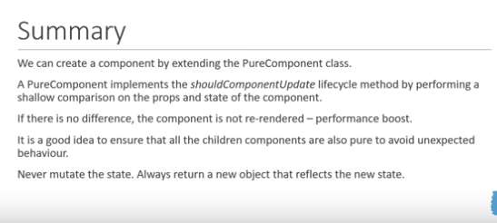

Shallow comparison (SC)
Primitive types
a (SC) b returns true if a and b have the same value and are of the same type
Ex:string ‘mike’ (SC) string ‘mike’ returns true

Complex types
a (SC) b returns true if a and b reference the exact same object.

let a = [1,2,3];
let b = [1,2,3];
let c = a;
let ab_eq=(a ===b) //false
let ac_eq=(a ===c) //true

a (SC) b will be false since they point/reference to different objects
a (SC) c will be true since they point to the same objects

-Pure components only work with class components,the alternative to function components is React.memo

Refs
- Make it possible to access DOM nodes directly within react.
- Are only for class components.

Forwarding Refs
- Is a technique for automatically passing a ref though a component to one of its children.

Portals
- Provide a way to render children into a DOM node that exists outside the DOM hierachy of the parent component.

Error Boundary
-A class component that implements either one or both of the lifecycle methods getDerivedStateFromError or componentDidCatch becomes an error boundary.
-The static method getDerivedStateFromError method is used to render a fall UI after an error is thrown and the componentDidCatch method is used to log the error info.
-Placement of the error boundary also matters as it controls if the entire app should have the fall back UI or just the component causing the problem.
- It provides a way to gracefully handle error in application code.
- They catch the error and provide a fallback ui.
- They catch errors during rendering, in lifecycle methods and constructors of the whole tree below them.They don’t catch errors inside event handlers.

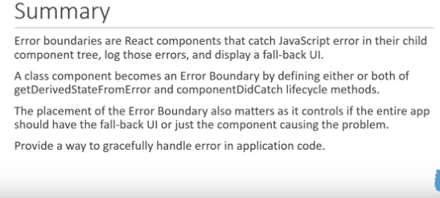

Higher Order Components – HOC

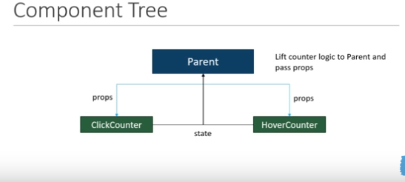

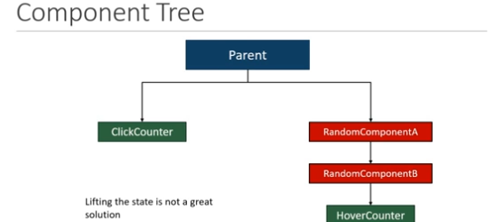

- A pattern where a function takes a component as an argument and returns a new component.

Const newComponent/ enhancedComponent = higherOrderComponent(originalComponent)

- HOC is used to share common functionality between components without having to repeat the code.

Render props
- In react its possible to use a prop whose value is a function to control what is actually rendered by a component.
- Render prop refers to a technique for sharing code btwn react components using a prop whose value is a function.

Context
- Context provides a way to pass data through the component tree without having to pass props down manually at every level.
- You can set a default value while creating context.
- There are 2 types of consuming context:
1.using the consumer
2.contextType – its disadvantage is that you can only subscribe to a single context

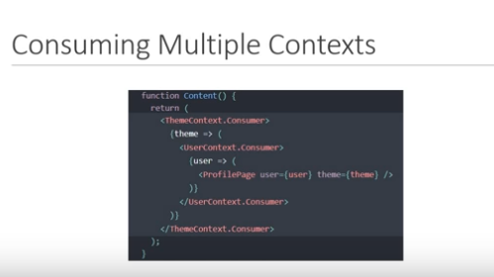

React and Http

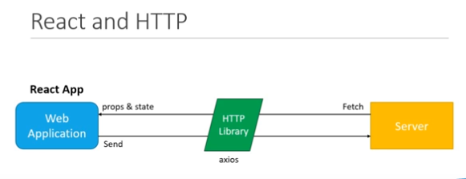

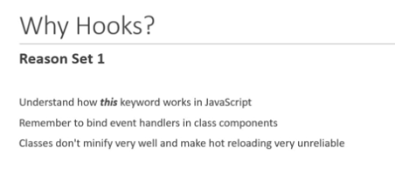

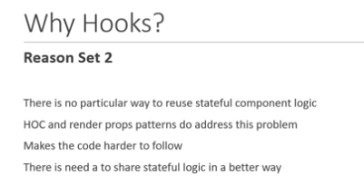

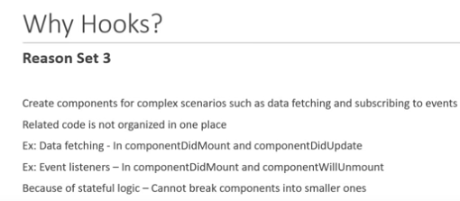

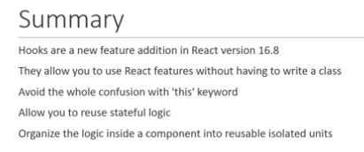

RULES OF HOOKS
1. Don’t call hooks inside loops,conditions or nested functions.
2.Only call hooks from react functions.-call them from within react functional components and not just any regular Js function.

UseState Hook
-The setter function provided by the useState hook does not automatically merge and update objects.You have to manually merge it yourself then pass the value to a setter function.

-useState allows you to add state to functional components.
-In classes, the state is always an object while with useState it can be a number ,array,string or boolean.
-The hook returns an array with 2 elements.The first element is the current value of the state, and the second element is a state setter function.
-If the new state value depends on the previous state value, you can pass a function to the setter function.
-When dealing with objects or arrays, always make sure to spread your state variable and then call the setter function.

useEffect
- If you think dependency array is a way to specify when to re-render effect you are going to run into problems.Instead it should be thought of as a way of letting react know of everything that the effect must watch for changes.
- It lets you perform side effects in functional components.
- Its a close replacement for componentDidMount,componentDidUpdate and componentWillUnmount.
- It runs after every render.
- When you want to execute some component cleanup code, you include it in a function and return that function from the function passed to useEffect.The cleanup code can be cancelling subscriptions, timers or even removing event handlers.

useContext

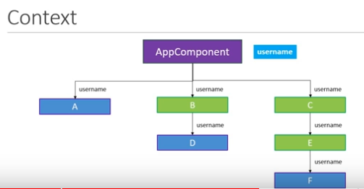

- Its makes the consumption of the context value simpler.

useReducer
-A hook used for state management.
- Its an alternative to useState.
- useState is built using useReducer.

UseState – state
useEffect -side effects
useContext – contextAPI
useReducer – reducers

- In reduce method in Js the method takes in 2 parameters,the reducer function and an initial value for the accumulator.

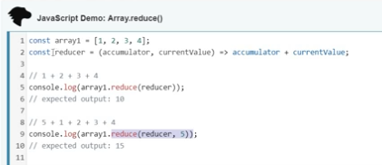

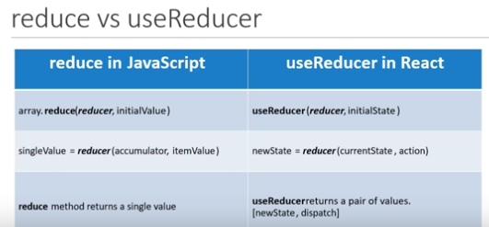

- The action parameter is what dictates the state transition from the current state to the new state.
- The dispatch method is used to specify the action.
- You can maintain both state and action as objects.
- When using action as an object you are able to pass additional data to the reducer function.
- When using state as an object you are able to keep track of multiple state variables.

Multiple useReducers
- When dealing with multiple state variables that have the same state transitions, it is a good idea to have multiple useReducers making use of the same reducer function.This will avoid the complexity of merging the state if it were to be an object and also prevent duplication of code in the reducer function.

useReducer with useContext

useReducer – local state management
Share state btwn components – global state management
-This can be done using useReducer + useContext

- You can mantain state in app.js and share that state with the different components nested at different levels in the componentry.
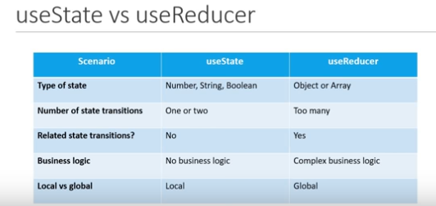

- If there are too many set state calls, you should consider moving that logic into a reducer function.You would be updating several state variables all that will be happening in the reducer function.

- Using the reducer hook over useState with context when dealing with global states has a simple advantage:with useReducer you only have to pass the one dispatch method down the componentry.That one dispatch method can update several state variables based on the action type.With useState we have to pass down multiple update functions, one for each state

useCallback Hook
- React.memo is a higher order component that will prevent a functional component from being re-rendered if its props or state do not change.
- useCallback is a hook that will return a memoized version of the callback function that only changes if one of the dependencies has changed.

-Why? - Its useful when passing callbacks to optimized child components that rely on reference equality to prevent unnecessary renders.

useMemo
- Difference btwn useCallback and useMemo is that useCallback caches the provided function instance itself whereas useMemo invokes the provided function and caches its result.
- It only recomputes the cached values when one of the dependencies has changed.This optimization helps to avoid expensive calculations on every render.
- It returns a catched value.

useRef
- Helps us access DOM nodes directly within functional components.
- Used to imparatively access DOM nodes in react functional components.
- Although useRef can hold a reference to a DOM node using a ref attribute, it can also be used to store any mutable value.
-The good thing about useRef is that the value will persist through out the re-renders while also not causing any additional renders when its value changes.
- It can also be used to create a generic container which can hold a mutable value similar to instance properties on a class component.It still remembers the stored data even after other state variables caused a re-render of this component.A good example of this is clearing an interval timer from an event handler.Does not cause re-renders when the data it stores changes.

Other hooks to look at:
-useImperativeHandle
- useLayoutEffect
- useDebugValue

Custom Hooks
- A custom hook is basically a Js function whose name starts with “use”
- They are important for purposes of sharing logic btwn components.(alternative to HOCs and Render Props)

React Render

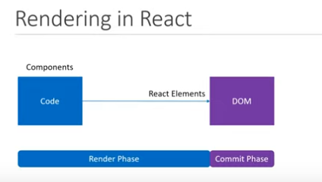

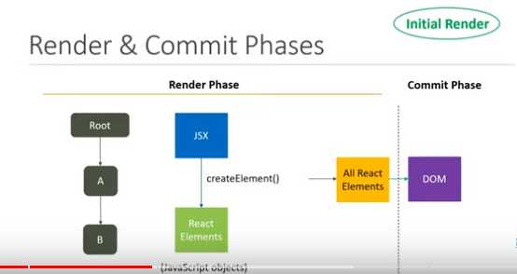

RE-RENDER

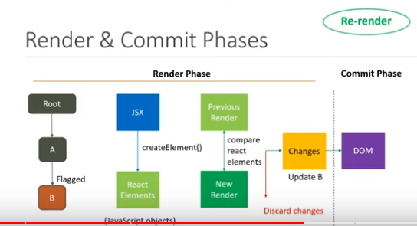

-Rendering is not the same as updating the DOM.A component may be rendered without any visible changes to the DOM.Example:During rendering if the component converts into the same react element as it did in the previous render, the elements are discarded and no changes are applied to the DOM.

-React handles DOM updates efficiently in the sense that all updates are batched and updated at once.This helps reduce the performance issues incurred by updating the DOM multiple times in rapid succession.

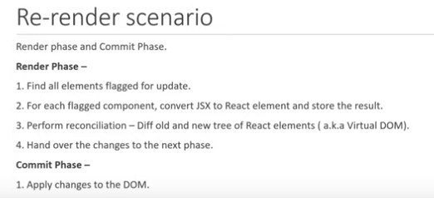

- If you update a state hook with the same value as the current state, react will render that component one more time and then bail out from subsequent renders.

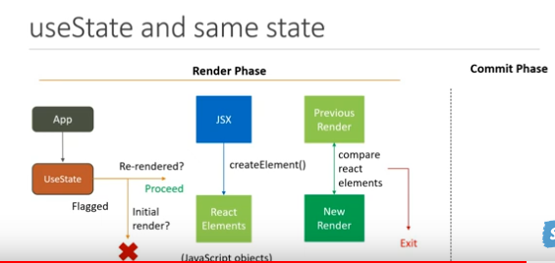

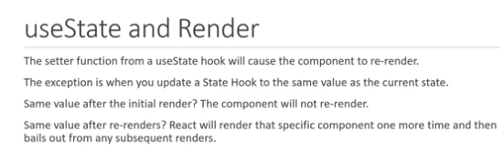

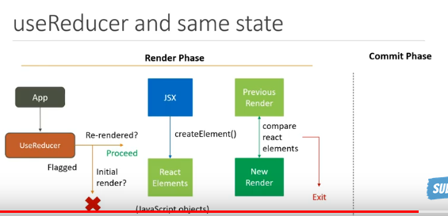

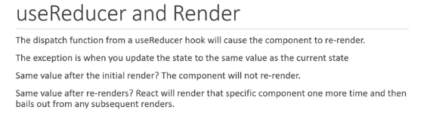

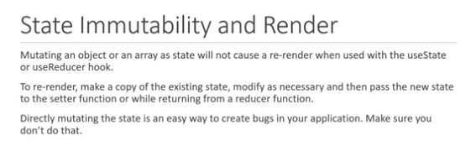

Parent and child & new state

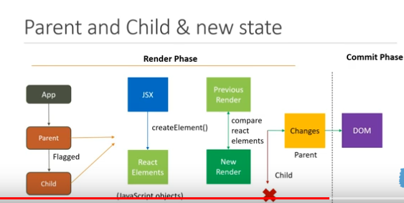

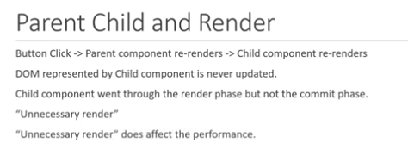

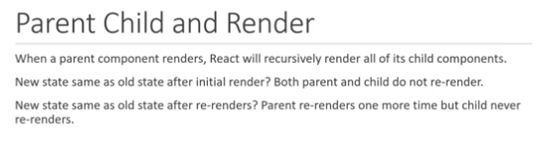

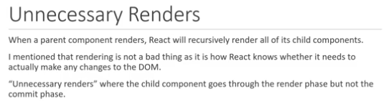

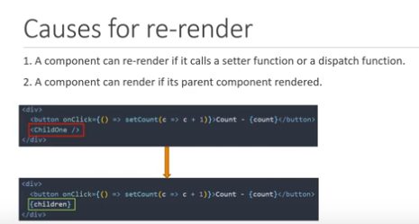

- To remove the unnecessary render caused by invoking the child component in the parents jsx, we moved the child component from being invoked in the parent components jsx to being passed as a prop.

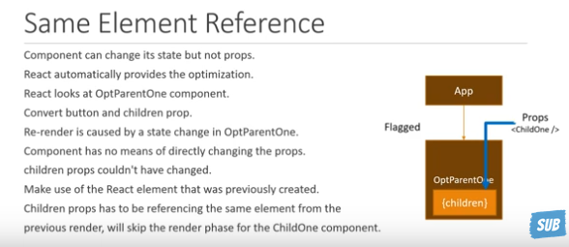

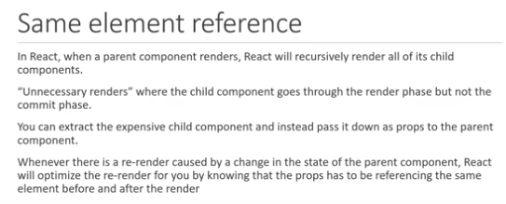

React memo
NOTE:React doesn’t care whether the props change, it will always render the child components just because the parent rendered.

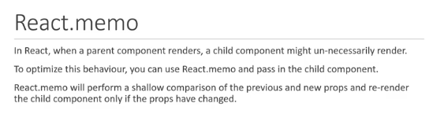

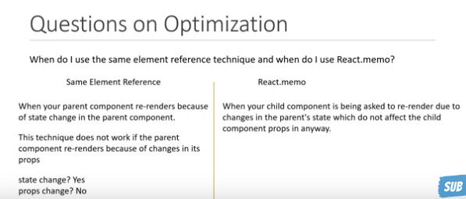

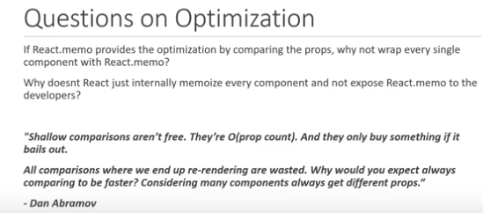

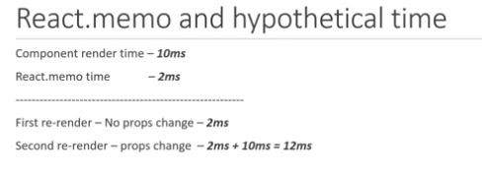

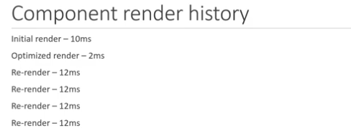

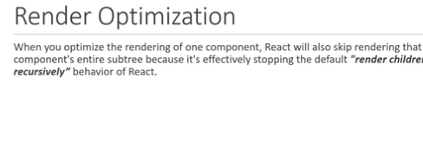

INCORRECT MEMO WITH CHILDREN
- In react props.children is always a new reference which will cause the child component to always render.
- There is no need to wrap your child component with react memo if the child component itself has children elements.
- The incorrect memo will simply add to your component render time as new references to the children props will always cause the memoized child components to re-render.

Incorrect memo with Impure Component
- When working with impure components make sure you know the consequences of using react.memo.
- Impure components are those whose jsx can change even though the props and state remain the same.Example:Using date and randomness.

Incorrect memo with props reference
- Every time the parent component that has an object or function renders, a new object or function reference is created and then passed in as props to the child component.If the reference changed, react memo cannot optimize and hence the child component also re-renders.

-If your component has objects or functions and you are wrapping one of its child components with react memo, that is an incorrect usage of memoization.

Rendering behaviour in react with respect to context

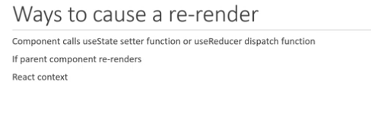

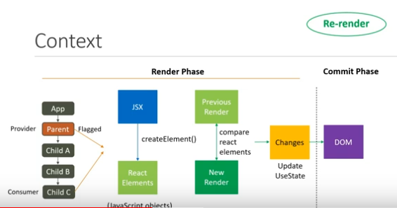

- If the context provider receives a new value, the components consuming the context value will also get updated.

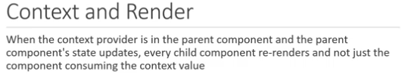

Context and memo

- You can optimize the context rendering behaviour with react memo by wrapping the child component of the context provider with react memo, state updates in the parent component will not force every component to re-render but only the components where the context is consumed.

Context and Same element reference

- React knows that a render is caused by a state change and a component cannot modify its own props hence the children prop could not have been modified.
- As react goes down the component tree it will only re-render the component which consumes the context value that has been changed.
- If you are using context in your component, make sure to either wrap the immediate child of the context provider with react memo or make sure to use the children props to make use of the ‘same element reference optimization’ that react provides.

REACT TYPESCRIPT

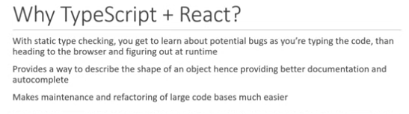

Prop types and tips

- You can destructure prop types.
- You can export/import types like components.
- Its possible to extract a type and use it in multiple places.

UseRef in typescript

- If you are sure that your reference is never null when you are accessing it, you can add the non-null assertion when invoking useRef.After null add the exclamation sign, this allows us to call focus without optional chaining.(using the useRef hook for Dom references)
-For dom references specify the dom element type, for mutable references specify the appropriate type.

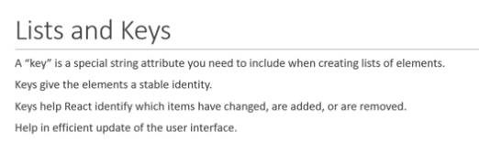

React interpreting keys

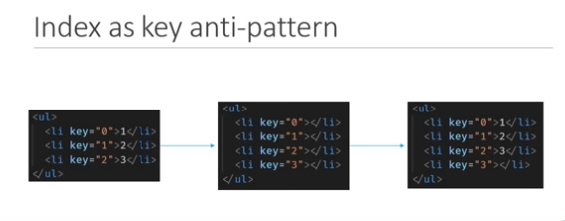

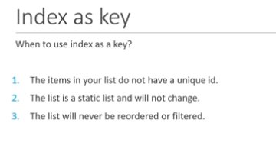

React Hook Form

- Manage form data
- submit form data
- Enforce validations and provide visual feedback

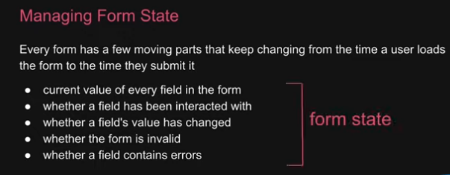

- The register function allows us to register a form control with react hook form
- NB:React hook form does not cause the component to re-render the traditional react forms that cause the component and its children to re-render on every key stroke.It follows the
uncontrolled inputs behaviour.

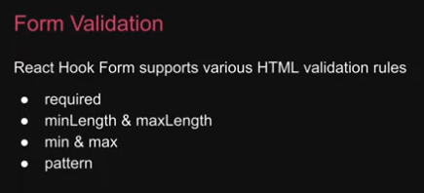

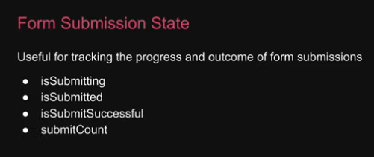

React Router

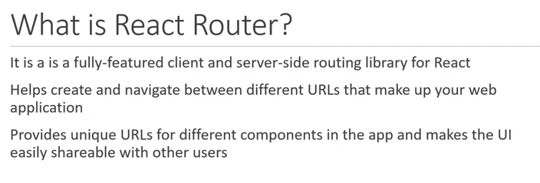
Index route

- When you have nested routes and you want a route to be rendered at the parent url, make use of an index route.

