An Initial Understanding of Task Interdependence in Software Development Teams: A Case Study
HASE Technical Report Nº 2017 - 001

George Marsicano¹, Victor Laerte de Oliveira², Leila Maria Rodrigues de Sousa Mariz², Fabio Q. B. da Silva²
¹ UnB/Gama Faculty, University of Brasilia, Brasília, DF, Brazil. georgemarsicano@unb.br

² Center for Informatics, Federal University of Pernambuco, Recife, PE, Brazil. {vlo2, lmrsm, fabio}@cin.ufpe.br

Data Analysis Process
The open coding of transcriptions was done with the selection of text segments relevant to the research and their naming (codes) (FIGURE 1).
For each interview, we generated codes that were constantly compared between each other (within the same interview, and between interviews), to identify similarities and differences, in order to find patterns in the data, so that they are organized and related to each other towards theory building [1].
Code structure was developed iteratively, i.e. from the codes identified from the first interview, new codes were added, according to their emergence before the subsequent analysis of the other interviews. To support this activity, the tool MAXQDA Plus 12 was used. At the end of the initial coding stage, 150 codes were identified.
FIGURE 1. OPEN CODING: BUILDING CODES
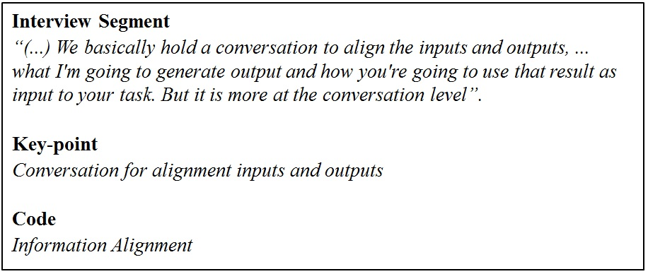
From this, the codes were grouped into categories representing the constructs of teamwork related to the task interdependence (FIGURE 2). The codes, constructions and their descriptions composed the analytical framework of the research (). After that, we went ahead with the process of building relationships between categories (FIGURE 4).
Finally, central categories were selected. From them, we generated propositions and explanations described in the next phases of the theory building process.
FIGURE 2. OPEN CODING: BUILDING CATEGORIES
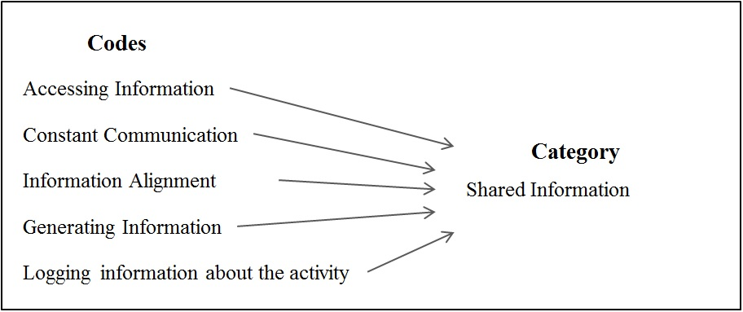

FIGURE 3. ANALYTICAL FRAMEWORK
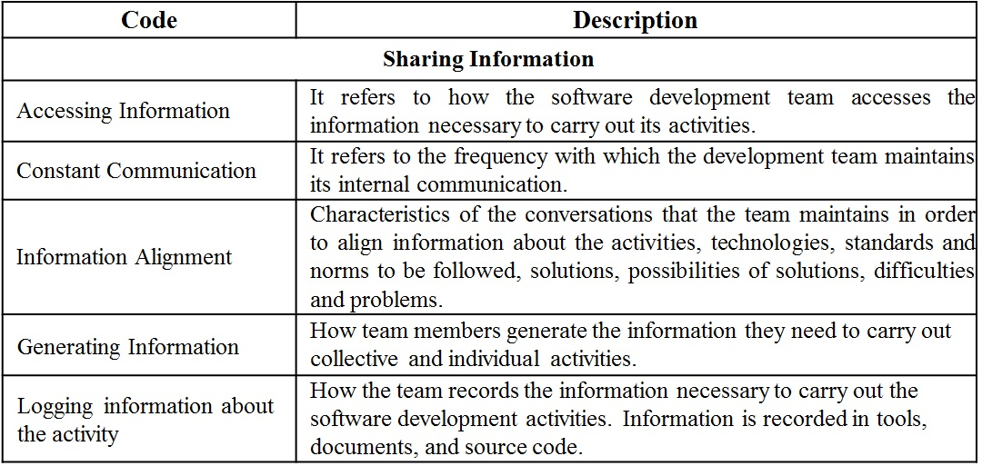
FIGURE 4. AXIAL CODING: BUILDING RELATIONSHIPS
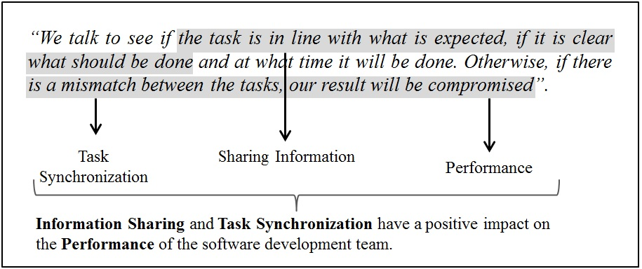

Results

Task Interdependence Antecedents
In order to better understanding of task interdependence in the context of the work dynamics on the software development team, some constructs that influence task interdependence were identified during the research. That is, depending on their change, task interdependence stronger, weaker, or non-existent. These constructs are:
Process – The use of a job methodology based on agile practices, to a certain case, can negatively influence the level of task interdependence, since in the context of agile software development teams, tasks must be broken into small parts so that they can be performed from start to finish independently. On the other hand, constant communication and encourage of the use of multidisciplinary and self-manageable teams can turn out to be positive factors that facilitate the use of task interdependence.
Team Structure – The team structure (specialist, multifunctional, size, distribution, etc.) is another antecedent that can influence task interdependence, since it can change the hierarchical relations among its members, as well as the need to maintain the synchronism between tasks.
Task Structure – According to the nature of the tasks, their structuring and division can cause more or less task interdependence in a project. Complex large tasks, for example, can generate the need to involve multiple people working in a complementary (interdependent) way. On the other hand, simple tasks can cause team members to work independently.
Project Moment – During project implementation, the level of interdependence between development team tasks can be changed. Structuring tasks such as setting an architecture, for example, can increase the level of interdependence among team members.
Project Leader Intervention– The project leader, being considered as the focal point for the resolution of issues (conflicts) associated with task interdependence interferes in the planning, structuring and distribution of tasks among the team members. In this sense, the strategy adopted by the project leader, can strengthen or weaken the level of task interdependence in the team.

Associated Constructs to Software Development Team Affected by Task Interdependence
During our investigations and, in accordance with Sjøberg, Dybå, Anda and Hannay Error: Reference source not found we have identified constructs related to the work of the software development team, which are affected in some way by task interdependence.
The first construct is the Information Sharing (IS), linked to the creation, registration and access to the information necessary for software development, as well as constant communication among those involved. The participant’s report indicate that task interdependence increases the need for sharing information among those involved in order to realize the tasks. The results points to two IS perspectives: external and internal. In the first, the development team needs information from the customer, the test team, the usability team, and the project leader. Sharing information with external agents the development team is basically done through tools, documents and face-to-face conversations.
“(...) the requirements are in the tool. If we have a question, we know we can discuss it in a meeting (...). Because without the requirements I cannot accomplish my task.”
“(...) the information I needed to carry out my tasks usually came from documentations or proofs of concepts.”
“(...), however, I need the design team to design for me the best UI that we are going to make and which components we will use (...). Otherwise, I may have problems or rework with my activity.”
From the internal perspective, information sharing is performed among the members of the development team, and it is also done through tools, documents and face-to-face conversations.
“(...) we basically do an alignment by talking about the input, output, what I'm going to generate as output and how you can take advantage of this output as input to your task.”
“(...) the thing is constant communication, constant communication, constant communication. It's something that we always emphasize our review meeting, which is one of the strengths of our team, communication. We never stop talking for a minute.”
“If it's something at the project level, something that can be standardized, then we create a document [in the tool].”
On this construct (IS) our findings indicate that the development team has an interdependence bond initiated and received in relation to its agents (external and internal).
The second construct is Mutual Help (MH), which is related to the internal work dynamics of the development team. In this context, each team member seeks to help others, either to realize a task or in the need to ask a question. The goal is to make the whole team grow and evolve together, both in the technical context and in relationships. The team's help environment is reported to be quite informal. In this context, task interdependence benefits the creation of a helping environment among team members.
“I do not even know how to talk, it depends a lot on the moment, but: ‘Look, I'm going to need this feature when you can finish it? If you need my help ...’. I do not even know how to formalize how this happens, it's quite normal (...) We depend on each other and we help each other.”
“I believe that in this part of the project we need to work more with the human aspects, because you are leaving something for someone. They are more human factors, in our view, we have a much larger group involvement in this more advanced stage of the project.”
“We try to help, see what can help to make this activity goes fast and in the right way (...). The idea is to make the team walk steadily and not stand still because someone had a problem.”
The third construct is Task Synchronization (TS), which refers to the maintenance of sequential task accomplishment. The challenge of TS is reported by development team members, as being an object of concern among those involved in the sense of not generating delays and/or blocking tasks. Thus, task interdependence increases the need for synchronism between them.
“If everyone is synchronized and the progress of my activity helps in the progress of the other, and when the other generate his activity, I can progress in mine.”
“The delay in my task may delay a schedule, because we have a scheduled start date for testing (...). Because of this, we need to keep our activities in sync (...). We are dependent.”
“We need to solve an X number of bugs so that we have enough material to then the test team start testing the application. So if I start to delay the tasks too much, it will definitely have an impact on the test schedule of someone.”
TS relates to both the activities between development team members (internal) and their activities with external agents (test team). In this sense, our findings point to a link, both of initiated and received interdependence, in relation to its agents (external and internal).
The fourth construct is the Knowledge Redundancy (KR), referring to the strategy adopted by the team, in what concerns to promote knowledge sharing among its members, i.e., team members should share the same knowledge in order to make possible to allocate any activity to any developer. This is a construct linked to the internal team dynamics.
“(...) the idea is that everyone can do everything when necessary, if someone is sick, or if someone cannot come for some reason.”
“As we have an idea of everybody to do everything everywhere [in the software], so that there is no centralization of knowledge (...).”
“(...) in the level that everyone on the team can make any activity.”
“So, I have to think about how I'm going to write the code, because after I have to explain to the team how it works. And also, because knowledge cannot be only with me”.
“We get together, discuss how it works and what the behavior of the framework is (...). Then there is a training on the fly.”
About Interpersonal Relationships (IR) among team members, points to people with close relations of friendship and partnership. When talking about interpersonal relationships with external agents (client), the team reports point in another direction, less close relation.
“(...) we have a very good integration, I know the team well and I consider myself as a friend outside the work environment, it is sometimes difficult to know how to separate this ... I really like my team and we have a good relationship (...). I think this helps a lot in the day-to-day when we need to interact and exchange information.”
“(...) I really like to socialize; this characteristic is part of my profile. So, it turns out that I get involved not only with things from work, but also, I get very involved with the people on my team, I have a very good relationship with people (...). I feel good helping in the growth of people and the team.”
Acting closely to Interpersonal Relations, the Sense of Belonging (FB) emerges as an individual construct, from where each research participants perceive their relationship with the team, feeling part of and believing in the value of teamwork. This construct is linked to the internal team dynamics. In this research, it was possible to verify a strong team sense of belonging among its members.
“I feel very much part of the team (...).”
“I feel totally part of the team (...). We have total freedom of opinion, of suggestion, of criticism. Receive positive and negative feedbacks. I'm fully integrated in this group. I have no limitations, I have a lot of freedom.”
The Competence and Skills (CS) of development team members is identified with a construct attributed to the internal team dynamics.
“We have one of the members that has a good knowledge in this web part. So, when I'm on a web task he guides me.”
“So, we already had one person on the team with experience in this technology. This person was indicated to go deeper in this web module and then pass on the knowledge.”
“Then, suddenly a bug can happen that I know my colleague on the side has more experience (...), we do not have a practice to pass a bug, but ask for support so that we can fix the bug as fast as possible.”
Another important construct identified is the Guarantee of Norms and Development Standards (GD) associated with the relationship between information sharing and outcomes generated by the development team. Such a construct is linked to the internal team dynamics.
“(...) the thing again is based on conversation. I try to modularize as much as possible, I'm tired of refactoring because I made the code and it can be replicated in three other classes ... I try to ensure the application of development standards to make life easier for all of the team.”
“(...) obviously the quality of what he does will directly interfere with my work. So the thing is constant communication (...). And be aware of the standards.”
From the perception of task interdependence in the development team, our research identifies some Feelings (FE) reported by the participants, which can moderate the relationship between the results obtained by the team and the phenomenon of task interdependence itself. Such feelings are generated, in part, by the discovery of “unexpected” interdependence. That is, something that was not identified during planning and that somehow impacts team work.
“If someone was stopped by my mistake, I become sadder, and wanting to solve this as soon as possible.”
“If there is a requirement that is not very well understood, and someone opens a bug, which in my view it's not (...), or the client says, ‘this is not specified, but it's a problem’, and was not documented, and I cannot find this information, this bug will come back to me, and it usually generates a feeling of revolt.”
“There's no feeling like, ‘Oh, I would like to be already in that next task and I'm not because there's something interrupting me’”.
Finally, the last construct refers to the team Performance (PE), i.e. the results generated. From the reports made by the research participants, the development team recognizes that internally, the relationships are of interdependence initiated and received among all its members (4 developers).
“Everyone interferes in everybody's work, because that's how I said it's a small team.”
“So, it's everything for everything. So, if I go to something, it will interfere directly with someone else's work.”
“(...) so the interdependence of tasks can happen from anyone to anyone. And, everyone impacts on the result.”

Relation between the Constructs and Task Interdependence
After the reported findings and interpretations of associated constructs to software development team affected by task interdependence, we returned to our data and identified five key relationships derived from the central categories of our model: Information Sharing, Task Synchronization, Knowledge Redundancy, Mutual Help, and Performance. According to the methodological structure Error: Reference source not found, on which this work is based, we will present in this section the propositions and the explanations, in a joint way. The relations between the constructs are represented in Error: Reference source not found.
Proposition 1: the need to increase Information Sharing mediated by Interpersonal Relationships, and Task Synchronization positively impact software development team performance.
Participants report that both the lack of information (business requirements, interface document, proofs of concept) needed to complete tasks, as well as the mismatch between them, generates direct impacts on the results obtained by the team. In this regard, it is necessary that the interaction between those involved (internal and external to the team) to be extended, in order to make the flow of information constant. To do so, the reports point to an exercise in information conversations, keeping the synchronization between the activities of the project.
“We talk to see if the task is aligned with what is expected, if it is clear what should be done and when it will be done. Otherwise, if there is a mismatch between the tasks, our result will be compromised.”
“The more our tasks depend on each other, the more we need to be aware of their execution sequencing. (...). And, we need to talk all the time to aligning information about the project.”
“Good relationships between team members help keep our constants conversations and all information aligned.”
Proposition 2: the creation of a Mutual Help and Knowledge Redundancy mediated by individual Competence and Skills, Interpersonal Relationships and the Sense of Team Belonging positively impacts the Performance of the software development team.
The report of good interpersonal relations between the members of the software development team associated with the strong sense of team belonging, as well as the diversity of knowledge and skills (seniority and mastery of technologies) facilitate the team's actions and willingness to give and receive help from each other, as well as sharing their knowledge, envisioning collective growth and improving team results.
“When we first detect the dependency between tasks, we enter into integration mode to when one ends before, the other goes there and tries to help.”
“It's cool you see that your help has generated a positive result (...). And then, you see an evolution, right? You've tried to help in some way and now you're able to discuss it in a good level. I'm learning and we're evolving together.”
“The results generated by the members of my team directly impact my result and vice versa. If someone does something that does not pass the knowledge to the rest of the team this can generate a further problem.”
“I feel that as a team member it is important that I help others so that the result is collective rather than individual.”
Proposition 3: Information Sharing helps to guarantee the use of Norms and Development Standards positively impacting Performance of the software development team.
The participant’s reports show the need to share information and attention to development standards, in order to guarantee good results, and to minimize the impact between tasks of different developers.
“(...) "... there is the most implicit part of the thing, which is how the person responsible for the task I'm depending on, has performed his task. Obviously, we discuss during the task. So, we usually know what the person is doing, and if you do something very out of the standards, we go there and give him a few advices to go back to the right way, or vice versa with me.”
“If not done in a correct and simple way will directly affect the outcome of others. It can generate bugs, problems of understanding, and then people may not be able to do their work because they are not understanding the code. Your task is totally connected with that of others.”
Proposition 4: the perception of Task Interdependence can be mediated by the Feelings generated, from its impact on the Performance of the software development team.
From their experiences with task interdependence and the obtained results, team members report their feelings, which tend to direct their perceptions and actions to different paths, impacting the way they treat or they will address the task interdependence.
“It happens when, sometimes has a task that holds everyone, for example, environment/architecture task. If it's not ready, no one can do it. You get kind of pressure to get it over with.”
“When I am depending on some task that is not yet finished ... we can go and see other things. (...). This is one of those cases that happen frequently, so it does not cause discomfort, it does not matter.”
“I do not like when there is any interdependence between the tasks, especially when it interrupts the work of the team, or when it disturbs us to comply with what was promised in the sprint.”

Summary of Results
Following presents a summary of the results found, according to the methodological proposal Error: Reference source not found used by the work. In the table constructs are identified as C1, C2, C3, ... C10. The propositions referring to the relations between the constructs are presented as P1, P2, P3 and P4. Explanations related to propositions are presented in E1, E2, E3 and E4. Finally, the scope of research, limiting the universe in which theory can be applied.

TABLE 1. CONSTRUCTS, PROPOSITIONS, EXPLANATIONS AND SCOPE OF TASK INTERDEPENDENCE IN SOFTWARE DEVELOPMENT TEAMS.
Constructs
C1 |  | Information Sharing
C2 |  | Mutual Help
C3 |  | Task Synchronization
C4 |  | Knowledge Redundancy
C5 |  | Interpersonal Relations
C6 |  | Sense of Belonging
C7 |  | Competence and Skills
C8 |  | Guarantee of Norms and Development Standards
C9 |  | Feelings
C10 |  | Performance
Propositions
P1 | The need to increase Information Sharing mediated by Interpersonal Relationships, and Task Synchronization positively impact software development team performance.
P2 | The creation of a Mutual Help and Knowledge Redundancy mediated by individual Competence and Skills, Interpersonal Relationships and Sense of Team Belonging positively impacts the Performance of the software development team.
P3 | Information Sharing helps to guarantee the use of Norms and Development Standards positively impacting the Performance of the software development team.
P4 | The perception of Task Interdependence can be mediated by the Feelings generated, from its impact on the Performance of the software development team.
Explanations
E1 | - The software development team needs the business requirements, interface document and proof of concept to finish their work;  - Maintaining synchronization of interdependent tasks is critical to the good performance of the team.
E2 | - Proximity and good relationship between team members facilitate help actions and redundancy of knowledge;;  - Different levels of seniority and mastery of technologies among members stimulate collective growth and improved team results;
E3 | - Sharing information helps spread the work patterns of the development team;  - The care and attention of the team members in maintaining the quality of the work, by guaranteeing the standards of codification, performance and usability, help to improve the results;
E4 | - The feelings of development team members influence their actions and perceptions about task interdependence.
Scope
 | It is assumed that the theory can be applied to software development teams (implementers), small (up to 5 members), physically located in the same place and have a work methodology based on agile practices.

III. References

- Runeson, P., & Höst, M., Guidelines for conducting and reporting case study research in software engineering. Empirical software engineering, 2009, 14(2), 131-164.
- Sjøberg, D. I., Dybå, T., Anda, B. C., & Hannay, J. E., Building theories in software engineering. In Guide to advanced empirical software engineering,Springer London, 2008, pp. 312-336.

