*By: Adrian Pichardo, Josh Rosenzweig, Ron Gerschel, Victor Lora*

*Muhlenberg College | 2400 Chew Street, Allentown, PA 18104*

*EVApp ApplicAtion*

*“The only way forward, if we are going to improve the quality of the environment, is to get everybody involved.”*

*-Richard Rogers*

Table of Contents

1. Executive Summary 3

2. Introduction 3

2.1 Overview 3

2.2 Abbreviations and Definitions 4

2.3 Background 5

3. Market Analysis 5

3.1 Needs Analysis 5

3.2 Competitive Analysis 6

4. Requirements 8

4.1 Actors and Use Cases 8

4.2 Requirements 9

4.3 Free vs. Premium 10

5 Design 11

5.1 User Interface Overview 11

5.2 User Interface Designs 11

6. Product Plan 13

6.1 Team Bio 13

6.2 Team Organization 13

6.3 Estimates & Schedule 14

6.4 Resource & Budget 14

6.5 Risks 14

7. References 16

# **1. Executive Summary**

Without researching anything, how many electric vehicles can you list? What are some key features, including range? Voltage is software that users can utilize through the use of an app on a smartphone, to allow for useful information relating to key information pertaining to an electric vehicle to be easily accessible. This app will also help to educate many uninformed people who purchase gasoline cars without considering electric vehicles. Our app will include a section where a user can visit to learn more about electric vehicles. Also today finding a charging station is not very easy so the app will integrate a map where an app owner can find charging stations near tem and record the location of that charging station for future uses. Users who own an electric car already will only need to enter what type of electric car they own to gather the appropriate information for their respective vehicle. This will assist an owner by including information on how charged their vehicle is and how far their vehicle can travel on its current charge. App owners who do not own an electric vehicle can compare gas cars to electric cars using the information provided on the app, and if they are interested in purchasing a vehicle they can receive dealerships information and pursue the vehicle. Car Manufacturers can have an exclusive account where they can add information about vehicles they are creating and edit their profile so that their website and contact information can be listed for users to view.

The app will include any vehicle that uses a battery, from only electric vehicles to plug-in hybrid electric vehicles to vehicles with an included onboard range extender. The database of vehicles will be created by collecting information from already existing databases, or can easily be added by an administrator or car manufacturer. Dealership locations and pricing will also be edited in the same way and will allow for a user to have direct contact with the dealership for extra information needed or to schedule a test drive. Most automobile manufacturers have produced an electric vehicle or have plans for one to be built in the future. The app will be made to accommodate guests, owners, manufacturers, and administrators. A database will be used to store most information, however, some information will need to be stored on the user's device.

This app is intended to assist in allowing for an easier transition from an internal combustion engine vehicle over to an electric vehicle.

# **2. Introduction**

## **2.1 Overview**

Most people will purchase a regular ICE car that best fits their needs and/or has the highest MPG available. In 2014, the U.S. alone used about 140 billion gallons of gasoline. The use of this much gasoline has had immense negative contributions to global warming. Electric Vehicles can help minimize the amount of gasoline the U.S. uses, which will in turn benefit the world as a whole. Most consumers are unaware of the benefits that electric vehicles provide. Most consumers are accustomed to searching for a new vehicle by comparing MPG ratings between different gasoline powered automobiles. In fact, most Americans put fuel economy at the top of their list when it comes to purchasing a new car. While most consumers use this MPG value, electric vehicle owners use MPGe values to compare vehicles. Most consumers are unaware that electric vehicles on average have a much higher MPGe value than a traditional car. This app would serve to inform consumers on purchasing an electric car by providing a comparison to traditional gasoline vehicles and also provide an extensive list of benefits that come with operating an electric vehicle. Most people are uninformed about electric vehicles and when people purchase an electric car there are some misconceptions that arise. Only 740,000 electric vehicles have been sold around the world and currently in the U.S. alone there are only 345,000 electric vehicles on the road. This may be only 1% of new U.S. cars sold each year, but this percentage is increasing per year. Electric cars provide for a cleaner travel alternative and are a planned future for most automobile manufacturers.

The app would also be a very useful tool for already existing owners of electric vehicles. The app would allow for current owners to assess how far their car can travel from their current location using the vehicles charge information. Users can enter if they plan on stopping to recharge or plan to make the entire trip (there and back) on a single charge. The app would also allow users to know when their vehicle will be fully charged and can list when the cheapest electricity will be available for their area off of peak usage hours. Another feature is assisting current owners on purchasing a newer or different model. The app will include information on various cars and will allow for a comparison to be created. Users will also have direct access to dealers for information on pricing and trade in values.

Some services do exist, but do not provide as much detail this app would provide for users. With future development these services could be incorporated into the app to allow for a single application with the most useful set of information to exist in one place.

## **2.2 Abbreviations and Definitions**

* **Internal Combustion Engine (ICE)** - a type of engine that generates energy by burning a type of fuel with air inside the engine.
* **Plug-in Hybrid Electric Vehicle (PHEV)** - a hybrid electric vehicle that utilizes rechargeable batteries and another source of energy to travel.
* **Range Extender** - a gasoline ICE that does not directly power the vehicle, but provides for extra energy needed to charge a battery within the vehicle.
* **Miles Per Gallon (MPG)** - is a measure of the average amount of miles traveled per gallon of fuel burned.
* **Miles Per Gallon Equivalent (MPGe)** - is a measure of the average amount of miles traveled by an electric powered vehicle that would be equivalent to a regular ICE car.

## **2.3 Background**

Most automobile manufacturers have produced an electric vehicle or have plans for one to be built in the near future. While most vehicles sold today are gasoline-powered vehicles, the transition to electric vehicles is slowly taking an effect. Electric vehicles also offer higher MPGe rates than current fuel efficient ICE vehicles.

“Consider the lack of familiarity. In a survey by researchers from Indiana University and the University of Kansas, respondents couldn't correctly answer basic factual questions about plug-in electric vehicles more than 60% of the time. Some 75% of wrong answers underestimated the beneficial aspects of the vehicles.” [2]

“The survey found that 37 percent said their leading consideration when shopping for their next car will be fuel economy. A distant second was quality (17 percent) followed by safety (16 percent), value (14 percent) and performance (6 percent). ‘These results make it clear that high fuel prices are continuing to impact driver behavior and influencing future purchase considerations,’ said Jeff Bartlett, Consumer Reports deputy auto editor. ‘While quality, safety and value are still important, this may be foreshadowing a market shift by folks seeking relief at the pump.’” [3]

# **3. Market Analysis**

## **3.1 Needs Analysis**

“The survey, conducted by the Consumer Reports National Research Center, found that car owners were open to different ways of saving at the pump, from downsizing to looking at hybrids, electric cars, or models with diesel engines. In all, nearly three quarters (73 percent) of participants said they would consider some type of alternatively fueled vehicle, with flex-fuel (which can run on E85 ethanol) and hybrid models leading the way. Younger buyers were more likely to consider an alternatively-fuel or purely electric vehicle than drivers over the age of 55.” [3]

The app will need to incorporate an organized UI that is easy to use for any age. Other services already exist that provide users with certain information, but not as much detail as this app would provide. The app would need to incorporate these extra services especially OnStar. OnStar is a service provided to users who purchase any General Motors vehicle. OnStar provides users of electric vehicles with information on the amount of charge their vehicle has and how much time a full charge will need to take from the given charge. This service would eventually be implemented into the app and will allow users to login to their OnStar account.

The app could build profits by either charging users a small charge on the App Store or Google Play store. Otherwise, manufacturers can be charged a small yearly subscription to have their most recent vehicles listed with nearby dealerships.

Owners and prospective owners are both included in the app to allow for an easy transition to occur, if a prospective owner decides to purchase an electric vehicle. Once the guest purchases an electric vehicle, they will have to create an account through the same app to allow for access to more features related to the vehicle that they have just purchased.

While most electric vehicles have an onboard computer that tells the driver information about range and charging times, they do not list all full details about the vehicle including a map with information on how far the vehicle is from a charging station. Most electric cars also do not allow the driver to contact a dealership or view newer models. The app will serve as a single place to find all information needed on all details on electric vehicles and can be easily accessed from a mobile device/tablet. There are few apps that can be considered a competition to this app because it will have many features that a single app in the market does not currently have.

It is assumed that most users of electric vehicles will have already purchased a mobile device/tablet and have access to download the app from their mobile device cloud store. Users will also need to have some free space on their mobile device/tablet to allow the app to store specific data pertaining to their respective profile.

## **3.2 Competitive Analysis**

**Four Competitors:**

1. Mobile app: GreenCharge
2. Mobile app: PlugShare
3. Mobile app: IPP Solar
4. Mobile app: Azra Network

|  |  |  |  |  |  |
| --- | --- | --- | --- | --- | --- |
| **Feature** | **EVApp** | **GreenCharge** | **PlugShare** | **IPP Solar** | **Azra Network** |
| **Set up Charge notifications and setup reminders** | X | X |  |  | X |
| **Calculate energy costs** | X | X |  |  |  |
| **Follow a charging sessions progress** |  |  |  | X | X |
| **Geo-localize available charging stations** | X | X |  | X | X |
| **Customize app with model, color, and year of vehicle** | X |  |  |  | X |
| **Search and find solar powered charging stations near vehicle** |  |  |  | X |  |
| **Store credit card information** |  |  | X | X |  |
| **Pay for charging** |  |  |  | X |  |
| **Review charging stations** |  |  | X |  |  |
| **View charging station ratings** |  |  | X |  |  |
| **Add new charging stations as they are discovered** |  |  | X |  |  |
| **Filter for charges that support the user's electric vehicle** |  |  | X |  |  |

# **4. Requirements**

## **4.1 Actors and Use Cases**

|  |  |  |  |  |  |
| --- | --- | --- | --- | --- | --- |
| **Use Case** | **Registered Users** | **Guest** | **Researcher** | **Manufacturer** | **Admin** |
| **Create account** | X | X | X | X |  |
| **View product info** | X | X | X | X |  |
| **Edit vehicle** |  |  | X |  |  |
| **Calculate range** | X | X | X |  |  |
| **View seller** | X | X |  | X |  |
| **View MPGe** | X | X | X |  |  |
| **View total miles** | X | X | X |  |  |
| **Edit available vehicle choice** |  |  |  | X | X |
| **Add user account** | X | X | X |  | X |
| **Add user info** | X | X | X |  | X |
| **Upgrade/Update software** |  |  |  |  | X |
| **Testing** |  |  |  |  | X |
| **Find charge pumps** | X | X | X |  |  |
| **Contact manufacturers** | X | X | X |  | X |
| **Contact auto mechanics** | X | X | X |  |  |
| **Contact charging stations** | X | X | X |  |  |
| **Record charging stations** |  |  |  | X | X |
| **Change settings** | X | X | X |  |  |
| **Add vehicles to favorites** | X | X | X |  |  |
| **Change vehicles in favorites** | X | X | X |  |  |
| **View facts** | X | X | X | X | X |

**Actors**

1. **Mobile Device Users / Guests** - These are the consumers that have downloaded the app and will have certain access provided through a created profile. There are two types of users, guests and current owners.
2. **Car Manufacturer** - Has the ability to contact the Administrator to be given access to changing certain details about vehicles. Can also access a separate seller side of app to assist in selling the vehicle.
3. **Researcher** - This could be any user that downloads the app and does not own an existing electric vehicle and is interested in discovering facts including charge time and how far they could travel with a single range if the vehicle was purchased.
4. **Administrator** - The Administrator has full access to all features created within the app. The Administrator controls the UI of the app and how the data is integrated into the app. The Administrator can add details about vehicles if not provided by manufacturer.

## **4.2 Requirements**

|  |  |  |  |  |
| --- | --- | --- | --- | --- |
| **Category** | **Requirement** | **Priority** | **Stage** | **Cost** |
| 1. **Database** | List of Vehicle Makes | High | Prototype | Free |
| 1. **Database** | List of Vehicle Models | High | Prototype | Free |
| 1. **Database** | List of Vehicle Years | High | Prototype | Free |
| 1. **Database** | List of Vehicle Style | High | Prototype | Free |
| 1. **Documentation** | Instruction & troubleshooting manual | High | Release | Free |
| 1. **Error Handling** | Error Handling | Med | Beta | Free |
| 1. **Hardware** | Mobile Device | High | Release | $99-400 |
| 1. **Hardware/Software** | GPS-Wi-Fi Location | Med | Prototype | Free |
| 1. **Hardware/Software** | Edmunds API | High | Prototype | Free |
| 1. **Installation** | Easy Installation | High | Release | Free |
| 1. **License** | Apple Developer License | High | Release/Beta | $99 |
| 1. **Licenses** | GPL License | Low | Beta | Free |
| 1. **Market** | Advertisement for Car Manufacturers | High | Post-release | ??? |
| 1. **Market** | Social Media – EVApp Promotion | High | Pre-release | ??? |
| 1. **Market** | Logos | Med | Pre-Release | $500 |
| 1. **Network** | Wi-Fi/Network Connection | Med | Prototype | Depends mobile carrier |
| 1. **Network** | API Calls – gather lists | High | Prototype | Free |
| 1. **Operation** | Save user’s vehicle | Low | Prototype | Free |
| 1. **Security** | Secure geo-location | Med | Beta | Unknown |
| 1. **Software** | iOS | High | Prototype | Free |
| 1. **Software** | Geo-fencing | Low | Beta | Free |
| 1. **Software** | Website | Med | Release | $20/year |
| 1. **Software** | Application | High | Prototype | $1.99 |
| 1. **Test & Docs** | Code Testing & Documentation | High | Release | Free |
| 1. **UI** | Select vehicle make | High | Prototype | Free |
| 1. **UI** | Select vehicle model | High | Prototype | Free |
| 1. **UI** | Select vehicle year | High | Prototype | Free |
| 1. **UI** | Select vehicle trim | High | Prototype | Free |
| 1. **UI** | Choose to remember vehicle | Low | Release | Free |
| 1. **UI** | Main Menu | High | Prototype | Free |
| 1. **UI** | Settings | High | Prototype | Free |
| 1. **UI** | Maps – Tracks mph, distance traveled and range | High | Prototype | Free |
| 1. **UI** | Gas Stations – Finds nearest gas stations | Med | Beta | Free |
| 1. **UI** | Charging Stations – Finds nearest charging stations | Med | Beta | Free |
| 1. **UI** | Accessories – Allows user to buy car parts | Low | Release | Free |
| 1. **UI** | Car Info – displays vehicle information | High | Prototype | Free |
| 1. **UI** | Certified Mechanic – Finds nearest mechanic | Low | Release | Free |
| 1. **UI** | Facts about electric vehicles - Promotion | High | Prototype | Free |
| 1. **UI** | Acknowledgement Page | Low | Release | Free |
| 1. **UI** | Help Page | High | Beta | Free |

## **4.3 Free vs. Premium**

|  |  |  |
| --- | --- | --- |
| **Features** | **Free** | **Premium** |
| **Car Info** | X | X |
| **Car Check: Check for Engine Codes** |  | X |
| **Nearest gas station when low range** |  | X |
| **Nearest mechanic when check engine** |  | X |
| **Get Fuel Reminders: < 20 mi. left** | X | X |
| **Charge/Get Gas Alerts** |  | X |
| **Maps: MPH, Distance Traveled, Range** | X | X |
| **Accessories: Find Parts for Vehicle** | X | X |

# **5 Design**

## **5.1 User Interface Overview**

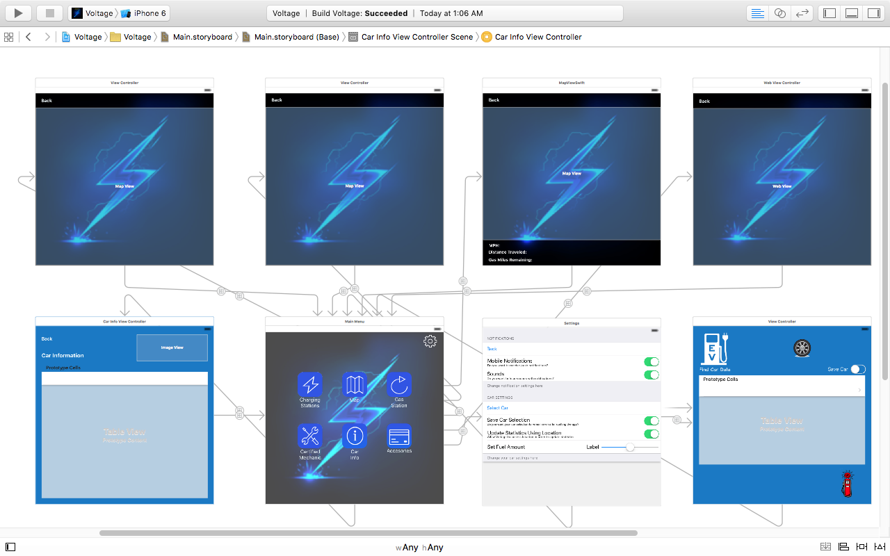

## **5.2 User Interface Designs**

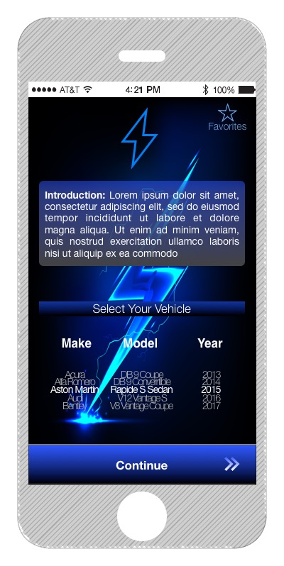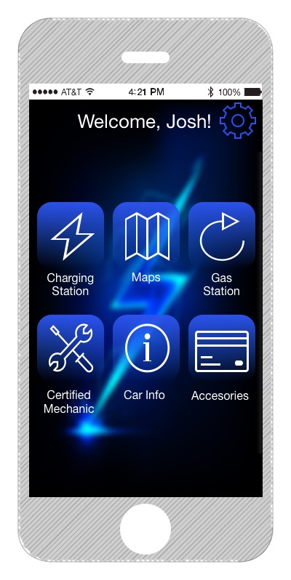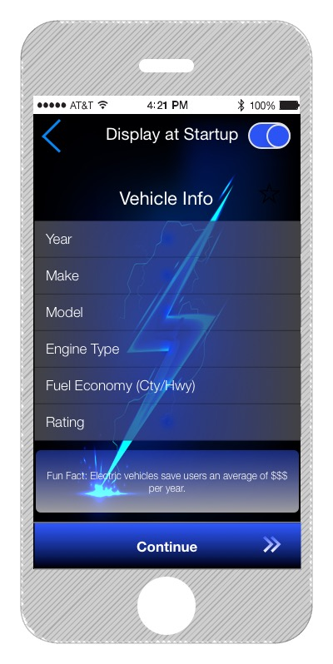

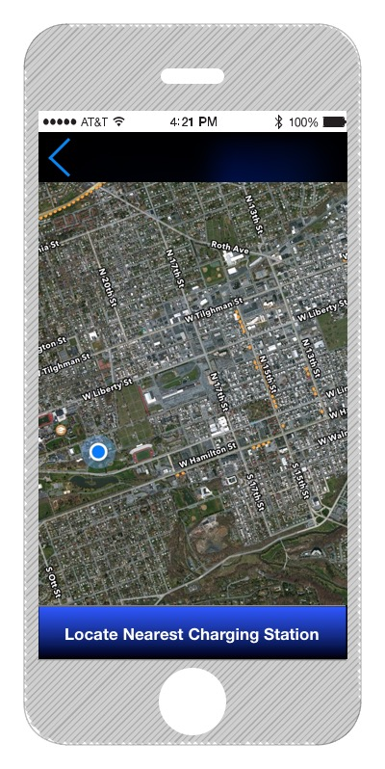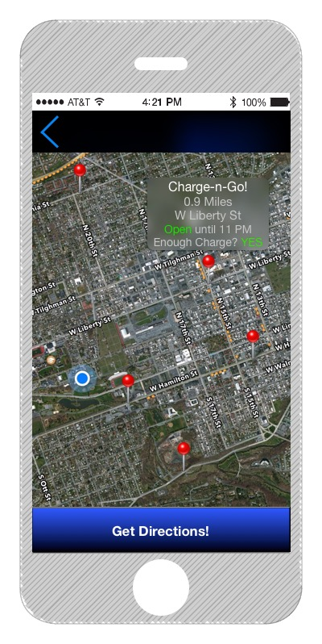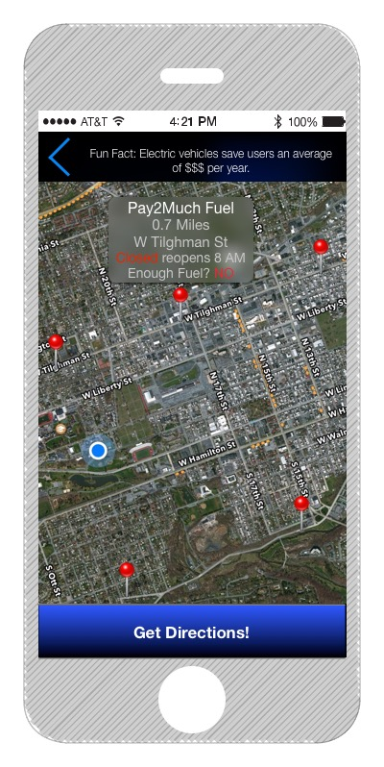

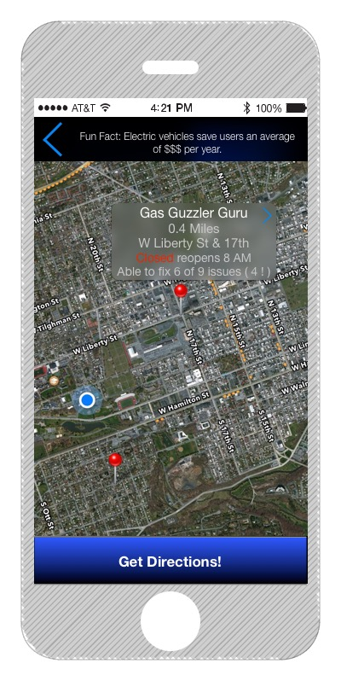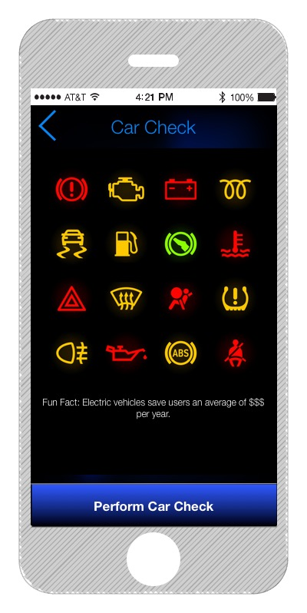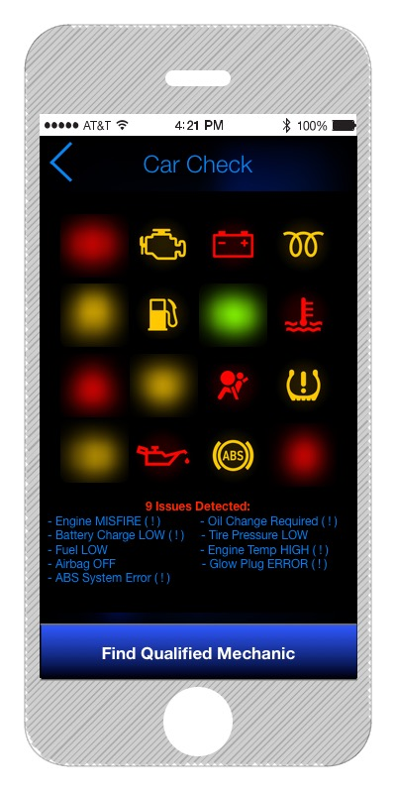

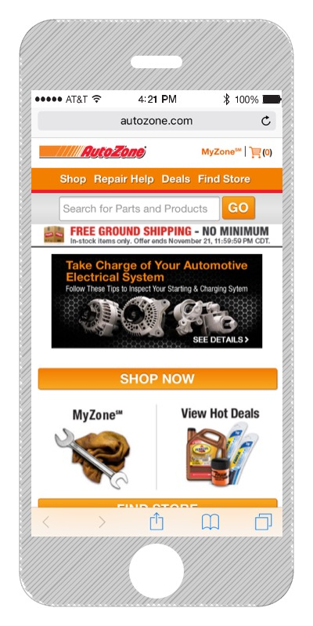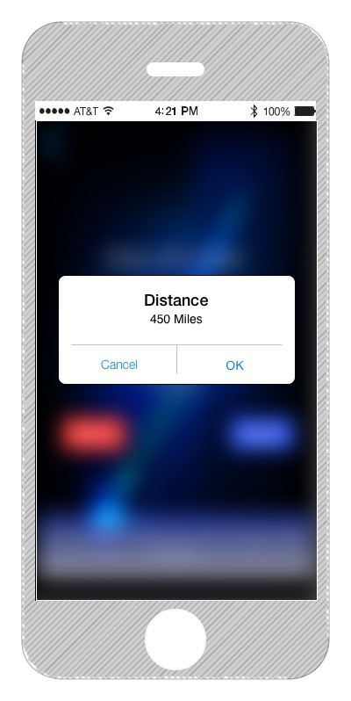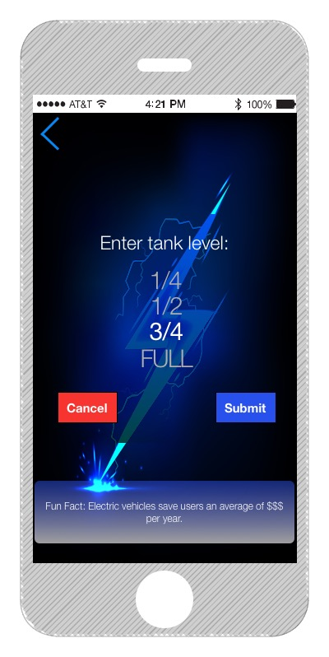

# **6. Product Plan**

## **6.1 Team Bio**

* Adrian Pichardo is currently a senior, majoring in Physical Science with a concentration in Computer Science at Muhlenberg. He came into this project with minimal knowledge of Swift and GitHub but did know how to use Xcode because in the summer of 2013 he took a C++ course where he used Xcode. For the EVApp project he worked on the fact feature, finding appropriate icons, and building unit and UI tests for the app.
* Ron Gerschel is currently a junior, majoring in Computer Science and Media & Communications at Muhlenberg.
* Joshua Rosenzweig is currently a junior, majoring in Computer Science at Muhlenberg.
* Victor Lora is currently a junior, majoring in Computer Science at Muhlenberg.

## **6.2 Team Organization**

The EVApp team has a simple approach to work management and decision-making. We established a checks and balance system in order to minimalize errors that make their way through the entire process. Our System is set up so that Adrian checks Ron, Ron checks Victor, Victor checks Josh, and Josh checks Adrian. In the case of a disagreement, majority rules through democracy. If a decision is split then Joshua Rosenzweig makes the decision.

## **6.3 Estimates & Schedule**

**Preparation** (3 people)

1. Learn the basics of swift syntax and language by watching tutorial videos and reading articles written by apple
2. Learn the basic layout for Xcode by watching tutorial videos and downloading an Xcode cheat sheet
3. Learn and install GitHub (Desktop client) watch tutorial videos and read tutorials if necessary
4. Make sure everyone has a solid understanding of the purpose and the design of the app
5. Set up GitHub and Slack account for the group to communicate effectively.

**User Interface** (4 people)

1. Get a hold of an API and an API key
2. Come up with a way to list all the car selections; separating make, model, and year
3. Create a back button in order for users to be able to correct any mistaken selections
4. Create a final page where the user can see their respective cars information.

**Code Review** (4 people)

1. Edit the code so that it resembles professional code
2. Document the code
3. Integrate icons into the User Interface
4. Create UI and unit tests
5. Review and reorganize the code

## **6.4 Resource & Budget (Projections)**

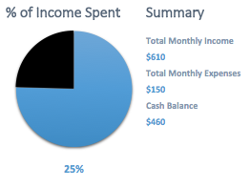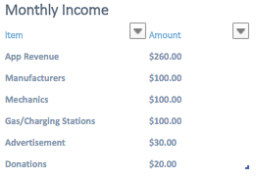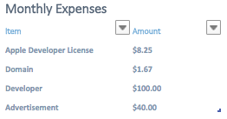

## **6.5 Risks**

* Server goes down
* No internet connection
* Car information is not available in the API
* App is not successful
* Electric vehicles stop being produced by car manufacturers
* Software is hacked and users become confused with our app
* Another app company feels like we have violated their intellectual property rights
* Our intellectual property rights get violated
* Multiple owners of one vehicle
* Electric vehicle’s dashboards become more technologically advanced and have the same features as our app has
* An owner decides to leave the software company

# **7. References**

1. http://www.eia.gov/tools/faqs/faq.cfm?id=23&t=10
2. http://www.wsj.com/articles/what-s-holding-back-electric-car-sales-1411937798
3. http://consumersunion.org/news/consumer-reports-survey-americans-say-fuel-economy-most-important-car-buying-factor/
4. http://energy.gov/articles/egallon-how-much-cheaper-it-drive-electricity
5. https://www.fueleconomy.gov/feg/evtech.shtml
6. http://www.autotrader.com/car-tips/electric-cars-benefits-and-disadvantages-208155
7. http://www.plugincars.com/electric-cars-pros-and-cons-128637.html
8. http://www.earth911.com/eco-tech/transportation/3-must-have-apps-for-locating-electric-vehicle-charging-stations/
9. https://en.wikipedia.org/wiki/Electric_vehicle
10. http://appcrawlr.com/ios-apps/best-apps-electric-vehicle
11. http://www.plugshare.com/
12. https://www.iconfinder.com/
13. https://developer.apple.com/support/purchase-activation/
14. Joshua Rosenzweig (Electric Vehicle Enthusiast, Chevy Volt driver, Philadelphia)
15. http://smallbusiness.chron.com/much-advertising-revenue-can-mobile-app-generate-76855.html