X-ROAD LOCAL LAB
The Browser Guide
A beginner’s step-by-step guide to building the LS-DEV X-Road network by clicking: every idea explained first, every page, every field, every check, and what to do when something goes wrong
Author | Motlatsi Victor Mpahane, student attachee
For | Someone who has never used X-Road, and has used Ubuntu and a web browser but is not an expert
You will build | A working X-Road network on your laptop in which the Ministry of Social Development checks pension applicants against the Ministry of Home Affairs’ population register
X-Road version | 7.7.0, Docker images from NIIS, on Ubuntu 26.04
Tested | Every value in this guide was used in a successful build (smoke test 7 of 7 passed)
Companions | Beginner Guide (concepts) · Build Report (commands and API) · REST and SOAP Services

Prepared with Claude (Anthropic). All identifiers, certificates and citizen data are synthetic and for learning only. Version 2 (beginner edition).

Contents

If the table above is empty: in Word right-click it → Update Field; in LibreOffice Tools → Update → Update All.

1. Read me first

1.1 What you will achieve
By the end of this guide you will have built, by yourself and mostly by clicking, a small but complete X-Road network on your laptop. Two pretend government ministries will exchange data through it:
- The Ministry of Social Development (MOSD) runs a Grants Portal where an officer processes Old Age Pension applications.
- The Ministry of Home Affairs (MOHA) runs the Population Registry: who exists, when they were born, whether they are alive.
- The portal asks the registry about an applicant through X-Road, and gets an answer that is signed, encrypted, permission-checked and logged on both sides.
You will also understand why each step is needed, which is what your lab coordinators will ask about.

1.2 Who this guide is for
You do not need to know X-Road. You should be able to open a terminal, type a command, open a web page, and download or upload a file. Section 1.5 explains every computer skill the guide uses. Every X-Road word is explained in plain language in section 2 before you meet it in a step.

1.3 How long it takes
Part | What you do | First time
Sections 1–2 | Read: how to use the guide, the ideas in plain language | 45 min
Section 3 | Get ready: start the lab, set up the browser | 20–30 min
Sections 4–5 | Tour of the admin pages (reading) | 15 min
Phase 1 (section 6) | Central Server | 30–45 min
Phase 2 (section 7) | ss1, the first Security Server | 60 min
Phase 3 (section 8) | ss2 and ss3 | 60 min
Phases 4–5 (sections 9–10) | The ministries’ applications and services | 30 min
Phase 6 (section 11) | Testing | 15–20 min
Section 12 | Break-it experiments | 30–45 min

Tip: Split it over sessions
A good split: session 1 = sections 1–6 (reading and Phase 1); session 2 = Phases 2–3; session 3 = Phases 4–6 and the experiments. Everything you configure is saved. Section 13.3 explains how to stop and resume safely.

1.4 How each step is written
Every step in the build has the same parts, always in the same order, so you always know where to look:
Part | What it tells you
What this step does | The purpose, in one or two plain sentences.
Before you start | What must already be done (only shown when it matters).
Where | Which browser tab and which page.
Do this | Numbered actions, one per line. Do them in order.
Table “Type or choose exactly” | The values to enter. Copy them exactly: capitals, dashes and punctuation matter.
Grey box You should now see | How to tell the step worked. Do not move on until it matches.
Blue box Why | The reason behind the step. This is where your understanding comes from.
Red box If it goes wrong | The most likely problems for this step and how to fix them.

Other conventions:
You see | It means
Keys and certificates | A label exactly as it appears on screen: a menu, tab, button or field. Tip: press Ctrl+F in the browser and type the label to find it on the page.
Clients → Add subsystem | Click the first item, then the second.
LS-DEV | Text to type exactly.
Green box with ✓ | A checkpoint at the end of a phase.

Tip: Where the screen labels come from
The bold menu, tab, field and status names were taken from the English text built into X-Road 7.7.0’s own admin pages, so they match your screen. Generic wizard buttons such as Next, Continue, Add, Save, OK or Submit can differ by a word; choose the one that moves forward. There are no screenshots in this guide: take your own as you go. They make excellent evidence for your Jira report.

1.5 Computer skills this guide uses

In the terminal
Task | How
Open a terminal | Press Ctrl+Alt+T.
Paste a command | Ctrl+Shift+V (plain Ctrl+V does not work in the terminal), or right-click → Paste.
Run it | Press Enter. Wait until the prompt (the line ending in $) comes back before typing the next command.
Stop a command that keeps running | Press Ctrl+C (used after watching a log).
Lines starting with # | Comments for you to read; do not type them.
It asks for a password | Type your Ubuntu login password. Nothing appears while you type; that is normal. Press Enter.

In the browser
Task | How
Open a new tab | Ctrl+T, then type the address and press Enter.
Reload a page to see a new status | F5 (or the circular arrow). You will do this a lot while waiting for registrations.
Find a label on the page | Ctrl+F and type it, e.g. Add subsystem.
Make a big table fit | Zoom out with Ctrl and −; back to normal with Ctrl+0.
Messages after you click | A short message pops up, usually at the bottom or top of the page, e.g. Member class saved. Green means success; red means an error. Read it before it disappears.
Wizards | Some actions open a form with several pages, steps shown across the top, and Next/Continue at the bottom.
Edit icons | A small pencil next to a value means Edit.
Toggles | A sliding switch: coloured is on, grey is off.
Drop-down lists | Click the field, then pick from the list that opens.

With files
Task | How
Find downloads | Files app → Downloads (or ~/Downloads in the terminal).
Rename a file | Click it once in the Files app, press F2, type the new name, Enter.
Pick a file quickly in an upload dialog | Press Ctrl+L, paste the full path (e.g. /home/victor/xroad-ls-lab/certs/ca.pem), Enter.
Open a .tar.gz archive | Right-click it in the Files app → Extract (or Extract Here). A folder with the contents appears next to it.

1.6 Six golden rules
- One step at a time. Do the steps in order; each depends on the ones before.
- Check before you move on. Every step has a “You should now see” box. If your screen does not match, stop and use the red box.
- Changes on the Central Server take 1–2 minutes to reach the Security Servers. After approving something, wait, then press F5.
- Type values exactly. GOV is not Gov; SS1 is not ss1 (both appear, in different fields).
- Name your files as soon as you download them (section 3.5). Most confusing errors come from uploading the wrong file.
- Never run `docker compose down -v` unless you mean to delete everything and start again.

1.7 If you get lost
- Go back to the last step whose “You should now see” box matched, and continue from there.
- Section 13 lists symptoms and fixes; section 13.4 explains how to undo common mistakes.
- You can always reset the whole lab and start again (section 13.5); a second build is much quicker.

2. The ideas, in plain language
Before clicking anything, it helps to know what the pieces are. This section uses an everyday picture; the technical word follows.

2.1 The picture: a trusted courier between ministries
Imagine the ministries must send each other confidential letters. They agree on a courier service with strict rules:
In the picture | In X-Road | In this lab
A registry office keeps the official list of which organisations and which mailrooms belong to the scheme, and publishes it as a signed list every minute. | Central Server and its global configuration | cs
Each ministry has its own mailroom. Staff hand letters only to their own mailroom, never directly to another ministry. | Security Server | ss2 (MOSD), ss3 (MOHA)
The scheme’s operator also runs a mailroom that carries joining requests to the registry office. | Management Security Server with the management services | ss1 (MCST)
A passport office issues ID cards: one for each mailroom, one for each ministry. | Certificate Authority (CA) issuing certificates | ca (the test CA)
Before trusting an ID card, a mailroom phones a hotline: “Is this card still valid?” | OCSP responder | ca, port 8888
A notary stamps the date and time on every logged letter. | Time-Stamping Authority (TSA) | ca, port 8899
A letter of introduction tells a new mailroom which registry office to trust and how to recognise its signature. | Configuration anchor | an XML file you download in Phase 1
Each mailroom keeps its stamps and keys in a safe with a combination. | Token and its PIN | PIN 123456xrd!
To get an ID card you fill in an application form and take it to the passport office. | Certificate Signing Request (CSR) | files ending in .der

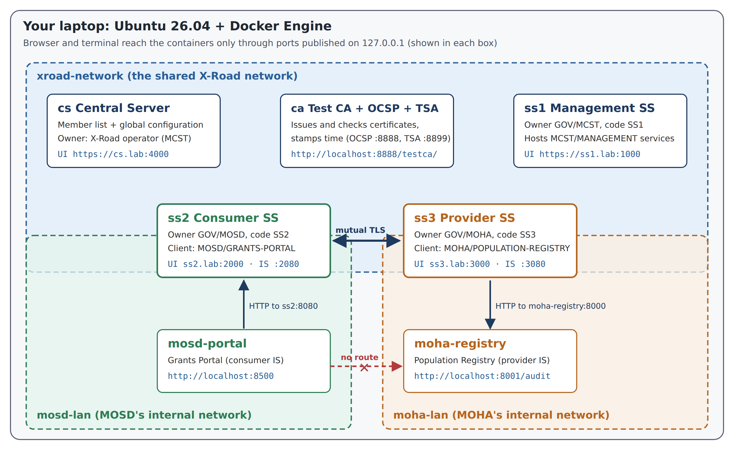
Figure 1. The real lab: seven programs (containers) on three private networks inside your laptop. The portal has no road to the registry except through ss2 and ss3.

2.2 Organisations, applications and services
X-Road names everything with a path, read from the most general to the most specific:
LS-DEV / GOV / MOHA / POPULATION-REGISTRY / population-api
| | | | |
network class ministry application service
Word | Plain meaning | In this lab
Instance | The whole network: one registry office | LS-DEV
Member class | A category of organisation | GOV (government)
Member (member code) | One organisation | MCST, MOSD, MOHA
Subsystem | One application (“department”) of an organisation. Permissions are given to subsystems. | MANAGEMENT, GRANTS-PORTAL, POPULATION-REGISTRY
Service | One thing a subsystem offers (“a counter you can go to”) | population-api, verifyIdentity
Security Server code | The name of one mailroom of a member | SS1, SS2, SS3

2.3 The two ID cards
Every Security Server needs two certificates. This is the idea people mix up most:
 | Authentication certificate (AUTH) | Signing certificate (SIGN)
Proves who… | …the server (mailroom) is | …the organisation (ministry) is
Used for | The secure connection between two Security Servers | Signing every message
Belongs to | One Security Server, e.g. ss3 | One member, e.g. MOHA
Needs registering on the Central Server? | Yes: that is the “joining” step | No: valid as soon as it is imported

2.4 How trust is set up
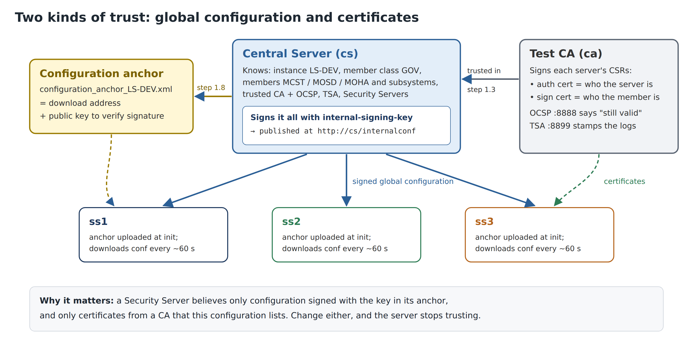
Figure 2. A Security Server trusts the Central Server through the anchor, and trusts certificates from the CA that the Central Server lists.
In short: you first set up the Central Server (Phase 1). Each Security Server then gets the anchor, proves who it is with certificates from the CA, and asks to join; the operator approves on the Central Server. From then on every Security Server downloads the signed list each minute and knows who everyone is.

2.5 What the ministries actually exchange
MOHA offers two services through ss3. population-api returns a citizen’s record, or only whether they are alive. verifyIdentity answers “do these details match?” without revealing the record. MOHA decides who may use them (access rights). The portal on the MOSD side uses both to decide pension eligibility. The companion document *REST and SOAP Services* explains them in depth.

2.6 The plan
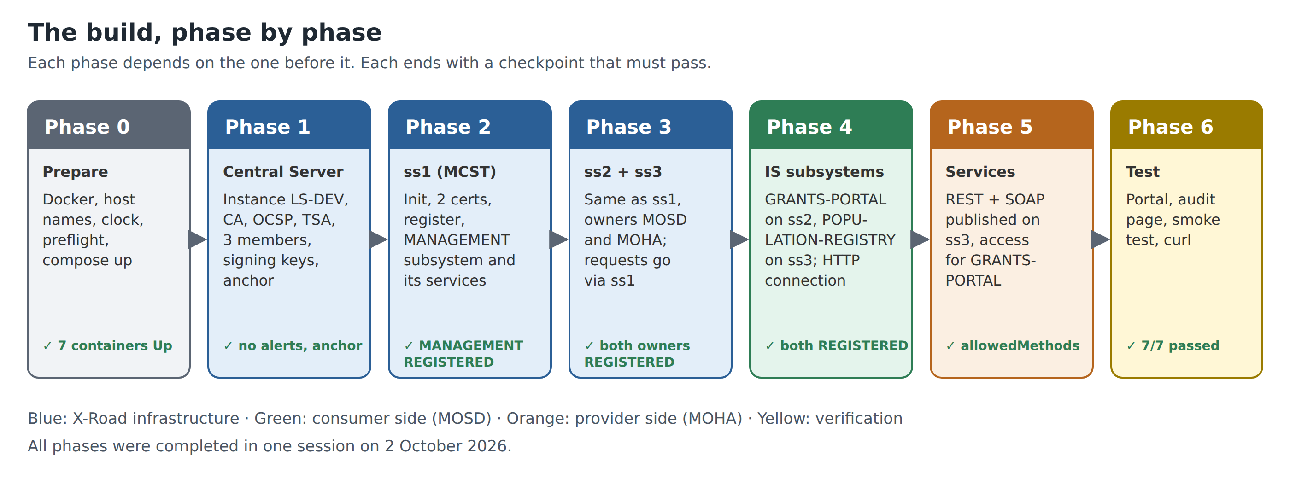
Figure 3. The six build phases. Each ends with a checkpoint.
Phase | In the picture | What you do
1 | Set up the registry office | Name the network, register the passport office and notary, list the three ministries, download the letter of introduction
2 | Open the operator’s mailroom | ss1 gets its ID cards, joins, and starts carrying joining requests
3 | Open the two ministries’ mailrooms | ss2 and ss3 get their ID cards and join through ss1
4 | Register the departments | GRANTS-PORTAL on ss2, POPULATION-REGISTRY on ss3
5 | Open MOHA’s counters | Publish the two services on ss3 and allow only GRANTS-PORTAL
6 | Send real letters | Test from the portal and read the audit trail

3. Getting ready

3.1 The only terminal steps
Three things cannot be done in a browser: starting the containers, adding the lab host names, and copying the CA certificates out of their container. Open a terminal (Ctrl+Alt+T) and run, from the lab folder:
cd ~/xroad-ls-lab
bash scripts/preflight.sh # checks the laptop; fix any FAIL line it prints
bash scripts/setup-hosts.sh # adds cs.lab, ss1.lab, ss2.lab, ss3.lab (asks for your password)
docker compose up -d --build # starts the 7 containers (first time: several GB download)
bash scripts/fetch-ca-certs.sh # writes certs/ca.pem, certs/ocsp.pem, certs/tsa.pem
Command | Why it is needed
setup-hosts.sh | Gives each admin page its own name. Browsers keep one login cookie per name, so with plain localhost logging in to ss2 would log you out of ss1.
docker compose up -d --build | Starts cs, ca, ss1, ss2, ss3, mosd-portal and moha-registry. The X-Road servers need 3–5 minutes to be ready after this.
fetch-ca-certs.sh | The test CA’s three certificates are needed in Phase 1. They live inside the ca container; this copies them to the certs/ folder so the browser can upload them.

Watch out: Check the clock
Certificates, OCSP and time-stamps all depend on the time. If you just booted from Windows, run timedatectl status and wait for System clock synchronized: yes before you start.

You should now see: Before you continue
bash scripts/preflight.sh ends with 0 failed; docker compose ps shows 7 containers Up; the four admin pages answer; certs/ holds ca.pem, ocsp.pem and tsa.pem.

3.2 Open your tabs
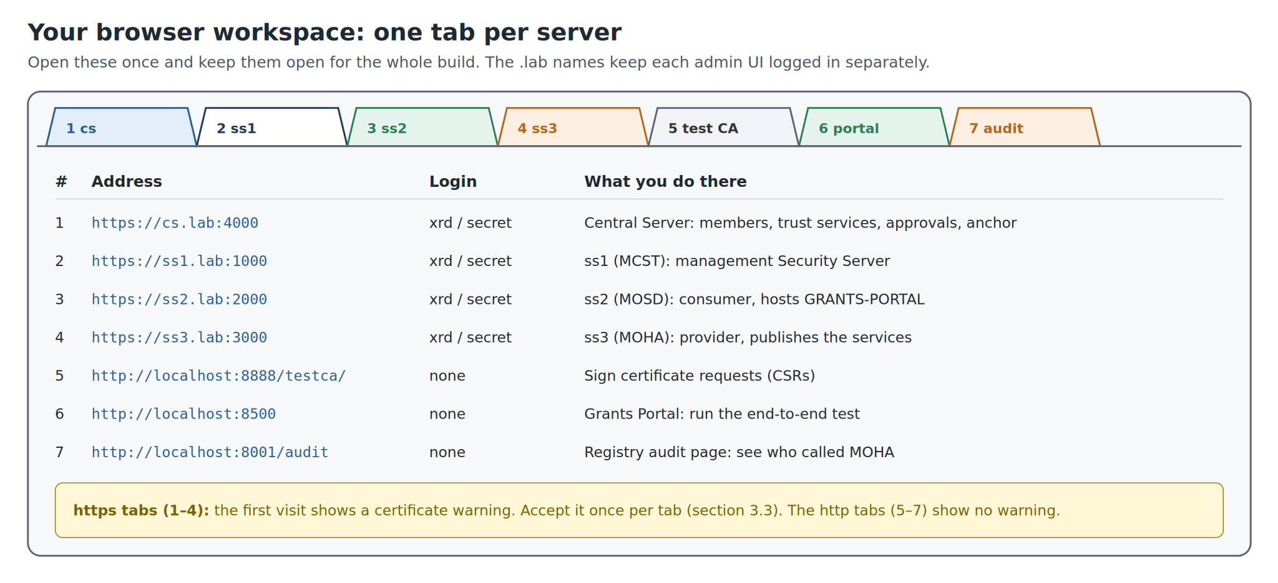
Figure 4. Open one tab per server and keep them open for the whole build.
- Open Firefox or Chrome.
- Open seven tabs (Ctrl+T each time) with the seven addresses in the figure, in that order.
- Bookmark them all in one folder: right-click the tab bar → Bookmark All Tabs… (Firefox) or Bookmark all tabs (Chrome), folder name X-Road lab.

3.3 Accepting the certificate warning
The four admin pages (tabs 1–4) use a certificate made by the server itself, so the first visit to each shows a warning. In this lab that is expected and safe, because the address is your own laptop. Accept it once per tab:
Browser | What you see | What to click
Firefox | Warning: Potential Security Risk Ahead | Advanced… → Accept the Risk and Continue
Chrome | Your connection is not private | Advanced → Proceed to cs.lab (unsafe)

Watch out: Only for this lab
Never accept such a warning on a real website. Here it is safe because every lab port is bound to 127.0.0.1 (your laptop only) and you know who made the certificate.

3.4 Logging in
- Each admin page opens with a login form asking for Username and Password.
- Type xrd and secret, then press Enter.
- If you are idle for a while you are logged out. Just log in again: nothing is lost.
If it goes wrong
Logged out every time you switch tabs: you are using localhost instead of the .lab names. Run bash scripts/setup-hosts.sh and use https://cs.lab:4000 etc.
Page does not load at all: the server is still starting (wait 3–5 minutes after starting the lab) or not running (docker compose ps).
Login refused: check Caps Lock; the login is exactly xrd / secret.

3.5 Files you will handle
You will move about 15 files between the browser and the servers. A little organisation now prevents the most common mistakes later. Make one folder per server (in a terminal):
mkdir -p ~/xroad-work/cs ~/xroad-work/ss1 ~/xroad-work/ss2 ~/xroad-work/ss3
After every download, move the file into the right folder and rename it as below. When a dialog asks for a file, press Ctrl+L and paste the path.
File | Comes from | Goes to | Save as
Configuration anchor (.xml) | cs (step 1.8) | ss1, ss2, ss3 at their first login | ~/xroad-work/cs/anchor.xml
Test CA certificates | fetch-ca-certs.sh (section 3.1) | cs (steps 1.3, 1.4) | stay in ~/xroad-ls-lab/certs/
2 CSRs per server (.der) | Add key wizard on that server | The test CA page | ~/xroad-work/ss1/ss1_sign.der, ss1_auth.der, …
2 certificates per server (.pem) | The test CA page | Import cert. on the same server | ~/xroad-work/ss1/ss1_sign.pem, ss1_auth.pem, …
Management TLS certificate (.tar.gz) | cs (step 2.14) | ss1 (step 2.14) | ~/xroad-work/cs/, then extract management-service.pem

Watch out: After a lab reset
Files from an earlier build do not work with a new one: the CA, the anchor and every certificate change. Empty ~/xroad-work and fetch new CA certificates after any reset.

4. A tour of the Central Server pages
Log in at https://cs.lab:4000. On a brand-new Central Server you first see the Initial Configuration page (step 1.1). After that, every page has the six-item menu shown below. Once Phase 1 has started, spend five minutes clicking through each menu item without changing anything, so the pages feel familiar.
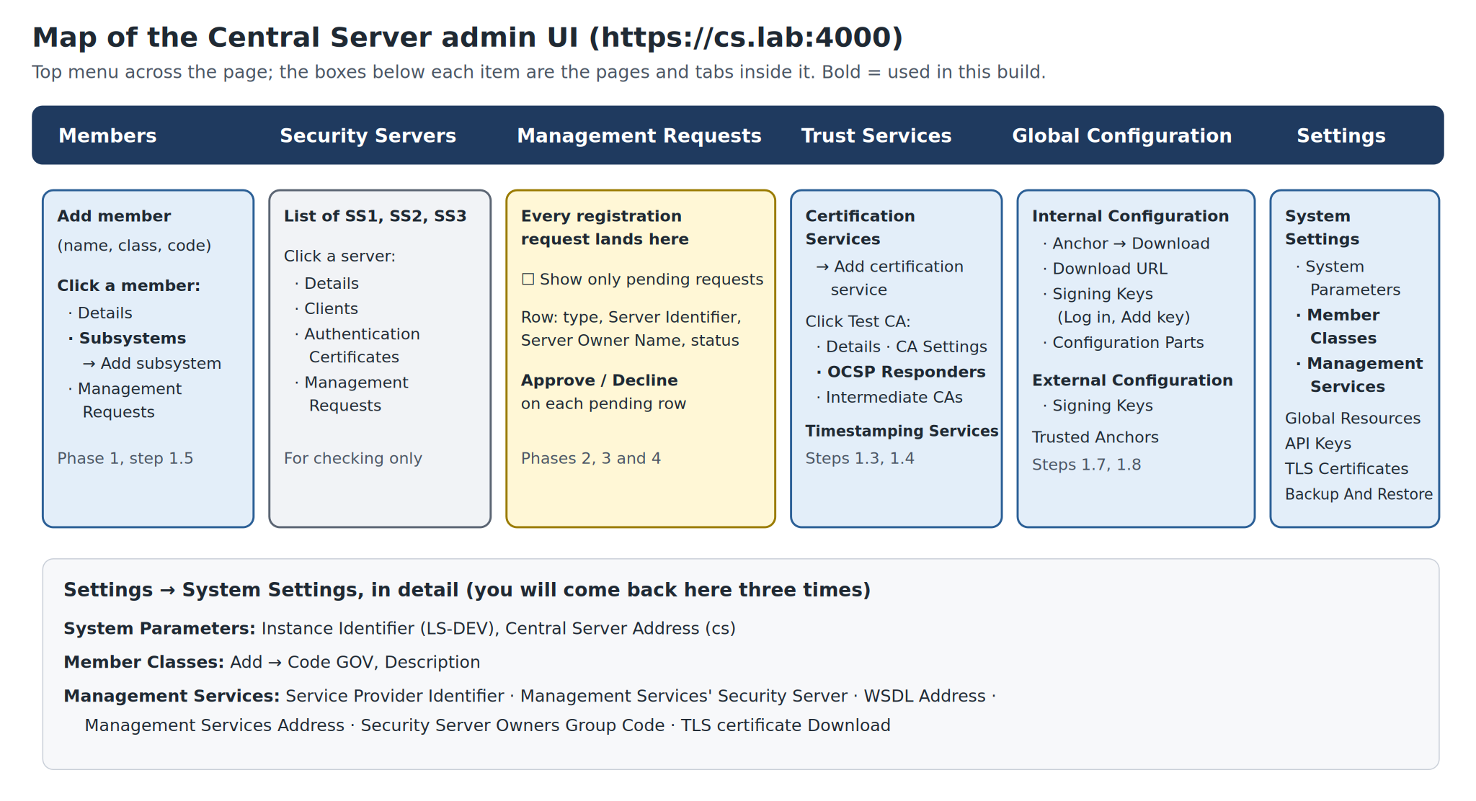
Figure 5. The Central Server admin pages. Bold items are used in this guide.
Menu item | What it is for | Used in
Members | The list of organisations in the network. Click one to see its Details, Subsystems and Management Requests. | Phase 1
Security Servers | Every registered Security Server, with its Clients, Authentication Certificates and requests. | Checking
Management Requests | Every request a Security Server sends (to join, to register an application…). Pending ones have Approve and Decline. Tick Show only pending requests to filter. | Phases 2–4
Trust Services | Certification Services (trusted CAs, each with OCSP Responders) and Timestamping Services. | Phase 1
Global Configuration | Tab Internal Configuration: the Anchor, Download URL, Signing Keys. Tab External Configuration: the same, for linking to other networks. Trusted Anchors: other networks. | Phase 1
Settings | System Settings (instance, Member Classes, Management Services), Global Resources, API Keys, TLS Certificates, Backup And Restore. | Phases 1–2

Tip: Red banners at the top
Right after initialisation the Central Server shows red banners, e.g. that no signing key exists. They are a to-do list, not errors, and they disappear as you finish Phase 1.

5. A tour of a Security Server’s pages
ss1, ss2 and ss3 run the same software, so their pages look the same. On the first login you get the Initial configuration wizard; after that, four menu items.
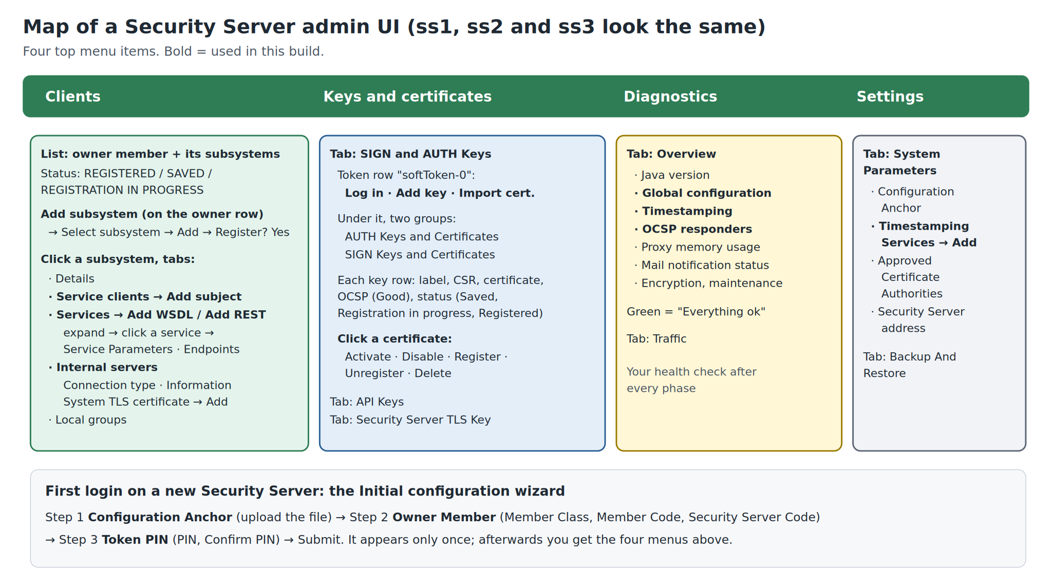
Figure 6. A Security Server’s admin pages. Bold items are used in this guide.
Menu item | What it is for
Clients | The owner (the ministry) and its applications (subsystems), with their status. Click a subsystem for its tabs: Details, Service clients, Services, Internal servers, Local groups.
Keys and certificates | Tab SIGN and AUTH Keys: the safe (softToken-0) with Log in, Add key and Import cert. buttons, and below it the AUTH and SIGN keys with their requests and certificates. Tabs API Keys and Security Server TLS Key.
Diagnostics | Tab Overview: health checks for Global configuration, Timestamping, OCSP responders and more. Green “Everything ok” is what you want. Use it as your health check after every phase.
Settings | Tab System Parameters: Configuration Anchor, Timestamping Services, Approved Certificate Authorities, the Security Server address. Tab Backup And Restore.

5.1 Status words you will meet
Where | Status | Plain meaning
Clients | SAVED | Added on this server only; nobody else knows about it yet.
Clients | REGISTRATION IN PROGRESS | Request sent; waiting for approval on cs, then for the next signed list (1–2 minutes).
Clients | REGISTERED | Done: the whole network knows this client lives here.
Keys and certificates | Request | An application form (CSR) exists for this key; no certificate imported yet.
Keys and certificates | Saved | Certificate imported but not registered. Normal for an AUTH certificate before you press Register.
Keys and certificates | Registration in progress / Registered | The same idea as for clients, for the AUTH certificate.
Keys and certificates | OCSP Good | The passport office confirms the ID card is valid.
Diagnostics | Everything ok (green) | That check is healthy. Yellow or red: read the message.
Services | Out of order | The default notice of a switched-off service. Switch it on with its toggle.

6. Phase 1: Set up the Central Server
In the picture: you set up the registry office. Tab: 1 (https://cs.lab:4000). Time: 30–45 minutes.
What you will do: give the network its name, say which passport office (CA) and notary (TSA) to trust, list the three ministries and their applications, choose who runs the joining-request service, create the keys that sign the official list, and download the letter of introduction (anchor).
You should now see: Before you start Phase 1
Section 3 is complete: the cs tab shows a login page, and certs/ca.pem, ocsp.pem, tsa.pem exist.

Step 1.1 Initialise the Central Server
What this step does: Gives the network its name and creates the safe (software token) that will hold the Central Server’s keys.
Where: cs tab. The first login shows the Initial Configuration page instead of the menu.
Do this:
- Log in with xrd / secret.
- Take a screenshot of this page now: it only appears once.
- In the Software Token section, type the PIN in PIN and again in Repeat PIN.
- In the Central Server Identification section, type the Instance Identifier and the Central Server Address.
- Click Submit.
Field on screen | Type or choose exactly
PIN / Repeat PIN | 123456xrd!
Instance Identifier | LS-DEV
Central Server Address | cs

You should now see
The message The Central Server initialized! Now continue with the full configuration. and the six-item menu. Red banners at the top are normal for now.
Check: Settings → System Settings shows Instance Identifier LS-DEV and Central Server Address cs.

Why
The instance identifier is the first part of every name in the network. cs is the address Security Servers use to download the official list: the container’s name inside Docker, not a name your browser knows. The PIN protects the safe that will hold the keys used to sign that list.

If it goes wrong
“Password confirmation does not match”: retype both PIN fields.
Wrong instance identifier typed: it cannot be changed afterwards. Reset the lab (section 13.5) and start Phase 1 again.

Step 1.2 Add the member class GOV
What this step does: Creates the category “government”, to which all three ministries belong.
Where: Settings → System Settings, the Member Classes section.
Do this:
- Click Add.
- Type the Code and Description.
- Click Add (or Save) in the dialog.
Field on screen | Type or choose exactly
Code | GOV
Description | Government ministries and agencies

You should now see
The message Member class saved. and GOV in the Member Classes list.

If it goes wrong
Typo in the code: delete the class (Delete member class? → confirm) and add it again. This only works while no member uses it.

Step 1.3 Trust the test CA and its OCSP responder
What this step does: Tells the network which passport office’s ID cards to accept, and where to check that a card is still valid.
Before you start: the CA certificates are in certs/ (section 3.1).
Where: Trust Services → Certification Services.
Do this:
- Click Add certification service.
- At Upload the certificate file from your computer, choose ca.pem: press Ctrl+L, paste /home/victor/xroad-ls-lab/certs/ca.pem, Enter. Continue.
- On the CA Settings page, leave This CA can only be used for TLS authentication (mark if true) unticked.
- In Certificate profile info, paste the profile name from the table below. Leave any ACME fields empty.
- Click Save. “Test CA” appears in the list.
- Click Test CA in the list, open the OCSP Responders tab, and click Add.
- In Add OCSP Responder, type the URL and upload ocsp.pem (same folder). Click Save.
Field on screen | Type or choose exactly
Certificate | /home/victor/xroad-ls-lab/certs/ca.pem (its subject is “Test CA”)
Certificate profile info | ee.ria.xroad.common.certificateprofile.impl.FiVRKCertificateProfileInfoProvider
OCSP responder URL | http://ca:8888
OCSP certificate | /home/victor/xroad-ls-lab/certs/ocsp.pem (“Test OCSP”)

You should now see
Trust Services lists Test CA, valid until 2046. Its OCSP Responders tab lists http://ca:8888.

Why
The certificate profile tells X-Road how to read the organisation’s identity out of an ID card issued by this CA. The test CA issues Finnish-style cards, hence “FiVRK”.
The URL uses ca, the container’s name, because the Security Servers (not your browser) phone the hotline from inside Docker.

If it goes wrong
Upload refused: you picked ocsp.pem or tsa.pem instead of ca.pem.
Typo in the profile name: certificate requests fail later in Phase 2. Copy-paste it, and check it under Test CA → CA Settings.
Wrong file added: open the certification service → Delete trust service, and add it again.

Step 1.4 Trust the time-stamping service
What this step does: Registers the notary that will stamp the time on every logged message.
Where: Trust Services → the Timestamping Services section (below Certification Services).
Do this:
- Click Add.
- Type the URL and upload tsa.pem.
- Click Save.
Field on screen | Type or choose exactly
URL | http://ca:8899
Certificate | /home/victor/xroad-ls-lab/certs/tsa.pem (“Test TSA”)

You should now see
http://ca:8899 in the Timestamping Services list.

Step 1.5 Add the three ministries and their applications
What this step does: Puts the three organisations and their applications on the official list, so their Security Servers can join later.
Where: Members.
Do this:
- Click Add member. Type Member Name, choose Member Class GOV, type Member Code (first row of the table). Click Add.
- Repeat for the second and third rows.
- Click MCST in the members list, open the Subsystems tab, click Add subsystem, type the Subsystem code MANAGEMENT, and click Add.
- Go back to Members. Do the same for MOSD (GRANTS-PORTAL) and MOHA (POPULATION-REGISTRY).
Field on screen | Type or choose exactly
Member Name: Ministry of Communications, Science and Technology | Class GOV, code MCST, subsystem MANAGEMENT
Member Name: Ministry of Social Development | Class GOV, code MOSD, subsystem GRANTS-PORTAL
Member Name: Ministry of Home Affairs | Class GOV, code MOHA, subsystem POPULATION-REGISTRY

You should now see
Three members in Members, each with one subsystem. The subsystems show no server yet; that comes in Phases 2–4.

Why
A Security Server can only join for an organisation the Central Server already knows. That is also why their names will fill in by themselves later.
MCST, the X-Road operator, gets a MANAGEMENT subsystem: it will provide the joining-request service.

If it goes wrong
Typo in a member or subsystem code: open the member → Delete member (or the subsystem → Delete Subsystem) and add it again. Codes cannot be edited; names can (Edit Member’s name).

Step 1.6 Choose who provides the management services
What this step does: Says which application handles joining requests from Security Servers: MCST’s MANAGEMENT subsystem.
Where: Settings → System Settings, the Management Services section.
Do this:
- Next to Service Provider Identifier, click the pencil (Edit).
- In the Select Subsystem dialog, type MCST in Search, select the row whose subsystem is MANAGEMENT, and click Select.
You should now see
Service Provider Identifier SUBSYSTEM:LS-DEV:GOV:MCST:MANAGEMENT and Service Provider Name Ministry of Communications, Science and Technology.
Management Services’ Security Server is still empty; you fill it in at step 2.11.
Write down two values shown here; you need them in Phase 2: WSDL Address http://cs/managementservices.wsdl and Management Services Address https://cs:4002/managementservice/manage/.

Why
Security Servers send their joining requests as X-Road messages to this application. MCST, as the operator, provides it.

Step 1.7 Create the keys that sign the official list
What this step does: Creates the keys the Central Server signs the global configuration with. Without them nothing is published.
Where: Global Configuration → tab Internal Configuration → Signing Keys section.
Do this:
- If the token row shows Log in, click it and type the Token PIN 123456xrd!. (In this lab it is usually already logged in.)
- Click Add key. In Key friendly name type internal-signing-key. Click Add.
- Open the External Configuration tab → Signing Keys → Add key → external-signing-key → Add.
You should now see
One key under each tab. Within one or two minutes the red banners disappear (press F5).

Why
From now on the Central Server signs the official list about once a minute with the internal key, and Security Servers only accept a list with a valid signature. The external key is for linking with other X-Road networks (federation); the lab does not use it, but the Central Server expects one.

Step 1.8 Download the anchor
What this step does: Downloads the letter of introduction that every Security Server needs in order to trust this Central Server.
Where: Global Configuration → Internal Configuration → Anchor section.
Do this:
- Click Download.
- Move the downloaded file to ~/xroad-work/cs/ and rename it anchor.xml.
- Note the first few characters of the Certificate Hash (SHA-224) shown in the Anchor section; you will compare them in step 2.1.
You should now see
The Anchor section shows a hash and a Created time; ~/xroad-work/cs/anchor.xml exists.

Why
The anchor holds the official list’s address (http://cs/internalconf) and the key that verifies its signature. Uploading it is how a Security Server decides which network to trust.

If it goes wrong
Anchor downloaded before step 1.7: download it again now; an anchor made before the signing key exists cannot be used.

✓ Checkpoint 1
No red banners on the Central Server. Trust Services shows Test CA (with OCSP) and one time-stamping service. Members shows three ministries with one subsystem each. anchor.xml is saved.

What you just built
A named network (LS-DEV) whose registry office trusts one passport office and one notary, knows three ministries and their applications, signs its official list every minute, and has a letter of introduction ready for the mailrooms.

Check your understanding
Answer in your own words before moving on. Model answers are in Appendix A.
- Why can the Security Servers not simply download the official list from anyone who offers it?
- Why does the OCSP URL say ca and not localhost?
- What would go wrong in Phase 2 if MOSD had not been added in step 1.5?

7. Phase 2: ss1, the operator’s Security Server
In the picture: you open the operator’s mailroom and make it carry joining requests. Tabs: 2 (ss1), 1 (cs), 5 (test CA). Time: about 60 minutes.
What you will do: steps 2.1–2.9 give ss1 its ID cards and let it join the network. Steps 2.10–2.15 set up the management services on ss1, so that ss2 and ss3 can join through it in Phase 3.
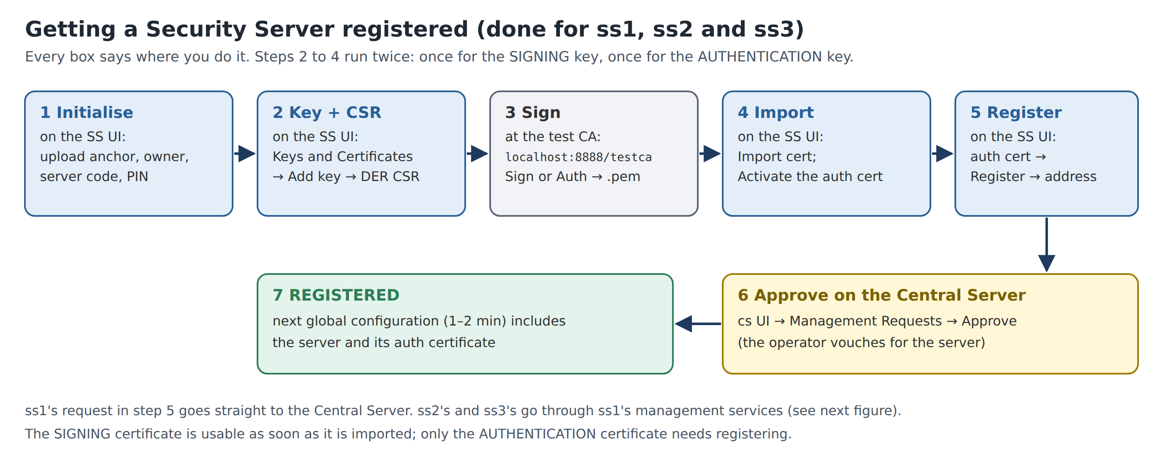
Figure 7. Steps 2.1 to 2.9: getting a Security Server registered. You will repeat them for ss2 and ss3.
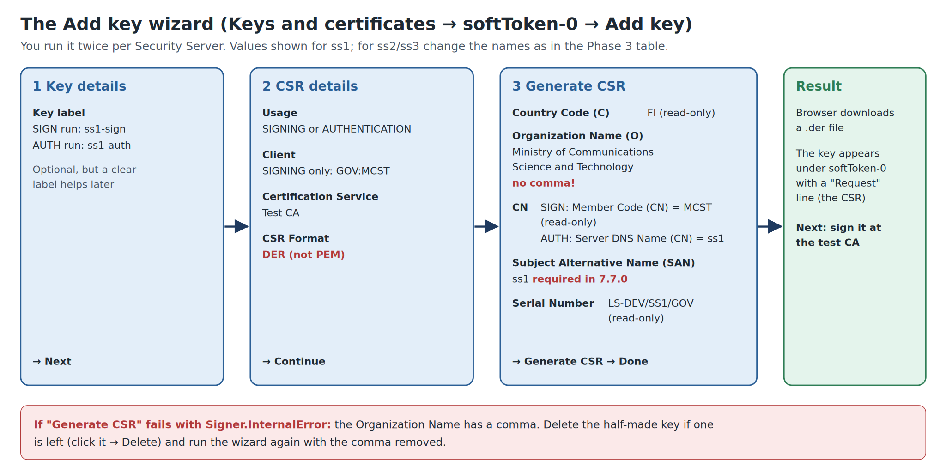
Figure 8. The Add key wizard with ss1’s values (steps 2.4 and 2.5). Mind the two red notes.

Step 2.1 Initialise ss1
What this step does: Gives ss1 the letter of introduction (anchor), tells it which ministry owns it, and creates its safe.
Where: ss1 tab (https://ss1.lab:1000). The first login opens the Initial configuration wizard.
Do this:
- Log in with xrd / secret. Take a screenshot of the wizard: it only appears once.
- Configuration Anchor page: click Upload and choose ~/xroad-work/cs/anchor.xml.
- A dialog shows Configuration anchor details: with Hash (SHA-224) and Generated. Check the hash starts with the characters you noted in step 1.8. Confirm.
- Owner Member page: choose Member Class GOV and type Member Code MCST. Wait a second: the member name fills in by itself (Ministry of Communications, Science and Technology).
- Type Security Server Code SS1. Continue.
- Token PIN page: type 123456xrd! in PIN and Confirm PIN. Click Submit.
Field on screen | Type or choose exactly
Configuration anchor | ~/xroad-work/cs/anchor.xml
Member Class / Member Code | GOV / MCST
Security Server Code | SS1
PIN / Confirm PIN | 123456xrd!

You should now see
Server initialised, then the four-item menu. Clients shows owner MCST with status SAVED.

Why
From now on ss1 downloads the official list from cs every minute. The owner name filled in by itself because MCST is on that list (step 1.5).

If it goes wrong
Name does not fill in: MCST is missing on cs (step 1.5), or the list has not been published yet. Wait 1–2 minutes and retype the code.
Anchor refused: it is an old anchor from an earlier build, or one downloaded before step 1.7. Download a fresh one (step 1.8).
PIN refused: it must be 123456xrd!, the same as in docker-compose.yml.

Step 2.2 Unlock the safe (only if asked)
What this step does: Logs in to the software token so that keys can be created. In this lab it usually unlocks itself.
Where: Keys and certificates → tab SIGN and AUTH Keys.
Do this:
- If softToken-0 shows Log in, or a banner says Please enter soft token PIN, click Log in and type 123456xrd!. Otherwise do nothing.
You should now see
The token row shows the Add key and Import cert. buttons.

Step 2.3 Add the time-stamping service
What this step does: Tells ss1 which notary to use for its message log.
Where: Settings → tab System Parameters → Timestamping Services section.
Do this:
- Click Add.
- In Add Timestamping Service, select Test TSA and click Add.
You should now see
Timestamping service added and http://ca:8899 in the list.

Step 2.4 Create the SIGNING key and its application form (CSR)
What this step does: Creates MCST’s signing key and the application form for its ID card.
Where: Keys and certificates → SIGN and AUTH Keys → on the softToken-0 row, click Add key.
Do this:
- Key details page: Key label ss1-sign. Next.
- CSR details page: Usage SIGNING; Client GOV:MCST; Certification Service Test CA; CSR Format DER. Continue.
- Generate CSR page: fill in the fields from the table. Leave read-only (greyed-out) fields as they are. Click Generate CSR.
- The browser downloads a .der file. Move it to ~/xroad-work/ss1/ and rename it ss1_sign.der.
- Click Done.
Field on screen | Type or choose exactly
Organization Name (O) | Ministry of Communications Science and Technology (no comma)
Member Code (CN) | MCST (read-only)
Subject Alternative Name (SAN) | ss1
Country Code (C) / Serial Number | FI / LS-DEV/SS1/GOV (read-only)

You should now see
Under SIGN Keys and Certificates, a key ss1-sign with a Request line under it.

If it goes wrong
Signer.InternalError when you click Generate CSR: the Organization Name contains a comma. X-Road writes the certificate subject as C=FI, O=…, CN=…, so a comma in the name breaks it. If a half-made key is left, click it → Delete key? → confirm, then repeat without the comma.
Subject Alternative Name required: version 7.7.0 always asks for it; type the server name.
Chose PEM by mistake: the test CA will refuse it. Delete the key and start this step again with DER.

Step 2.5 Create the AUTHENTICATION key and its CSR
What this step does: Creates ss1’s own key and the application form for the server’s ID card.
Where: Same place: softToken-0 → Add key.
Do this:
- Key label ss1-auth. Next.
- Usage AUTHENTICATION (no Client is asked); Certification Service Test CA; CSR Format DER. Continue.
- Fill in the fields from the table and click Generate CSR.
- Move the download to ~/xroad-work/ss1/, rename it ss1_auth.der, and click Done.
Field on screen | Type or choose exactly
Organization Name (O) | Ministry of Communications Science and Technology
Server DNS Name (CN) | ss1
Subject Alternative Name (SAN) | ss1

You should now see
Under AUTH Keys and Certificates, a key ss1-auth with a Request line.

Why
Two ID cards, two jobs (section 2.3): the signing card belongs to the organisation MCST and signs messages; the authentication card belongs to this server and proves who it is when Security Servers connect.

Step 2.6 Sign both CSRs at the test CA
What this step does: Turns the two application forms into ID cards (certificates).
Where: Test CA tab (http://localhost:8888/testca/), page Test CA: CSR signing.
Do this:
- CSR: choose ~/xroad-work/ss1/ss1_sign.der. Type: select Sign. Press Sign.
- Move the downloaded certificate to ~/xroad-work/ss1/ and rename it ss1_sign.pem.
- Again with ss1_auth.der: Type Auth → Sign → rename the result to ss1_auth.pem.
You should now see
Two certificates, ss1_sign.pem and ss1_auth.pem, in ~/xroad-work/ss1/.

Why
A real CA checks documents before signing. The test CA signs anything, so the lab can run on one laptop.

If it goes wrong
Error page from the test CA: the CSR is PEM, not DER. Delete that key on the server and redo its step with DER.
Choose Sign or Auth yourself rather than Autodetect from file name.

Step 2.7 Import the certificates and activate the AUTH one
What this step does: Puts the ID cards into the safe next to their keys.
Where: Keys and certificates → SIGN and AUTH Keys.
Do this:
- On the softToken-0 row click Import cert. and choose ss1_auth.pem. It attaches itself to the ss1-auth key.
- Click the new certificate under ss1-auth to open its details page. Click Activate. Go back.
- Click Import cert. again and choose ss1_sign.pem.
You should now see
Uploading certificate succeeded each time. The SIGN certificate shows Registered straight away. The AUTH certificate shows Saved and OCSP Good.

If it goes wrong
Certificate does not attach to a key, or the import fails: it belongs to another server’s CSR. Use the file from this server’s folder.
OCSP not Good after a minute: check the laptop clock (timedatectl status) and the OCSP URL from step 1.3.

Step 2.8 Ask to join: register the AUTH certificate
What this step does: Sends the request “ss1 belongs to MCST; please add it to the network”.
Where: Same page, the ss1-auth certificate row.
Do this:
- Click Register.
- In Registration request, field Security server DNS name or IP address, type ss1. Confirm.
Field on screen | Type or choose exactly
Security server DNS name or IP address | ss1

You should now see
Certificate registration request sent successfully and the status Registration in progress.

Why
ss1 is the first Security Server, so its request goes straight to the Central Server.

Step 2.9 Approve the request on the Central Server
What this step does: The operator confirms that the server really belongs to the ministry.
Where: cs tab → Management Requests.
Do this:
- Find the pending request whose Server Identifier is LS-DEV:GOV:MCST:SS1.
- Click Approve, then confirm in Approve management request.
- Go back to the ss1 tab. Wait 1–2 minutes, then press F5 on Clients.
You should now see
On ss1: Clients shows MCST REGISTERED, and the AUTH certificate shows Registered. On cs: Security Servers lists SS1.

Why
Approval is X-Road’s trust model in action: a server joins only after the operator vouches for it.

If it goes wrong
No request appears on cs: check that step 2.8 succeeded.
Still “in progress” after approval: wait another minute and press F5; the change arrives with the next signed list.

7.1 The management services
ss1 is now a member of the network. Next, make it host the service that carries joining requests. The first attempt fails on purpose: read the “Why” box in step 2.10.

Step 2.10 Add the MANAGEMENT subsystem (the first try fails on purpose)
What this step does: Adds MCST’s MANAGEMENT application to ss1.
Where: ss1 → Clients.
Do this:
- On the MCST owner row, click Add subsystem.
- Click Select Subsystem and pick MANAGEMENT from the list.
- Tick Register subsystem. Click Add subsystem.
You should now see
An error mentioning UnknownMember and clientReg. This is expected. MCST:MANAGEMENT now appears in Clients with status SAVED.

Why
To register an application, a Security Server calls the management service clientReg. But MANAGEMENT is the application that provides clientReg, and no server hosts it yet: a chicken-and-egg problem. Step 2.11 solves it from the Central Server side.

Step 2.11 Register MANAGEMENT from the Central Server
What this step does: Tells the Central Server directly that MCST’s MANAGEMENT lives on ss1.
Where: cs → Settings → System Settings → Management Services section.
Do this:
- Next to Management Services’ Security Server, click Edit.
- In Select Security Server, choose SS1 and click Select.
- Go to the ss1 tab, wait 1–2 minutes, and press F5 on Clients.
You should now see
ss1 Clients: MCST:MANAGEMENT REGISTERED.

Step 2.12 Add the management services
What this step does: Loads the list of joining-request services (a WSDL file) into MANAGEMENT.
Where: ss1 → Clients → click MANAGEMENT → tab Services.
Do this:
- Click Add WSDL.
- Type the URL below and click Add.
- Switch the new WSDL row’s toggle on.
Field on screen | Type or choose exactly
URL | http://cs/managementservices.wsdl

You should now see
WSDL added. Expanding the row shows ten services such as clientReg, authCertDeletion and ownerChange. The toggle is on.

Step 2.13 Point every management service at the Central Server
What this step does: Replaces a placeholder address with the Central Server’s real address.
Where: Same tab: click the arrow to expand the WSDL row.
Do this:
- Notice that every service’s URL is http://INSERT_MANAGEMENT_SERVICE_ADDRESS_HERE: a placeholder that must be replaced.
- Click any service, for example clientReg, to open its Service Parameters.
- Type the Service URL and Timeout (s) below, and tick Verify TLS certificate.
- Tick Apply to all in WSDL next to each of the three fields.
- Click Save.
Field on screen | Type or choose exactly
Service URL | https://cs:4002/managementservice/manage/
Timeout (s) | 60
Verify TLS certificate | ticked

You should now see
Service saved; all ten services show the cs address.

If it goes wrong
If you skip this step, ss2 and ss3 cannot join in Phase 3.

Step 2.14 Trust the Central Server’s TLS certificate
What this step does: Lets ss1 recognise the Central Server when it connects to it over HTTPS.
Where: First cs → Settings → TLS Certificates; then ss1 → Clients → MANAGEMENT → tab Internal servers.
Do this:
- On cs, in the Management Service TLS certificate section, click Download certificate. You get a .tar.gz file.
- Move it to ~/xroad-work/cs/. Right-click it in the Files app → Extract. Inside is management-service.pem.
- On ss1, tab Internal servers, section Information System TLS certificate: click Add and upload management-service.pem.
You should now see
A certificate with a Certificate Hash under Information System TLS certificate.

Why
Step 2.13 switched on TLS verification for an HTTPS address, so ss1 must know exactly which certificate the Central Server will show.

If it goes wrong
Cannot open the .tar.gz: in a terminal: cd ~/xroad-work/cs && tar -xzf *.tar.gz && ls.

Step 2.15 Allow every Security Server owner to use the services
What this step does: Gives every ministry that owns a Security Server permission to send joining requests.
Where: ss1 → Clients → MANAGEMENT → tab Service clients.
Do this:
- Click Add subject.
- Member / Group page: search for security-server-owners and select the global group (Security server owners). Next.
- Services page: tick all ten services. Click Add Selected.
You should now see
Access rights added successfully; security-server-owners appears under Service clients.

Why
security-server-owners is a group the Central Server maintains automatically: every member that owns a Security Server. MOSD and MOHA will be in it as soon as their servers join.

✓ Checkpoint 2
ss1 Clients: MCST and MCST:MANAGEMENT both REGISTERED.
ss1 Keys and certificates: ss1-auth and ss1-sign Registered, OCSP Good.
ss1 Diagnostics: Global configuration and OCSP responders Everything ok. Timestamping may still say waiting or unknown until the first message in Phase 6; that is normal.

What you just built
The operator’s mailroom is open, holds the operator’s ID cards, and runs the joining-request service with the right address, the right TLS trust and the right permissions.

Check your understanding
Answer in your own words before moving on. Model answers are in Appendix A.
- Which certificate needed registering on the Central Server, and why only that one?
- Why did registering MANAGEMENT fail the first time?
- What would happen in Phase 3 without step 2.15?

8. Phase 3: ss2 (MOSD) and ss3 (MOHA)
In the picture: you open the two ministries’ mailrooms. Tabs: 3 (ss2), 4 (ss3), 1 (cs), 5 (test CA). Time: about 60 minutes.
What you will do: the same nine steps as 2.1–2.9, once for ss2 (steps 3A.1–3A.9) and once for ss3 (steps 3B.1–3B.9). They are written out in full so you never need to work out the values. Only ss1 hosts management services, so steps 2.10–2.15 are not repeated.
Value | ss2 | ss3
Admin page | https://ss2.lab:2000 | https://ss3.lab:3000
Owner: Member Class / Member Code | GOV / MOSD | GOV / MOHA
Security Server Code | SS2 | SS3
Organization Name (O) | Ministry of Social Development | Ministry of Home Affairs
Server DNS name, SAN and register address | ss2 | ss3
Files folder | ~/xroad-work/ss2/ | ~/xroad-work/ss3/

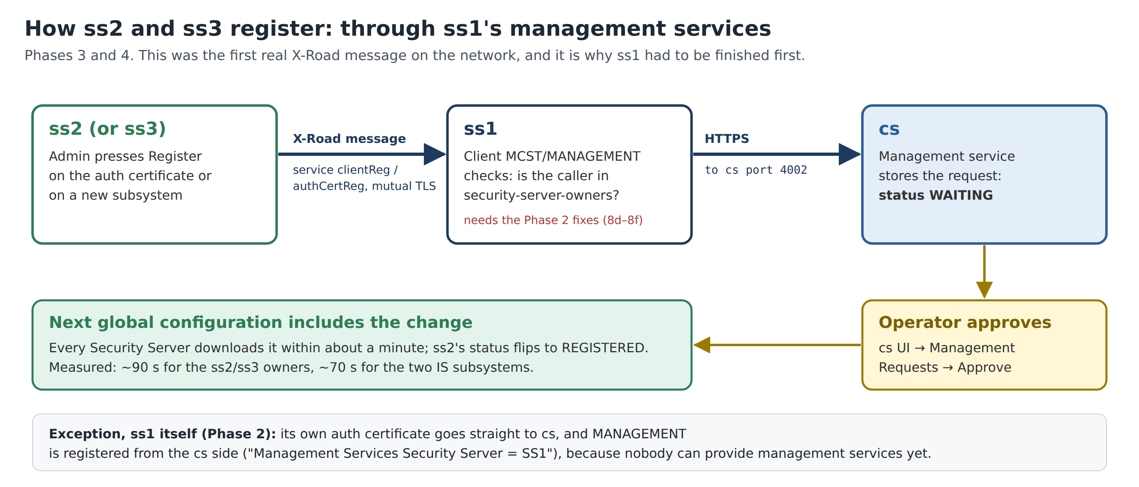
Figure 9. This time the joining request travels through ss1’s management services before it reaches cs.

8.1 ss2, the Ministry of Social Development

Step 3A.1 Initialise ss2
What this step does: Gives ss2 the letter of introduction (anchor), tells it which ministry owns it, and creates its safe.
Where: ss2 tab (https://ss2.lab:2000). The first login opens the Initial configuration wizard.
Do this:
- Log in with xrd / secret. Take a screenshot of the wizard: it only appears once.
- Configuration Anchor page: click Upload and choose ~/xroad-work/cs/anchor.xml.
- A dialog shows Configuration anchor details: with Hash (SHA-224) and Generated. Check the hash starts with the characters you noted in step 1.8. Confirm.
- Owner Member page: choose Member Class GOV and type Member Code MOSD. Wait a second: the member name fills in by itself (Ministry of Social Development).
- Type Security Server Code SS2. Continue.
- Token PIN page: type 123456xrd! in PIN and Confirm PIN. Click Submit.
Field on screen | Type or choose exactly
Configuration anchor | ~/xroad-work/cs/anchor.xml
Member Class / Member Code | GOV / MOSD
Security Server Code | SS2
PIN / Confirm PIN | 123456xrd!

You should now see
Server initialised, then the four-item menu. Clients shows owner MOSD with status SAVED.

Why
From now on ss2 downloads the official list from cs every minute. The owner name filled in by itself because MOSD is on that list (step 1.5).

If it goes wrong
Name does not fill in: MOSD is missing on cs (step 1.5), or the list has not been published yet. Wait 1–2 minutes and retype the code.
Anchor refused: it is an old anchor from an earlier build, or one downloaded before step 1.7. Download a fresh one (step 1.8).
PIN refused: it must be 123456xrd!, the same as in docker-compose.yml.

Step 3A.2 Unlock the safe (only if asked)
What this step does: Logs in to the software token so that keys can be created. In this lab it usually unlocks itself.
Where: Keys and certificates → tab SIGN and AUTH Keys.
Do this:
- If softToken-0 shows Log in, or a banner says Please enter soft token PIN, click Log in and type 123456xrd!. Otherwise do nothing.
You should now see
The token row shows the Add key and Import cert. buttons.

Step 3A.3 Add the time-stamping service
What this step does: Tells ss2 which notary to use for its message log.
Where: Settings → tab System Parameters → Timestamping Services section.
Do this:
- Click Add.
- In Add Timestamping Service, select Test TSA and click Add.
You should now see
Timestamping service added and http://ca:8899 in the list.

Step 3A.4 Create the SIGNING key and its application form (CSR)
What this step does: Creates MOSD’s signing key and the application form for its ID card.
Where: Keys and certificates → SIGN and AUTH Keys → on the softToken-0 row, click Add key.
Do this:
- Key details page: Key label ss2-sign. Next.
- CSR details page: Usage SIGNING; Client GOV:MOSD; Certification Service Test CA; CSR Format DER. Continue.
- Generate CSR page: fill in the fields from the table. Leave read-only (greyed-out) fields as they are. Click Generate CSR.
- The browser downloads a .der file. Move it to ~/xroad-work/ss2/ and rename it ss2_sign.der.
- Click Done.
Field on screen | Type or choose exactly
Organization Name (O) | Ministry of Social Development
Member Code (CN) | MOSD (read-only)
Subject Alternative Name (SAN) | ss2
Country Code (C) / Serial Number | FI / LS-DEV/SS2/GOV (read-only)

You should now see
Under SIGN Keys and Certificates, a key ss2-sign with a Request line under it.

If it goes wrong
Signer.InternalError when you click Generate CSR: the Organization Name contains a comma. X-Road writes the certificate subject as C=FI, O=…, CN=…, so a comma in the name breaks it. If a half-made key is left, click it → Delete key? → confirm, then repeat without the comma.
Subject Alternative Name required: version 7.7.0 always asks for it; type the server name.
Chose PEM by mistake: the test CA will refuse it. Delete the key and start this step again with DER.

Step 3A.5 Create the AUTHENTICATION key and its CSR
What this step does: Creates ss2’s own key and the application form for the server’s ID card.
Where: Same place: softToken-0 → Add key.
Do this:
- Key label ss2-auth. Next.
- Usage AUTHENTICATION (no Client is asked); Certification Service Test CA; CSR Format DER. Continue.
- Fill in the fields from the table and click Generate CSR.
- Move the download to ~/xroad-work/ss2/, rename it ss2_auth.der, and click Done.
Field on screen | Type or choose exactly
Organization Name (O) | Ministry of Social Development
Server DNS Name (CN) | ss2
Subject Alternative Name (SAN) | ss2

You should now see
Under AUTH Keys and Certificates, a key ss2-auth with a Request line.

Why
Two ID cards, two jobs (section 2.3): the signing card belongs to the organisation MOSD and signs messages; the authentication card belongs to this server and proves who it is when Security Servers connect.

Step 3A.6 Sign both CSRs at the test CA
What this step does: Turns the two application forms into ID cards (certificates).
Where: Test CA tab (http://localhost:8888/testca/), page Test CA: CSR signing.
Do this:
- CSR: choose ~/xroad-work/ss2/ss2_sign.der. Type: select Sign. Press Sign.
- Move the downloaded certificate to ~/xroad-work/ss2/ and rename it ss2_sign.pem.
- Again with ss2_auth.der: Type Auth → Sign → rename the result to ss2_auth.pem.
You should now see
Two certificates, ss2_sign.pem and ss2_auth.pem, in ~/xroad-work/ss2/.

Why
A real CA checks documents before signing. The test CA signs anything, so the lab can run on one laptop.

If it goes wrong
Error page from the test CA: the CSR is PEM, not DER. Delete that key on the server and redo its step with DER.
Choose Sign or Auth yourself rather than Autodetect from file name.

Step 3A.7 Import the certificates and activate the AUTH one
What this step does: Puts the ID cards into the safe next to their keys.
Where: Keys and certificates → SIGN and AUTH Keys.
Do this:
- On the softToken-0 row click Import cert. and choose ss2_auth.pem. It attaches itself to the ss2-auth key.
- Click the new certificate under ss2-auth to open its details page. Click Activate. Go back.
- Click Import cert. again and choose ss2_sign.pem.
You should now see
Uploading certificate succeeded each time. The SIGN certificate shows Registered straight away. The AUTH certificate shows Saved and OCSP Good.

If it goes wrong
Certificate does not attach to a key, or the import fails: it belongs to another server’s CSR. Use the file from this server’s folder.
OCSP not Good after a minute: check the laptop clock (timedatectl status) and the OCSP URL from step 1.3.

Step 3A.8 Ask to join: register the AUTH certificate
What this step does: Sends the request “ss2 belongs to MOSD; please add it to the network”.
Where: Same page, the ss2-auth certificate row.
Do this:
- Click Register.
- In Registration request, field Security server DNS name or IP address, type ss2. Confirm.
Field on screen | Type or choose exactly
Security server DNS name or IP address | ss2

You should now see
Certificate registration request sent successfully and the status Registration in progress.

Why
Unlike ss1’s, this request travels as an X-Road message through ss1’s management services to the Central Server. It is the first real X-Road message on your network, and the reason ss1 had to be finished first.

If it goes wrong
Register fails with UnknownMember, AccessDenied or SslAuthenticationFailed: the problem is on ss1. Check Phase 2 steps 2.13 (service address), 2.14 (TLS certificate) and 2.15 (access rights).

Step 3A.9 Approve the request on the Central Server
What this step does: The operator confirms that the server really belongs to the ministry.
Where: cs tab → Management Requests.
Do this:
- Find the pending request whose Server Identifier is LS-DEV:GOV:MOSD:SS2.
- Click Approve, then confirm in Approve management request.
- Go back to the ss2 tab. Wait 1–2 minutes, then press F5 on Clients.
You should now see
On ss2: Clients shows MOSD REGISTERED, and the AUTH certificate shows Registered. On cs: Security Servers lists SS2.

Why
Approval is X-Road’s trust model in action: a server joins only after the operator vouches for it.

If it goes wrong
No request appears on cs: check ss1’s Diagnostics, and that ss1’s MANAGEMENT is REGISTERED.
Still “in progress” after approval: wait another minute and press F5; the change arrives with the next signed list.

8.2 ss3, the Ministry of Home Affairs

Step 3B.1 Initialise ss3
What this step does: Gives ss3 the letter of introduction (anchor), tells it which ministry owns it, and creates its safe.
Where: ss3 tab (https://ss3.lab:3000). The first login opens the Initial configuration wizard.
Do this:
- Log in with xrd / secret. Take a screenshot of the wizard: it only appears once.
- Configuration Anchor page: click Upload and choose ~/xroad-work/cs/anchor.xml.
- A dialog shows Configuration anchor details: with Hash (SHA-224) and Generated. Check the hash starts with the characters you noted in step 1.8. Confirm.
- Owner Member page: choose Member Class GOV and type Member Code MOHA. Wait a second: the member name fills in by itself (Ministry of Home Affairs).
- Type Security Server Code SS3. Continue.
- Token PIN page: type 123456xrd! in PIN and Confirm PIN. Click Submit.
Field on screen | Type or choose exactly
Configuration anchor | ~/xroad-work/cs/anchor.xml
Member Class / Member Code | GOV / MOHA
Security Server Code | SS3
PIN / Confirm PIN | 123456xrd!

You should now see
Server initialised, then the four-item menu. Clients shows owner MOHA with status SAVED.

Why
From now on ss3 downloads the official list from cs every minute. The owner name filled in by itself because MOHA is on that list (step 1.5).

If it goes wrong
Name does not fill in: MOHA is missing on cs (step 1.5), or the list has not been published yet. Wait 1–2 minutes and retype the code.
Anchor refused: it is an old anchor from an earlier build, or one downloaded before step 1.7. Download a fresh one (step 1.8).
PIN refused: it must be 123456xrd!, the same as in docker-compose.yml.

Step 3B.2 Unlock the safe (only if asked)
What this step does: Logs in to the software token so that keys can be created. In this lab it usually unlocks itself.
Where: Keys and certificates → tab SIGN and AUTH Keys.
Do this:
- If softToken-0 shows Log in, or a banner says Please enter soft token PIN, click Log in and type 123456xrd!. Otherwise do nothing.
You should now see
The token row shows the Add key and Import cert. buttons.

Step 3B.3 Add the time-stamping service
What this step does: Tells ss3 which notary to use for its message log.
Where: Settings → tab System Parameters → Timestamping Services section.
Do this:
- Click Add.
- In Add Timestamping Service, select Test TSA and click Add.
You should now see
Timestamping service added and http://ca:8899 in the list.

Step 3B.4 Create the SIGNING key and its application form (CSR)
What this step does: Creates MOHA’s signing key and the application form for its ID card.
Where: Keys and certificates → SIGN and AUTH Keys → on the softToken-0 row, click Add key.
Do this:
- Key details page: Key label ss3-sign. Next.
- CSR details page: Usage SIGNING; Client GOV:MOHA; Certification Service Test CA; CSR Format DER. Continue.
- Generate CSR page: fill in the fields from the table. Leave read-only (greyed-out) fields as they are. Click Generate CSR.
- The browser downloads a .der file. Move it to ~/xroad-work/ss3/ and rename it ss3_sign.der.
- Click Done.
Field on screen | Type or choose exactly
Organization Name (O) | Ministry of Home Affairs
Member Code (CN) | MOHA (read-only)
Subject Alternative Name (SAN) | ss3
Country Code (C) / Serial Number | FI / LS-DEV/SS3/GOV (read-only)

You should now see
Under SIGN Keys and Certificates, a key ss3-sign with a Request line under it.

If it goes wrong
Signer.InternalError when you click Generate CSR: the Organization Name contains a comma. X-Road writes the certificate subject as C=FI, O=…, CN=…, so a comma in the name breaks it. If a half-made key is left, click it → Delete key? → confirm, then repeat without the comma.
Subject Alternative Name required: version 7.7.0 always asks for it; type the server name.
Chose PEM by mistake: the test CA will refuse it. Delete the key and start this step again with DER.

Step 3B.5 Create the AUTHENTICATION key and its CSR
What this step does: Creates ss3’s own key and the application form for the server’s ID card.
Where: Same place: softToken-0 → Add key.
Do this:
- Key label ss3-auth. Next.
- Usage AUTHENTICATION (no Client is asked); Certification Service Test CA; CSR Format DER. Continue.
- Fill in the fields from the table and click Generate CSR.
- Move the download to ~/xroad-work/ss3/, rename it ss3_auth.der, and click Done.
Field on screen | Type or choose exactly
Organization Name (O) | Ministry of Home Affairs
Server DNS Name (CN) | ss3
Subject Alternative Name (SAN) | ss3

You should now see
Under AUTH Keys and Certificates, a key ss3-auth with a Request line.

Why
Two ID cards, two jobs (section 2.3): the signing card belongs to the organisation MOHA and signs messages; the authentication card belongs to this server and proves who it is when Security Servers connect.

Step 3B.6 Sign both CSRs at the test CA
What this step does: Turns the two application forms into ID cards (certificates).
Where: Test CA tab (http://localhost:8888/testca/), page Test CA: CSR signing.
Do this:
- CSR: choose ~/xroad-work/ss3/ss3_sign.der. Type: select Sign. Press Sign.
- Move the downloaded certificate to ~/xroad-work/ss3/ and rename it ss3_sign.pem.
- Again with ss3_auth.der: Type Auth → Sign → rename the result to ss3_auth.pem.
You should now see
Two certificates, ss3_sign.pem and ss3_auth.pem, in ~/xroad-work/ss3/.

Why
A real CA checks documents before signing. The test CA signs anything, so the lab can run on one laptop.

If it goes wrong
Error page from the test CA: the CSR is PEM, not DER. Delete that key on the server and redo its step with DER.
Choose Sign or Auth yourself rather than Autodetect from file name.

Step 3B.7 Import the certificates and activate the AUTH one
What this step does: Puts the ID cards into the safe next to their keys.
Where: Keys and certificates → SIGN and AUTH Keys.
Do this:
- On the softToken-0 row click Import cert. and choose ss3_auth.pem. It attaches itself to the ss3-auth key.
- Click the new certificate under ss3-auth to open its details page. Click Activate. Go back.
- Click Import cert. again and choose ss3_sign.pem.
You should now see
Uploading certificate succeeded each time. The SIGN certificate shows Registered straight away. The AUTH certificate shows Saved and OCSP Good.

If it goes wrong
Certificate does not attach to a key, or the import fails: it belongs to another server’s CSR. Use the file from this server’s folder.
OCSP not Good after a minute: check the laptop clock (timedatectl status) and the OCSP URL from step 1.3.

Step 3B.8 Ask to join: register the AUTH certificate
What this step does: Sends the request “ss3 belongs to MOHA; please add it to the network”.
Where: Same page, the ss3-auth certificate row.
Do this:
- Click Register.
- In Registration request, field Security server DNS name or IP address, type ss3. Confirm.
Field on screen | Type or choose exactly
Security server DNS name or IP address | ss3

You should now see
Certificate registration request sent successfully and the status Registration in progress.

Why
Unlike ss1’s, this request travels as an X-Road message through ss1’s management services to the Central Server. It is the first real X-Road message on your network, and the reason ss1 had to be finished first.

If it goes wrong
Register fails with UnknownMember, AccessDenied or SslAuthenticationFailed: the problem is on ss1. Check Phase 2 steps 2.13 (service address), 2.14 (TLS certificate) and 2.15 (access rights).

Step 3B.9 Approve the request on the Central Server
What this step does: The operator confirms that the server really belongs to the ministry.
Where: cs tab → Management Requests.
Do this:
- Find the pending request whose Server Identifier is LS-DEV:GOV:MOHA:SS3.
- Click Approve, then confirm in Approve management request.
- Go back to the ss3 tab. Wait 1–2 minutes, then press F5 on Clients.
You should now see
On ss3: Clients shows MOHA REGISTERED, and the AUTH certificate shows Registered. On cs: Security Servers lists SS3.

Why
Approval is X-Road’s trust model in action: a server joins only after the operator vouches for it.

If it goes wrong
No request appears on cs: check ss1’s Diagnostics, and that ss1’s MANAGEMENT is REGISTERED.
Still “in progress” after approval: wait another minute and press F5; the change arrives with the next signed list.

✓ Checkpoint 3
ss2 Clients: MOSD REGISTERED. ss3 Clients: MOHA REGISTERED. All four new certificates OCSP Good. cs Security Servers lists SS1, SS2 and SS3.

What you just built
All three mailrooms are open and trusted. ss2’s and ss3’s joining requests were the first real X-Road messages on your network, carried by ss1.

Check your understanding
Answer in your own words before moving on. Model answers are in Appendix A.
- How did ss2’s joining request reach the Central Server?
- Why could you type the ministry names for ss2 and ss3 exactly as they are, but not MCST’s?

9. Phase 4: Register the ministries’ applications
In the picture: you register the departments that will exchange letters. Tabs: 3 (ss2), 4 (ss3), 1 (cs). Time: 15 minutes.

Step 4.1 Add POPULATION-REGISTRY on ss3
What this step does: Tells the network that MOHA’s registry application lives behind ss3.
Where: ss3 → Clients.
Do this:
- On the MOHA owner row, click Add subsystem.
- Click Select Subsystem → POPULATION-REGISTRY.
- Tick Register subsystem → click Add subsystem.
You should now see
Client registration request sent successfully; status REGISTRATION IN PROGRESS.

Step 4.2 Add GRANTS-PORTAL on ss2
What this step does: Tells the network that MOSD’s portal lives behind ss2.
Where: ss2 → Clients.
Do this:
- On the MOSD owner row, click Add subsystem.
- Click Select Subsystem → GRANTS-PORTAL.
- Tick Register subsystem → click Add subsystem.
You should now see
Status REGISTRATION IN PROGRESS.

Step 4.3 Approve both on the Central Server
Where: cs → Management Requests.
Do this:
- Find the two pending requests: one for client LS-DEV:GOV:MOHA:POPULATION-REGISTRY from SS3, one for LS-DEV:GOV:MOSD:GRANTS-PORTAL from SS2.
- Click Approve on each and confirm.
- Wait 1–2 minutes, then press F5 on the Clients page of ss2 and of ss3.
You should now see
Both subsystems REGISTERED.

Why
The official list now records which application lives on which server. That is how ss2 will know to send requests for MOHA/POPULATION-REGISTRY to ss3.

Step 4.4 Set GRANTS-PORTAL’s connection type to HTTP
What this step does: Lets the portal talk to ss2 in plain HTTP, as this lab’s portal does.
Where: ss2 → Clients → GRANTS-PORTAL → tab Internal servers.
Do this:
- Under Connection type, choose HTTP.
- Save if asked.
You should now see
Connection type updated.

Why
The portal sends plain HTTP to http://ss2:8080. With the default (HTTPS), ss2 would refuse it with SslAuthenticationFailed. A real deployment keeps HTTPS and gives ss2 the application’s TLS certificate.

✓ Checkpoint 4
ss2: MOSD:GRANTS-PORTAL REGISTERED, connection type HTTP. ss3: MOHA:POPULATION-REGISTRY REGISTERED.

What you just built
Both ministries’ applications are known to the network and attached to their mailrooms.

10. Phase 5: Publish MOHA’s services
In the picture: MOHA opens two counters and decides who may use them. Tab: 4 (ss3) → Clients → POPULATION-REGISTRY. Time: 15–20 minutes.

Step 5.1 Add the REST service (population-api)
What this step does: Publishes the registry’s REST interface: the full record, and the vital status only.
Where: Tab Services.
Do this:
- Click Add REST.
- For URL type choose OpenAPI 3 Description.
- Type the URL and Service Code below. Click Add.
Field on screen | Type or choose exactly
URL | http://moha-registry:8000/openapi.yaml
Service Code | population-api

You should now see
OpenApi3 service added. Expand the row: Service URL http://moha-registry:8000/api. Click the service → tab Endpoints: GET /citizens/* and GET /citizens/*/vital-status.

Why
ss3 reads the real address from the description’s servers: line and creates one endpoint per path. The URL only works from ss3, because moha-registry exists only on MOHA’s private network. That is the point: nobody else can reach the registry directly.

If it goes wrong
ss3 cannot fetch the URL: the registry container is not running. Run docker compose ps, then docker compose start moha-registry.

Step 5.2 Add the SOAP service (verifyIdentity)
What this step does: Publishes the identity check that answers “do these details match?” without revealing the record.
Where: Same tab.
Do this:
- Click Add WSDL, type the URL, and click Add.
Field on screen | Type or choose exactly
URL | http://moha-registry:8000/soap/population.wsdl

You should now see
WSDL added; service verifyIdentity.v1 with URL http://moha-registry:8000/soap.

Step 5.3 Switch both on
Do this:
- New services start switched off and show Out of order. Switch the toggle on for the REST row and for the WSDL row.
You should now see
Service description enabled twice.

Step 5.4 Allow GRANTS-PORTAL, and only GRANTS-PORTAL
What this step does: MOHA decides who may use its counters.
Where: Tab Service clients.
Do this:
- Click Add subject.
- Member / Group page: search GRANTS-PORTAL and select LS-DEV:GOV:MOSD:GRANTS-PORTAL. Next.
- Services page: tick population-api and verifyIdentity. Click Add Selected.
You should now see
Access rights added successfully. Click GRANTS-PORTAL in the list: both services appear under Access Rights Given.

Why
The provider decides. MOHA chooses on its own ss3 who may use its data; MOSD cannot give itself access. REST access can even be limited to a single endpoint (experiment 12.2).

✓ Checkpoint 5
On ss3 both services are switched on, and GRANTS-PORTAL has access to population-api and verifyIdentity. Wait 1–2 minutes before Phase 6.

What you just built
MOHA’s registry is reachable through X-Road, but only by MOSD’s Grants Portal, and only for these two services.

Check your understanding
Answer in your own words before moving on. Model answers are in Appendix A.
- Who decided that GRANTS-PORTAL may call MOHA’s services, and on which server?
- Why can your browser not open http://moha-registry:8000/openapi.yaml?
- What would the portal see if step 4.4 had been skipped?

11. Phase 6: Test everything in the browser
In the picture: the first real letters between the ministries. Tabs: 6 (portal), 7 (audit), 3 and 4 (Diagnostics). Time: 15–20 minutes.
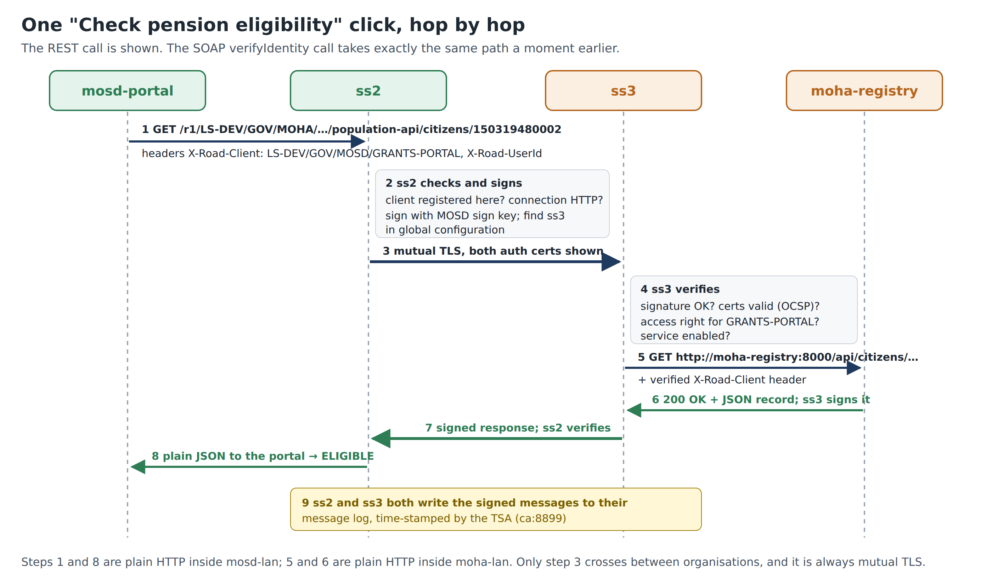
Figure 10. What happens on one click of “Check pension eligibility”.

11.1 The Grants Portal
Open http://localhost:8500. The page is titled Grants Portal · Old Age Pension intake. The Applicant form has National ID, Date of birth, First name, Surname and Officer (X-Road userId), and four buttons:
Button | X-Road calls it makes | Shows
Check pension eligibility | SOAP verifyIdentity + REST getCitizen | A decision, ELIGIBLE or REJECT, with reasons
Verify identity | SOAP verifyIdentity only | Match or no match, without revealing the record
Look up record | REST GET /citizens/{id} | The full citizen record
Vital status only | REST GET /citizens/{id}/vital-status | Alive or deceased only

Do this:
- Click Sample applicants (synthetic data) to open the list, and click Use next to Thabo Letsie. The form fills in.
- Click Check pension eligibility.
- Read the green result: Eligible for Old Age Pension, with four ticks: identity details match the register, recorded as alive, Mosotho citizen, and age at least 70.
- Scroll down to X-Road trace: two green entries, one SOAP and one REST, each with a status and a time in milliseconds.
- Click an entry to expand it. Request shows what the portal sent to ss2 (note the X-Road-Client header). Response headers added by X-Road shows headers such as X-Road-Id and X-Road-Request-Hash, added by the Security Servers. Response body is MOHA’s answer.
- Repeat with every sample applicant and compare with the table below.
Applicant | Expected result | Why
Mpho Mokoena | ELIGIBLE | all four conditions met
Thabo Letsie | ELIGIBLE | all four conditions met
Lineo Ramakatane | REJECT | born 1990, too young
Teboho Mofokeng | REJECT | recorded as deceased
Unknown Person (999999999999) | REJECT, not in the register | MOHA has no such citizen; the registry’s “not found” answer passes through unchanged

If it goes wrong
Red trace with UnknownService or UnknownMember: the Phase 5 changes have not reached ss2 yet. Wait two minutes and try again.
Red trace with a “Fix:” hint: follow the hint; the portal recognises the common X-Road errors.
“Could not reach consumer Security Server”: ss2 is stopped. Run docker compose ps.

11.2 The registry’s audit page: MOHA’s view
Open http://localhost:8001/audit; it refreshes itself every 5 seconds. Each pension check adds two rows. Columns: Time, API (REST/SOAP), Operation, National ID, X-Road client, User, Message ID, Outcome.
Why
The X-Road client value LS-DEV/GOV/MOSD/GRANTS-PORTAL was added by ss3 after it checked ss2’s signature, so MOHA can trust it. User officer.ntsane comes from the portal’s Officer field. MOHA can see exactly which ministry, application and officer asked about which citizen: that is the X-Road audit trail.

11.3 The Security Servers’ health
- ss2 → Diagnostics → Overview: Global configuration, Timestamping and OCSP responders all show Everything ok.
- The same on ss3. Time-stamping turns green once messages have been logged, which your tests just did.
✓ Checkpoint 6
Thabo Letsie is ELIGIBLE with two green traces; all five samples are as in the table; the audit page shows the verified caller; Diagnostics are green on ss2 and ss3. Your X-Road network works end to end.

Tip: Optional: the automated check
In a terminal, bash tests/smoke-test.sh runs seven checks, including that the portal cannot bypass X-Road. Expect 7 passed, 0 failed.

What you just built
A working X-Road network: MOSD’s portal checks pension applicants against MOHA’s register through two Security Servers, with every message signed, permission-checked, logged and time-stamped.

Check your understanding
Answer in your own words before moving on. Model answers are in Appendix A.
- In the trace, which headers were added by X-Road rather than by the portal or the registry?
- Why does Teboho Mofokeng get REJECT even though the identity check passes?
- How does MOHA know who asked about a citizen?

12. Break it to learn it
Each experiment changes one thing. Write down your prediction first, try it, and read the error in the portal (each failed trace shows the error and a Fix: hint). Then undo the change and confirm that Check pension eligibility works again before the next experiment. Changes on ss2 and ss3 take effect within seconds.
Tip: Screenshots for your report
Take a screenshot of each broken state. They are the clearest evidence that you understand how access, services and connections are controlled.

12.1 Take away access to the REST service
Predict first: which of the two calls in a pension check will fail?
Do it:
- ss3 → Clients → POPULATION-REGISTRY → tab Service clients → click GRANTS-PORTAL.
- Remove the access right for population-api only (keep verifyIdentity).
- Portal: Check pension eligibility for Thabo Letsie.
You should now see
The SOAP trace stays green; the REST trace is red with AccessDenied and the hint “ss3 has not granted GRANTS-PORTAL access to this service…”. No decision can be made.

What it teaches: access is granted per service, by the provider, and checked on the provider’s Security Server.
Undo it, then check that the portal works again:
- Same page → Add service → tick population-api → Add Selected.

12.2 Minimal disclosure: allow the vital-status endpoint only
Predict first: can the portal still learn whether a person is alive? Can it see their record?
Do it:
- Remove population-api from GRANTS-PORTAL’s access rights (as in 12.1).
- ss3 → POPULATION-REGISTRY → Services → expand the REST row → click population-api → tab Endpoints.
- Open the access rights of GET /citizens/*/vital-status → Add subjects → select GRANTS-PORTAL → Add Selected.
- Portal: Thabo Letsie → Vital status only, then Look up record.
You should now see
Vital status only works; Look up record fails with AccessDenied.

What it teaches: X-Road can grant access to a single endpoint, so a ministry shares only the data a purpose needs.
Undo it, then check that the portal works again:
- Remove the endpoint-level right, then give population-api back at service level (as in the 12.1 undo).

12.3 Switch off the SOAP service
Predict first: what does a caller see when a provider takes a service offline?
Do it:
- ss3 → POPULATION-REGISTRY → Services → switch the WSDL row’s toggle off.
- In Disable notice type Maintenance until 14:00 → OK.
- Portal: Verify identity.
You should now see
ServiceDisabled, with your notice text.

What it teaches: a provider can take a service offline without deleting it, and tell callers why.
Undo it, then check that the portal works again:
- Switch the toggle back on.

12.4 The registry goes down
Predict first: which part will X-Road blame?
Do it:
- This one uses the terminal: docker compose stop moha-registry.
- Portal: Check pension eligibility.
You should now see
Both traces red, with ServiceFailed or a network error reported from ss3, the provider side.

What it teaches: X-Road error codes say where in the chain a failure happened: ClientProxy = the caller’s Security Server, ServerProxy = the provider’s Security Server, ServiceFailed = the application behind it.
Undo it, then check that the portal works again:
- Run docker compose start moha-registry, wait a few seconds, and test again.

12.5 Wrong connection type on the caller’s side
Predict first: will the request even leave ss2?
Do it:
- ss2 → Clients → GRANTS-PORTAL → Internal servers → set Connection type to HTTPS.
- Portal: any button.
You should now see
SslAuthenticationFailed, with the hint “Connection type mismatch…”.

What it teaches: the connection type controls how an application must connect to its own Security Server; ss2 refuses before anything is sent.
Undo it, then check that the portal works again:
- Set Connection type back to HTTP.

12.6 Wrong surname
Predict first: does the portal learn the correct surname?
Do it:
- Portal: Use Thabo Letsie, change Surname to Letsi, click Check pension eligibility.
You should now see
The identity check answers “no match”, naming the surname as the field that does not match; the decision is REJECT.

What it teaches: verification without disclosure: MOHA confirms or denies the details without revealing the true record.
Undo it, then check that the portal works again:
- Nothing to undo: click Use again.

13. When things go wrong

13.1 A method that works
- Stop and read the message or status. X-Road error names usually say which part complained: ClientProxy = ss2, ServerProxy = ss3, ServiceFailed = the registry.
- Check Diagnostics on the server involved: Global configuration, OCSP and Timestamping should say Everything ok.
- Check Management Requests on cs: is something still waiting for approval?
- Wait two minutes and press F5 after any change on cs.
- Change one thing at a time, then test again.

13.2 Symptoms and fixes
What you see | Likely cause | Fix
Logged out whenever you switch tabs | Using localhost for several admin pages | Use the .lab addresses (section 3.2)
Page will not load | Server still starting, or stopped | Wait 3–5 min; docker compose ps
Owner name does not fill in (initialisation) | Member not on cs, or list not published yet | Check cs Members; wait 1–2 min
Anchor refused (initialisation) | Old anchor from an earlier build | Download a fresh anchor (1.8)
Signer.InternalError on Generate CSR | Comma in Organization Name (O) | Remove the comma; delete the half-made key
Test CA shows an error | CSR in PEM format | Create the key again with CSR Format DER
Imported certificate does not attach to a key | Certificate from another server’s CSR | Import the file from this server’s folder
OCSP not Good | Clock wrong, or wrong OCSP URL | timedatectl status; check step 1.3
AUTH certificate stuck in Registration in progress | Not approved on cs, or ss1’s management services not working | Approve on cs; check steps 2.13–2.15
UnknownMember … clientReg on ss1 | Expected the first time (2.10) | Step 2.11
UnknownMember / AccessDenied / SslAuthenticationFailed when ss2 or ss3 register | ss1’s management services incomplete | Steps 2.13, 2.14, 2.15
“certificate is not yet valid”, time-stamp errors | Laptop clock wrong (e.g. just booted from Windows) | Wait for NTP sync; timedatectl status
UnknownService right after Phase 5 | The change has not reached ss2 yet | Wait 1–2 minutes
Portal: “Could not reach consumer Security Server” | ss2 stopped or not initialised | docker compose ps; check the ss2 admin page
ss3 cannot add the OpenAPI or WSDL | moha-registry not running | docker compose start moha-registry

13.3 Stopping and resuming
When | Do
End of a session | Terminal, in the lab folder: docker compose stop. All configuration is kept, and shutting down or rebooting is then safe.
Start of the next session | Terminal: docker compose start, wait 3–5 minutes, check timedatectl status. Browser: open your bookmarked tabs, log in, and glance at Diagnostics on each Security Server.
Never | docker compose down -v: it deletes every volume, i.e. everything in this guide.

13.4 Undoing common mistakes
Mistake | How to undo it
Wrong member code or subsystem code on cs | cs → Members → the member → Delete member (or the subsystem → Delete Subsystem), then add it correctly. Only possible while nothing is registered for it.
Wrong key or CSR on a Security Server | Keys and certificates → click the key → delete it (Delete key? → confirm). Then run the Add key wizard again.
Wrong certificate imported | Click the certificate → delete it (Delete certificate? → confirm). Import the right file.
A request declined by mistake | Declined requests are not repeated automatically: on the Security Server, press Register again.
Wrong subsystem added on a Security Server | Clients → the subsystem → Unregister client (if it is registered), then Delete client. Add the right one.
Wrong service URL or service code (Phase 5) | Services → expand → Edit URL, or delete the service description and add it again.
A whole server is in a muddle | Easiest: reset the whole lab and start again (13.5). With practice the rebuild is quick.

13.5 Starting again
Reset everything (deletes all configuration; run in the lab folder):
docker compose down -v
rm -f certs/*.pem
docker compose up -d
# then repeat section 3.1 (new CA certificates) and start again at Phase 1
Return to a saved working state if you made a backup (for example ~/xroad-backup/lab-working-2026-10-03.tar.gz):
bash ~/xroad-backup/restore.sh
Watch out: After either one
Empty ~/xroad-work: old anchors and certificates do not match the new or restored network.

13.6 Housekeeping
- API keys: keys created for scripted work can be revoked on cs under Settings → API Keys, and on each Security Server under Keys and certificates → tab API Keys.
- Keep your anchor (~/xroad-work/cs/anchor.xml): you need it again only if a Security Server is rebuilt.

14. Progress checklist
Print this page and tick each box as you go.

Getting ready
☐ Preflight passes; host names set; 7 containers Up
☐ Certificates fetched into certs/
☐ ~/xroad-work folders made; seven tabs open and bookmarked; certificate warnings accepted

Phase 1: Central Server
☐ 1.1 Initialised (LS-DEV, cs)
☐ 1.2 Member class GOV
☐ 1.3 Test CA + OCSP http://ca:8888
☐ 1.4 TSA http://ca:8899
☐ 1.5 MCST, MOSD, MOHA + subsystems
☐ 1.6 Management services provider MCST:MANAGEMENT
☐ 1.7 Internal and external signing keys
☐ 1.8 Anchor downloaded; no red banners

Phase 2: ss1
☐ 2.1–2.3 Initialised, safe unlocked, TSA added
☐ 2.4–2.6 SIGN and AUTH CSRs signed
☐ 2.7–2.9 Imported, activated, registered, approved: MCST REGISTERED
☐ 2.10–2.11 MANAGEMENT REGISTERED
☐ 2.12–2.15 WSDL, service address, TLS certificate, access rights

Phase 3: ss2 and ss3
☐ 3A.1–3A.9 ss2: MOSD REGISTERED
☐ 3B.1–3B.9 ss3: MOHA REGISTERED

Phases 4 to 6
☐ 4.1–4.4 GRANTS-PORTAL and POPULATION-REGISTRY REGISTERED; connection type HTTP
☐ 5.1–5.4 REST and SOAP services on; GRANTS-PORTAL has access
☐ 11.1 Portal results correct for all five samples
☐ 11.2–11.3 Audit page shows the verified caller; Diagnostics green

Break it to learn it
☐ 12.1 Access denied
☐ 12.2 Endpoint-only access
☐ 12.3 Service switched off
☐ 12.4 Registry down
☐ 12.5 Connection type
☐ 12.6 Wrong surname

15. Quick reference

15.1 Addresses and logins
What | Address | Login
Central Server | https://cs.lab:4000 | xrd / secret
ss1 · ss2 · ss3 | https://ss1.lab:1000 · https://ss2.lab:2000 · https://ss3.lab:3000 | xrd / secret
Test CA signing page | http://localhost:8888/testca/ | —
Grants Portal | http://localhost:8500 | —
Registry audit page | http://localhost:8001/audit | —
Token PIN, everywhere | 123456xrd! | —

15.2 Addresses you type into the admin pages
Typed where | Address
cs: OCSP responder (1.3) | http://ca:8888
cs: time-stamping service (1.4) | http://ca:8899
ss1: management services WSDL (2.12) | http://cs/managementservices.wsdl
ss1: management service address (2.13) | https://cs:4002/managementservice/manage/
ss3: REST description (5.1) | http://moha-registry:8000/openapi.yaml
ss3: WSDL (5.2) | http://moha-registry:8000/soap/population.wsdl

The names ca, cs and moha-registry exist only inside Docker. They are used by the servers, not by your browser, so they will not open in a tab.

15.3 Glossary
Word | Plain meaning
Access right | Permission, set by the provider, for a subsystem to use a service (or one endpoint of it).
Anchor | The letter of introduction: the Central Server’s address and the key that verifies its signed list.
AUTH certificate | The ID card of a Security Server, used when Security Servers connect to each other.
CA | Certificate Authority: the passport office that signs certificates.
Certificate | An ID card: a public key plus whose it is, signed by a CA.
Central Server | The registry office: keeps and signs the official list of who is who.
CSR | Certificate Signing Request: the application form for a certificate.
DER / PEM | Two file formats for the same certificate data: binary (DER) and text (PEM).
Endpoint | One method and path of a REST service, e.g. GET /citizens/*/vital-status.
Global configuration | The signed official list every Security Server downloads each minute.
Management services | The operator’s service (on ss1) that carries joining and registration requests to the Central Server.
Member | An organisation in the network, e.g. MOHA.
OCSP | The hotline that confirms a certificate has not been cancelled.
Security Server | An organisation’s mailroom: signs, encrypts, checks permissions, logs.
Service | Something a subsystem offers, e.g. population-api.
SIGN certificate | The ID card of an organisation, used to sign its messages.
Subsystem | One application of a member; the thing permissions are given to.
Token, PIN | The safe holding a server’s keys, and its combination.
TSA | Time-Stamping Authority: the notary that stamps the time on logged messages.

Appendix A. Model answers
Compare these with your own answers to the “Check your understanding” questions. Different words are fine; the idea is what matters.

Phase 1
Why can the Security Servers not simply download the official list from anyone who offers it?
Because they only accept a list signed with the key in their anchor. The anchor ties them to this Central Server.
Why does the OCSP URL say `ca` and not `localhost`?
The Security Servers call it from inside Docker, where the CA container is reachable by its name ca. There, localhost would mean the Security Server itself.
What would go wrong in Phase 2 if MOSD had not been added in step 1.5?
ss2 could not be initialised with owner MOSD (the name would not fill in) and could not join, because the Central Server only accepts known members.

Phase 2
Which certificate needed registering on the Central Server, and why only that one?
The AUTH certificate. It identifies the server, and joining means the operator vouches that this server belongs to the member. The SIGN certificate only needs to come from a trusted CA.
Why did registering MANAGEMENT fail the first time?
Registering needs the clientReg service, which MANAGEMENT itself provides and which no server hosted yet. It was registered from the Central Server side instead.
What would happen in Phase 3 without step 2.15?
ss2 and ss3 would get AccessDenied when they sent their joining requests through ss1.

Phase 3
How did ss2’s joining request reach the Central Server?
As an X-Road message from ss2 to the MANAGEMENT subsystem on ss1, which checked that MOSD is in security-server-owners and passed it on to the Central Server’s management service.
Why could you type the ministry names for ss2 and ss3 exactly as they are, but not MCST’s?
They contain no comma. A comma would split the certificate’s subject into the wrong fields.

Phases 4 and 5
Who decided that GRANTS-PORTAL may call MOHA’s services, and on which server?
MOHA, on its own Security Server, ss3.
Why can your browser not open `http://moha-registry:8000/openapi.yaml`?
The name moha-registry only exists on MOHA’s private Docker network, and only ss3 is on that network.
What would the portal see if step 4.4 had been skipped?
SslAuthenticationFailed from ss2, because the portal speaks plain HTTP.

Phase 6
In the trace, which headers were added by X-Road rather than by the portal or the registry?
The response headers starting with X-Road-, for example X-Road-Id and X-Road-Request-Hash.
Why does Teboho Mofokeng get REJECT even though the identity check passes?
The REST record says he is deceased, so the “recorded as alive” condition fails.
How does MOHA know who asked about a citizen?
From the verified X-Road client and the user ID in each request, recorded on its audit page and in both Security Servers’ signed, time-stamped message logs.

