X-ROAD LOCAL LAB
REST and SOAP in X-Road
How MOHA’s two services are described, published, protected, called and combined in the LS-DEV lab
Author | Motlatsi Victor Mpahane, student attachee
Scope | The REST service population-api and the SOAP service verifyIdentity v1 of LS-DEV/GOV/MOHA/POPULATION-REGISTRY, and how the MOSD Grants Portal uses them
Based on | The lab’s own code: moha-registry/app/main.py, openapi.yaml, population.wsdl, mosd-portal/app/xroad.py, mosd-portal/app/main.py, tests/verifyIdentity.xml
X-Road version | 7.7.0

Prepared with Claude (Anthropic). All identifiers and citizen data are synthetic.

Contents

If the table above is empty: in Word right-click it → Update Field; in LibreOffice Tools → Update → Update All.

1. The big picture
The lab uses both of X-Road’s message styles side by side, for one business purpose: deciding whether an Old Age Pension applicant qualifies. MOHA’s Population Registry offers its data through two interfaces, and X-Road publishes both under one subsystem, LS-DEV/GOV/MOHA/POPULATION-REGISTRY.
Service code | Protocol | Operation | What it answers | What it discloses
population-api | REST (JSON over HTTP) | GET /citizens/{id} (getCitizen) | The full citizen record | Everything: names, birth date, sex, district, village, citizenship, alive/deceased, death date
 |  | GET /citizens/{id}/vital-status (getVitalStatus) | Alive or deceased | Only the status (and death date)
verifyIdentity v1 | SOAP (XML envelope over HTTP POST) | verifyIdentity | “Do these details match?” | found, match, which fields mismatched, vital status. Never the record itself.

Why: Why both?
Real governments run both kinds of systems: older ones, and X-Road’s original protocol, use SOAP; newer ones use REST. X-Road treats them as equals: same certificates, same signing, same access control, same logging. Only the envelope differs, that is, how the caller says *who it is* and *what it wants*.

Neither application ever talks to the other directly:
mosd-portal ──HTTP──► ss2 ══ signed, mutual TLS ══► ss3 ──HTTP──► moha-registry
(MOSD LAN) (consumer SS) (provider SS) (MOHA LAN)
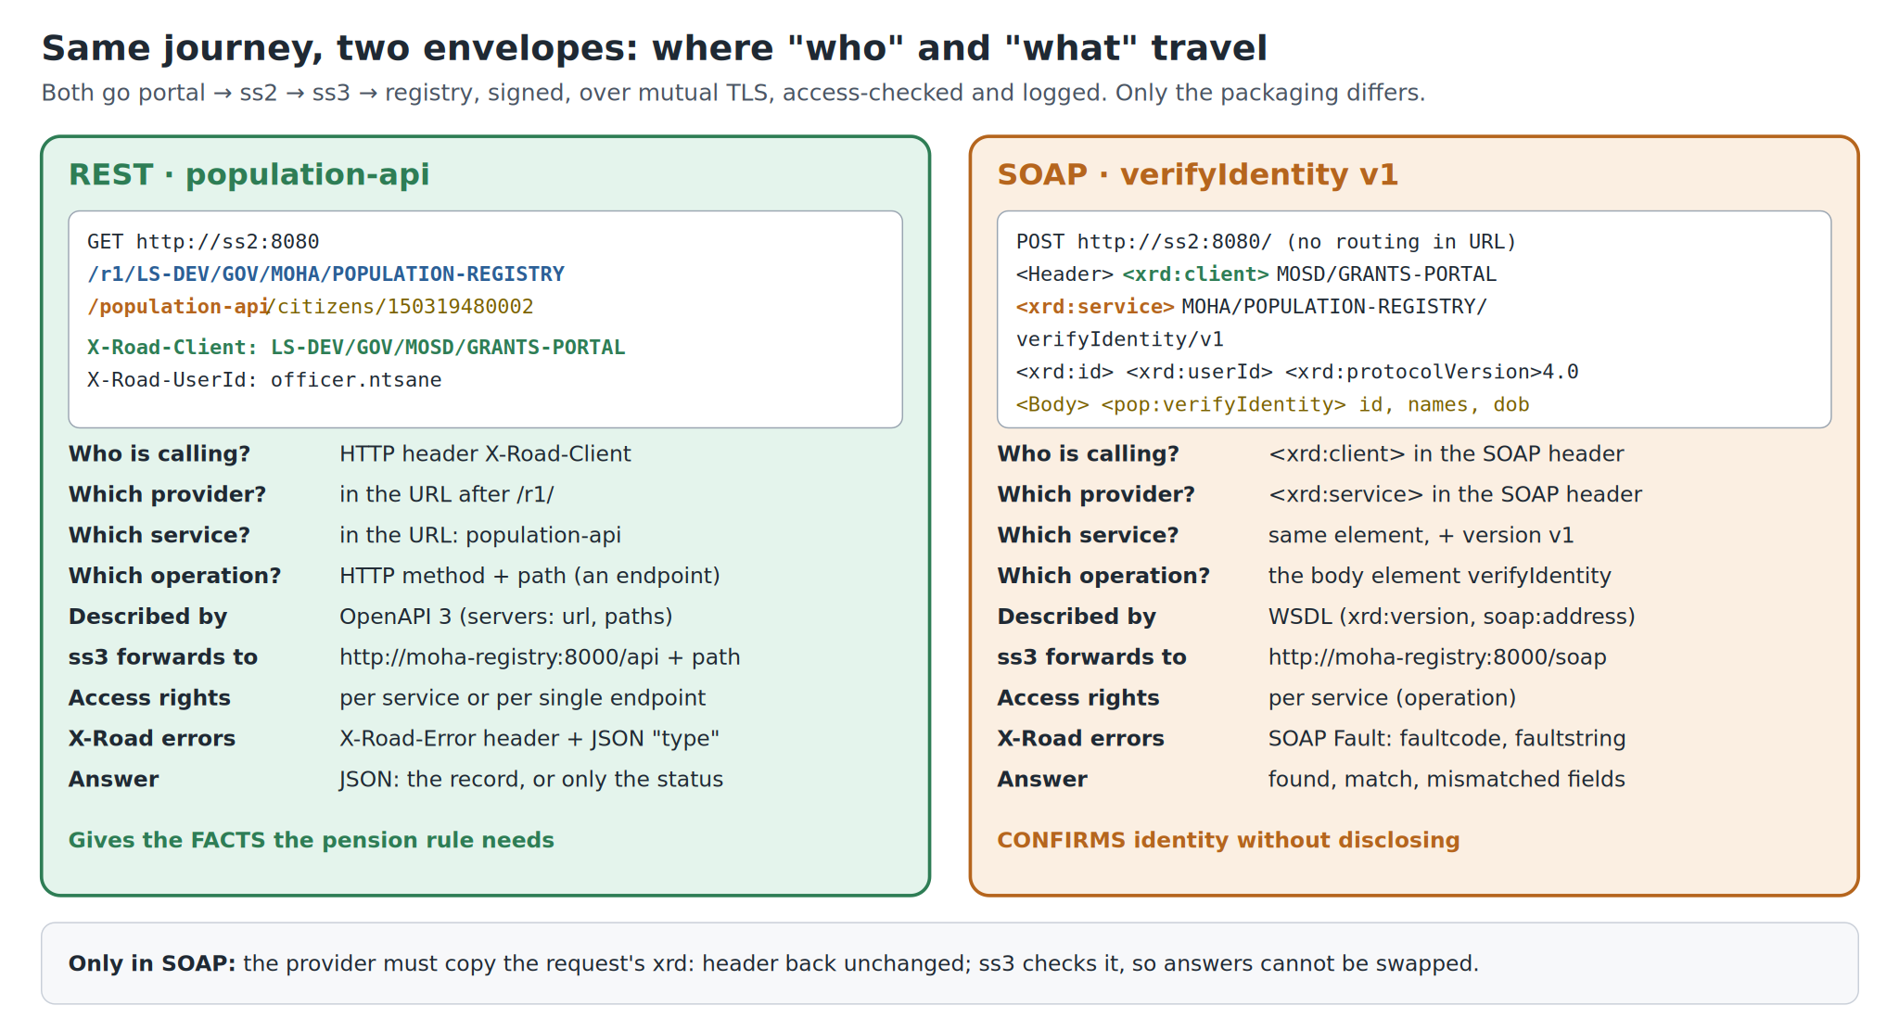
Figure 1. The same journey in two envelopes: where the caller’s identity and the target service travel in REST and in SOAP.

2. Where the services come from: the provider side

2.1 The registry implements them
In moha-registry/app/main.py:
REST GET /api/citizens/{id} → get_citizen()
REST GET /api/citizens/{id}/vital-status → get_vital_status()
SOAP POST /soap → soap_endpoint() (accepts only <pop:verifyIdentity>)
It also serves the two service descriptions that ss3 imports: /openapi.yaml for REST and /soap/population.wsdl for SOAP.

2.2 ss3 reads the descriptions (Phase 5)
X-Road does not guess anything. It takes everything from these two files:
ss3 needs to know | From the OpenAPI file (REST) | From the WSDL (SOAP)
Service name | You type it: population-api | The operation name: verifyIdentity
Version | (none) | <xrd:version>v1</xrd:version>
Where to forward | servers: url: http://moha-registry:8000/api | <soap:address location="http://moha-registry:8000/soap"/>
Finer-grained units | Each path becomes an endpoint: GET /citizens/*, GET /citizens/*/vital-status | (none: access is per operation)

{nationalId} becomes * because path parameters turn into wildcards; that is why ss3 lists GET /citizens/*.
Why: Why the WSDL declares the X-Road header elements inline
The WSDL defines xrd:client, xrd:service, xrd:id, xrd:userId and xrd:protocolVersion itself instead of importing X-Road’s schema from the internet. That way ss3 can read the WSDL with no internet access.

2.3 MOHA grants access (Phase 5, step 5.4)
On ss3, GRANTS-PORTAL was given rights to population-api (all its endpoints) and to verifyIdentity. The provider decides; MOSD cannot grant itself anything. REST rights can be narrowed to a single endpoint; experiment 12.2 in the Browser Guide does exactly that.

2.4 How ss2 finds the service
ss3 keeps the service list itself and answers questions about it (section 6). Global configuration only tells ss2 *where* POPULATION-REGISTRY lives: on the Security Server SS3, at address ss3.

3. A REST call, hop by hop

3.1 What the portal sends to ss2
From rest_get() in mosd-portal/app/xroad.py:
GET http://ss2:8080/r1/LS-DEV/GOV/MOHA/POPULATION-REGISTRY/population-api/citizens/150319480002
X-Road-Client: LS-DEV/GOV/MOSD/GRANTS-PORTAL
X-Road-UserId: officer.ntsane
Accept: application/json
The URL carries the routing:
/r1 / LS-DEV/GOV/MOHA/POPULATION-REGISTRY / population-api / citizens/150319480002
│ └──────────── provider subsystem ┘ └ service code ┘ └ path inside the API ┘
└ X-Road REST protocol, version 1
- Who is calling: the HTTP header X-Road-Client.
- What is wanted: the URL: provider, service code, path.
- The officer: X-Road-UserId, recorded for accountability, not used for access control.

3.2 What happens in between
- ss2 checks that GRANTS-PORTAL is a client registered on this server and that the connection type (HTTP) matches. It signs the request with MOSD’s sign key, looks up POPULATION-REGISTRY in global configuration (on ss3), and opens mutual TLS to ss3.
- ss3 checks the signature and the certificates (OCSP), then the access right: may GRANTS-PORTAL call population-api, and this exact method + path (GET /citizens/*)? It also checks that the service is enabled.
- ss3 rewrites the URL: it removes the X-Road prefix and appends the rest to the service URL from the OpenAPI file, adding X-Road headers the registry can trust because ss3 verified them:
GET http://moha-registry:8000/api/citizens/150319480002
X-Road-Client: LS-DEV/GOV/MOSD/GRANTS-PORTAL ← verified by ss3
X-Road-Id: LS-DEV-… ← unique message ID
X-Road-UserId: officer.ntsane
4. The registry: get_citizen() reads the X-Road-* headers (rest_xroad_meta()), writes an audit row and returns JSON.
5. Back the same way: ss3 signs the response, ss2 verifies it, and both write the exchange to their message logs with a TSA time-stamp. The portal receives the JSON plus headers such as X-Road-Id and X-Road-Request-Hash.

3.3 Errors in REST
Case | What comes back | How the portal treats it
The registry has no such citizen | HTTP 404 with {"error": "NOT_FOUND", …}, passed through unchanged | A normal answer (smoke-test check 5)
X-Road refuses (access, disabled, unknown…) | X-Road-Error header and JSON {"type": "Server.ServerProxy.AccessDenied", "message": …} | An error with a “Fix:” hint (rest_get(), lines 114–125)

4. A SOAP call, hop by hop

4.1 What the portal sends to ss2
From build_verify_envelope(); the same message is in tests/verifyIdentity.xml:
POST http://ss2:8080/ ← the server root: no routing information in the URL
Content-Type: text/xml; charset=utf-8

<soapenv:Envelope …>
<soapenv:Header>
<xrd:client id:objectType="SUBSYSTEM"> ← WHO is calling
LS-DEV / GOV / MOSD / GRANTS-PORTAL
</xrd:client>
<xrd:service id:objectType="SERVICE"> ← WHAT is wanted
LS-DEV / GOV / MOHA / POPULATION-REGISTRY / verifyIdentity / v1
</xrd:service>
<xrd:id>3868363e-…</xrd:id> ← message ID (the portal makes a UUID)
<xrd:userId>officer.ntsane</xrd:userId>
<xrd:protocolVersion>4.0</xrd:protocolVersion> ← X-Road SOAP protocol version
</soapenv:Header>
<soapenv:Body>
<pop:verifyIdentity> ← the actual question
<pop:nationalId>150319480002</pop:nationalId>
<pop:firstName>Thabo</pop:firstName>
<pop:surname>Letsie</pop:surname>
<pop:dateOfBirth>1948-03-15</pop:dateOfBirth>
</pop:verifyIdentity>
</soapenv:Body>
</soapenv:Envelope>
Everything is inside the message. The xrd: header does the job of REST’s URL and X-Road-Client header, and the identifiers are structured XML elements instead of a slash-separated string.

4.2 What happens in between
The checks are the same as for REST: signing, mutual TLS, OCSP, access rights, enabled service. The differences:
- ss3 forwards the whole envelope to the WSDL’s address, http://moha-registry:8000/soap. There is no URL rewriting.
- Access is per operation: verifyIdentity as a whole. SOAP has no endpoints.

4.3 The registry’s answer
soap_endpoint() in moha-registry/app/main.py:
- Reads the xrd: header for the audit log (_identifier_to_str() turns the XML identifier back into LS-DEV/GOV/MOSD/GRANTS-PORTAL).
- Compares each supplied field with the record, ignoring upper/lower case and skipping fields the caller left out.
- Replies:
<soapenv:Header> …the request header, copied back UNCHANGED… </soapenv:Header>
<soapenv:Body>
<pop:verifyIdentityResponse>
<pop:nationalId>150319480002</pop:nationalId>
<pop:found>true</pop:found>
<pop:match>true</pop:match>
<pop:vitalStatus>ALIVE</pop:vitalStatus>
</pop:verifyIdentityResponse>
</soapenv:Body>
Why: Why the header is echoed
X-Road’s SOAP protocol requires the provider to copy the request’s xrd: header back unchanged. ss3 checks that the response header matches the request, so a response cannot be swapped for another message. That is what resp_env.append(header) (line 214) does.

With a wrong surname the answer is match=false with <pop:mismatchedFields>surname</pop:mismatchedFields>: the caller learns that something is wrong and which field, but not the correct value.

4.4 Errors in SOAP
Registry errors and X-Road errors both come back as a SOAP Fault, for example <faultcode>Server.ServerProxy.AccessDenied</faultcode>. The portal reads faultcode to choose its “Fix:” hint (verify_identity(), line 196).

5. REST and SOAP side by side
 | REST (population-api) | SOAP (verifyIdentity v1)
Where the portal sends it | http://ss2:8080/r1/<provider>/<service>/<path> | http://ss2:8080/ (POST)
Caller identity | X-Road-Client HTTP header | <xrd:client> in the SOAP header
Target service | In the URL | <xrd:service> in the SOAP header
Message ID | Created by ss2, returned as X-Road-Id | Created by the client (<xrd:id>)
Version | (none in this lab) | <xrd:serviceVersion>v1 (from the WSDL’s xrd:version)
Service description | OpenAPI 3 YAML | WSDL
Access-rights granularity | Service or single endpoint (method + path) | Service (operation)
ss3 forwards to | Service URL + remaining path | WSDL soap:address
Provider must echo the header | No | Yes
X-Road error format | X-Road-Error header + JSON type / message | SOAP Fault faultcode / faultstring
Signing, mutual TLS, OCSP, time-stamped logs | Yes | Yes, identical

6. Asking X-Road about services: metaservices
Security Servers also answer questions *about* services. The smoke test uses the REST ones:
# Which REST services does POPULATION-REGISTRY offer?
curl -H "X-Road-Client: LS-DEV/GOV/MOSD/GRANTS-PORTAL" \
http://localhost:2080/r1/LS-DEV/GOV/MOHA/POPULATION-REGISTRY/listMethods

# Which of them may GRANTS-PORTAL call, down to the endpoints?
curl -H "X-Road-Client: LS-DEV/GOV/MOSD/GRANTS-PORTAL" \
http://localhost:2080/r1/LS-DEV/GOV/MOHA/POPULATION-REGISTRY/allowedMethods
allowedMethods is answered by ss3, so it is a quick way to check access rights from the consumer’s side. SOAP has equivalents (listMethods, allowedMethods, getWsdl) that are called with an envelope.

7. How the portal combines them

7.1 The four buttons
Button | Calls | Why this combination
Verify identity | SOAP only | Confirms the applicant is who they claim, without MOSD seeing the record
Look up record | REST GET /citizens/{id} | The full record, when the officer genuinely needs it
Vital status only | REST GET /citizens/{id}/vital-status | The minimum needed for “is this person alive?”
Check pension eligibility | SOAP then REST getCitizen | Both answers combined into one decision

7.2 The pension decision
assess_pension() in mosd-portal/app/main.py:
- Did either call fail? → UNABLE; the trace shows why.
- SOAP says found=false → REJECT, “Not in the population register”. This is decided from the SOAP answer alone; the REST 404 is then expected.
- Otherwise four conditions must all hold:
Condition | Comes from
Identity details match the register | SOAP match
Recorded as alive | REST vitalStatus
Mosotho citizen (citizenship LS) | REST citizenship
Age 70 or over (demo rule PENSION_AGE) | REST dateOfBirth

Why: The design point
SOAP answers “is this person who they say they are?” without disclosing data. REST provides the facts the rule needs. Endpoint-level access lets a less trusted caller be given vital-status only. The less a caller needs, the less it gets: minimal disclosure, enforced by MOHA’s own Security Server rather than by MOSD’s good behaviour.

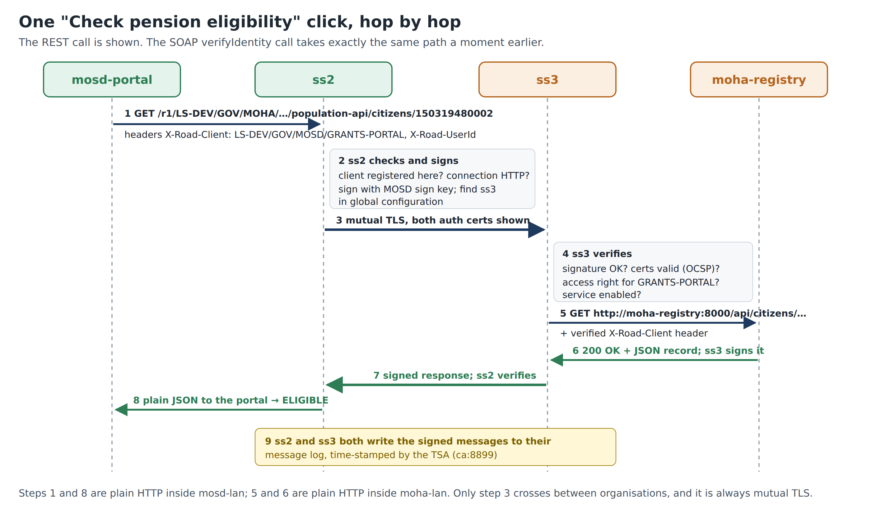
Figure 2. One click of “Check pension eligibility”, hop by hop (the REST call is shown; the SOAP call takes the same path just before it).

8. What each common error means
Error | REST / SOAP | Decided by | Meaning
AccessDenied | both | ss3 | No right to this service, or to this endpoint
ServiceDisabled | both | ss3 | Service description switched off (returns the disable notice)
UnknownService | both | ss2 / ss3 | Wrong service code or version, or configuration not yet refreshed
SslAuthenticationFailed | both | ss2 | The portal’s connection type does not match (HTTP vs HTTPS)
InvalidClientIdentifier | both | ss2 | X-Road-Client / <xrd:client> is not a client on ss2
ServiceFailed / network error | both | ss3 | The registry is down or returned an error
HTTP 404 {"error": "NOT_FOUND"} | REST | registry | A normal answer: no such citizen. Not an X-Road error.
found=false | SOAP | registry | The SOAP equivalent of “not found”

9. Try it yourself
These work once the lab has reached Phase 5 (services published, access granted). Run them from the lab folder:
cd ~/xroad-ls-lab

# REST: full record (-i shows the X-Road-* response headers)
curl -i -H "X-Road-Client: LS-DEV/GOV/MOSD/GRANTS-PORTAL" -H "X-Road-UserId: me" \
http://localhost:2080/r1/LS-DEV/GOV/MOHA/POPULATION-REGISTRY/population-api/citizens/150319480002

# REST: status only
curl -H "X-Road-Client: LS-DEV/GOV/MOSD/GRANTS-PORTAL" \
http://localhost:2080/r1/LS-DEV/GOV/MOHA/POPULATION-REGISTRY/population-api/citizens/050519500004/vital-status

# SOAP: the ready-made envelope (edit the surname in a copy to see match=false)
curl -H "Content-Type: text/xml; charset=utf-8" --data-binary @tests/verifyIdentity.xml http://localhost:2080/
Then open http://localhost:8001/audit: your calls appear with client LS-DEV/GOV/MOSD/GRANTS-PORTAL, the user ID you sent, and the message ID.
Try | Expect
REST with -i | HTTP 200, JSON record, response headers X-Road-Id, X-Road-Request-Hash
REST vital-status for 050519500004 | {"nationalId": "050519500004", "vitalStatus": "DECEASED", "dateOfDeath": …}
REST with ID 999999999999 | HTTP 404, {"error": "NOT_FOUND", …} from the registry
SOAP as provided | <pop:found>true</pop:found><pop:match>true</pop:match>
SOAP with surname changed | match false and mismatchedFields surname
Change X-Road-Client to a made-up subsystem | An X-Road error from ss2 (the client is not registered there)

10. Summary for reports
In one paragraph
MOHA publishes one subsystem, POPULATION-REGISTRY, with two services. population-api is a REST API described by OpenAPI, with two endpoints (full record and vital status). verifyIdentity v1 is a SOAP operation described by a WSDL; it confirms identity details without returning the record. ss3 learns each service’s internal address and structure from those descriptions, and MOHA grants access per service, or for REST per endpoint.
The consumer always calls its own Security Server, ss2. For REST, the client identity travels in the X-Road-Client header and the target in the /r1/… URL. For SOAP, both travel in the xrd: SOAP header, which the provider must echo back unchanged.
Either way, the message is signed, carried over mutual TLS, access-checked by the provider’s Security Server and time-stamped in both message logs. The Grants Portal combines both services: SOAP to verify the applicant, REST for the facts the pension rule needs. That is minimal disclosure enforced by the data owner.

Key points to remember
- One subsystem can publish both REST and SOAP services; X-Road secures them identically.
- Service descriptions (OpenAPI, WSDL) are where ss3 learns the real address and structure. The registry’s address is never given to the consumer.
- REST: identity in a header, target in the URL, access down to single endpoints.
- SOAP: identity and target in the envelope header, which the provider must echo; access per operation.
- The provider decides access; the consumer’s Security Server only checks that the caller is its own registered client.
- Combining a non-disclosing check (SOAP) with narrowly scoped data (REST endpoints) is how X-Road supports minimal disclosure.

