X-ROAD LOCAL LAB
The Browser Guide
Build the LS-DEV X-Road network by clicking: every page, every field, every check, from the first login to a working data exchange between MOSD and MOHA
Author | Motlatsi Victor Mpahane, student attachee
For | Anyone setting up the lab for the first time, using only the admin web pages
X-Road version | 7.7.0, Docker images from NIIS, on Ubuntu 26.04
Tested | Every value in this guide was used in the successful build of 2 October 2026 (smoke test 7/7)
Companions | X-Road Lab Beginner Guide (concepts) · X-Road Lab Build Report (commands and API)

Prepared with Claude (Anthropic). All identifiers, certificates and citizen data are synthetic and for learning only.

Contents

If the table above is empty: in Word right-click it → Update Field; in LibreOffice Tools → Update → Update All.

1. How to use this guide
This guide builds the whole lab through the admin web pages of the X-Road servers. Apart from three short commands to start the lab (section 3.1), everything is done by clicking in a browser. Each step tells you where to go, what to click in order, what to type, what you should see afterwards, and what to do if it goes wrong.

1.1 Conventions
You see | It means
Keys and certificates | A label exactly as it appears on screen: a menu, tab, button or field. Click or find it.
Clients → Add subsystem | Click the first item, then the second.
LS-DEV | Type this exactly, including capitals and punctuation.
Grey box “You should now see” | The check that tells you the step worked. Do not move on until it matches.
Red box “If it goes wrong” | The most likely causes and fixes for that step.
Blue box “Why” | The reason behind the step. Optional reading, but it is what turns clicking into understanding.

Tip: Where the screen labels come from
Menu, tab, field and status names in bold were taken from the English text files built into X-Road 7.7.0’s own admin pages, so they match what you see. Generic wizard buttons such as Next, Continue, Add, Save or Submit can differ by a word; pick the one that moves forward.

1.2 Values used throughout
What | Value
Admin login, all four admin pages | Username xrd, password secret
Token PIN, everywhere | 123456xrd!
X-Road instance | LS-DEV
Member class | GOV (Government ministries and agencies)
X-Road operator | MCST, Ministry of Communications, Science and Technology; subsystem MANAGEMENT; Security Server SS1
Consumer | MOSD, Ministry of Social Development; subsystem GRANTS-PORTAL; Security Server SS2
Provider | MOHA, Ministry of Home Affairs; subsystem POPULATION-REGISTRY; Security Server SS3
Certificate profile | ee.ria.xroad.common.certificateprofile.impl.FiVRKCertificateProfileInfoProvider
Services | REST population-api, SOAP verifyIdentity v1

1.3 Time plan
Part | Content | First time
Section 3 | Getting ready, browser set-up | 20–30 min
Sections 4–5 | Tour of the admin pages (reading) | 15 min
Phase 1 | Central Server | 30–45 min
Phase 2 | ss1, the management Security Server | 45–60 min
Phase 3 | ss2 and ss3 | 40–60 min
Phases 4–5 | Subsystems, services, access rights | 30 min
Phase 6 | Testing in the portal | 15 min
Part C | Break-it experiments | 30–45 min

Everything you configure is saved. You can stop between any two steps: run docker compose stop at the end of a session and docker compose start at the next.

2. What you are building
Seven programs run in Docker on your laptop. Five of them form an X-Road network; two are ministry applications. At the end, the MOSD Grants Portal checks Old Age Pension applicants against the MOHA Population Registry, and every request travels portal → ss2 → ss3 → registry, signed, encrypted, access-checked and logged.
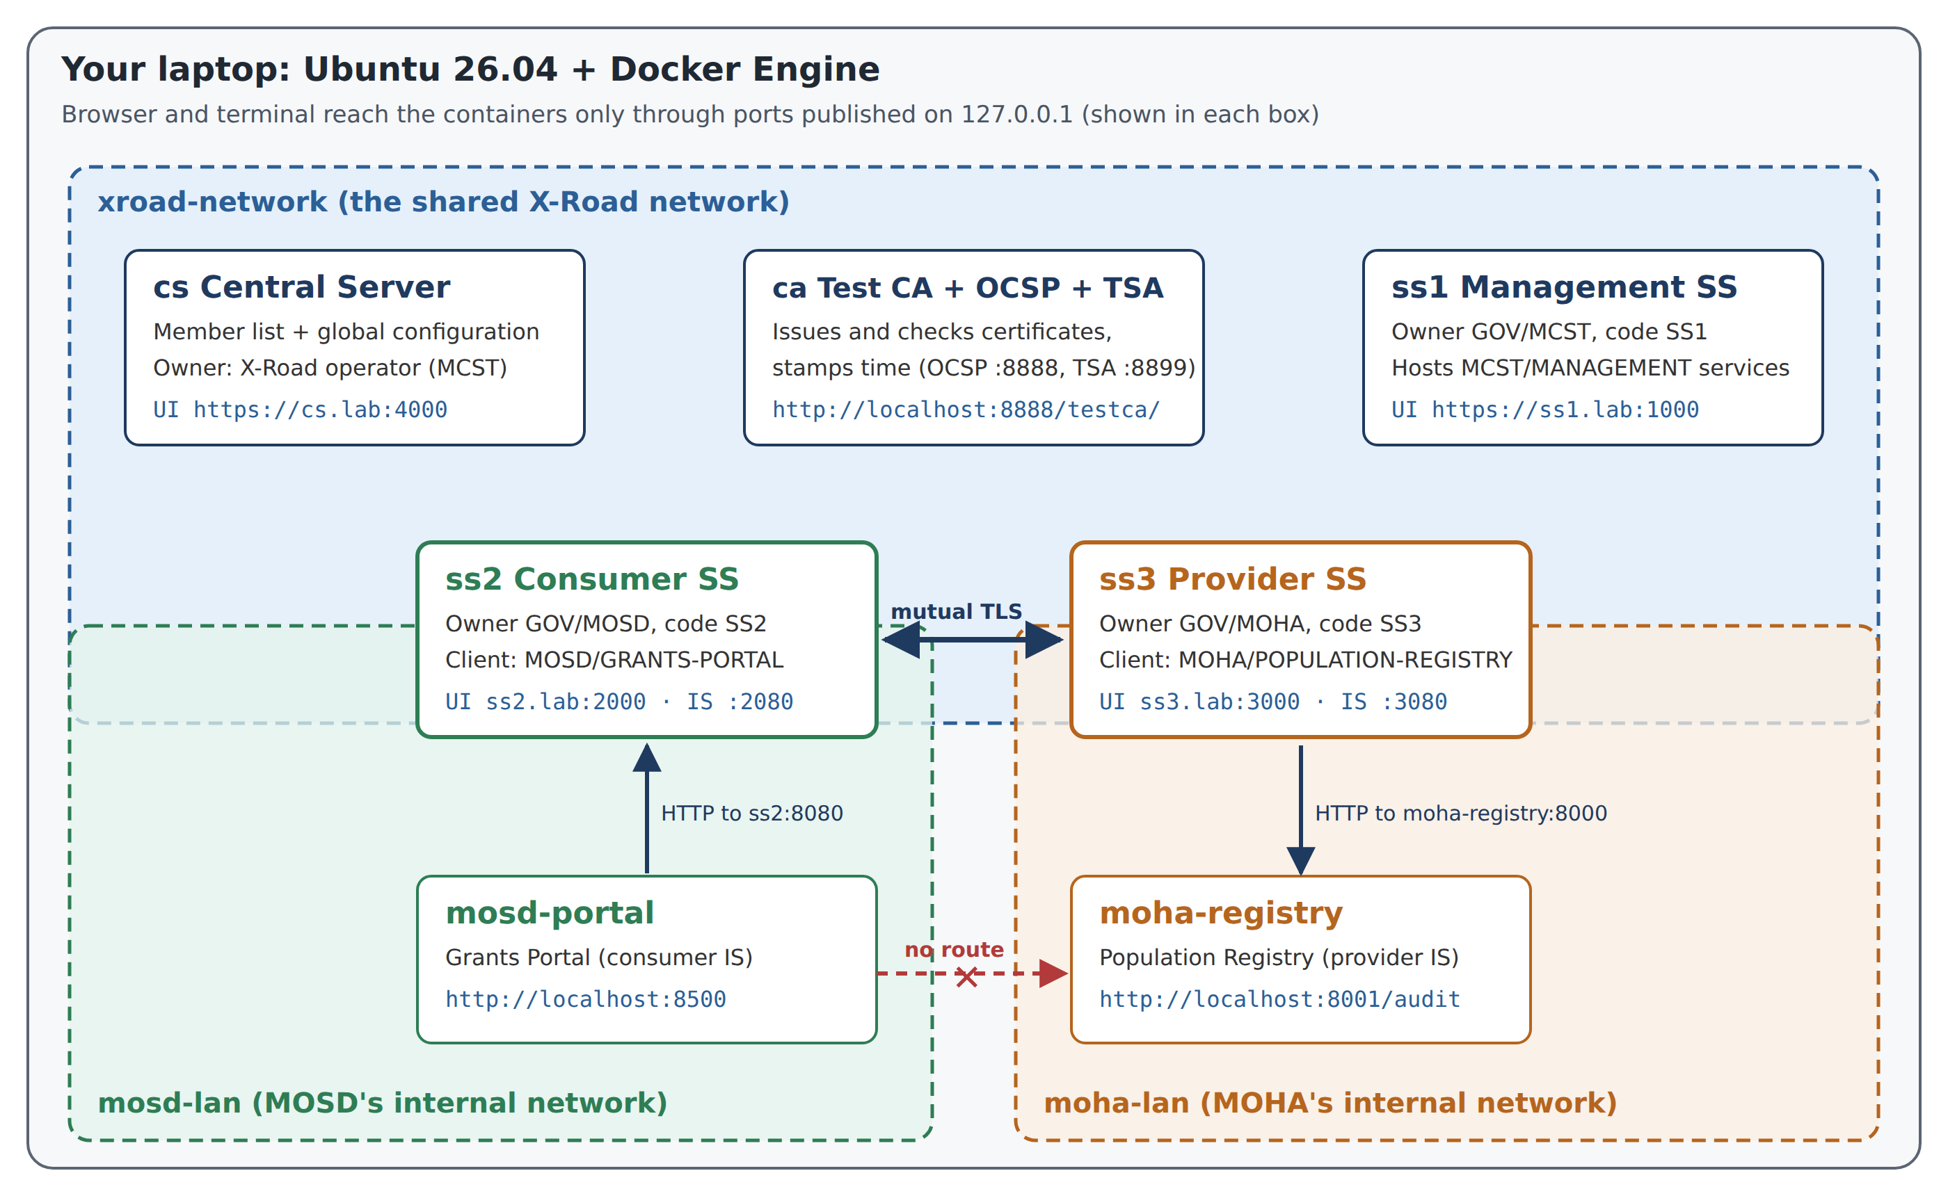
Figure 1. The seven containers and three networks. The portal has no road to the registry except through ss2 and ss3.
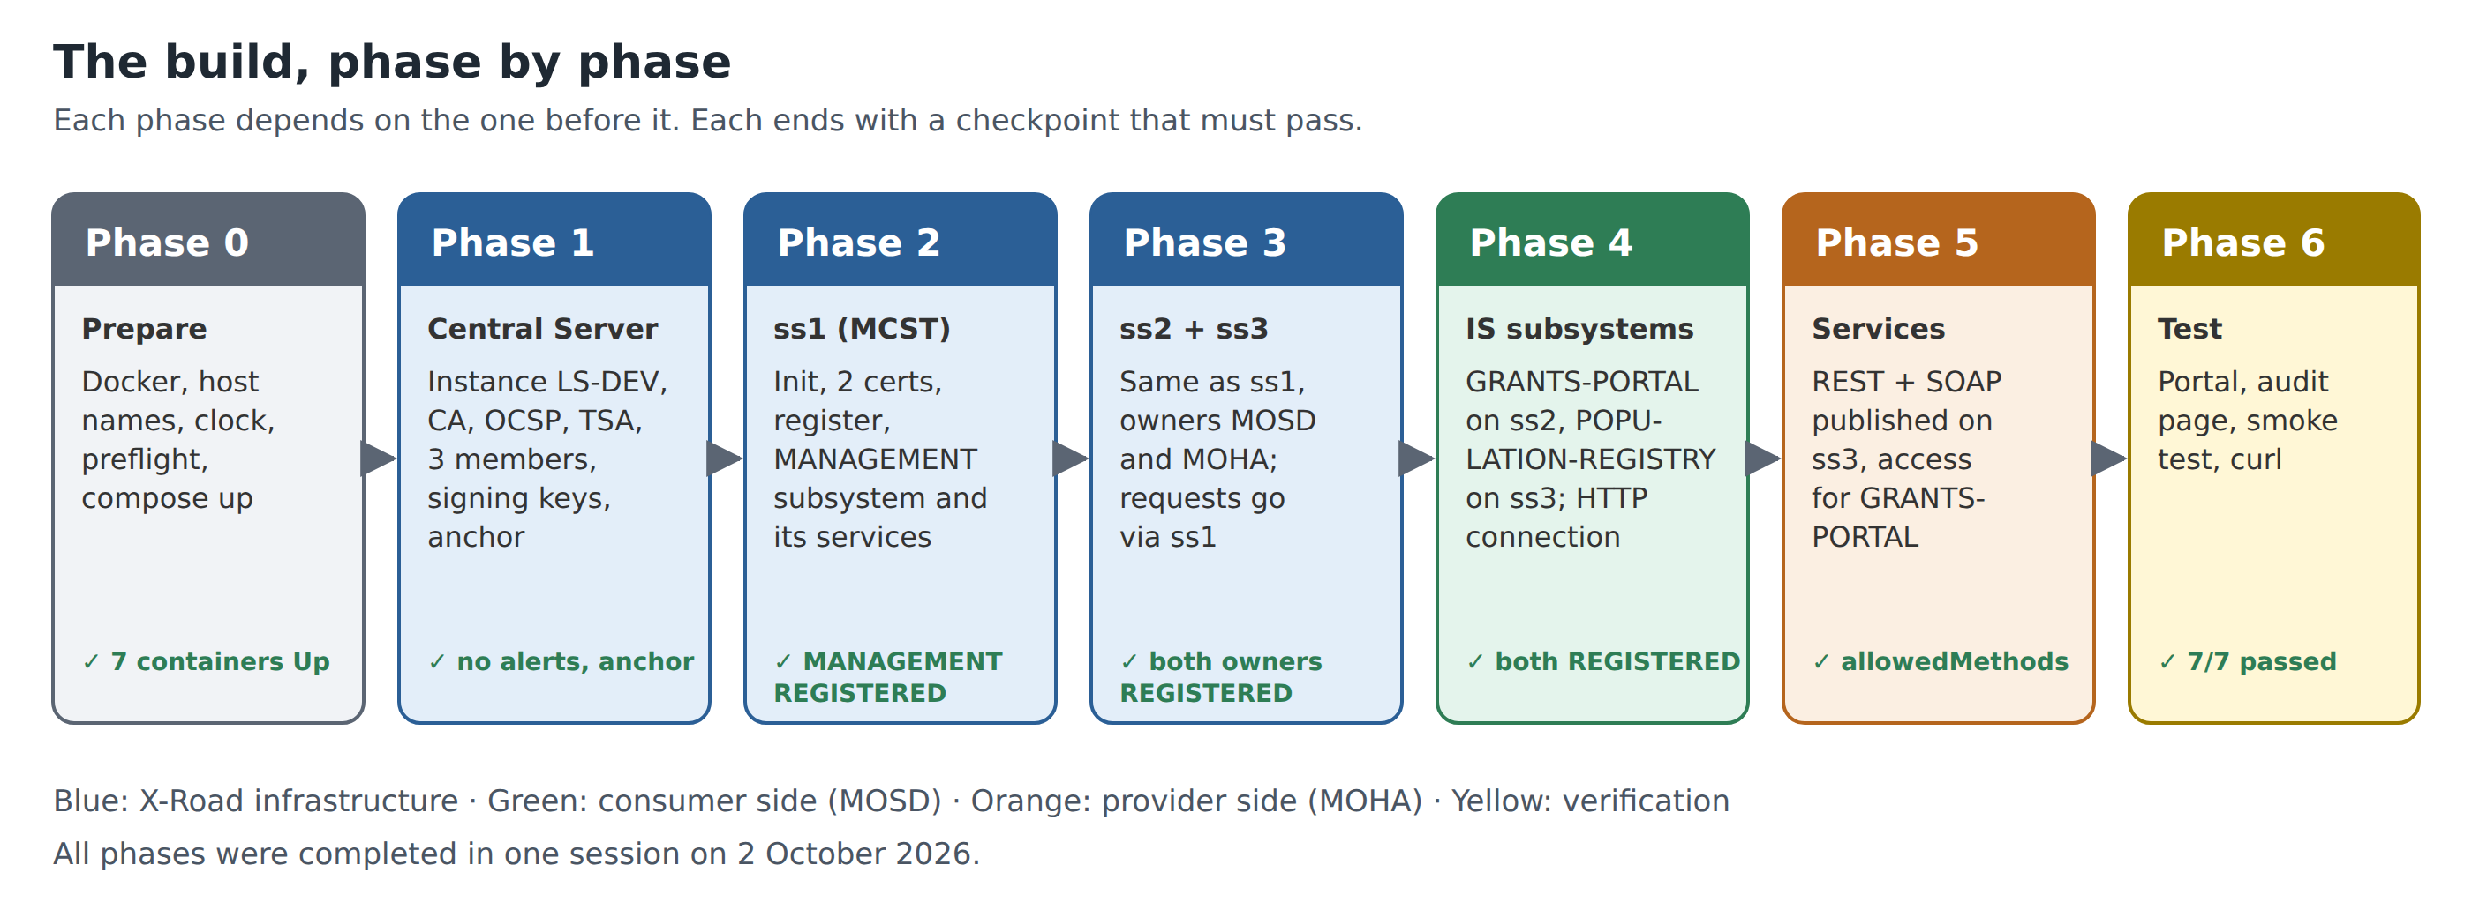
Figure 2. The six build phases. Each ends with a checkpoint.
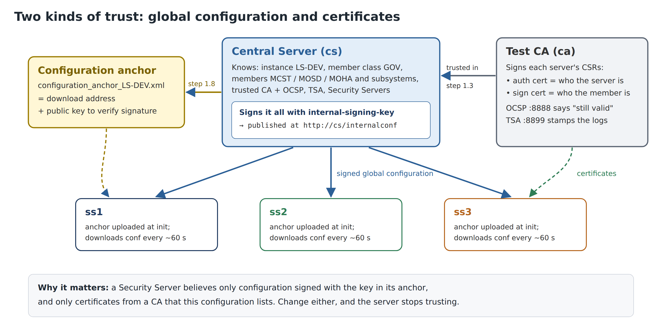
Figure 3. What you set up in Phase 1: the Central Server’s signed configuration, trusted through the anchor, and the CA it lists.

3. Getting ready

3.1 The only terminal steps
Three things cannot be done in a browser: starting the containers, adding the lab host names, and copying the CA certificates out of their container. Open a terminal (Ctrl+Alt+T) and run, from the lab folder:
cd ~/xroad-ls-lab
bash scripts/preflight.sh # checks the laptop; fix any FAIL line it prints
bash scripts/setup-hosts.sh # adds cs.lab, ss1.lab, ss2.lab, ss3.lab (asks for your password)
docker compose up -d --build # starts the 7 containers (first time: several GB download)
bash scripts/fetch-ca-certs.sh # writes certs/ca.pem, certs/ocsp.pem, certs/tsa.pem
Command | Why it is needed
setup-hosts.sh | Gives each admin page its own name. Browsers keep one login cookie per name, so with plain localhost logging in to ss2 would log you out of ss1.
docker compose up -d --build | Starts cs, ca, ss1, ss2, ss3, mosd-portal and moha-registry. The X-Road servers need 3–5 minutes to be ready after this.
fetch-ca-certs.sh | The test CA’s three certificates are needed in Phase 1. They live inside the ca container; this copies them to the certs/ folder so the browser can upload them.

Watch out: Check the clock
Certificates, OCSP and time-stamps all depend on the time. If you just booted from Windows, run timedatectl status and wait for System clock synchronized: yes before you start.

3.2 Open your tabs
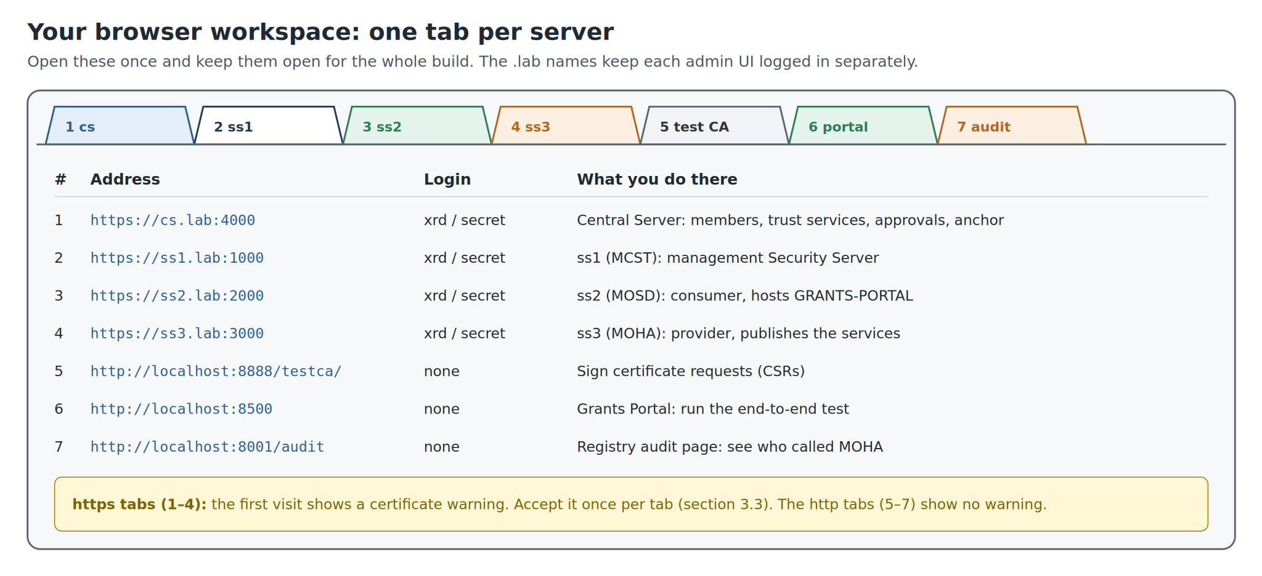
Figure 4. Open one tab per server and keep them open for the whole build.
Firefox and Chrome both work. Bookmark the seven addresses in a folder called “X-Road lab” so they are one click away next time.

3.3 Accepting the certificate warning
The four admin pages use a self-signed certificate, so the first visit to each shows a warning. This is expected in the lab: the certificate was made by the server itself, not by a public authority. Accept it once per address:
Browser | What you see | What to click
Firefox | Warning: Potential Security Risk Ahead | Advanced… → Accept the Risk and Continue
Chrome | Your connection is not private | Advanced → Proceed to cs.lab (unsafe)

Watch out: Only for this lab
Never accept such a warning on a real website. Here it is safe because the address is your own laptop (all lab ports are bound to 127.0.0.1) and you know who made the certificate.

3.4 Logging in
- Open the tab. The login page asks for Username and Password.
- Type xrd and secret, then press Enter.
- After a period of inactivity you are logged out automatically. Just log in again: nothing is lost.
If it goes wrong
Logged out every time you switch tabs: you are using localhost instead of the .lab names. Run bash scripts/setup-hosts.sh and use https://cs.lab:4000 etc.
Page does not load at all: the server is still starting (wait 3–5 minutes after docker compose up) or not running (docker compose ps).

3.5 Uploading and downloading files
You will move about 15 files between the browser and the servers. To avoid mix-ups:
- In any upload dialog, press Ctrl+L and paste a full path, e.g. /home/victor/xroad-ls-lab/certs/ca.pem. Much faster than clicking through folders.
- Downloads land in ~/Downloads. Right after each download, rename the file so you know which server and key it belongs to (suggested names below).
- Keep one folder per server, e.g. ~/Downloads/xroad/ss1/, if you prefer.
File | Comes from | Goes to | Suggested name
Configuration anchor (.xml) | cs: Global Configuration → Internal Configuration → Anchor → Download | ss1, ss2, ss3 at their first login | configuration_anchor_LS-DEV.xml
ca.pem, ocsp.pem, tsa.pem | fetch-ca-certs.sh (section 3.1) | cs: Trust Services | (keep)
6 CSRs (.der) | Add key wizard on ss1, ss2, ss3 | Test CA signing page | ss1_sign.der, ss1_auth.der, …
6 certificates (.pem) | Test CA signing page | Import cert. on the same server | ss1_sign.pem, ss1_auth.pem, …
Management TLS certificate (.tar.gz) | cs: Settings → System Settings → Management Services | ss1: MANAGEMENT → Internal servers | extract management-service.pem

4. A tour of the Central Server pages
Log in at https://cs.lab:4000. On a brand-new Central Server you first see the Initial Configuration page (Phase 1, step 1.1). After that the page always has the six-item menu shown below.
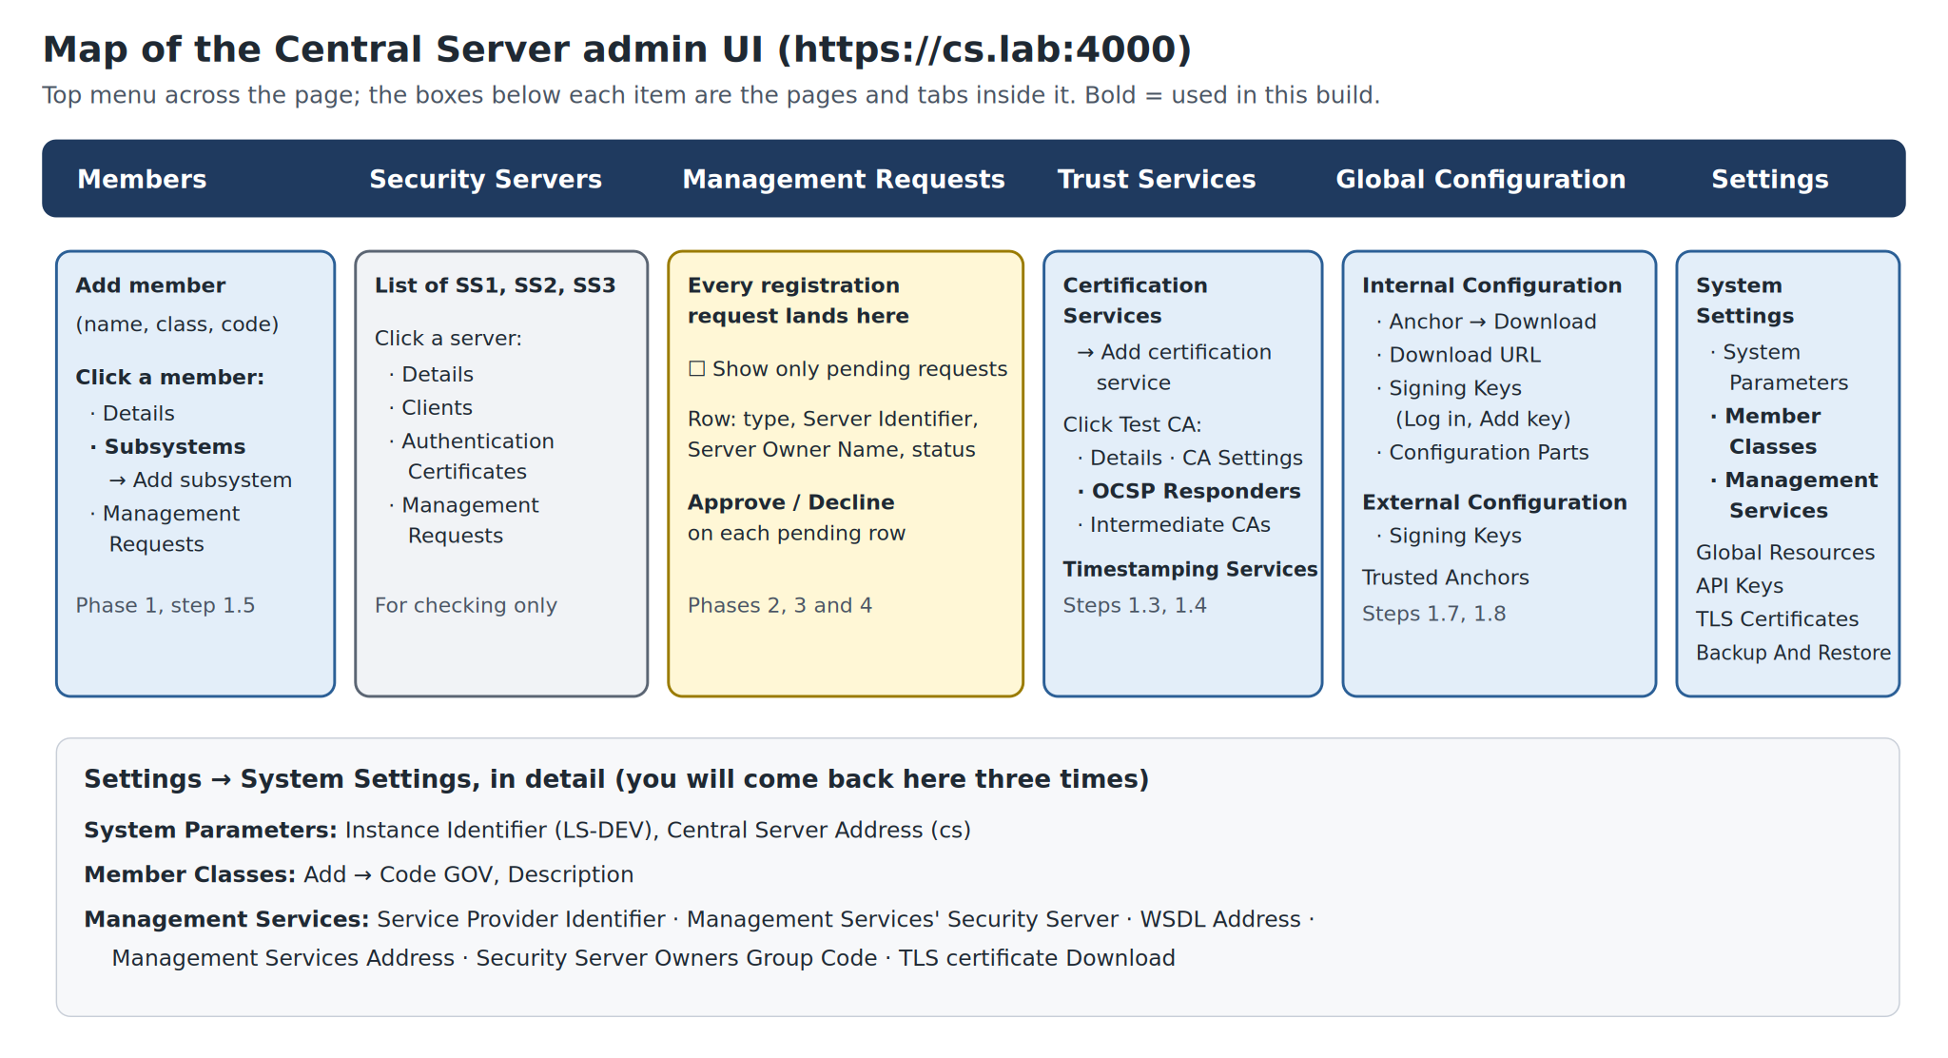
Figure 5. The Central Server admin pages. Bold items are used in this guide.
Menu item | What it is for | Used in
Members | The list of organisations in the network. Click one to see its Details, Subsystems and Management Requests. | Phase 1
Security Servers | Every registered Security Server, with its Clients, Authentication Certificates and requests. | Checks
Management Requests | Every request a Security Server sends (register a server, register a subsystem…). Pending ones have Approve and Decline. Tick Show only pending requests to filter. | Phases 2–4
Trust Services | Certification Services (trusted CAs, each with OCSP Responders) and Timestamping Services. | Phase 1
Global Configuration | Internal Configuration: the Anchor, Download URL, Signing Keys and configuration parts. External Configuration: the same for federation. Trusted Anchors: other networks. | Phase 1
Settings | System Settings (instance, Member Classes, Management Services), Global Resources, API Keys, TLS Certificates, Backup And Restore. | Phases 1–2

Tip: Red banners at the top
Right after initialisation the Central Server shows red alert banners, e.g. that no signing key exists. They are a to-do list, not errors. They disappear as you finish Phase 1.

5. A tour of a Security Server’s pages
ss1, ss2 and ss3 run the same software, so their pages look the same. On first login you get the Initial configuration wizard; afterwards, four menu items.
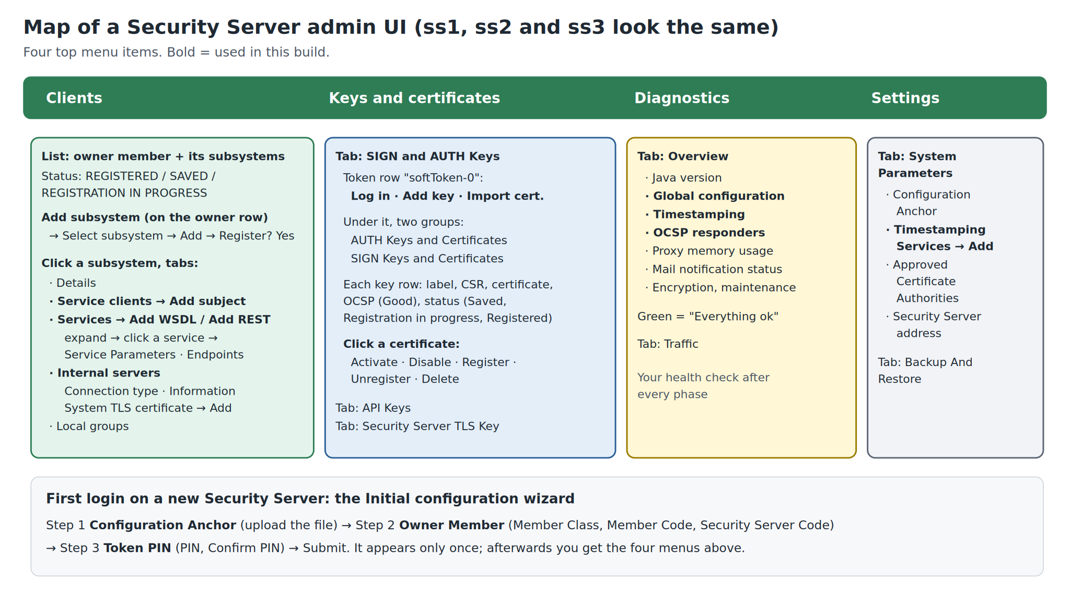
Figure 6. A Security Server’s admin pages. Bold items are used in this guide.
Menu item | What it is for
Clients | The owner member and its subsystems, with their status. Click a subsystem for its tabs: Details, Service clients, Services, Internal servers, Local groups.
Keys and certificates | Tab SIGN and AUTH Keys: the software token (softToken-0) with Log in, Add key and Import cert., and below it the AUTH and SIGN keys with their requests and certificates. Tabs API Keys and Security Server TLS Key.
Diagnostics | Tab Overview: health of Global configuration, Timestamping, OCSP responders and more. “Everything ok” in green is what you want. Your check after every phase.
Settings | Tab System Parameters: Configuration Anchor, Timestamping Services, Approved Certificate Authorities, Security Server address. Tab Backup And Restore.

5.1 Status words you will meet
Where | Status | Meaning
Clients | SAVED | Added on this server, not yet sent for registration.
Clients | REGISTRATION IN PROGRESS | Request sent; waiting for approval on cs and the next global configuration.
Clients | REGISTERED | Done. The whole network knows this client lives here.
Keys and certificates | Saved | Certificate imported but not registered (normal for an AUTH certificate before step “Register”).
Keys and certificates | Registration in progress / Registered | Same as for clients, for the AUTH certificate.
Keys and certificates | OCSP Good | The CA confirms the certificate is valid.
Keys and certificates | Request | A CSR exists for this key and is waiting for its certificate.
Diagnostics | Everything ok (green) | That check is healthy. Yellow/red: read the message.
Services | Out of order | Default notice of a disabled service description. Enable it with the toggle.

6. Phase 1: Configure the Central Server
Tab: https://cs.lab:4000 · Goal: create the LS-DEV network, tell it which CA and time-stamping service to trust, list the three ministries, and download the anchor that the Security Servers need.

1.1 Initialise the Central Server
Where: cs tab, first login: the Initial Configuration page.
- Log in with xrd / secret.
- In the Software Token section type the PIN and Repeat PIN.
- In the Central Server Identification section type the Instance Identifier and the Central Server Address.
- Click Submit.
Field on screen | Type or choose
PIN / Repeat PIN | 123456xrd!
Instance Identifier | LS-DEV
Central Server Address | cs

You should now see
The message The Central Server initialized! Now continue with the full configuration. and the six-item menu. Settings → System Settings shows Instance Identifier LS-DEV and Central Server Address cs.

Why
The instance identifier is the first part of every X-Road name. The address cs is what the Security Servers use to download configuration; it is the container’s name inside Docker, not a name your browser uses. The PIN protects the software token, which will hold the keys that sign the configuration.

1.2 Add the member class GOV
Where: Settings → System Settings → Member Classes.
- Click Add.
- Fill in Code and Description.
- Click Add (or Save).
Field on screen | Type or choose
Code | GOV
Description | Government ministries and agencies

You should now see
Member class saved. and GOV in the Member Classes list.

1.3 Trust the test CA and its OCSP responder
Where: Trust Services → Certification Services.
- Click Add certification service.
- Upload the certificate file from your computer: choose certs/ca.pem (Ctrl+L, paste /home/victor/xroad-ls-lab/certs/ca.pem). Continue.
- On CA Settings: leave This CA can only be used for TLS authentication (mark if true) unticked.
- In Certificate profile info paste the profile class name (table below). Leave any ACME fields empty.
- Click Save. “Test CA” appears in the list.
- Click Test CA → tab OCSP Responders → Add.
- In Add OCSP Responder type the URL and upload certs/ocsp.pem. Click Save.
Field on screen | Type or choose
Certificate | certs/ca.pem (subject “Test CA”)
Certificate profile info | ee.ria.xroad.common.certificateprofile.impl.FiVRKCertificateProfileInfoProvider
OCSP responder URL | http://ca:8888
OCSP certificate | certs/ocsp.pem (subject “Test OCSP”)

You should now see
Trust Services lists Test CA, valid until 2046. Its OCSP Responders tab lists http://ca:8888.

Why
The profile tells X-Road how to read the member identity out of certificates issued by this CA; the test CA issues Finnish-style certificates, hence “FiVRK”. The URL uses ca, the container name, because the Security Servers (not your browser) call it from inside Docker.

If it goes wrong
Upload refused: you picked ocsp.pem or tsa.pem instead of ca.pem. Profile typo: certificate requests fail later in Phase 2. Copy-paste the class name; open Test CA → CA Settings to check it.

1.4 Trust the time-stamping service
Where: Trust Services → Timestamping Services.
- Click Add.
- Type the URL and upload the certificate.
- Click Save.
Field on screen | Type or choose
URL | http://ca:8899
Certificate | certs/tsa.pem (subject “Test TSA”)

You should now see
http://ca:8899 in the Timestamping Services list.

1.5 Add the three ministries and their subsystems
Where: Members.
- Click Add member. Fill in Member Name, Member Class and Member Code (first row of the table). Click Add.
- Repeat for the other two ministries.
- Click MCST in the list → tab Subsystems → Add subsystem → Subsystem code MANAGEMENT → Add.
- Do the same for MOSD (GRANTS-PORTAL) and MOHA (POPULATION-REGISTRY).
Field on screen | Type or choose
Ministry of Communications, Science and Technology | class GOV, code MCST, subsystem MANAGEMENT
Ministry of Social Development | class GOV, code MOSD, subsystem GRANTS-PORTAL
Ministry of Home Affairs | class GOV, code MOHA, subsystem POPULATION-REGISTRY

You should now see
Three members in Members, each with one subsystem. The subsystems have no server yet; that comes in Phases 2–4.

Why
A Security Server can only register an owner or subsystem that the Central Server already knows. Adding them now means their names fill in automatically later.

1.6 Choose the management services provider
Where: Settings → System Settings → Management Services.
- Next to Service Provider Identifier click Edit (pencil).
- In Select Subsystem search MCST, select the row with subsystem MANAGEMENT, click Select.
You should now see
Service Provider Identifier SUBSYSTEM:LS-DEV:GOV:MCST:MANAGEMENT, Service Provider Name Ministry of Communications, Science and Technology. Management Services’ Security Server is still empty (filled in Phase 2). Note the WSDL Address http://cs/managementservices.wsdl and the Management Services Address https://cs:4002/managementservice/manage/: you need both in Phase 2.

Why
Security Servers send their registration requests as X-Road messages to this subsystem. MCST, the operator, provides that service.

1.7 Create the configuration signing keys
Where: Global Configuration → Internal Configuration → Signing Keys.
- If the token row shows Log in, click it and enter the Token PIN 123456xrd!. (In this lab it is usually already logged in.)
- Click Add key → Key friendly name internal-signing-key → Save.
- Open tab External Configuration → Signing Keys → Add key → external-signing-key → Save.
You should now see
One key under each tab. Within a minute or two the red banners disappear.

Why
From now on the Central Server signs the global configuration about once a minute with the internal key. Security Servers only accept configuration with a valid signature.

1.8 Download the anchor
Where: Global Configuration → Internal Configuration → Anchor.
- Click Download.
- Save it as configuration_anchor_LS-DEV.xml in ~/Downloads.
You should now see
The Anchor section shows a Certificate Hash (SHA-224) and a Created time; the file is in ~/Downloads.

Why
The anchor holds the configuration’s address (http://cs/internalconf) and the key that verifies it. Uploading it is how a Security Server decides which network to trust.

✓ Checkpoint 1
No red banners on the Central Server; Trust Services shows Test CA (with OCSP) and one time-stamping service; Members shows three ministries with a subsystem each; the anchor file is saved.

7. Phase 2: ss1, the management Security Server
Tabs: https://ss1.lab:1000 (ss1), https://cs.lab:4000 (cs), http://localhost:8888/testca/ (test CA). Goal: a registered Security Server for MCST that hosts the management services, so that ss2 and ss3 can register through it in Phase 3.
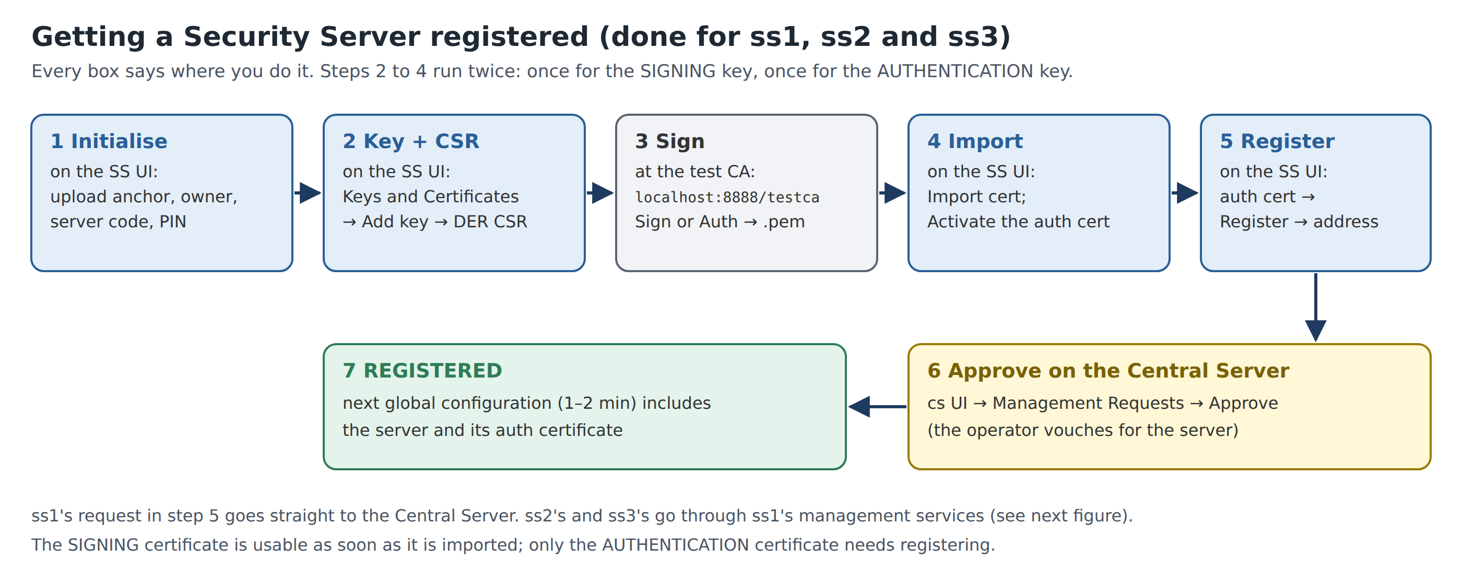
Figure 7. Steps 2.1 to 2.9: getting a Security Server registered. The same steps are repeated for ss2 and ss3.

2.1 Initialise ss1
Where: ss1 tab, first login: the Initial configuration wizard.
- Configuration Anchor: click Upload, choose configuration_anchor_LS-DEV.xml. The dialog shows Configuration anchor details: with Hash (SHA-224) and Generated. Check the hash matches the one on cs (step 1.8), then confirm.
- Owner Member: choose Member Class GOV, type Member Code MCST. The member name fills in by itself. Type Security Server Code SS1. Continue.
- Token PIN: PIN and Confirm PIN 123456xrd!. Click Submit.
You should now see
Server initialised, then the four-item menu. Clients shows owner MCST with status SAVED.

If it goes wrong
Name does not fill in: MCST is missing on cs (step 1.5) or the configuration has not been published yet. Wait 1–2 minutes and retype the code.
PIN rejected: it must be the same as XROAD_TOKEN_PIN in docker-compose.yml, i.e. 123456xrd!.

2.2 Log in to the token (only if asked)
Where: Keys and certificates → tab SIGN and AUTH Keys.
- If softToken-0 shows Log in (or a banner says Please enter soft token PIN), click Log in and type 123456xrd!.
You should now see
The token row shows Add key and Import cert. buttons.

2.3 Add the time-stamping service
Where: Settings → tab System Parameters → Timestamping Services.
- Click Add.
- In Add Timestamping Service select Test TSA and click Add.
You should now see
Timestamping service added and http://ca:8899 in the list.

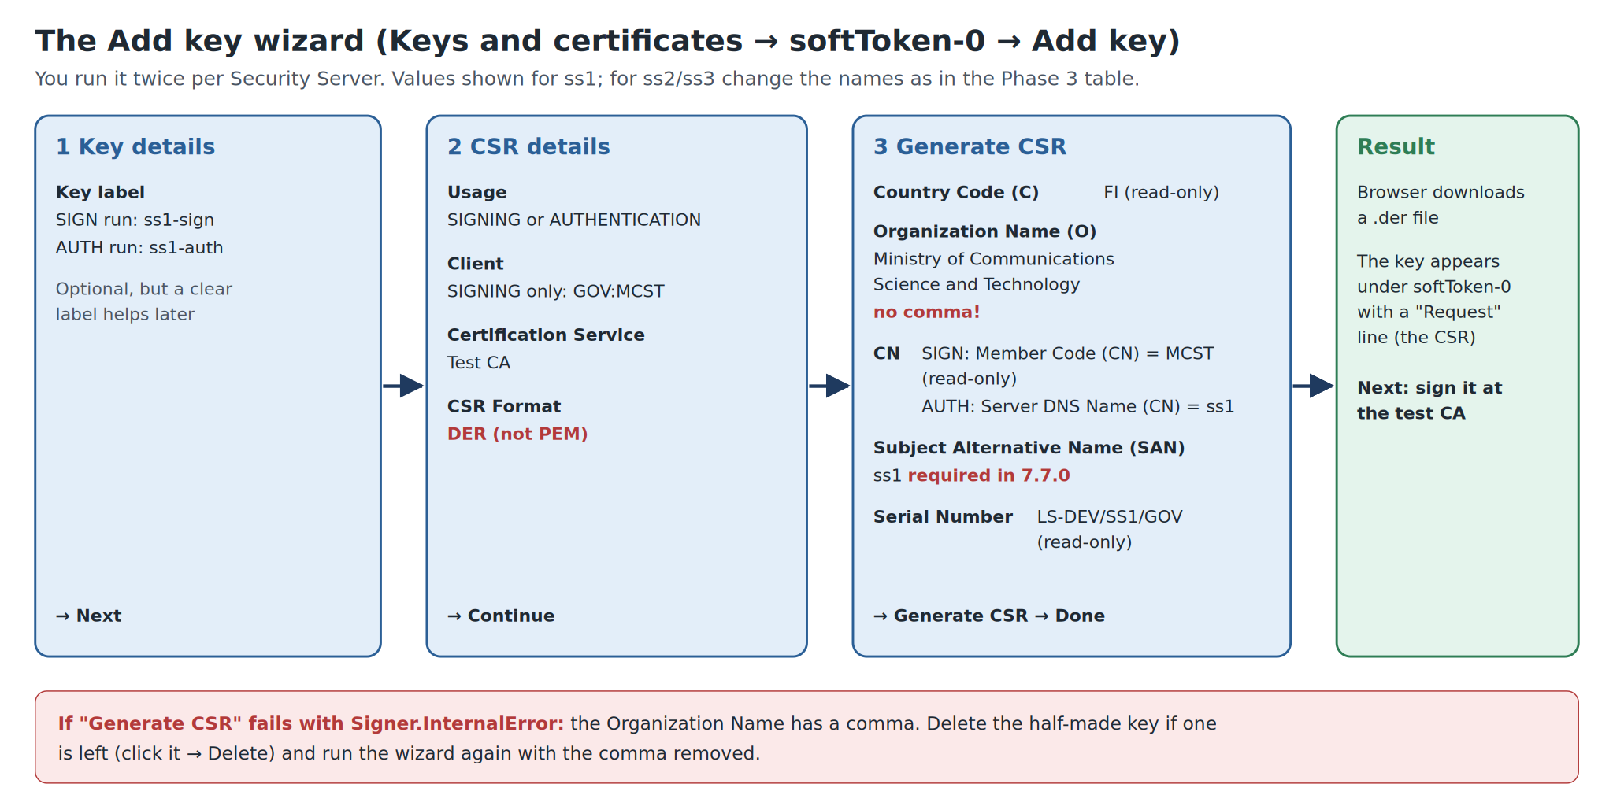
Figure 8. The Add key wizard with ss1’s values. Mind the two red notes.

2.4 Create the SIGNING key and its CSR
Where: Keys and certificates → SIGN and AUTH Keys → softToken-0 → Add key.
- Key label: ss1-sign. Next.
- CSR details: Usage SIGNING, Client GOV:MCST, Certification Service Test CA, CSR Format DER. Continue.
- Generate CSR: fill the fields below, leave read-only fields as they are, click Generate CSR.
- The browser downloads a .der file. Rename it ss1_sign.der. Click Done.
Field on screen | Type or choose
Organization Name (O) | Ministry of Communications Science and Technology (no comma)
Member Code (CN) | MCST (read-only)
Subject Alternative Name (SAN) | ss1
Country Code (C) / Serial Number | FI / LS-DEV/SS1/GOV (read-only)

You should now see
Under SIGN Keys and Certificates a key ss1-sign with a Request line.

If it goes wrong
Signer.InternalError on Generate CSR: a comma in Organization Name. X-Road writes the certificate subject as C=FI, O=…, CN=…, so a comma breaks it. Delete any half-made key (click it → Delete) and repeat without the comma.
SAN field required: 7.7.0 always asks for it; use the server name ss1.

2.5 Create the AUTHENTICATION key and its CSR
Where: Same place: softToken-0 → Add key.
- Key label ss1-auth.
- Usage AUTHENTICATION (no Client is asked), Certification Service Test CA, CSR Format DER.
- Fill the fields below and click Generate CSR. Rename the download ss1_auth.der.
Field on screen | Type or choose
Organization Name (O) | Ministry of Communications Science and Technology
Server DNS Name (CN) | ss1
Subject Alternative Name (SAN) | ss1

You should now see
Under AUTH Keys and Certificates a key ss1-auth with a Request line.

Why
Two certificates, two jobs. The signing certificate belongs to the organisation (MCST) and signs messages. The authentication certificate belongs to this server and proves who it is when Security Servers connect to each other.

2.6 Sign both CSRs at the test CA
Where: Test CA tab: http://localhost:8888/testca/ (page Test CA: CSR signing).
- CSR: choose ss1_sign.der. Type: select Sign. Press Sign. Rename the downloaded certificate ss1_sign.pem.
- Again with ss1_auth.der, Type Auth → Sign → rename to ss1_auth.pem.
You should now see
Two .pem files. (A real CA would check documents first; the test CA signs anything.)

If it goes wrong
Error from the test CA: the CSR was PEM. Delete the key on ss1 and create it again with CSR Format DER.
Select Sign/Auth explicitly rather than Autodetect from file name, which depends on the file name.

2.7 Import the certificates and activate the AUTH one
Where: Keys and certificates → SIGN and AUTH Keys.
- On softToken-0 click Import cert. and choose ss1_auth.pem. It attaches itself to the ss1-auth key.
- Click the new certificate under ss1-auth → click Activate → go back.
- Import cert. again with ss1_sign.pem.
You should now see
Uploading certificate succeeded each time. The SIGN certificate shows Registered at once; the AUTH certificate shows Saved, OCSP Good.

2.8 Send the registration request
Where: Same page, the AUTH certificate row.
- Click Register on the ss1-auth certificate.
- In Registration request, Security server DNS name or IP address: ss1. Click Add/Save.
You should now see
Certificate registration request sent successfully; status Registration in progress.

2.9 Approve the request on the Central Server
Where: cs tab → Management Requests.
- Find the pending request for Server Identifier LS-DEV:GOV:MCST:SS1 (type: add certificate).
- Click Approve and confirm Approve management request.
- Back on ss1, wait 1–2 minutes and refresh.
You should now see
On ss1, Clients shows MCST REGISTERED and the AUTH certificate shows Registered. On cs, Security Servers lists SS1.

Why
Approval is X-Road’s trust model: the operator confirms that this server really belongs to MCST before it joins.

2.10 Add the MANAGEMENT subsystem (the first try fails on purpose)
Where: ss1 → Clients.
- On the MCST owner row click Add subsystem.
- Click Select Subsystem, choose MANAGEMENT, tick Register subsystem, click Add subsystem.
You should now see
An error mentioning UnknownMember and clientReg. This is expected. MANAGEMENT now appears with status SAVED.

Why
To register a subsystem, a Security Server calls the management service clientReg. But MANAGEMENT is the subsystem that provides clientReg, and no server hosts it yet. The next step registers it from the Central Server instead.

2.11 Register MANAGEMENT from the Central Server
Where: cs → Settings → System Settings → Management Services.
- Next to Management Services’ Security Server click Edit.
- In Select Security Server pick SS1 and click Select.
- Back on ss1 wait 1–2 minutes and refresh Clients.
You should now see
ss1 Clients: MCST:MANAGEMENT REGISTERED.

2.12 Add the management services
Where: ss1 → Clients → MANAGEMENT → tab Services.
- Click Add WSDL, type the URL and click Add.
- Switch the new WSDL row’s toggle on.
Field on screen | Type or choose
URL | http://cs/managementservices.wsdl

You should now see
WSDL added; ten services such as clientReg, authCertDeletion, ownerChange…; the row is enabled.

2.13 Point every management service at the Central Server
Where: Same tab: expand the WSDL row.
- Note that each service’s URL is http://INSERT_MANAGEMENT_SERVICE_ADDRESS_HERE: a placeholder.
- Click any service (e.g. clientReg) → Service Parameters.
- Set Service URL, Timeout (s) and Verify TLS certificate as below, and tick Apply to all in WSDL next to each.
- Click Save.
Field on screen | Type or choose
Service URL | https://cs:4002/managementservice/manage/
Timeout (s) | 60
Verify TLS certificate | ticked

You should now see
Service saved; all ten services now show the cs address.

If it goes wrong
Skip this and ss2/ss3 cannot register in Phase 3. The README before October 2026 did not mention it.

2.14 Trust the Central Server’s TLS certificate
Where: cs → Settings → System Settings → Management Services, then ss1 → Clients → MANAGEMENT → tab Internal servers.
- On cs, in the Management Services section, download the TLS certificate. You get a .tar.gz archive.
- Open it in the Files app (double-click) and extract management-service.pem.
- On ss1, tab Internal servers → Information System TLS certificate → Add → upload management-service.pem.
You should now see
A certificate with a Certificate Hash listed under Information System TLS certificate.

Why
Step 2.13 switched on TLS verification for an HTTPS address, so ss1 must know exactly which certificate cs will show.

2.15 Let every Security Server owner use the services
Where: ss1 → Clients → MANAGEMENT → tab Service clients.
- Click Add subject.
- Member / Group: search for the global group security-server-owners (Security server owners), select it, Next.
- Services: tick all ten services, click Add Selected.
You should now see
Access rights added successfully; security-server-owners in the Service clients list.

✓ Checkpoint 2
ss1 Clients: MCST and MCST:MANAGEMENT both REGISTERED.
ss1 Keys and certificates: ss1-auth and ss1-sign Registered, OCSP Good.
ss1 Diagnostics: Global configuration and OCSP responders Everything ok. Timestamping may say waiting/unknown until the first message in Phase 6; that is normal.

8. Phase 3: ss2 (MOSD) and ss3 (MOHA)
Goal: both ministries’ Security Servers registered. You repeat Phase 2 steps 2.1 to 2.9 on each server with the values below. Steps 2.10 to 2.15 are not repeated: only ss1 hosts management services.
Value | ss2 | ss3
Admin page | https://ss2.lab:2000 | https://ss3.lab:3000
Owner Member: Member Class / Member Code | GOV / MOSD | GOV / MOHA
Security Server Code | SS2 | SS3
Key labels | ss2-sign, ss2-auth | ss3-sign, ss3-auth
SIGN key: Client | GOV:MOSD | GOV:MOHA
Organization Name (O), both keys | Ministry of Social Development | Ministry of Home Affairs
AUTH key: Server DNS Name (CN) | ss2 | ss3
Subject Alternative Name (SAN), both keys | ss2 | ss3
File names | ss2_sign.der/.pem, ss2_auth.der/.pem | ss3_sign.der/.pem, ss3_auth.der/.pem
Register: Security server DNS name | ss2 | ss3
Request to approve on cs | LS-DEV:GOV:MOSD:SS2 | LS-DEV:GOV:MOHA:SS3

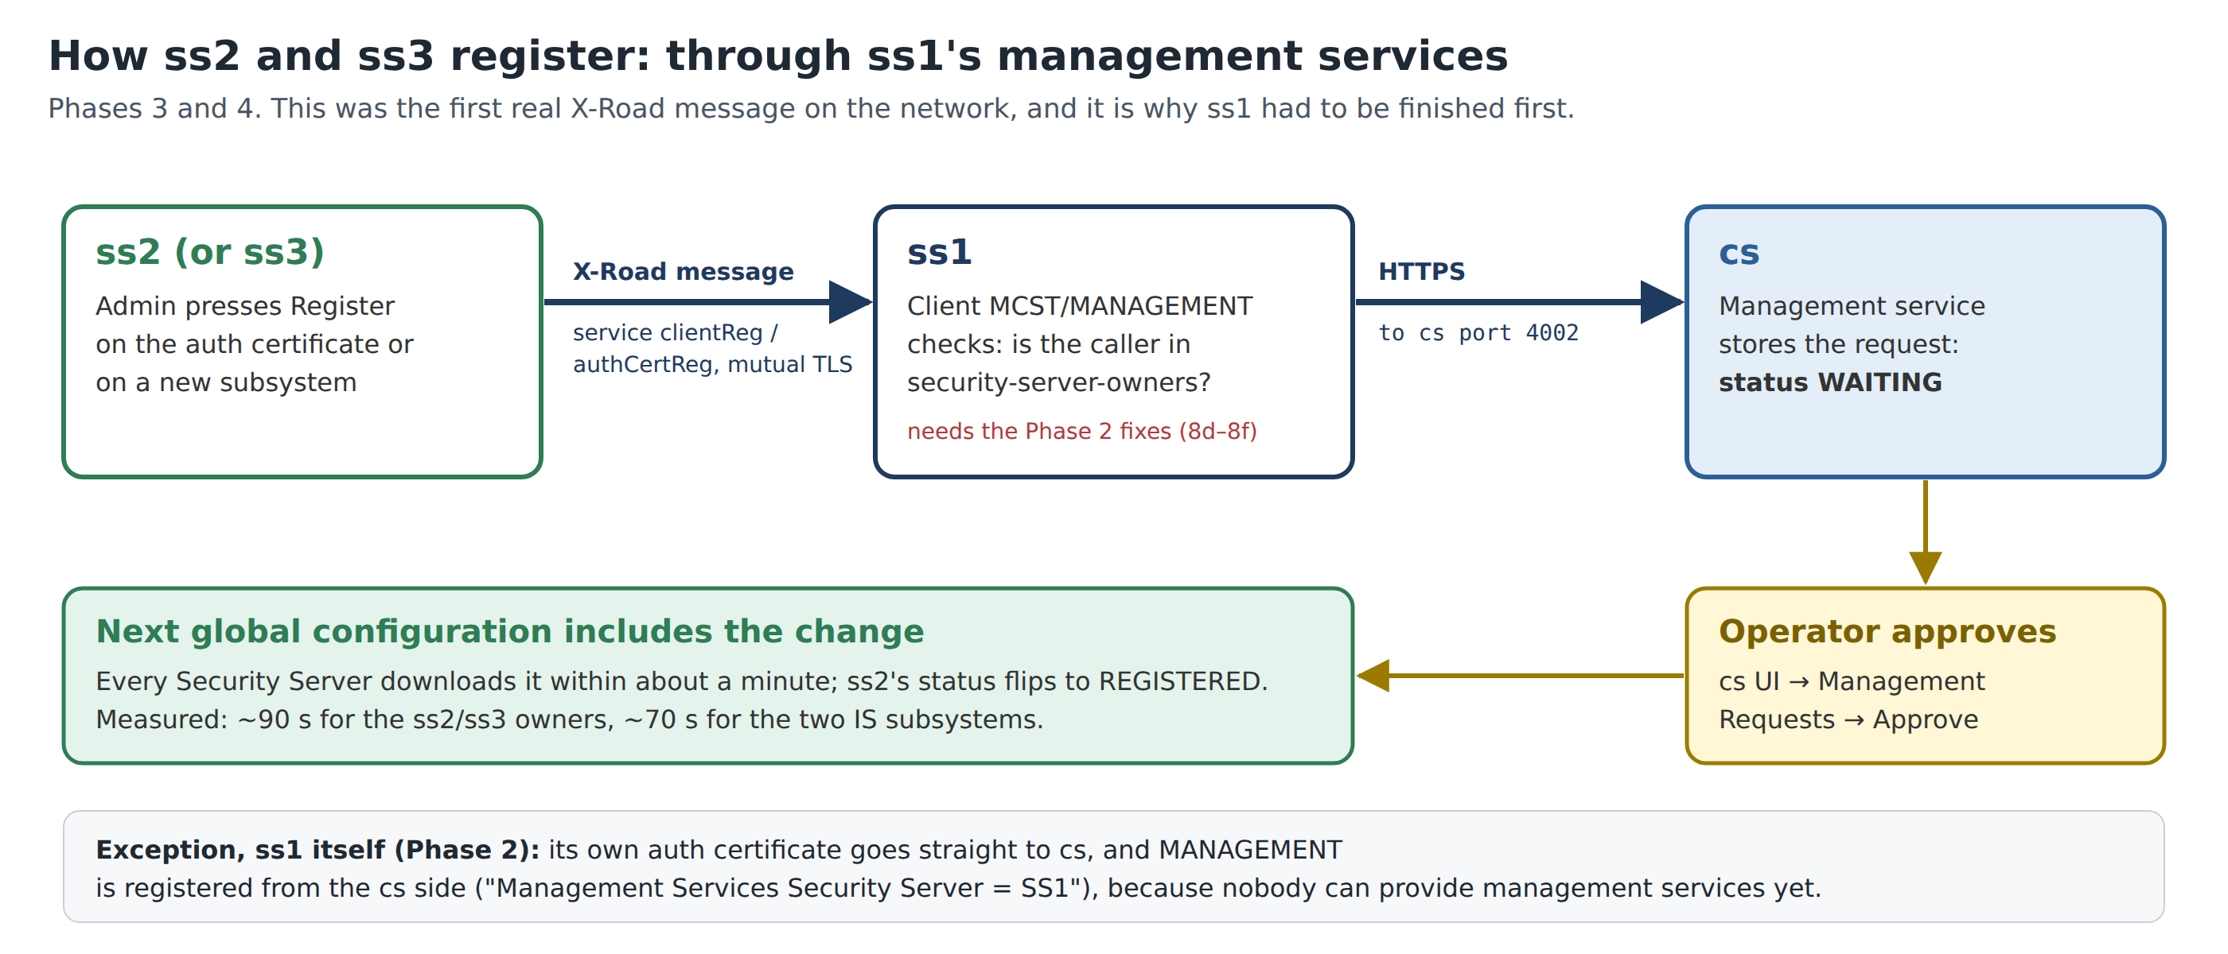
Figure 9. This time the registration request travels through ss1’s management services before it reaches cs.

8.1 The steps, for each server
- Initialise (step 2.1): upload the same anchor; owner and server code from the table; PIN 123456xrd!.
- Token (2.2): log in if asked.
- Time-stamping (2.3): Settings → System Parameters → Timestamping Services → Add → Test TSA.
- SIGNING key (2.4): label, Client, O and SAN from the table; CSR Format DER.
- AUTHENTICATION key (2.5): label, O, CN and SAN from the table; DER.
- Sign both at the test CA (2.6): Sign for the sign CSR, Auth for the auth CSR. Name the files per server.
- Import (2.7): AUTH certificate first → Activate; then the SIGN certificate.
- Register (2.8): on the AUTH certificate, address ss2 / ss3.
- Approve on cs (2.9): Management Requests → the request for SS2 / SS3 → Approve.
Why
The ministry names have no commas, so you can type them as they are. Unlike ss1’s request, these go ss2 → ss1 → cs: ss1 checks that MOSD belongs to security-server-owners and passes the request on. It is the first real X-Road message on your network.

If it goes wrong
Register fails with UnknownMember, AccessDenied or SslAuthenticationFailed: the problem is on ss1. Go back to Phase 2 steps 2.13 (service URL), 2.14 (TLS certificate) and 2.15 (access rights).
Request never appears on cs: check ss1 Diagnostics; make sure ss1’s MANAGEMENT is REGISTERED.

✓ Checkpoint 3
ss2 Clients: MOSD REGISTERED. ss3 Clients: MOHA REGISTERED (about 90 seconds after approval). Both servers’ certificates OCSP Good. cs Security Servers lists SS1, SS2 and SS3.

9. Phase 4: Register the information systems
Goal: put each ministry application on its Security Server: POPULATION-REGISTRY on ss3, GRANTS-PORTAL on ss2.

4.1 Add POPULATION-REGISTRY on ss3
Where: ss3 → Clients.
- On the MOHA owner row click Add subsystem.
- Select Subsystem → POPULATION-REGISTRY.
- Tick Register subsystem → Add subsystem.
You should now see
Client registration request sent successfully; status REGISTRATION IN PROGRESS.

4.2 Add GRANTS-PORTAL on ss2
Where: ss2 → Clients.
- On the MOSD owner row click Add subsystem.
- Select Subsystem → GRANTS-PORTAL.
- Tick Register subsystem → Add subsystem.
You should now see
Status REGISTRATION IN PROGRESS.

4.3 Approve both on the Central Server
Where: cs → Management Requests.
- Two pending client registration requests: for LS-DEV:GOV:MOHA:POPULATION-REGISTRY from SS3 and for LS-DEV:GOV:MOSD:GRANTS-PORTAL from SS2.
- Approve each.
- Wait 1–2 minutes and refresh ss2 and ss3.
You should now see
Both subsystems REGISTERED (about 70 seconds after approval).

Why
Global configuration now records which subsystem lives on which server. That is how ss2 will know to send requests for MOHA/POPULATION-REGISTRY to ss3.

4.4 Set GRANTS-PORTAL’s connection type to HTTP
Where: ss2 → Clients → GRANTS-PORTAL → tab Internal servers.
- Under Connection type choose HTTP.
- Save if asked.
You should now see
Connection type updated.

Why
The portal sends plain HTTP to http://ss2:8080. With the default HTTPS, ss2 would refuse it with SslAuthenticationFailed. Real deployments keep HTTPS and give ss2 the application’s TLS certificate.

✓ Checkpoint 4
ss2: MOSD:GRANTS-PORTAL REGISTERED, connection type HTTP. ss3: MOHA:POPULATION-REGISTRY REGISTERED.

10. Phase 5: Publish MOHA’s services
Tab: ss3 → Clients → POPULATION-REGISTRY. Goal: publish the REST and SOAP APIs and let only GRANTS-PORTAL call them.

5.1 Add the REST service
Where: Tab Services.
- Click Add REST.
- URL type: OpenAPI 3 Description.
- Type URL and Service Code below, click Add.
Field on screen | Type or choose
URL | http://moha-registry:8000/openapi.yaml
Service Code | population-api

You should now see
OpenApi3 service added. Expanded, it shows Service URL http://moha-registry:8000/api and, on its Endpoints tab, GET /citizens/* and GET /citizens/*/vital-status.

Why
ss3 reads the address from the spec’s servers: line and the endpoints from its paths. The URL works only from ss3: moha-registry exists only on MOHA’s internal network, which is the point.

5.2 Add the SOAP service
Where: Same tab.
- Click Add WSDL, type the URL, click Add.
Field on screen | Type or choose
URL | http://moha-registry:8000/soap/population.wsdl

You should now see
WSDL added; service verifyIdentity.v1 with URL http://moha-registry:8000/soap.

5.3 Enable both
- New descriptions show Out of order (disabled). Switch the toggle on for the REST row and for the WSDL row.
You should now see
Service description enabled twice.

5.4 Grant access to GRANTS-PORTAL
Where: Tab Service clients.
- Click Add subject.
- Member / Group: search GRANTS-PORTAL, select LS-DEV:GOV:MOSD:GRANTS-PORTAL, Next.
- Services: tick population-api and verifyIdentity, click Add Selected.
You should now see
Access rights added successfully. GRANTS-PORTAL listed; clicking it shows both services under Access Rights Given.

Why
The provider decides. MOHA chooses on its own ss3 who may call its data; MOSD cannot give itself access.

✓ Checkpoint 5
On ss3 both service descriptions are enabled, and GRANTS-PORTAL has access to population-api and verifyIdentity. Wait 1–2 minutes before Phase 6 so ss2 receives the new configuration.

11. Phase 6: Test everything in the browser
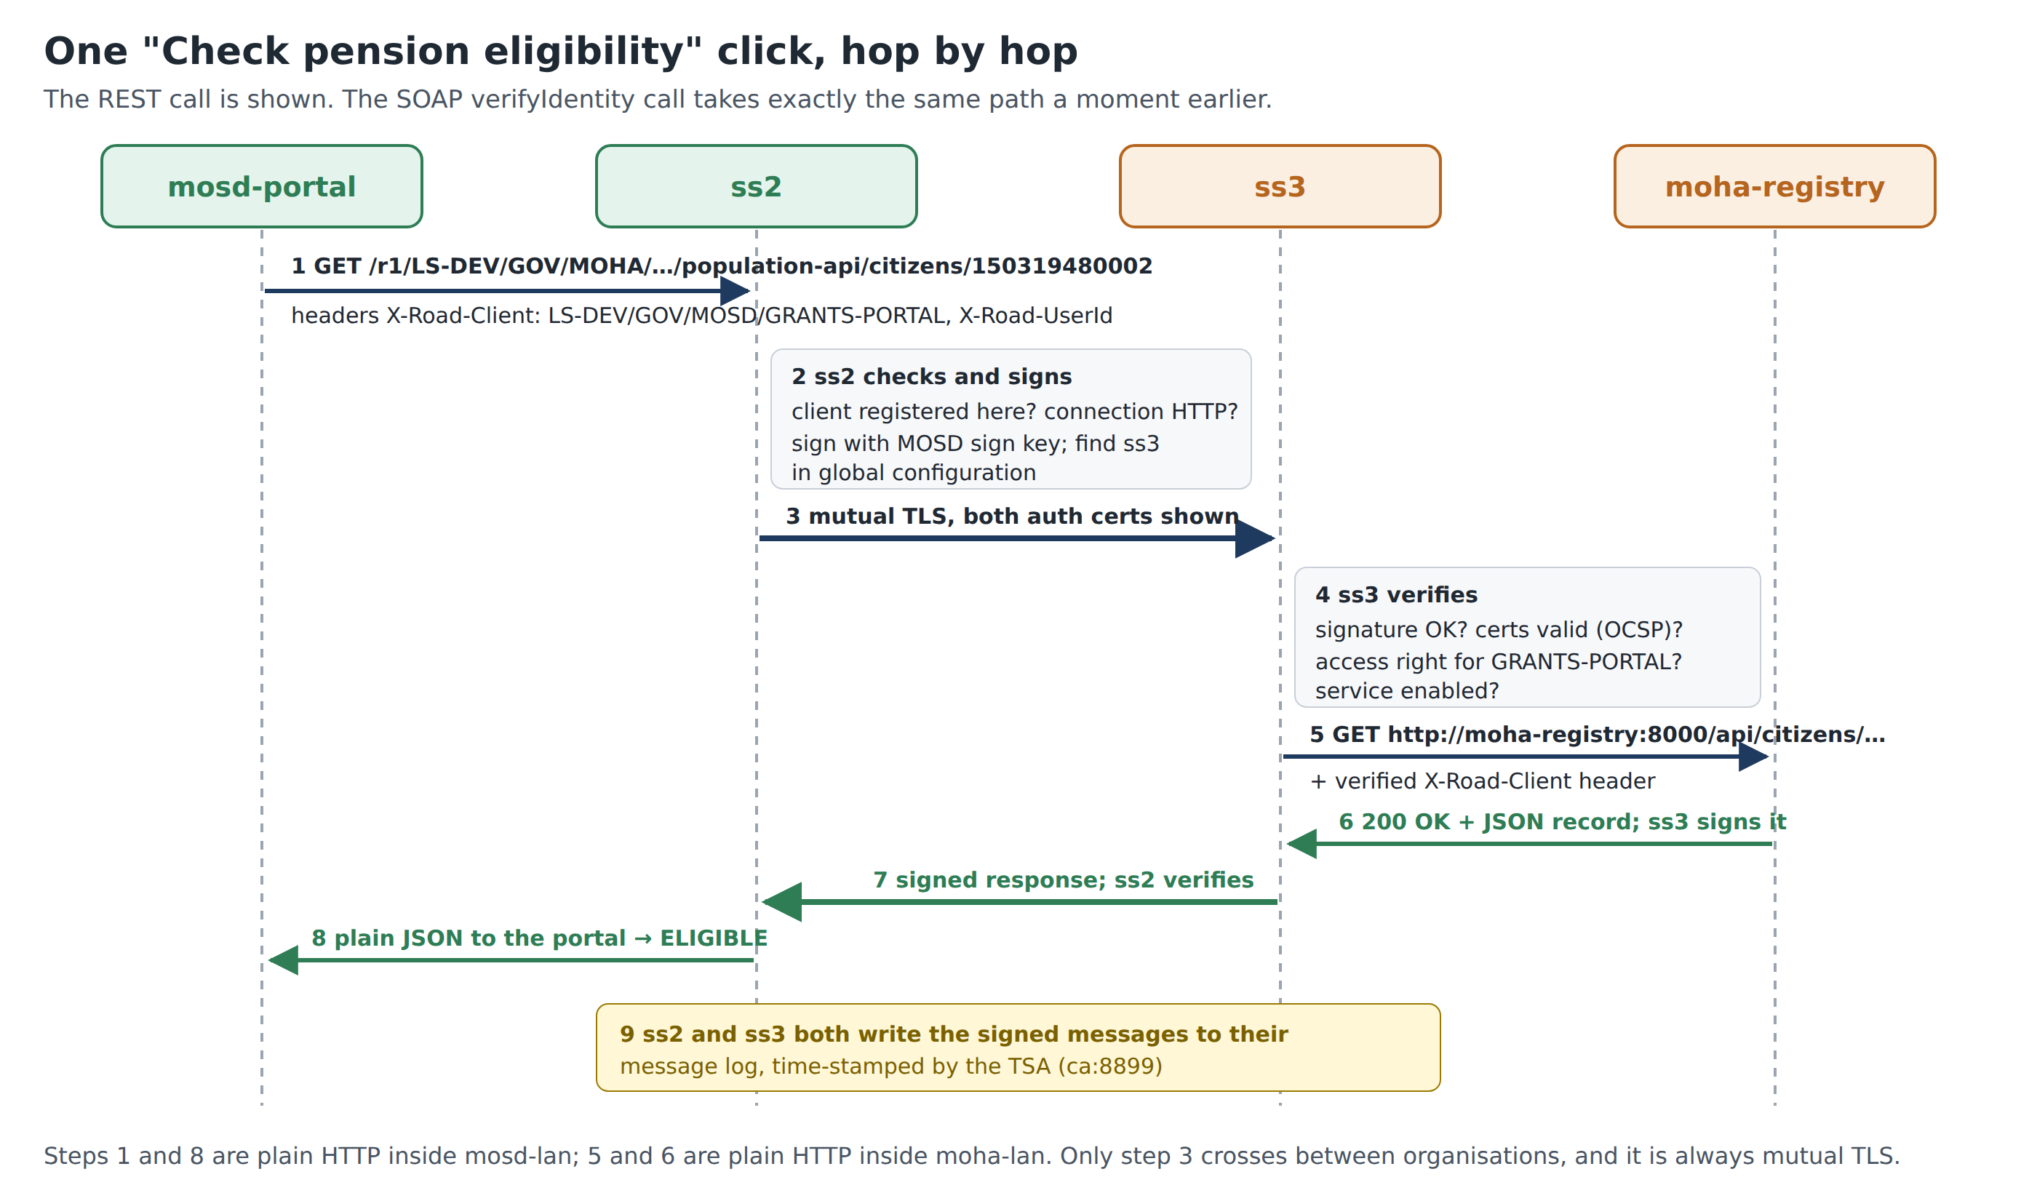
Figure 10. What happens on one click of “Check pension eligibility”.

11.1 The Grants Portal
Open http://localhost:8500 (Grants Portal · Old Age Pension intake). The Applicant form has National ID, Date of birth, First name, Surname and Officer (X-Road userId), and four buttons:
Button | X-Road calls it makes | Shows
Check pension eligibility | SOAP verifyIdentity + REST getCitizen | Decision ELIGIBLE / REJECT with reasons
Verify identity | SOAP verifyIdentity only | Match / no match, without revealing the record
Look up record | REST GET /citizens/{id} | The full citizen record
Vital status only | REST GET /citizens/{id}/vital-status | Alive or deceased only

- Open Sample applicants (synthetic data) and click Use next to Thabo Letsie. The form fills in.
- Click Check pension eligibility.
- Read the green result: Eligible for Old Age Pension with three ticks (identity matches, alive, age at least 70).
- Scroll to X-Road trace: two green entries, SOAP and REST, with status and time in ms. Click one to expand: Request (what the portal sent to ss2, including the X-Road-Client header), Response headers added by X-Road (e.g. X-Road-Id, X-Road-Request-Hash), Response body.
- Repeat with every sample applicant and compare with the table.
Applicant | Expected result | Why
Mpho Mokoena | ELIGIBLE
Thabo Letsie | ELIGIBLE
Lineo Ramakatane | REJECT | born 1990, too young
Teboho Mofokeng | REJECT | recorded as deceased
Unknown Person (999999999999) | REJECT, Not found | not in the register; the registry’s 404 passes through unchanged

11.2 The registry’s audit page (MOHA’s view)
Open http://localhost:8001/audit. Each pension check adds two rows. Columns: Time, API (REST/SOAP), Operation, National ID, X-Road client, User, Message ID, Outcome.
Why
The X-Road client LS-DEV/GOV/MOSD/GRANTS-PORTAL was added by ss3 after it verified ss2’s signature, so MOHA can trust it. User officer.ntsane comes from the form’s Officer field. MOHA can see exactly which ministry, system and officer asked about which citizen: that is the X-Road audit trail.

11.3 The Security Servers’ health
- ss2 → Diagnostics → Overview: Global configuration, Timestamping and OCSP responders all Everything ok.
- Same on ss3. Time-stamping turns green once messages have been logged, which your tests just did.
✓ Checkpoint 6
Thabo Letsie ELIGIBLE with two green traces; all five samples as in the table; the audit page shows the verified caller; Diagnostics green on ss2 and ss3. Your X-Road network works end to end.

Tip: Optional: the automated check
In a terminal, bash tests/smoke-test.sh runs seven checks, including that the portal cannot bypass X-Road. Expect 7 passed, 0 failed.

12. Part C: Break it to learn it
Each experiment changes one thing. Predict what will happen, try it, read the error in the portal (each failed trace shows the error and a Fix: hint), then undo it and confirm the portal works again. Changes on ss2/ss3 take effect within seconds; give global-configuration changes 1–2 minutes.

12.1 Take away access to the REST service
Predict first: which of the two calls in a pension check will fail?
Do it:
- ss3 → Clients → POPULATION-REGISTRY → tab Service clients → click GRANTS-PORTAL.
- Remove the access right for population-api only (keep verifyIdentity).
- Portal: Check pension eligibility for Thabo Letsie.
You should now see
The SOAP trace is green; the REST trace is red with AccessDenied and the hint “ss3 has not granted GRANTS-PORTAL access to this service…”.

What it teaches: access is granted per service, by the provider, and checked on the provider’s Security Server.
Undo:
- Same page → Add service → tick population-api → Add Selected.

12.2 Minimal disclosure: allow the vital-status endpoint only
Predict first: can the portal still see whether a person is alive? Can it see their record?
Do it:
- Remove population-api from GRANTS-PORTAL’s access rights (as in 12.1).
- ss3 → POPULATION-REGISTRY → Services → expand the REST description → click population-api → tab Endpoints.
- On GET /citizens/*/vital-status open its access rights → Add subjects → select GRANTS-PORTAL → Add Selected.
- Portal: Thabo Letsie → Vital status only, then Look up record.
You should now see
Vital status only works; Look up record fails with AccessDenied.

What it teaches: X-Road can grant access to a single endpoint, so a ministry shares only the data a purpose needs.
Undo:
- Remove the endpoint-level right and grant population-api again at service level (12.1 undo).

12.3 Switch off the SOAP service
Predict first: what does the caller see when a provider takes a service offline?
Do it:
- ss3 → POPULATION-REGISTRY → Services → switch the WSDL row’s toggle off.
- In Disable notice type e.g. Maintenance until 14:00 → OK.
- Portal: Verify identity.
You should now see
ServiceDisabled, with your notice text in the response.

What it teaches: a provider can take a service offline without deleting it, and tell callers why.
Undo:
- Switch the toggle back on.

12.4 The registry goes down
Predict first: which component will X-Road blame?
Do it:
- This one needs the terminal: docker compose stop moha-registry.
- Portal: Check pension eligibility.
You should now see
Both traces red with ServiceFailed or a network error from ss3 (the provider side).

What it teaches: X-Road error codes say where in the chain a failure happened: ClientProxy = consumer’s Security Server, ServerProxy = provider’s Security Server, ServiceFailed = the application behind it.
Undo:
- docker compose start moha-registry, wait a few seconds, test again.

12.5 Wrong connection type on the consumer side
Predict first: will the request even leave ss2?
Do it:
- ss2 → Clients → GRANTS-PORTAL → Internal servers → Connection type HTTPS.
- Portal: any button.
You should now see
SslAuthenticationFailed, hint “Connection type mismatch…”.

What it teaches: the connection type controls how an application must connect to its own Security Server; ss2 refuses before anything is sent.
Undo:
- Set Connection type back to HTTP.

12.6 Wrong surname
Predict first: does the portal learn the correct surname?
Do it:
- Portal: Use Thabo Letsie, change Surname to Letsi, click Check pension eligibility.
You should now see
SOAP answer match=false, mismatchedFields=surname; decision REJECT.

What it teaches: verification without disclosure: MOHA confirms or denies the details without revealing the true record.
Undo:
- Nothing to undo: click Use again.

13. Part D: When things go wrong

13.1 A method that works
- Read the status or error code. It usually names the component: ClientProxy = ss2, ServerProxy = ss3, ServiceFailed = the registry.
- Check Diagnostics on the server involved: global configuration, OCSP and time-stamping should be Everything ok.
- Check Management Requests on cs: is something still pending?
- Wait two minutes after any change on cs: Security Servers only see it in the next global configuration.
- Change one thing at a time, then test again.

13.2 Symptoms and fixes
What you see | Likely cause | Fix
Logged out whenever you switch tabs | Using localhost for several admin pages | Use the .lab addresses (section 3.2)
Page will not load | Server still starting or stopped | Wait 3–5 min; docker compose ps
Owner name does not fill in (init) | Member not on cs, or configuration not yet published | Check cs Members; wait 1–2 min
Signer.InternalError on Generate CSR | Comma in Organization Name (O) | Remove the comma; delete the half-made key
Test CA returns an error | CSR in PEM format | New key with CSR Format DER
Imported certificate does not attach to a key | Certificate is from another server’s CSR | Import the right file (use the naming in 3.5)
AUTH certificate stuck in Registration in progress | Not approved on cs, or ss1’s management services not working | Approve on cs; check Phase 2 steps 2.13–2.15
UnknownMember … clientReg on ss1 | Expected the first time (step 2.10) | Step 2.11
UnknownMember / AccessDenied / SslAuthenticationFailed when ss2/ss3 register | ss1 management services incomplete | Steps 2.13, 2.14, 2.15
“certificate is not yet valid”, OCSP or time-stamp errors | Laptop clock wrong (e.g. after Windows) | Wait for NTP sync; timedatectl status
UnknownService right after Phase 5 | Configuration not yet on ss2 | Wait 1–2 minutes
Portal: “Could not reach consumer Security Server” | ss2 stopped or not initialised | docker compose ps; ss2 admin page
ss3 cannot add the OpenAPI/WSDL | moha-registry not running | docker compose ps; docker compose start moha-registry

13.3 Daily routine
When | Do
Start of a session | Terminal: docker compose start, wait 3–5 minutes, check timedatectl status. Browser: open your bookmarked tabs, log in, glance at Diagnostics on each Security Server.
End of a session | Terminal: docker compose stop. All configuration is kept.
Never | docker compose down -v: it deletes every volume, i.e. everything in this guide.

13.4 Housekeeping
- API keys: keys created for scripted work can be revoked on cs under Settings → API Keys, and on each Security Server under Keys and certificates → tab API Keys.
- Anchor file: keep configuration_anchor_LS-DEV.xml; you need it again only if a Security Server is rebuilt.

14. Progress checklist
Print this page and tick each box as you go.

Getting ready
☐ Preflight passes; host names set; 7 containers Up
☐ Certificates fetched into certs/
☐ Seven tabs open and bookmarked; certificate warnings accepted

Phase 1 — Central Server
☐ 1.1 Initialised (LS-DEV, cs)
☐ 1.2 Member class GOV
☐ 1.3 Test CA + OCSP http://ca:8888
☐ 1.4 TSA http://ca:8899
☐ 1.5 MCST, MOSD, MOHA + subsystems
☐ 1.6 Management services provider MCST:MANAGEMENT
☐ 1.7 Internal and external signing keys
☐ 1.8 Anchor downloaded; no red banners

Phase 2 — ss1
☐ 2.1–2.3 Initialised, token, TSA
☐ 2.4–2.6 SIGN and AUTH CSRs signed
☐ 2.7–2.9 Imported, activated, registered, approved: MCST REGISTERED
☐ 2.10–2.11 MANAGEMENT REGISTERED
☐ 2.12–2.15 WSDL, service URL, TLS certificate, access rights

Phase 3 — ss2 and ss3
☐ ss2: MOSD REGISTERED
☐ ss3: MOHA REGISTERED

Phases 4 to 6
☐ GRANTS-PORTAL and POPULATION-REGISTRY REGISTERED; connection type HTTP
☐ REST and SOAP services enabled; GRANTS-PORTAL has access
☐ Portal results correct for all five samples
☐ Audit page shows the verified caller; Diagnostics green

Part C
☐ 12.1 Access denied
☐ 12.2 Endpoint-only access
☐ 12.3 Service disabled
☐ 12.4 Registry down
☐ 12.5 Connection type
☐ 12.6 Wrong surname

15. Quick reference and glossary

15.1 Addresses
What | Address | Login
Central Server | https://cs.lab:4000 | xrd / secret
ss1 · ss2 · ss3 | https://ss1.lab:1000 · https://ss2.lab:2000 · https://ss3.lab:3000 | xrd / secret
Test CA signing page | http://localhost:8888/testca/ | —
Grants Portal | http://localhost:8500 | —
Registry audit page | http://localhost:8001/audit | —

15.2 URLs you type into the admin pages
Typed where | URL
cs: OCSP responder (1.3) | http://ca:8888
cs: time-stamping service (1.4) | http://ca:8899
ss1: management services WSDL (2.12) | http://cs/managementservices.wsdl
ss1: management service URL (2.13) | https://cs:4002/managementservice/manage/
ss3: REST service description (5.1) | http://moha-registry:8000/openapi.yaml
ss3: WSDL (5.2) | http://moha-registry:8000/soap/population.wsdl

These names (ca, cs, moha-registry) exist only inside Docker. They are used by the servers, not by your browser, so they will not open in a tab.

15.3 Glossary
Term | Meaning
Anchor | File with the Central Server’s configuration address and the key that verifies it.
AUTH certificate | Proves which Security Server you are talking to.
SIGN certificate | Proves which organisation sent a message.
CSR | Certificate Signing Request: what you send to a CA to get a certificate.
DER / PEM | Binary and text formats of the same certificate data.
Global configuration | The signed list of members, servers, CAs and services every Security Server downloads each minute.
Management services | Services on MCST/MANAGEMENT (hosted by ss1) that carry registration requests to cs.
OCSP | Online check that a certificate is still valid.
Subsystem | One application of a member; access rights are given to subsystems.
Token | The protected key store on each server, unlocked with the PIN.
TSA | Time-Stamping Authority: signs the time on the message logs.

