X-Road Lab Report
MOSD ↔ MOHA Identity Exchange over X-Road 7.7.0
4 October 2026 · Motlatsi Victor Mpahane · Local Docker Compose lab, instance LS-DEV

1. Summary
On 4 October 2026 I rebuilt a local X-Road 7.7.0 test network and got the Ministry of Social Development (MOSD) Grants Portal fetching citizen data from the Ministry of Home Affairs (MOHA) Population Registry, entirely over X-Road. All three test calls (REST record lookup, REST vital status, SOAP identity check) returned HTTP 200, and the MOHA audit log recorded each one with the verified X-Road client LS-DEV/GOV/MOSD/GRANTS-PORTAL.
The network has one Central Server (cs), three Security Servers (ss1 for MCST management services, ss2 for MOSD, ss3 for MOHA), a test CA with OCSP and time-stamping, and the two ministry information systems. Each information system can reach only its own Security Server, so every request had to pass through ss2 → ss3.

2. Environment and identifiers
Instance LS-DEV, member class GOV, X-Road 7.7.0 in Docker Compose on Ubuntu, all ports bound to 127.0.0.1.
Component | Owner | Identifier | Admin / URL
Central Server (cs) | X-Road operator | LS-DEV | https://cs.lab:4000
ss1 | Ministry of Communications, Science and Technology | LS-DEV:GOV:MCST:SS1 | https://ss1.lab:1000
ss2 | Ministry of Social Development | LS-DEV:GOV:MOSD:SS2 | https://ss2.lab:2000
ss3 | Ministry of Home Affairs | LS-DEV:GOV:MOHA:SS3 | https://ss3.lab:3000
Management services | MCST | LS-DEV:GOV:MCST:MANAGEMENT | hosted on ss1
Grants Portal (consumer IS) | MOSD | LS-DEV:GOV:MOSD:GRANTS-PORTAL | http://localhost:8500
Population Registry (provider IS) | MOHA | LS-DEV:GOV:MOHA:POPULATION-REGISTRY | http://localhost:8001/audit
Test CA, OCSP, TSA | — | Test CA | http://ca:8888 (OCSP), http://ca:8899 (TSA)

The Population Registry has no user screens; its audit page is the only browser view, by design.

3. Architecture
Three diagrams describe the lab: where each container runs and how the networks separate them (Diagram 1), what happens on one eligibility check (Diagram 2), and how a Security Server joins the network through ss1 (Diagram 3). The full docker-compose.yml is in Appendix A.
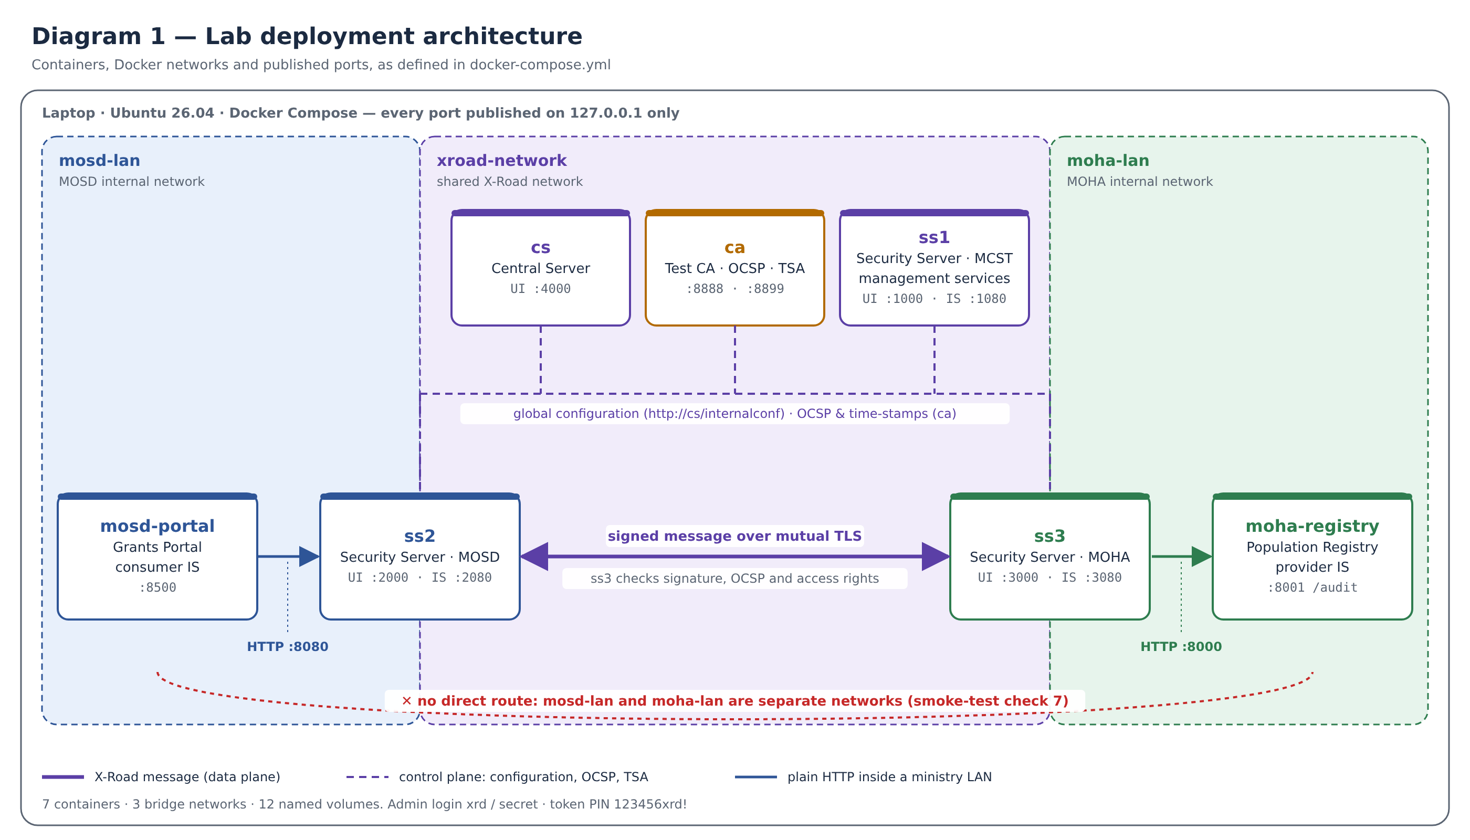
Diagram 1. Lab deployment architecture: 7 containers on 3 Docker networks. The portal can reach the registry only through ss2 and ss3.
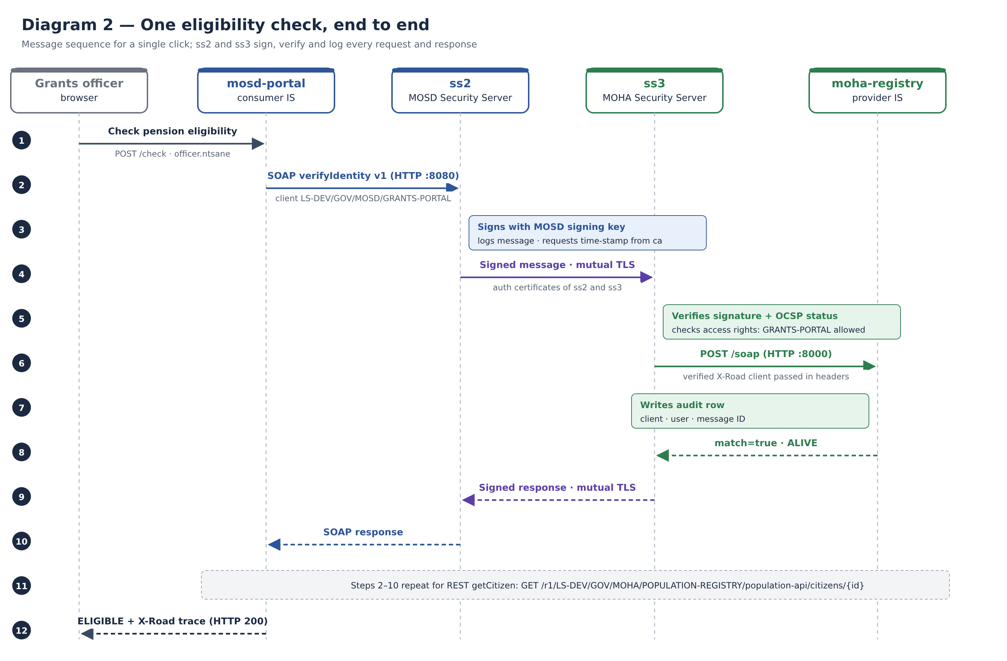
Diagram 2. Message sequence for one eligibility check: signed and verified on both Security Servers, logged at the registry.
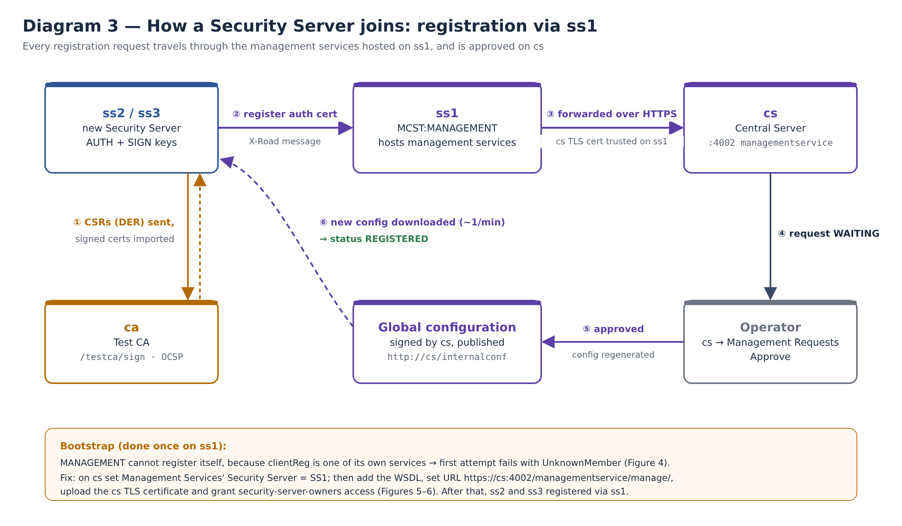
Diagram 3. Registration flow: requests from ss2 and ss3 travel through the management services on ss1 and are approved on cs.

4. Work done
All six phases of the lab guide were completed, in this order.
- Central Server. Initialised cs with instance LS-DEV and address cs. Added member class GOV, the Test CA with its OCSP responder, and the Test TSA. Added members MCST, MOSD and MOHA, each with one subsystem. Set the management service provider to MCST:MANAGEMENT, added internal and external signing keys, and downloaded the configuration anchor.
- ss1 (management Security Server). Initialised with owner GOV:MCST, server code SS1. Added the TSA, generated SIGN and AUTH keys and CSRs (DER), signed them at the Test CA, imported and activated the certificates, and registered the AUTH certificate. Registered MANAGEMENT by setting SS1 as the Management Services' Security Server on cs. Added the management WSDL, set the service URL https://cs:4002/managementservice/manage/, installed the cs TLS certificate, and gave security-server-owners access to all management services.
- ss2 (MOSD) and ss3 (MOHA). Repeated initialisation, keys, CSRs, certificate import and AUTH registration with owners GOV:MOSD and GOV:MOHA; approved both on cs.
- IS subsystems. Registered POPULATION-REGISTRY on ss3 and GRANTS-PORTAL on ss2; approved both on cs.
- MOHA services on ss3. Added REST population-api from http://moha-registry:8000/openapi.yaml and SOAP verifyIdentity v1 from the WSDL. Enabled both and granted access to LS-DEV:GOV:MOSD:GRANTS-PORTAL.
- Testing. Ran the three calls from the Grants Portal and confirmed them on the MOHA audit page.

5. Management requests on cs
All six registration requests were approved; cs now lists SS1, SS2 and SS3.
Id | Created | Type | Server | Status
6 | 2026-10-04 20:51 | Client registration (GRANTS-PORTAL) | LS-DEV:GOV:MOSD:SS2 | Approved
5 | 2026-10-04 20:50 | Client registration (POPULATION-REGISTRY) | LS-DEV:GOV:MOHA:SS3 | Approved
4 | 2026-10-04 20:44 | Auth certificate registration | LS-DEV:GOV:MOHA:SS3 | Approved
3 | 2026-10-04 20:31 | Auth certificate registration | LS-DEV:GOV:MOSD:SS2 | Approved
2 | 2026-10-04 20:05 | Client registration (MANAGEMENT) | LS-DEV:GOV:MCST:SS1 | Approved
1 | 2026-10-04 12:20 | Auth certificate registration | LS-DEV:GOV:MCST:SS1 | Approved

6. Test results
Test applicant: Mpho Mokoena, national ID 010119550001, born 1955-01-01 (synthetic data); officer officer.ntsane.
Call | API | Result in portal | HTTP | Time | Message ID
verifyIdentity v1 | SOAP | Found: yes; details match: yes; ALIVE | 200 | 159 ms | c968d4a9-fea3-484b-8318-a0f333fa2591
getVitalStatus | REST | ALIVE (minimal disclosure) | 200 | 187 ms | LS-DEV-23bcc6fd-07f5-4b84-9629-686b327ed6…
getCitizen | REST | Full record: F, Maseru · Ha Thetsane, LS, ALIVE | 200 | 594 ms | LS-DEV-91a9d6c8-48b2-4ce8-a100-0f0ea2d341b0

The MOHA audit page logged all three calls (19:10–19:12) with X-Road client LS-DEV/GOV/MOSD/GRANTS-PORTAL. That client ID comes from the message ss2 signed and ss3 verified, so the registry can trust who is asking without its own login.

7. Problems and fixes
What I saw | Cause | Fix
ss1: Signer.InternalError, MCST:MANAGEMENT has no suitable certificates (Figure 1) | MANAGEMENT registered before the owner's certificates were in place | Finished owner registration, then retried
ss1: ClientProxy.UnknownMember on MANAGEMENT/clientReg (Figure 4) | Expected: MANAGEMENT cannot register through services not yet hosted | Set Management Services' Security Server to SS1 on cs
CSR fails with Signer.InternalError | Comma in Organization Name | Removed the comma
cs: configuration signing / generation fails | Signing keys or management provider missing | Added both keys; set provider MCST:MANAGEMENT
ss1: TSA Add greyed out | Test CA / TSA not yet on cs | Added on cs, waited 2 min, refreshed

8. Still to do
- Run Check pension eligibility for every sample applicant.
- Run bash tests/smoke-test.sh (7 checks).
- Confirm OCSP Good and time-stamping green on ss1–ss3.
- Run the failure experiments (remove access rights, disable WSDL, stop moha-registry).

9. Evidence: screenshots in order
The 17 screenshots below, taken between 19:36 and 21:13 on 4 October 2026, follow the build from ss1 management services through to the end-to-end test.

Phase 2 — ss1 and management services
Figure 1. ss1: first MANAGEMENT registration attempt fails (Signer.InternalError, no suitable certificates), before the owner certificates were ready.
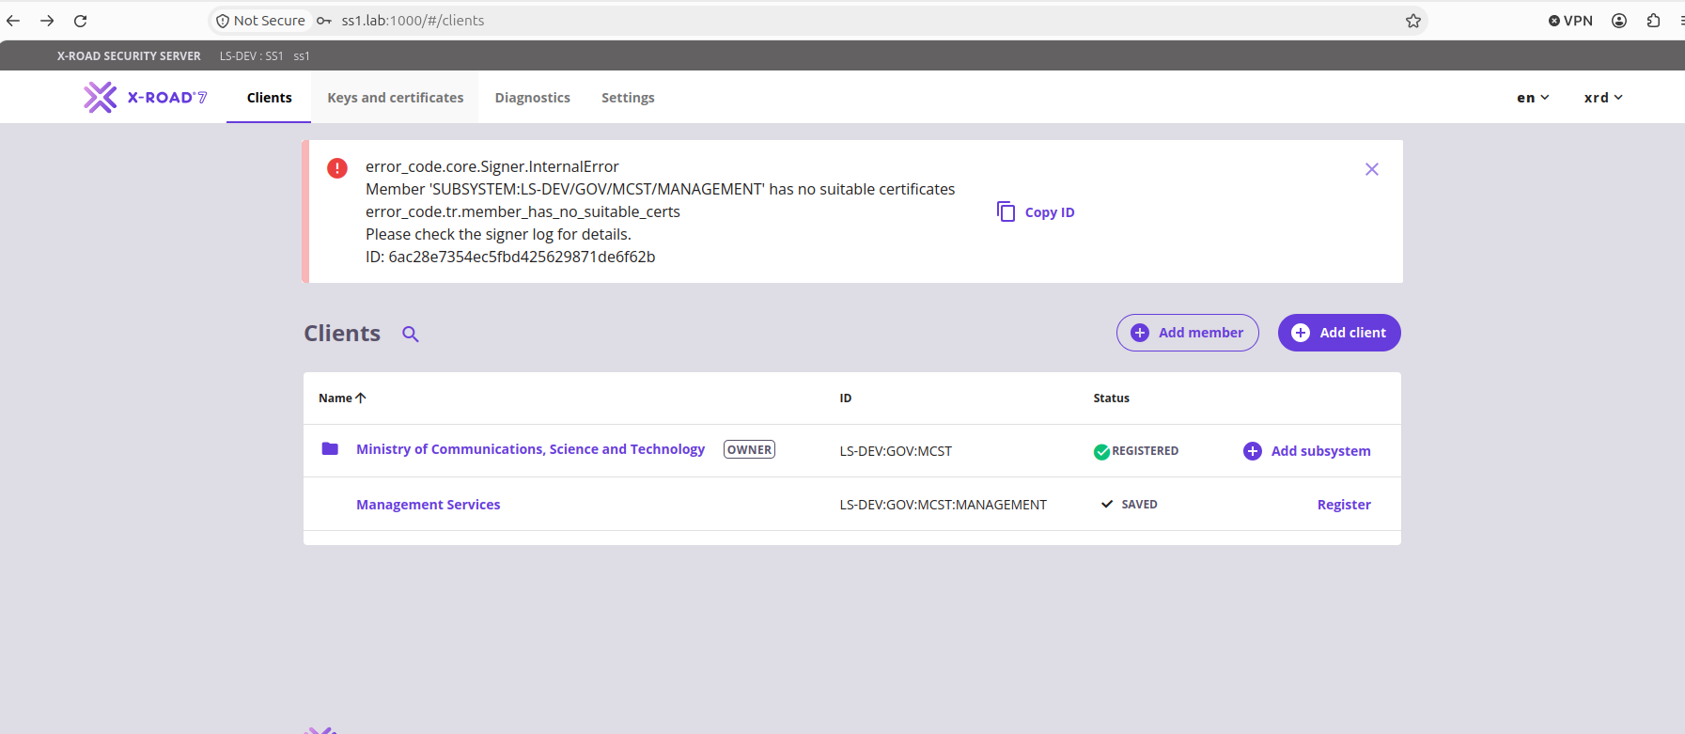
Figure 2. ss1: SIGN and AUTH certificates imported and REGISTERED.
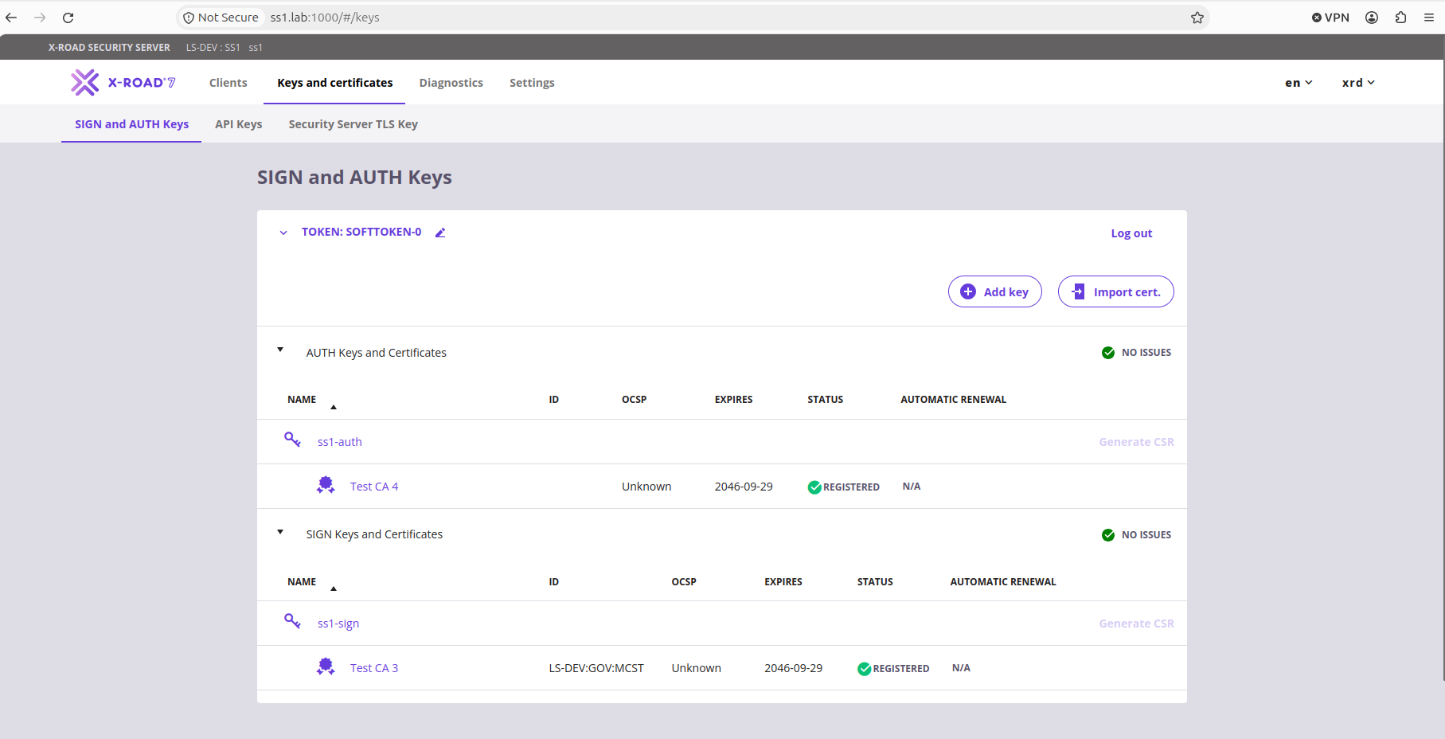
Figure 3. ss1 Diagnostics: global configuration "Everything ok"; time-stamping and OCSP waiting for their first request.
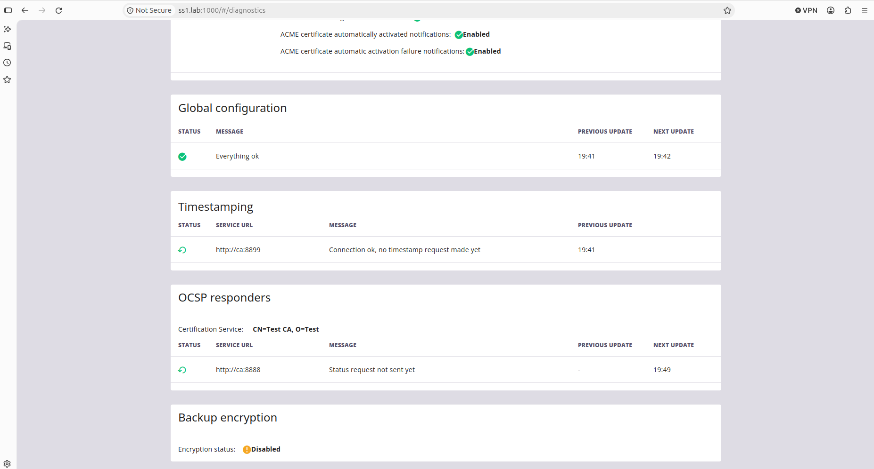
Figure 4. ss1: expected ClientProxy.UnknownMember on MANAGEMENT clientReg, because the management services were not yet hosted.
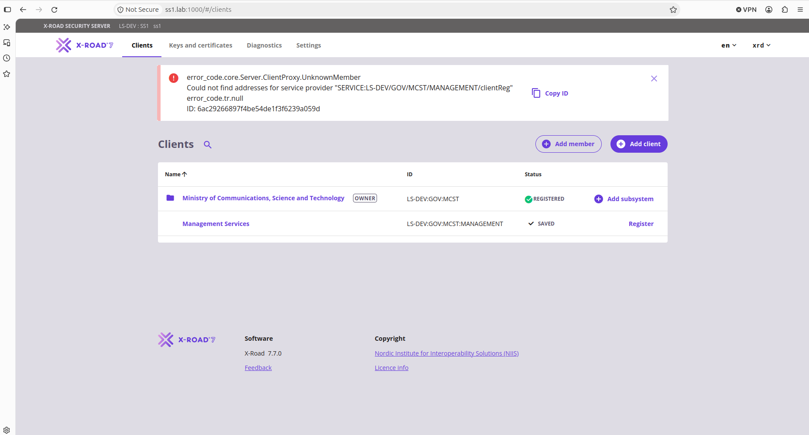
Figure 5. cs: Management Services settings. Provider is MCST:MANAGEMENT; the Management Services' Security Server was then set to SS1.
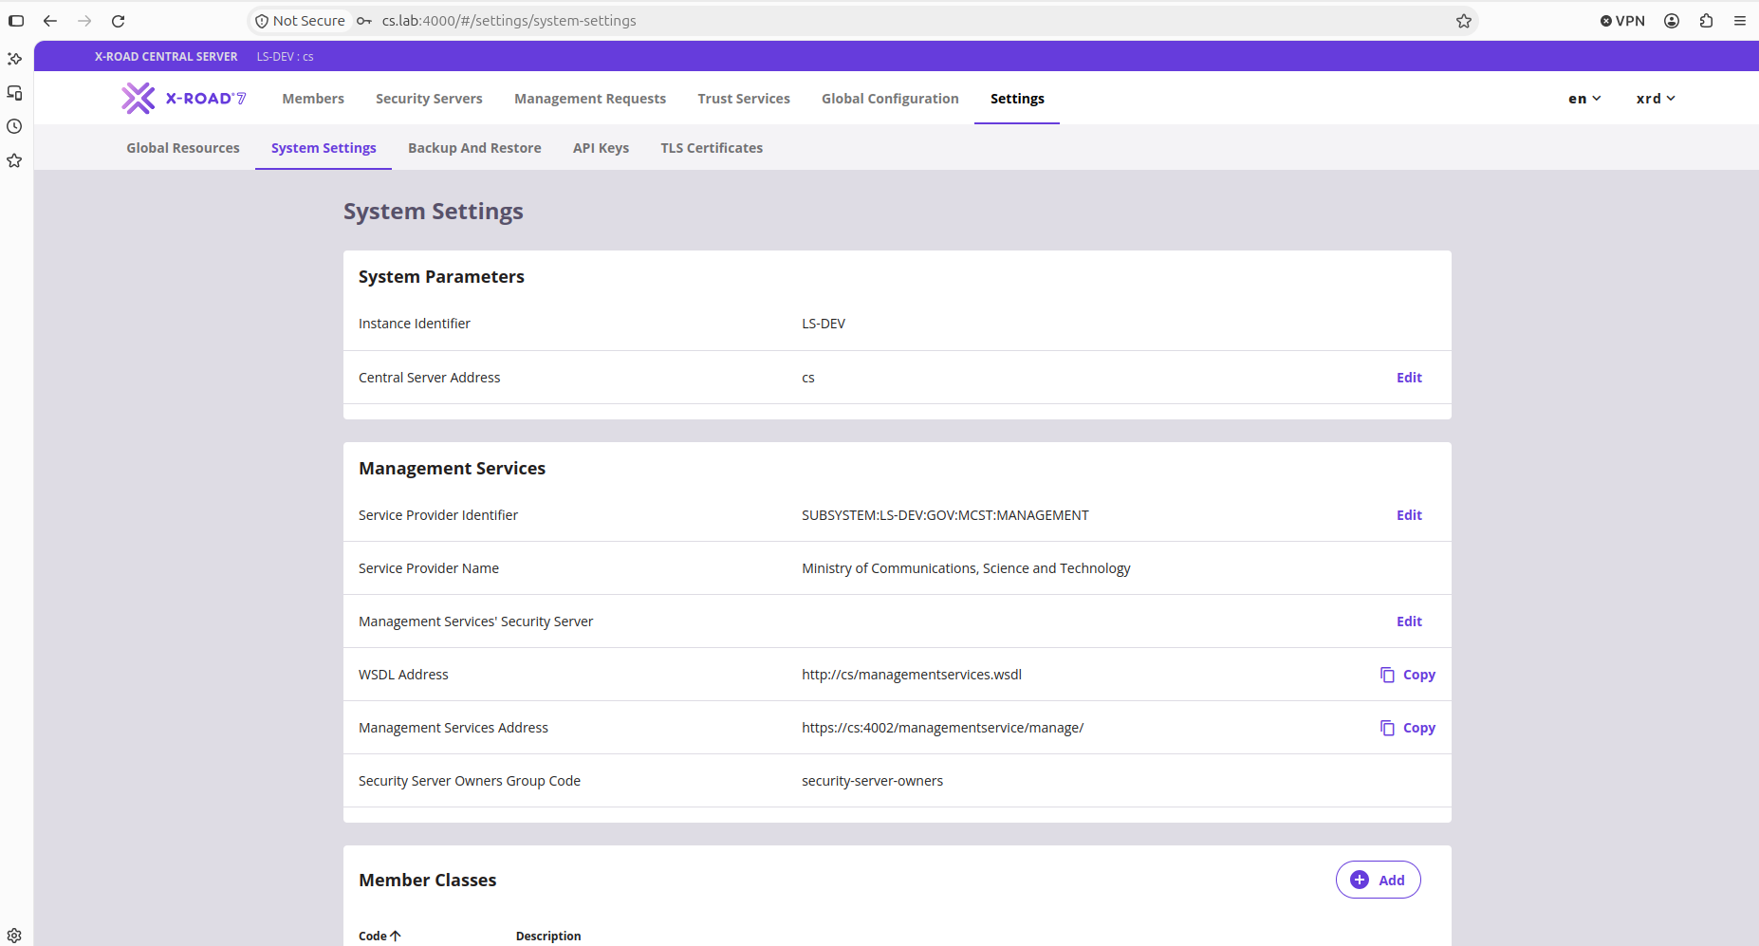
Figure 6. ss1: security-server-owners given access to the management services.
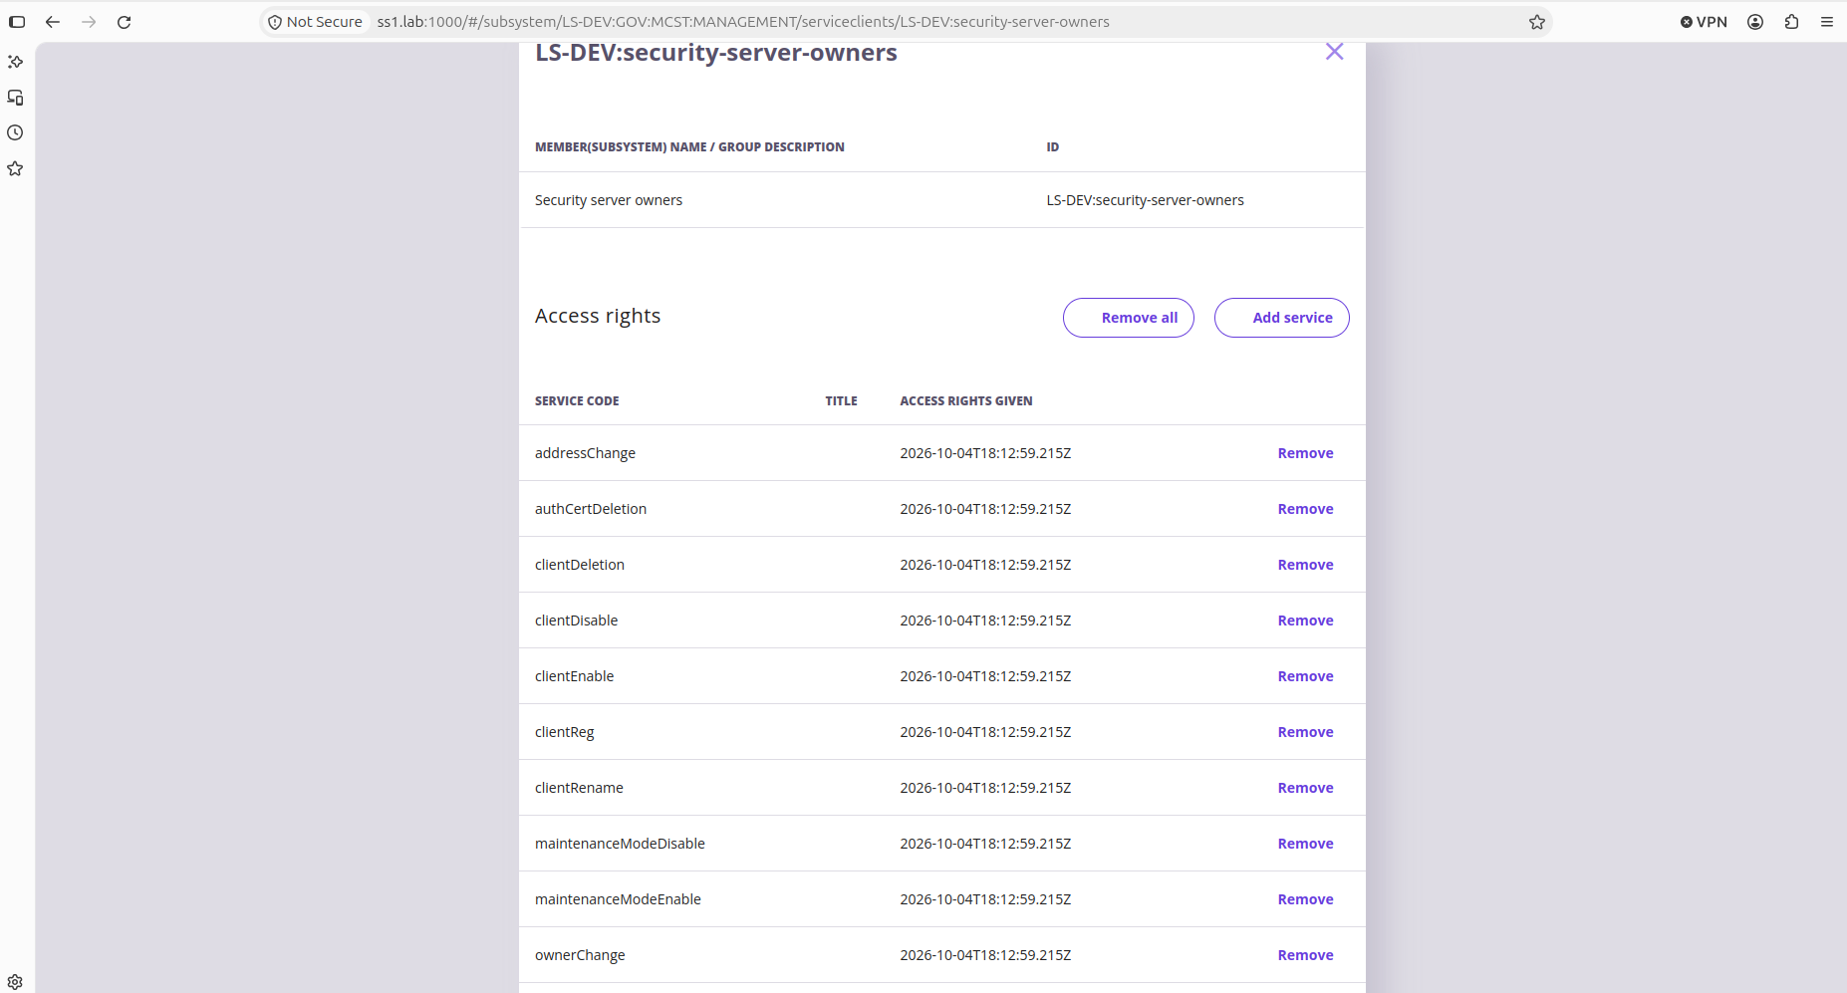

Phase 3 — ss2 and ss3
Figure 7. cs: SS1, SS2 and SS3 all registered.
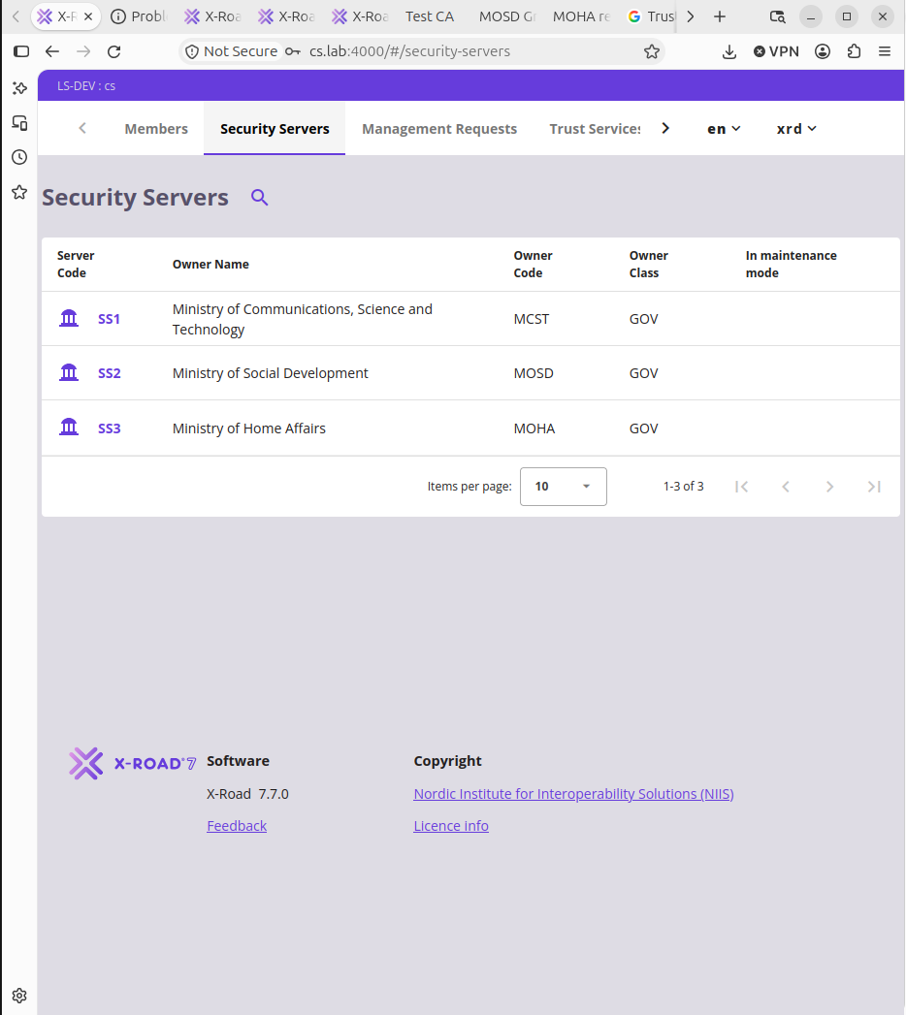

Phase 4 — IS subsystems
Figure 8. ss3: adding the POPULATION-REGISTRY subsystem with Register ticked.
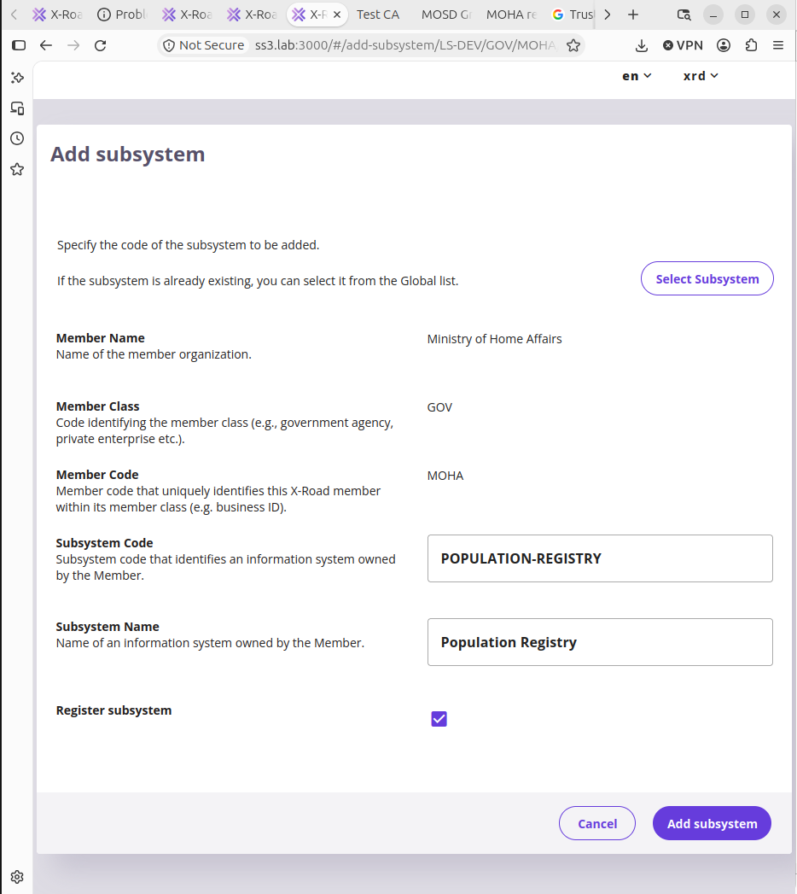
Figure 9. cs: all six management requests APPROVED.
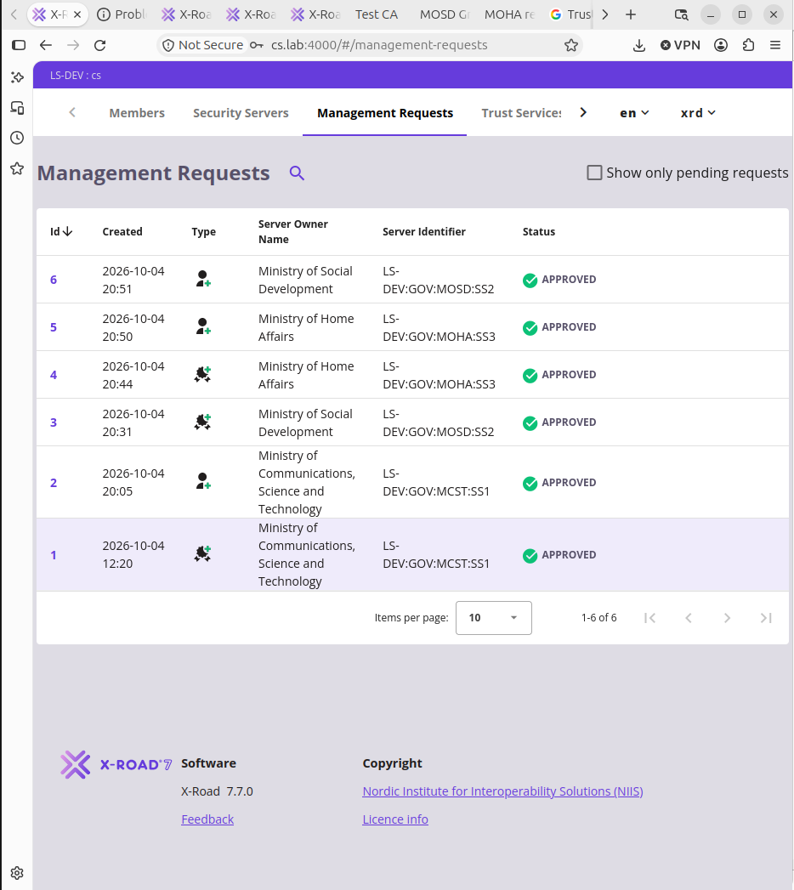
Figure 10. ss3: Population Registry "Registration in progress".
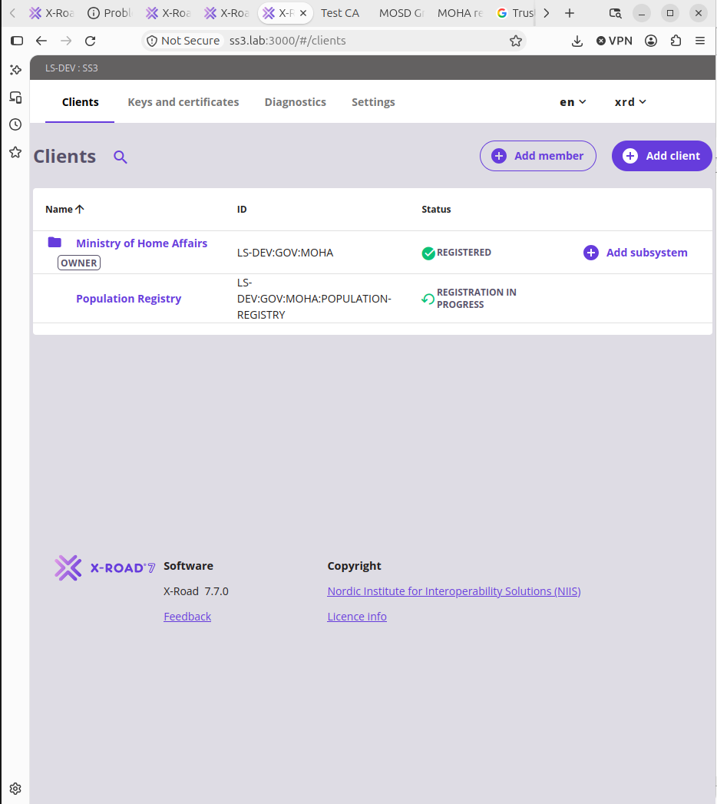
Figure 11. ss3: Population Registry REGISTERED.
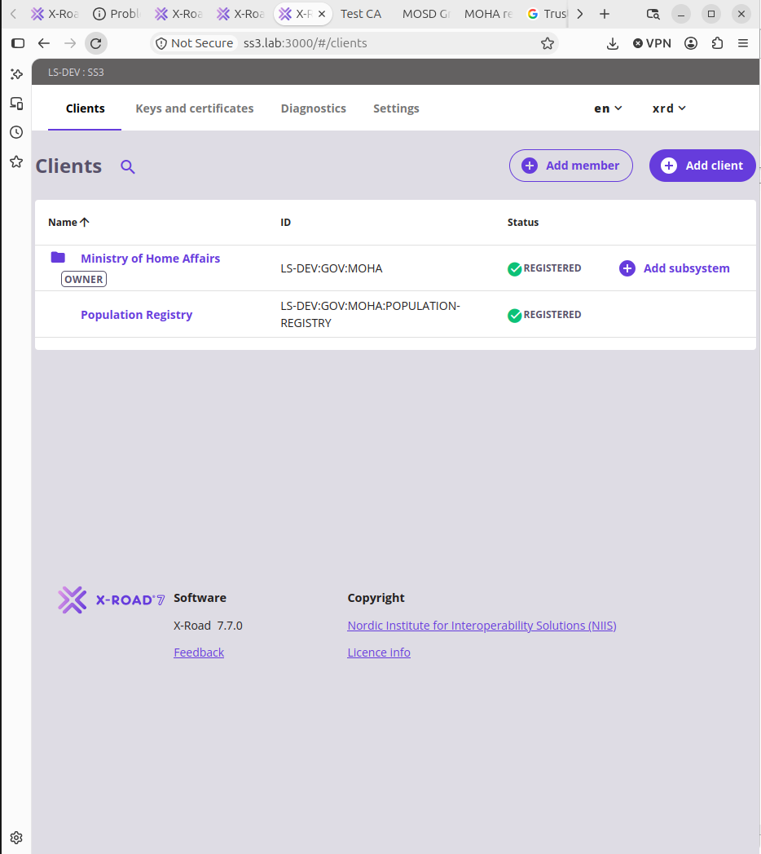

Phase 5 — MOHA services
Figure 12. ss3: adding the REST service population-api from the OpenAPI 3 description.
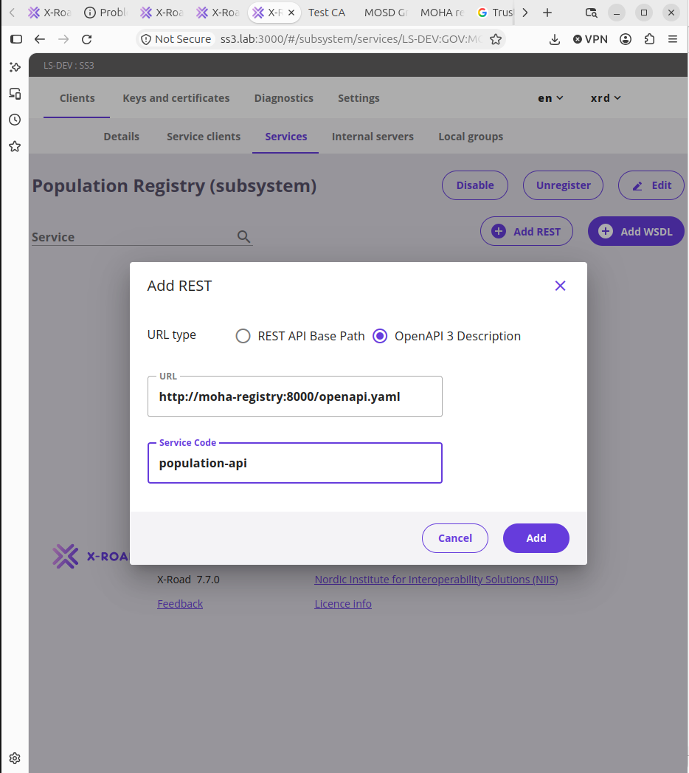
Figure 13. ss3: granting access to LS-DEV:GOV:MOSD:GRANTS-PORTAL.
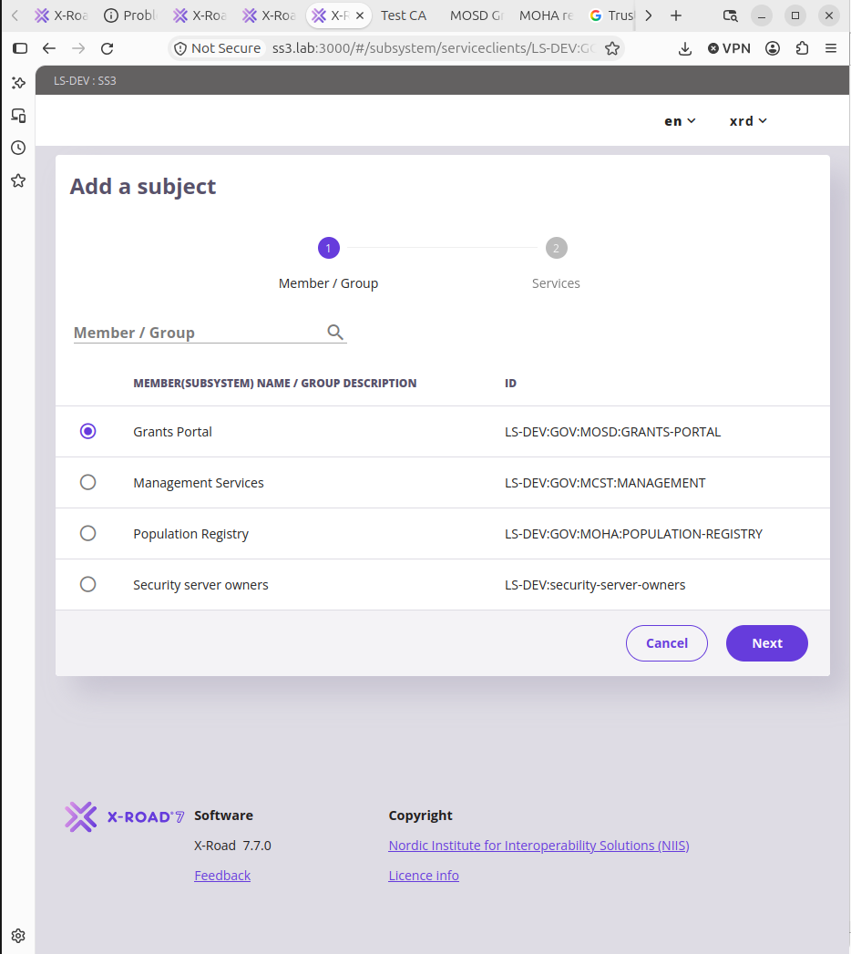

Phase 6 — End-to-end test
Figure 14. Grants Portal: REST getCitizen, HTTP 200 in 594 ms.
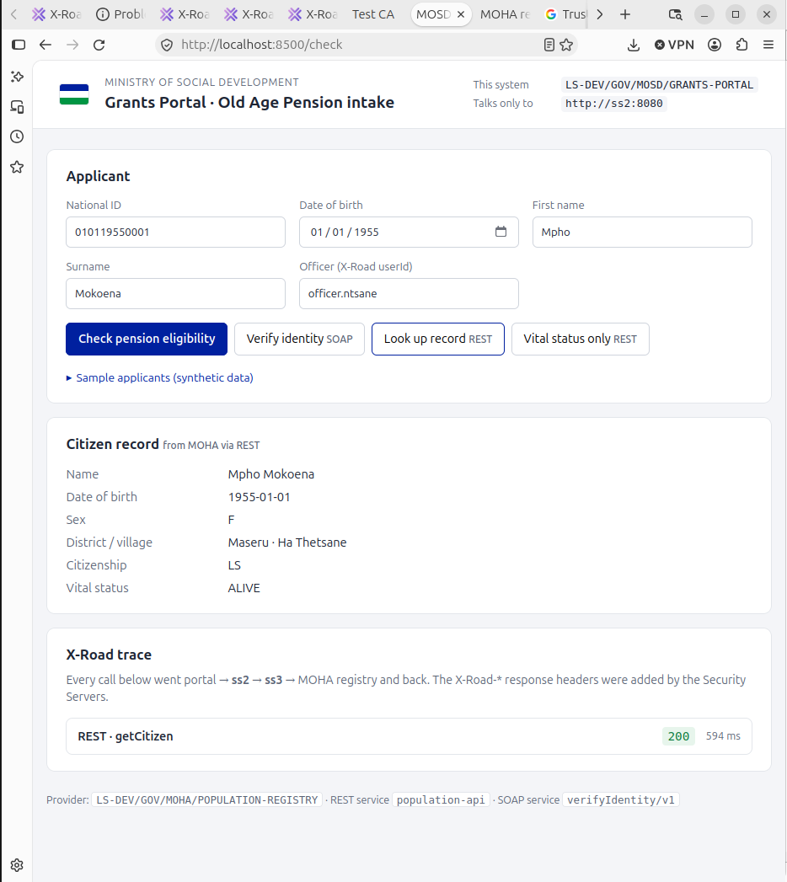
Figure 15. Grants Portal: REST getVitalStatus, HTTP 200 in 187 ms.
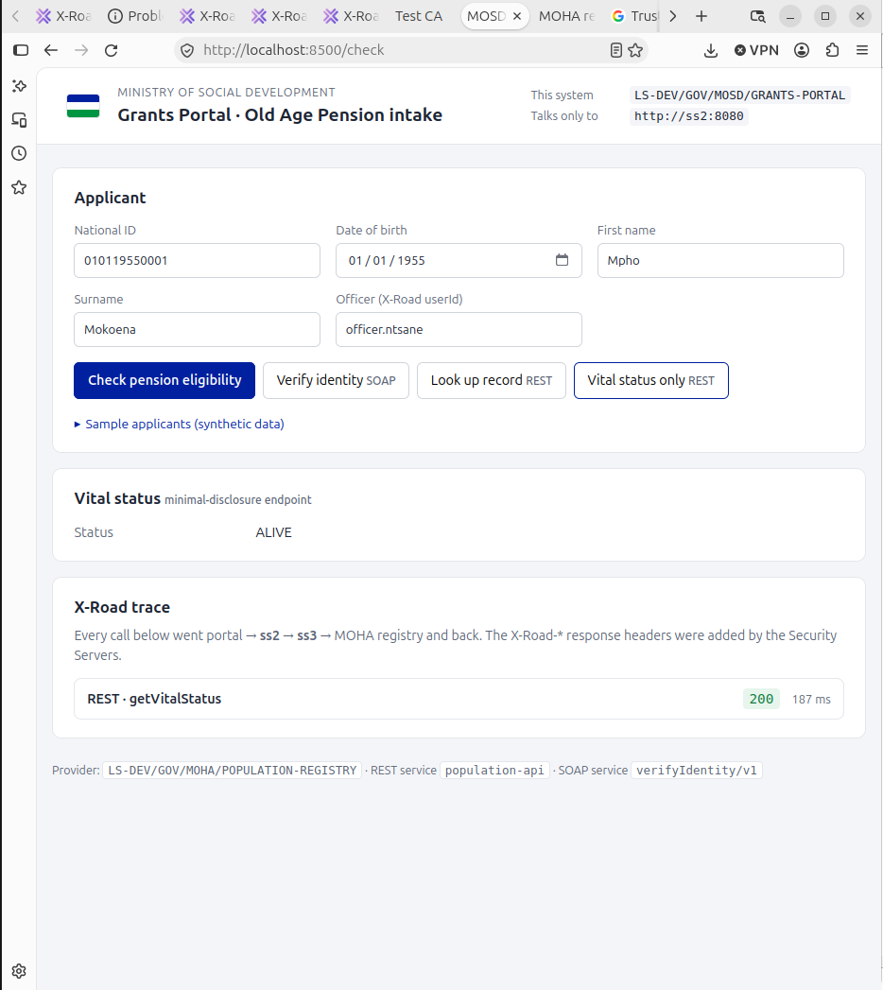
Figure 16. Grants Portal: SOAP verifyIdentity v1, HTTP 200 in 159 ms.
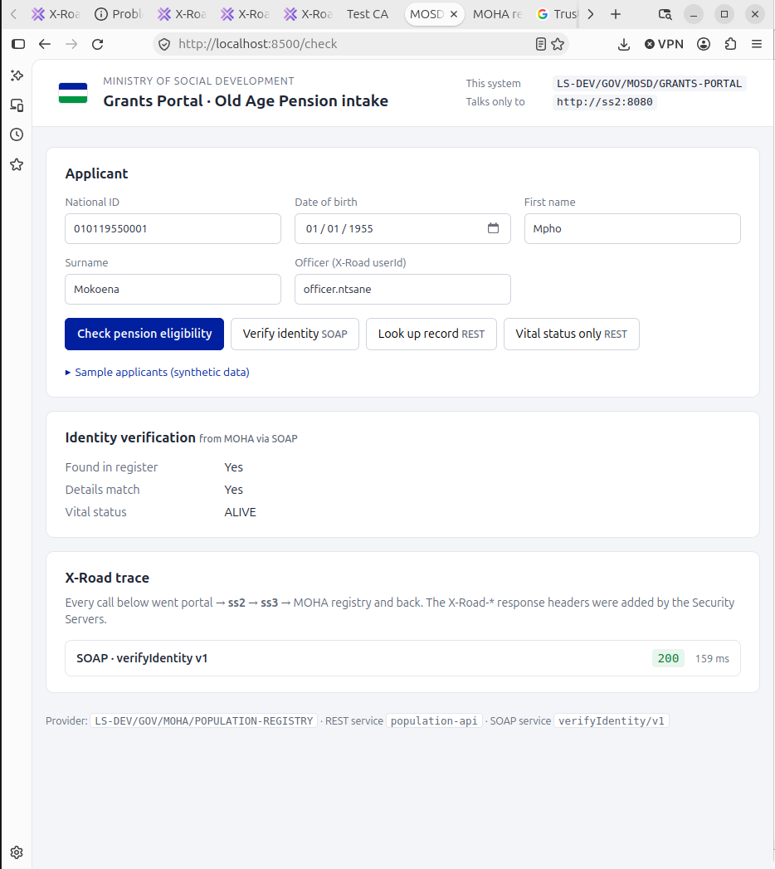
Figure 17. MOHA audit log: all three calls received from GRANTS-PORTAL.
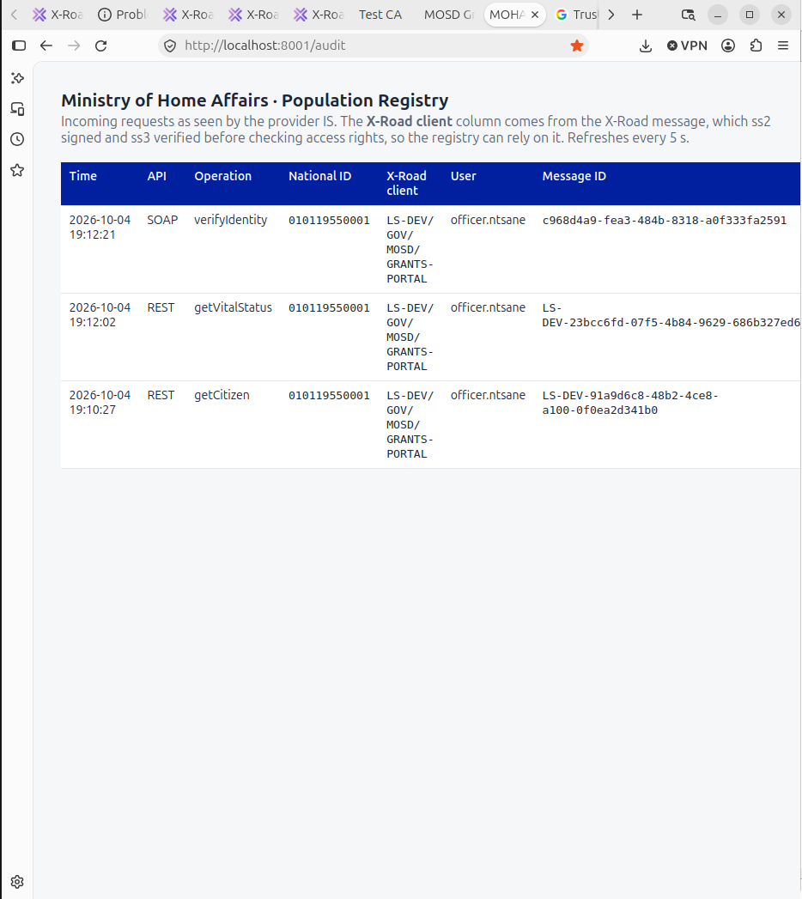

Appendix A. docker-compose.yml
The complete file used for the lab, unchanged. Start everything with docker compose up -d --build; stop with docker compose stop (never down -v, which deletes all 12 volumes).
# X-Road local lab: Lesotho government data exchange (LS-DEV)
#
# Based on the NIIS Knowledge Base guide "How to Set Up a Local Test
# Environment Using Docker Compose" (X-Road 7.7.0), extended with two
# information systems:
#
# mosd-portal (consumer IS) Ministry of Social Development Grants Portal
# LS-DEV/GOV/MOSD/GRANTS-PORTAL -> uses ss2
# moha-registry (provider IS) Ministry of Home Affairs Population Registry
# LS-DEV/GOV/MOHA/POPULATION-REGISTRY -> behind ss3
#
# Networks model a real deployment:
# xroad-network the shared "X-Road network": cs, ca and all Security Servers
# mosd-lan MOSD's internal network: only ss2 and the portal
# moha-lan MOHA's internal network: only ss3 and the registry
# The portal cannot reach the registry directly; it must go through ss2 -> ss3.
#
# Host ports (bound to 127.0.0.1: reachable only from this laptop.
# Docker publishes ports past ufw, so binding to loopback is what keeps
# the admin UIs and their default xrd/secret login off your Wi-Fi.)
# 4000 Central Server admin UI https://cs.lab:4000
# 8888 Test CA (signing UI + OCSP) http://localhost:8888/testca/
# 1000/2000/3000 ss1/ss2/ss3 admin UI https://ss1.lab:1000 etc.
# (cs.lab / ssN.lab are /etc/hosts aliases for 127.0.0.1; see README)
# 1080/2080/3080 ss1/ss2/ss3 consumer HTTP (1443/2443/3443 for HTTPS)
# 8500 MOSD Grants Portal http://localhost:8500
# 8001 MOHA registry audit/docs http://localhost:8001/audit
#
# Admin login for cs and all Security Servers: xrd / secret
# Token PIN everywhere: 123456xrd!

services:
cs:
image: niis/xroad-central-server:noble-7.7.0
container_name: cs
environment:
XROAD_TOKEN_PIN: 123456xrd!
ports:
- 127.0.0.1:4000:4000
volumes:
- cs-db-volume:/var/lib/postgresql/16/main
- cs-conf-volume:/etc/xroad
networks:
- xroad-network

ca:
image: ghcr.io/nordic-institute/xrddev-testca:latest
container_name: ca
ports:
- 127.0.0.1:8888:8888
volumes:
- ca-volume:/home/ca
networks:
- xroad-network

# Management Security Server, owned by the X-Road operator (MCST)
ss1:
image: niis/xroad-security-server-sidecar:7.7.0
container_name: ss1
ports:
- 127.0.0.1:1000:4000
- 127.0.0.1:1080:8080
- 127.0.0.1:1443:8443
environment:
XROAD_TOKEN_PIN: 123456xrd!
XROAD_ADMIN_USER: xrd
XROAD_ADMIN_PASSWORD: secret
XROAD_LOG_LEVEL: INFO
volumes:
- ss1-db-volume:/var/lib/postgresql/16/main
- ss1-conf-volume:/etc/xroad
- ss1-archive-volume:/var/lib/xroad
networks:
- xroad-network
depends_on:
- cs
- ca

# Consumer Security Server, owned by MOSD
ss2:
image: niis/xroad-security-server-sidecar:7.7.0
container_name: ss2
ports:
- 127.0.0.1:2000:4000
- 127.0.0.1:2080:8080
- 127.0.0.1:2443:8443
environment:
XROAD_TOKEN_PIN: 123456xrd!
XROAD_ADMIN_USER: xrd
XROAD_ADMIN_PASSWORD: secret
XROAD_LOG_LEVEL: INFO
volumes:
- ss2-db-volume:/var/lib/postgresql/16/main
- ss2-conf-volume:/etc/xroad
- ss2-archive-volume:/var/lib/xroad
networks:
- xroad-network
- mosd-lan
depends_on:
- cs
- ca

# Provider Security Server, owned by MOHA
ss3:
image: niis/xroad-security-server-sidecar:7.7.0
container_name: ss3
ports:
- 127.0.0.1:3000:4000
- 127.0.0.1:3080:8080
- 127.0.0.1:3443:8443
environment:
XROAD_TOKEN_PIN: 123456xrd!
XROAD_ADMIN_USER: xrd
XROAD_ADMIN_PASSWORD: secret
XROAD_LOG_LEVEL: INFO
volumes:
- ss3-db-volume:/var/lib/postgresql/16/main
- ss3-conf-volume:/etc/xroad
- ss3-archive-volume:/var/lib/xroad
networks:
- xroad-network
- moha-lan
depends_on:
- cs
- ca

# ---------------------------------------------------------------------------
# Information systems
# ---------------------------------------------------------------------------

# Provider IS: REST (OpenAPI 3) + SOAP (WSDL) population registry
moha-registry:
build: ./moha-registry
image: ls-lab/moha-registry:1.0
container_name: moha-registry
ports:
# Only so you can open /audit and /docs from your browser.
# In production a provider IS is never exposed like this.
- 127.0.0.1:8001:8000
networks:
- moha-lan
restart: unless-stopped

# Consumer IS: grants officer web app
mosd-portal:
build: ./mosd-portal
image: ls-lab/mosd-portal:1.0
container_name: mosd-portal
environment:
XROAD_SS_URL: http://ss2:8080
XROAD_CLIENT: LS-DEV/GOV/MOSD/GRANTS-PORTAL
XROAD_PROVIDER: LS-DEV/GOV/MOHA/POPULATION-REGISTRY
XROAD_REST_SERVICE: population-api
XROAD_SOAP_SERVICE: verifyIdentity
XROAD_SOAP_VERSION: v1
ports:
- 127.0.0.1:8500:8000
networks:
- mosd-lan
depends_on:
- ss2
restart: unless-stopped

volumes:
cs-db-volume:
name: cs-db-data
cs-conf-volume:
name: cs-conf-data
ca-volume:
name: ca-data
ss1-db-volume:
name: ss1-db-data
ss1-conf-volume:
name: ss1-conf-data
ss1-archive-volume:
name: ss1-archive-data
ss2-db-volume:
name: ss2-db-data
ss2-conf-volume:
name: ss2-conf-data
ss2-archive-volume:
name: ss2-archive-data
ss3-db-volume:
name: ss3-db-data
ss3-conf-volume:
name: ss3-conf-data
ss3-archive-volume:
name: ss3-archive-data

networks:
xroad-network:
name: xroad-network
driver: bridge
mosd-lan:
name: mosd-lan
driver: bridge
moha-lan:
name: moha-lan
driver: bridge

