

VICTOR KAMANU NGURE

084106

ELECTRO VIBRATION AND TOUCH SCREENS: CREATING VIRTUAL TEXTURE

Touch and gesture interaction has become a standard interface in mobile devices. Through physically touching something, we can feel a wide variety of sensations that allow us to experience the world. We can enjoy the feeling of textures, as well as the feeling of different objects and materials. Beyond experience, tactile sensations also guide us in everyday tasks and helps us explore object properties that we are not able to see. Today’s touch input technologies do not provide any tactile feedback and therefore the user cannot take full advantage of their sense of touch.
Through modern tactile technologies that are still in the development phase such as the Tesla Touch by Disney, users can feel a wide variety of tactile sensations on touch screen surfaces. This includes ridges, edges, protrusions, bumps or a combination of these textures.

Tactile sensations are generated by varying electric fields applied to a touch panel. The tactile panel consists of a glass plate covered by a thin insulation layer.

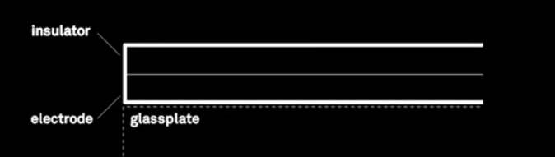

A periodic electric signal applied to the transport electrode displaces charges within the insulation layer creating an oscillating electric field.
When a finger is placed on the touch panel, a periodic motion of electrical charges is induced at the tip of the finger. This results in a periodic attraction force between the finger and the panel, modifying the friction between the sliding finger and the panel and thus producing a sensation of tactile texture.

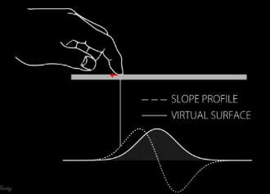

This technology can enhance the user experience in not only images but also videos.
Tactile technology has its pros and cons. Some of its pros includes;

1. Improving E Commerce.

Through simulation of different textures, tactile technologies can improve the quality of e commerce. Users can feel the texture and quality of different fabrics available before making a conclusive decision on what to buy.

2. Make mobile devices more accessible.

Through incorporation of tactile technologies in mobile devices, a braille application can be developed. This will allow blind people to use mobile devices as they can manouver their way around using the application.

3. Better gaming and drawing applications.

Tactile technology will enhance the feeling of painting on a virtual canvas in drawing application. The artist can feel the different textures of paints and choose the appropriate one to use.
Gaming can also be enhanced by tactile technologies. Through the use of friction and drag, the player can feel the change of texture in racing games such as bumps and edges.

However since this technology is very new, it has some cons that are yet to be solved for it to be successful. Implementing the alternating voltage results in a much bulkier device than with an ordinary capacitive touchscreen. As the technology sees more frequent use, however, there may be technological developments that allow more smart phone and tablet manufacturers to feature electro vibration without compromising on their designs.

Tactile technology will open up a great deal of opportunities that can improve our interaction with software. There will be better user experience since more senses will be involved during our interaction with our mobile devices.

