# Koala

The **koala** or, inaccurately, **koala bear** (***Phascolarctos cinereus***) is an arboreal herbivorous marsupial native to Australia. It is the only extant representative of the family Phascolarctidae and its closest living relatives are the wombats. The koala is found in coastal areas of the mainland's eastern and southern regions, inhabiting Queensland, New South Wales, Victoria, and South Australia. It is easily recognisable by its stout, tailless body and large head with round, fluffy ears and large, spoon-shaped nose. The koala has a body length of 60–85 cm (24–33 in) and weighs 4–15 kg (9–33 lb). Fur colour ranges from silver grey to chocolate brown.

Koalas from the northern populations are typically smaller and lighter in colour than their counterparts further south. These populations possibly are separate subspecies, but this is disputed.

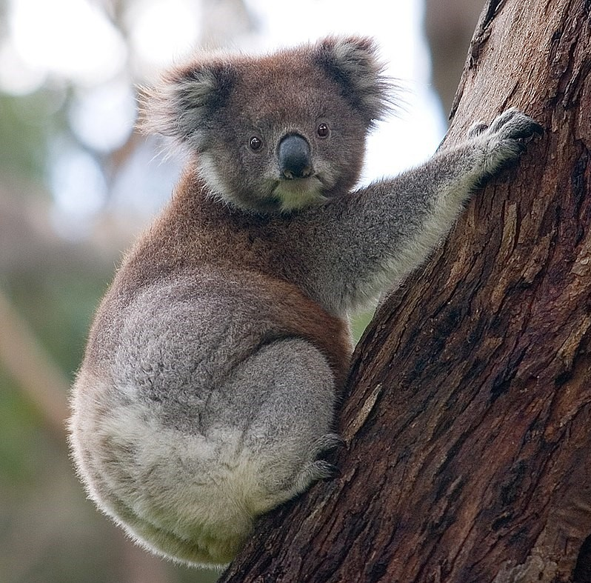

Lorem Ipsum is simply dummy text of the printing and typesetting industry. Lorem Ipsum has been the industry's standard dummy text ever since the 1500s, when an unknown printer took a galley of type and scrambled it to make a type specimen book. It has survived not only five centuries, but also the leap into electronic typesetting, remaining essentially unchanged. It was popularised in the 1960s with the release of Letraset sheets containing Lorem Ipsum passages, and more recently with desktop publishing software like Aldus PageMaker including versions of Lorem Ipsum.